Lesson Title

Purpose:
Learning Objectives:  Students will be able to: | Primary Core Component  *Replace this line with image and name*
Length | Materials Required

Activity Title *include type and name, see ex.* (# min)
Overview
Text

Content to be Explored
Text

Materials
text
Instructions

Teacher Tips

(note, delete these row if not needed)
Slide #: Title  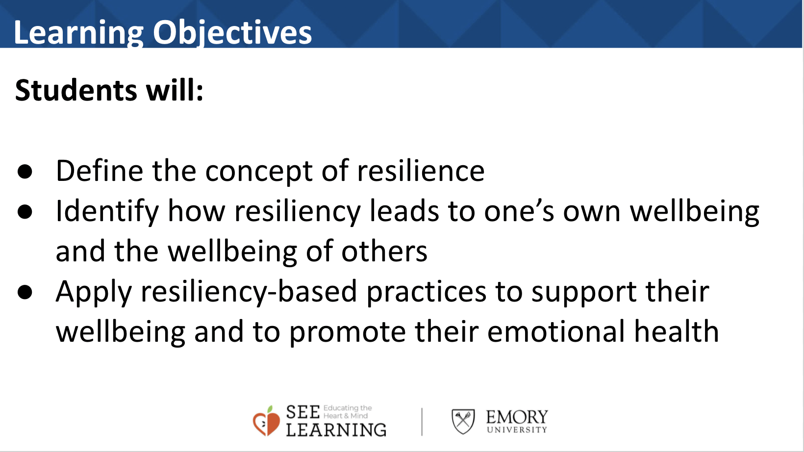 | Sample Script  Corresponding script for teachers here.

Activity title (# min)
Overview
Text

Content to be Explored
Text

Materials
text
Instructions

Teacher Tips

(note, delete these row if not needed)
Slide #: Title | Sample Script  Corresponding script for teachers here.

Activity title (# min)
Overview
Text

Content to be Explored
Text

Materials
text
Instructions

Teacher Tips

(note, delete these row if not needed)
Slide #: Title | Sample Script  Corresponding script for teachers here.

Activity title (# min)
Overview
Text

Content to be Explored
Text

Materials
text
Instructions

Teacher Tips

(note, delete these row if not needed)
Slide #: Title | Sample Script  Corresponding script for teachers here.

