Events and Systemic Structures

Purpose:
In this learning experience, students learn about how to more deeply understand an action or event by considering the many variables and factors that have led to it, including underlying systemic structures. Rather than placing all blame or praise on an individual, students can identify how internal and external structures, some of which are beyond an individual’s control, contribute to events. This understanding can deepen an appreciation of interdependence and common humanity.
Learning Objectives:  Students will be able to:  - Analyze the personal, social, and systems structures that contribute to an individual’s behavior, including underlying systemic structures.  - Explore how identifying the deeper structures that shape behavior helps us better understand and empathize with others’ situations and our own, and come up with better solutions. | Primary Core Component  Appreciating Interdependence  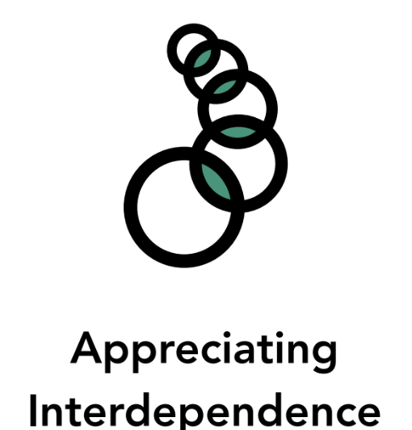
Length  40 Minutes | Materials Required  - Large sheets of paper  - Markers or pencils  - Iceberg graphic (included below)  - Copies of the handout “A Tale of Two  - Math Tests” (included below)

Check In (3 min)
Slide 2 : Check In   | Sample Script  - “Let’s do a short attention practice. How do we want our body to be?  - First we’ll take a comfortable and upright posture. I’ll be keeping my eyes open, but you can close them or look at the ground.  - Now choose one of your resources from your resource kit, or you can think of a new resource if you like: something that makes you feel better, safer, happier.  - Let’s bring our resource to mind and focus on it for a few moments quietly. You can also do grounding if you prefer. [Pause.]  - What do you notice inside? If you feel pleasant or neutral, you can rest your mind on that. If you feel unpleasant, you can shift to a place in your body that feels better. [Pause.]  - Now let’s become aware of our breathing. Let’s see if we can pay attention to the breath as it enters and leaves our body.  - If you find paying attention to the breath uncomfortable, then feel free to go back to your resource or grounding. [Pause for 15-30 seconds.]  - If you ever get distracted, you can just return your attention to the breath. You can also count your breath. [Pause for a longer time, such as 30-60 seconds or longer.]  - Now let’s end the practice and open our eyes. What did you notice?” [Share aloud.]

Presentation/Discussion: The Tip of the Iceberg (10 min)
Overview

In this presentation/discussion, students will discuss the idea of understanding events and
behaviors using the metaphor of the iceberg to explore context, patterns, systemic structures,
and interdependence.

Content to be Explored

- Actions and events can be understood not just through patterns of behavior, but also by looking at deeper systemic structures that underlie those patterns, like the submerged part of an iceberg.
- Identifying the deeper structures that shape behavior helps us better understand and empathize with others’ situations and our own, and come up with better solutions.

Materials
- Large chart paper
- Iceberg graphic (included below)

Instructions
- Draw an iceberg on a large piece of chart paper or the blackboard, show a photo of an iceberg, or show the image provided at the end of this learning experience.
- Ask students if they’d like to guess what percentage of an iceberg is typically visible
- above the water and what percentage is below the water. [Only 10% is visible above water.]
- Explain that the iceberg here is a metaphor for understanding events and behaviors. When we see a person do something, like say some angry words or fail a test, for example, we often know very little about the context. That action—the angry words or failing a test—is the tip of the iceberg, what we can see. When we look deeper into the context, it is like looking beneath the surface of the water to see all the things that contributed to that event.
- Share the iceberg graphic with students. At the top is the individual event (saying angry words, failing a test, passing a test.) These are easily visible to everyone.
- Show the next level: Just below the event are patterns of behavior. For example, the person who said angry words may often speak angrily. The person who failed the test may not study very hard. The person who passed the test might be a very good student in general. This second level can be seen by people who watch and pay attention over time.
- Show the next level: Beneath the patterns of behavior is an even deeper level, which we can only see by investigating deeply and doing systems thinking. This is the level of systemic structure. Systemic structures help to explain the patterns of behavior above them. They are called “systemic” because they point to larger systems around the individual in question. They are called “structures” because they lie beneath, support, and shape people’s patterns of behavior.
- Explain that we can explore systemic structures by asking our interdependence question: “What does this depend on?” Taking the event, such as doing well on a test, ask, “What does doing well on a test depend on? It depends on studying hard, which is the pattern of behavior. But what does that pattern of behavior itself depend on? What internal and external factors support that?”
- As they make suggestions, write them under two lists: “internal” and “external.” Explain that an internal factor is something within the person. Many of these have been explored already in SEE Learning, such as the ability to regulate one’s nervous system, focus attention, and navigate emotions. An external factor is something outside that person, such as a tutor, supportive parents or guardians, good books and study materials, a good teacher, time, having a good environment to study in, not having to work or do many chores that would prevent studying, etc.
- Conclude by tying the systems thinking back to empathy and compassion with these two questions:
  - “How might analyzing events and behaviors in this way help us empathize with others?
  - How might it help us practice self-compassion towards ourselves?”
Slide 3: The Tip of the Iceberg  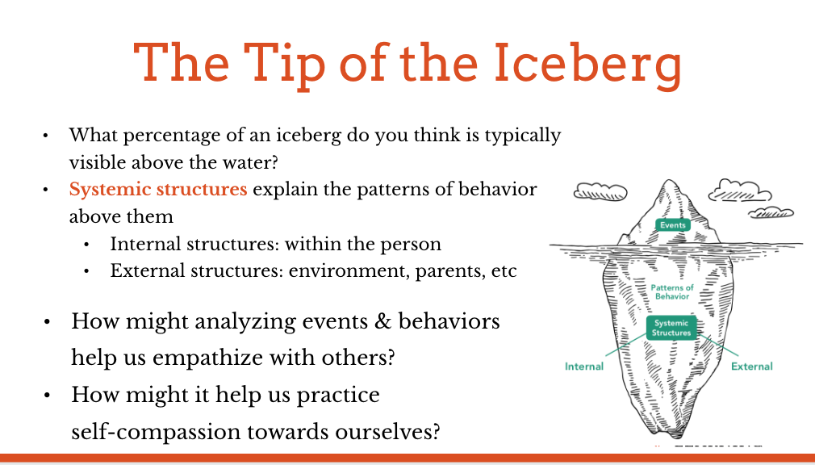 | Sample Script  - “Who has seen a photo of an iceberg, or even an actual iceberg? [Pause for responses.] What percentage of an iceberg do you think is typically visible above the water and what percentage is below the water, invisible to an approaching ship? [Answer: Only 10% of an iceberg is visible above the water. Show drawing or provided image of an iceberg.]  - Behavior is similar to an iceberg. What we can see and know about at first glance is like the tip of the iceberg: but what led to it lies beneath the surface, and we often can’t see it right away. When an event occurs, we often praise or blame what we think we saw in that an individual’s behavior without thinking about the larger context, including underlying systemic structures.  - Picture this iceberg as a visual representation of an event. At the top is the individual event, like saying angry words, failing a test, or passing a test. These are easily visible to everyone.  - Just below the event are patterns of behavior. For example, the person who said angry words may often speak angrily. The person who failed the test may not study very hard. The person who passed the test might be a very good student in general. This second level can be seen by people who watch and pay attention over time.  - But beneath the patterns of behavior is an even deeper level, which we can only see by investigating deeply and doing systems thinking. This is the level of systemic structure. Systemic structures help to explain the patterns of behavior above them. They are called “systemic” because they point to larger systems around the individual in question. They are called “structures” because they lie beneath, support, and shape people’s patterns of behavior.  - How would we know what the systemic structures are? We can start by asking our interdependence question: “What does this depend on?” Taking the event, such as doing well on a test, ask, “What does doing well on a test depend on? Does it depend on any patterns of behavior?” [Invite responses and write them, such as studying hard, paying attention in class, etc.]  - But what do these patterns of behavior depend on? Let’s go a bit deeper to the level of systemic structure. [Invite responses.]  - At this deeper level, we can talk of internal and external structures. Internal is something within the person. We’ve explored many of these: the ability to regulate one’s nervous system, focus attention, and navigate emotions. An external factor is something outside that person, like one’s environment or other people. What systemic structures support the ability to study well? [Write student suggestions under two lists: “internal” and “external.” External systemic structures can include: a good school environment, supportive parents or guardians, good books and study materials, good teachers, time, having a good environment to study in, not having to work or do many chores that would prevent studying, having been praised or supported in the past for studying, etc.]  - How might analyzing events and behaviors in this way help us empathize with others?  - How might it help us practice self-compassion towards ourselves?  - When we look at these factors we start to see how that behavior is taking place within a broader system of interdependence.”

Insight Activity 1: Looking for Systemic Structures (15 min)
Overview
In small groups, students will consider a scenario and brainstorm a list of possible variables that could have contributed to different results for the two characters. Through comparing their brainstormed lists, they will consider the ways in which an event is the cumulative result of many factors.

Content to be Explored
In analyzing events, systems thinking encourages us to consider a longer time frame of analysis, so that we can uncover the connections between past influences and present outcomes.

Materials
- Paper
- Markers or pencils
- Copies of the handout “A Tale of Two Math Tests” (included below)

Instructions
- Have students break into groups of 4-5 students each.
- Provide each group with a handout that includes the scenario and instructions (provided below.)
- Instruct students to discuss the scenario as a group and to create two lists, based on their group brainstorm: one list should identify the factors and variables that might have led to Asia doing well on the math test; the other list should name all the factors and variables they can think of that might have contributed to Arnav doing poorly.
- Remind students to consider all of the internal and the external factors they can imagine might have contributed to the different outcomes.
- Let students know when they have two minutes left to complete their brainstorm and to decide on a spokesperson who will read their lists to the class.
- When the time is up, ask each group to share their brainstormed lists with the class.
- You might invite the speaker from each group to briefly raise their hand each time the person sharing with the class says one of the factors that is on their list, too. This acknowledges the similarities between the lists and the full work of each team, without hearing the redundant items. Then each subsequent speaker only reads aloud the factors that they haven’t already checked off when it was read by a previous spokesperson.
- Conclude by discussing one or more debrief questions.
- Often when people try to correct an event, they only go down one level beneath the surface to the patterns of behavior. They try to change or “fix” that person’s behavior. For example, how might a teacher or adult try to “fix” a student who is failing or not doing well on their exams? What type of effects might those actions have?
- If we look deeper at the underlying structures, both internal and external, what might those include? What systemic structures help some students to do well? Which ones make it harder for some students to do well?
- How might systems thinking help Asia and Arnav? How might it help the teachers or adults working with them?
- What other events might we be able to understand better if we were to use this systems analysis?”

Scenario: A Tale of Two Math Tests
- Asia and Arnav are in the same math class and took a test last week. When the tests were returned by the teacher, Asia was very happy to see that she not only passed, but she got an “A,” the highest grade in the class! When Arnav got his test, however, he saw that he received an “F” despite having met with the teacher for extra help. When their teacher handed back the tests, she praised Asia’s hard work. She told Arnav, however, that she was disappointed he didn’t do better.
Slide 4: Looking for Systemic Structures  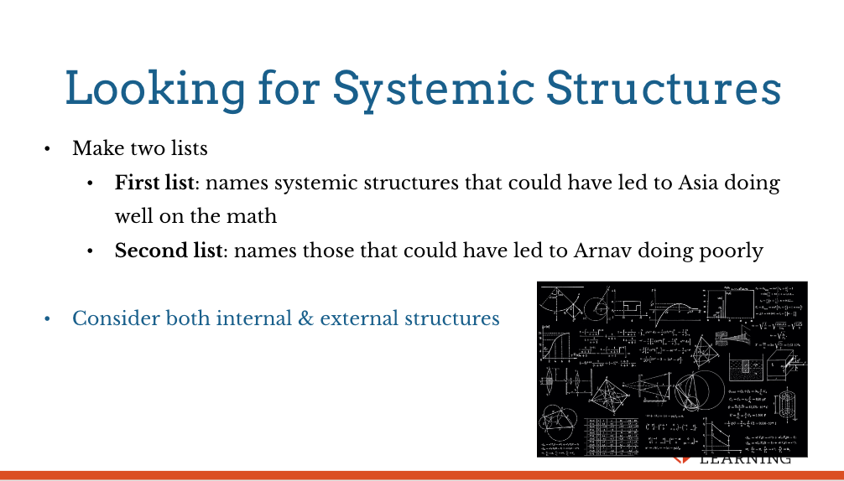 | Sample Script  - Now that you’re in your small work group, your task is to work together to review the scenario “A Tale of Two Math Tests” and think about it in terms of the “systems thinking iceberg.” Your group will make two lists: one that names some systemic structures that could have led to Asia doing well on the math test and the other list that names those that could have led to Arnav doing poorly.  - Consider both internal and external structures. There are no “right answers.” Rather, this is a chance to think broadly about many possible factors that might help lead to either of these outcomes. Please, everyone work to ensure that all voices in your group are heard, and be sure you record your ideas on your poster. You’ll have about six minutes for this.  - [Alert the groups when they have about two minutes left, and ask them to decide on a spokesperson who will read their lists to the class.]  - Would the spokesperson in each group please raise your hand? [Count off to acknowledge each speaker, so the process goes smoothly as you begin.] All spokespeople, please listen carefully as your counterparts read their ideas. When you hear an idea that is the same as, or very similar to, one on your list, please raise your hand and check it off your list. Everyone, please note when hands go up, so we’ll see where similarities in thought occurred. When it is your turn to speak for your group, please share only the items on your lists that have not already been shared by others, and checked off on your list. [Engage in discussion as appropriate to your group. Then debrief with the following questions:]  - Often when people try to correct an event, they only think about aspects that are just beneath the surface, as they’re thinking about a behavior. They try to change or “fix” that person’s behavior. For example, how might a teacher or adult try to “fix” a student who is failing or not doing well on their exams? What type of effects might those actions have?  - How might systems thinking help Asia and Arnav? How might it help the teachers or adults working with them?  - What other events might we be able to understand better if we were to use this systems analysis?”

Reflective Practice: Understanding Success through a Systems-Thinking Lens (10 min)
Overview
Students will draw a systems thinking iceberg that shows the systemic structures that contributed to an accomplishment that they have achieved.

Content to be Explored
- Our actions are the result of many factors and variables, some of which we have control over and some of which we don’t.
- We can appreciate ourselves for the positive choices we’ve made that helped bring a positive result to ourselves and others.
- We can thank others for the factors that we had no control over but that helped us achieve a goal or accomplishment.

Materials
- Paper for drawing
- Markers or crayons for each student

Instructions
- Ask students to identify an accomplishment that they have achieved, even something small. This could be a goal they reached, an opportunity they’ve had, or some small improvement or change they’ve made.
- Pass out paper and markers for all. Invite students to create an iceberg drawing that should be labeled with the achievement written at the tip of the iceberg, the part above water. Then, they can add the patterns of behavior and systemic structures (internal and external) that contributed to their achievement, placing these under the surface of the water.
- In identifying systemic structures, students may start with very concrete actions, such as a person who helped them directly. To help them find the systemic structure from that, ask them to continue asking the interdependence question: “What did that depend on?” In other words, why was that person able to help them? Did that person need help from someone before them? What system(s) made it possible for this help to be given and received?
- Ask students to star the factors that they have some control over.
- Ask students to identify something they want to appreciate themselves for, connected to this accomplishment, and invite them to silently give themselves that message, noticing how that feels.
- Ask students to identify two people who are represented in their drawing who helped them reach their goal, and invite them to silently thank those people as well. Note that they may also wish to reach out to those people and thank them directly, too.
- Invite students to share out if they are comfortable.

Teaching Tips
- Students may need some prompting or assistance in identifying an accomplishment. Remind them that accomplishments can be in any realm of their life, and can be small things that we may take for granted but that are actually important, for example: academic (learning something new, learning to read or write), social (having a friendship), physical (being able to play a sport), creative (being able to draw, sing, or play an instrument), and so on.
Slide 5: Understanding Success through a Systems-Thinking Lens  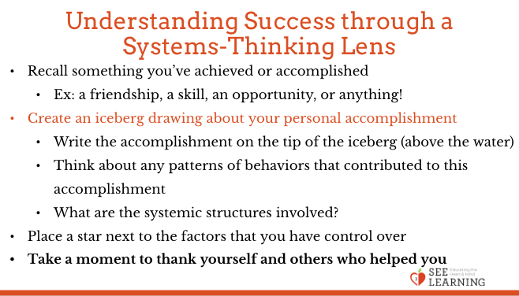 | Sample Script  - Now we’re going to create a systems thinking iceberg of our own. Think for a moment about something you’ve achieved or accomplished. This could be a small thing. It doesn’t have to be anything super special. It can be an opportunity you’ve had, or something you’ve learned, even learning to read and write. It could be a friendship you have or a skill you have, like playing a sport or playing an instrument. It could be an event like doing well on something or being able to do something fun. [Pause.]  - On your paper you’ll create an iceberg drawing about your personal accomplishment. Please write the accomplishment on the tip of the iceberg, the part above water. Below that, see if there are any patterns of behavior that helped or contributed to your accomplishment, either by yourself or by others.  - If you have trouble thinking of something to put here, ask the interdependence question: “What does this depend on?”  - Now go one level deeper. What are the systemic structures that were involved? Remember these can be internal and external. Again we find these by looking for connections and asking about interdependence. What was necessary? What did these things depend on? Were any larger systems involved?  - You can think back in time also. Were other people involved? Other systems? [Provide time for thinking, drawing and writing. Move through the classroom.]  - We have just a few minutes left, so please finish the last idea that you’re working on right now. [Pause.] And then look back over all of the factors and ideas that you recorded. Put a star next to the factors that you have some control over. [Pause.]  - Now identify something about this achievement that you want to appreciate yourself for, and silently give yourself that message of appreciation. It can sometimes be easier to think of nice things to say to others than to ourselves, so take this moment to notice how that feels inside when you express your appreciation to yourself.  - If you can identify people in your drawing who helped you, take a moment to silently thank them also.  - Now if anyone would like, you can share with the class one thing about your systems thinking iceberg.”

Debrief (2 min)
Slide 6: Debrief  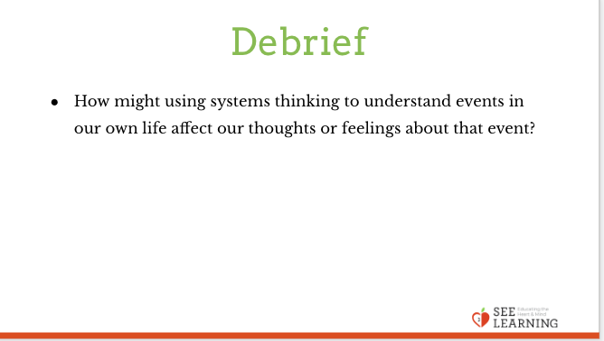 | Sample Script  - How might using systems thinking to understand events in our own life affect our thoughts or feelings about that event?

