Exploring Systems Thinking

Purpose:
In this learning experience, students analyze the ways in which their school is a system, and identify the ways in which the people in the system are interconnected and interdependent. Students will explore the ways in which parts of the system (the people within the school) act together toward common goals, and impact one another through their daily choices, attitudes and behaviors. This exploration provides a deeper understanding of interdependence that can help students gain an appreciation of the ways in which our behaviors, and the behaviors of others, have far-reaching consequences.
Learning Objectives:  Students will:  - Explore how to apply the principles of systems thinking  - Identify the ways in which the school operates as a system.  - Explore how individuals within the school system impact one another.  - Explore the ways in which changing one part of a system leads to changes (some intended, some unintended) in other parts of the system. | Primary Core Component:  
Length  35 Minutes | Materials Required  - Large charts Paper  - Markers  - Writing utensils  - Copy of the Systems Thinking Checklists

Check In (3 min)
Slide 2: Check In   | Sample Script  - “Let’s prepare for a short attention practice. How do we want our body to be?  - First we’ll take a comfortable and upright posture. Then we’ll keep our eyes on the ground or close them.  - Before we strengthen our attention, we’ll do some resourcing or grounding to calm our bodies. Choose one of your resources from your resource kit, or you can choose a new one, or you can imagine one.  - Now let’s just bring our resource to mind. And let’s see if we can just pay attention to our resource with our mind for a few moments quietly. Or if you’d rather do grounding, you can do that too. Whichever you choose, we’re going to rest quietly and pay attention for a few moments. [Pause.]  - What do you notice inside? If you feel pleasant or neutral, you can rest your mind on that.  - If you feel unpleasant, you can shift to a different resource, or you can ground. You can also change your posture but try not to disturb anyone else if you do that. Otherwise, just keep your attention resting with your resource. [Pause.]  - Now let’s become aware of our breathing. Let’s see if we can pay attention to the breath as it enters and leaves our body.  - If you find paying attention to the breath uncomfortable, then feel free to go back to your resource or grounding, or just take a small break, making sure not to disturb anyone else. [Pause for 15-30 seconds.]  - If you ever get distracted, you can just return your attention to the breath. You can also count your breath. [Pause for a longer time, such as 30-60 seconds or longer.]  - You can strengthen your attention by focusing on sensations or by focusing on the breath. It’s your choice - it’s always up to you.  - What did you notice?” [Share aloud.]

Presentation/Discussion: What is Systems Thinking? (7 min)
Overview
In this engagement, students are introduced to basic principles of systems thinking through a simple checklist.

Content to be Explored
- A system is something that has parts, and its parts are connected to each other.
- When we look for the ways that things are connected, we are doing systems thinking.
- Systems are everywhere!

Materials
- Whiteboard or chart paper
- Markers
- Copy of the Systems Thinking Checklist (MS_CH7_LX3 _HD_PAYTON)

Instructions
- Tell students you will be talking about systems thinking today. Give them the definition of a system.
  - “A system is something that has parts, and its parts are connected to each other in such a way that if we change one part, we affect other parts in the system, and possibly even the whole system.”
- Explain what systems thinking is:
  - “When we look at something and its parts, and think about how the parts are connected and related to each other and to the whole, we are doing systems thinking.”
  - Introduce your students to the Systems Thinking Checklist, which helps us to explore things as systems. Use the checklist with them to explore the human body as an example of a system.
    - “Systems Thinking Checklist:
    - 1. Does it have parts and what are they?
    - 2. Are the parts connected to each other? How?
    - 3. If we change one part, does it affect other parts? How?
    - 4. Are the parts connected to other things on the outside? How?”
- Ask students to suggest additional things that they could explore as systems. Run each suggestion through the Systems Thinking Checklist.
- Conclude the discussion by reminding students: Systems thinking means looking for connections between the parts of a larger whole.
Teacher Tips
- Almost everything has parts and can be thought of as a kind of system. Since the point is not to correctly identify what is and what is not a system, but rather to teach a certain way of looking at things as systems, be encouraging even when students suggest things that may not immediately appear to be systems.
- It can be helpful to show your students visual examples of things that can be easily recognized as systems, such as a house of cards (or any other construction where removing one part would cause it to collapse), a mechanical watch or other mechanical objects where one can see the inner workings, a quilt where many threads are interconnected to form a larger whole; etc.
Slide 3: What is Systems Thinking?  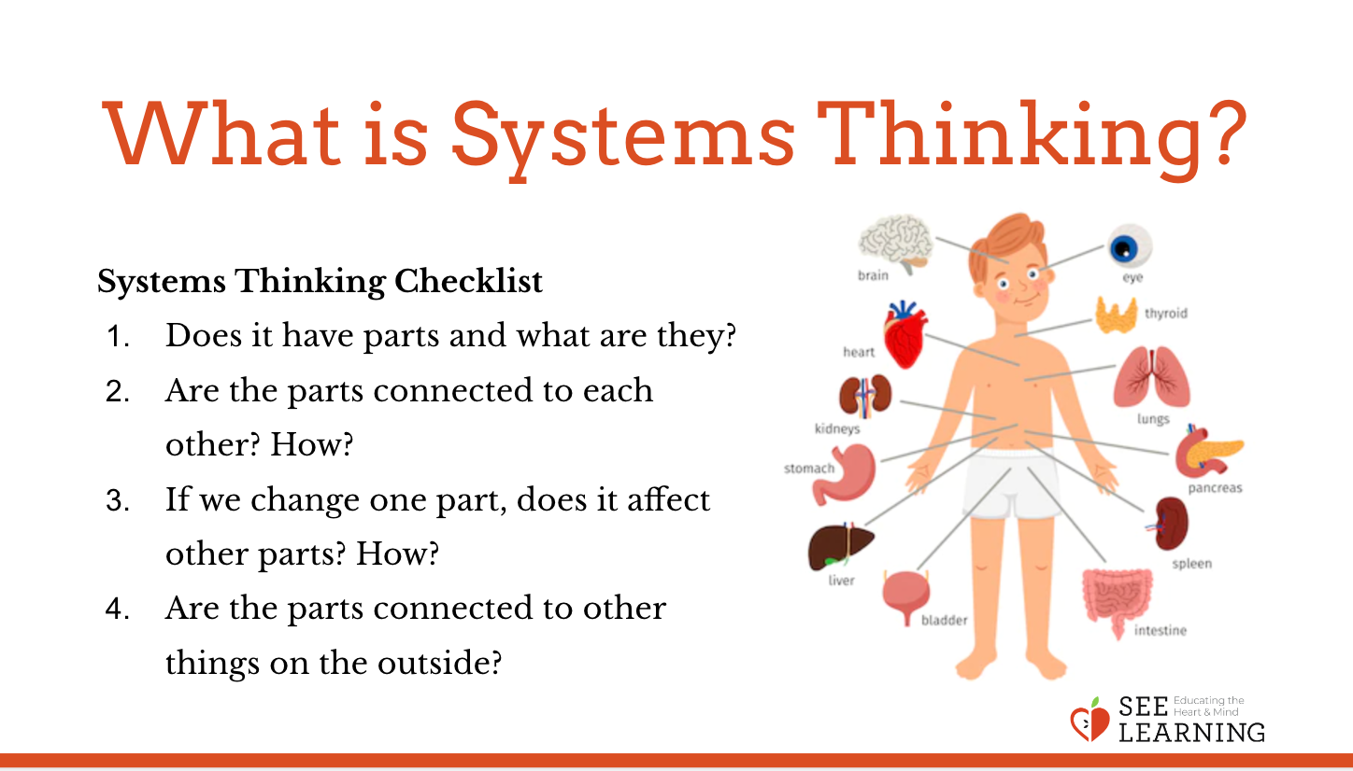 | Sample Script  - “Today we’re going to learn about an interesting way of thinking. It’s called systems thinking.  - A system is something that has parts, and its parts are connected to each other in such a way that if we change one part, we affect other parts in the system, and possibly even the whole system.  - When we look at something and its parts, and then think about how the parts are connected and related to each other and to the whole, we are doing systems thinking.  - Systems thinking is essential for understanding anything that has complexity. Imagine if we were trying to understand something complex, but we just looked at the individual parts on their own, and failed to recognize how they interacted or were part of a larger system. We probably wouldn’t arrive at a deep understanding and we could easily make mistakes.  - To get started with systems thinking, we have a simple checklist we can use.  - Systems Thinking Checklist:  - 1. Does it have parts and what are they?  - 2. Are the parts connected to each other? How?  - 3. If we change one part, does it change other parts?  - 4. Are the parts connected to other things on the outside? How?  - We can use this checklist to look at anything complex, like the environment or our bodies. Why might it be important to think of our body as a system, rather than just a set of independent parts?  - Let’s think of other things. What else might be a system? [Take examples from the class. Spend time going through at least one more example, using the checklist to see if the example is a system. If time permits, use the checklist for more examples.] Many things are systems.  - What problems might arise if we didn’t think of these things as systems?  - Systems thinking means looking for connections between things and how they make up a larger, interconnected whole. Once we start looking for connections, we find that systems are everywhere.”

Insight Activity: Systems Mapping Our School and Extending Unintended Consequences (20 min)
Overview
In this activity, students will explore how the school can be understood as a system and will “map” the school as a system to show the connections between its parts. Students will work in small groups to explore the impact of a change on the school system. They will identify the ways in which change to one part of the system can cause “unintended consequences” in another part of the system.

Content to be Explored
- We can map and analyze systems and their parts.
- Things and people in the system impact one another in complex ways.
- Changing one part of the system can cause “unintended consequences” in another part of the system.
- In thinking about a change to a system, it can be helpful to think about the needs and feelings of all the people who could be impacted.

Materials
- Large chart paper and markers. You may want to use butcher paper, or tape together
- a few pieces of chart paper so that you can draw the systems map large enough for the whole class to see it from their seats.
- Paper for students
- Pencils or markers

Instructions
- Explain that the class will now apply systems thinking to your school.
- Draw a circle in the middle of the chart paper or board and label it “our school.”
- Use the systems thinking checklist to create a mapping of the school as a system, by going through each question and inviting students to draw and write on the chart paper. For example, when listing the parts of the school, ask them to name the various people and groups of people who are involved in the school or connected to it (teachers, students, the principal/school head, janitors, secretaries, nurses, bus drivers, parents, etc).
- Ask how the people in this system are connected to each other. [As necessary, prompt them with questions from the sample script below.]
- If there is anyone listed in the circle who is not yet connected to another person/ group, guide students in making the connections visible.
- Ask them what they notice about the systems map and encourage them to make connections to previous learning, and to other areas that seem related to this experience.
- Divide students into groups of 4-6. Provide each group with a scenario and the question prompts below, as well as a large piece of paper to write on. Ask them to read the scenario and then explore as a group how the change described in the scenario might affect the school as a system and the people in it, answering each of the question prompts.
- Invite each group to share their scenario and their response to the questions about the impact that scenario might have. After each group shares, invite other students to suggest other consequences that might arise from such a change.

Teacher Tips
- During the discussion, your students may come up with responses that you had not considered. Be open to their responses and thought processes to help them explore the interconnectedness between the parts of a system.
- If the provided scenarios do not fit your context, create your own scenario or brainstorm one with your students.
  - Scenarios
    - 1. The school decides to increase the size of the school by 500 students.
    - 2. The principal/school head has set very high goals for student achievement. If enough students can reach those goals, then the state will provide our school with more money. [Remember to explore both challenging aspects of this situation, and possible strategies the school already employs, or could employ—peer mentoring, collaborative learning, welcome ambassadors, explicit social and emotional learning experiences—that could work toward the “achievement of the high grades for state funding opportunity.”]
    - 3. The people who run the school are considering moving the start time of the school day to one hour earlier.
    - 4. The school is deciding to eliminate student clubs, organizations, and sports in favor of academics.
  - “What consequences—positive, negative, or unintended—might arise for the school and the people in it? Are there any consequences that might be positive for some people but negative for others?
  - How would people’s feelings and needs be affected?
  - Might this change lead to any negative or positive feedback loops?
  - What might some of the long-term effects on the school be?
  - How might the school best ensure that this change is implemented in a compassionate way?”
Slide 4: Systems Mapping Our School and Extending Unintended Consequences  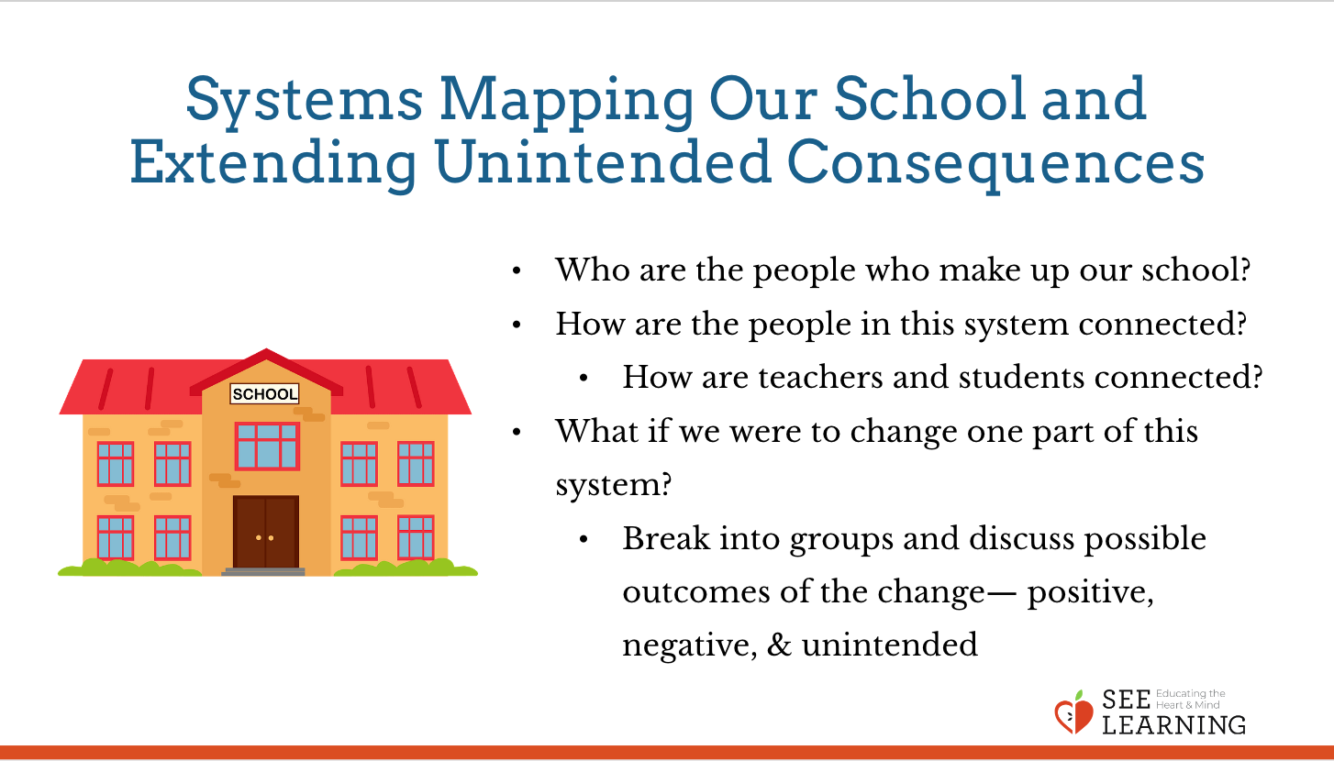 | Sample Script  - “Now that we know what a system is and we’ve practiced some systems thinking, we’re going to learn how to create a systems map.  - Let’s consider our school as a system. [Draw a large circle on the chart paper and label the circle “our school” or the name of your school.]  - Let’s focus on the people in our school as a system. Who are the people who make up our school? [As students provide answers, write each one of them within the large circle. Help them stretch to include everyone they can think of, including various ages and roles, who is connected to your school.]  - A systems map shows the connections between the parts of a system, so we can make note of that here. How are the people in this system connected with each other? Let’s see how many connections we can find. [As necessary, prompt them with some of the following questions:]  - What are some of relationships between the teachers and the students? For example, do students need to pay attention to their teachers? Do teachers need to pay attention to their students? So, attention is one of the ways that students and teachers are connected. [To show this connection between teachers and students, draw a line labeled “attention” that connects the teachers and the students on the systems map. The lines have arrows on both ends to show that attention is both given and received by both parties.]  - What are some other ways teachers and students are connected? [Take responses and add a few more lines that are labeled to show the nature of the connections.]  - Is there anyone here who isn’t connected yet to at least several other people? If so, let’s see how they might be connected.  - What do you notice about this systems map?  - What if we were to change one part of this system? For example, what if 50 new students started at our school tomorrow? Would that create any change in the system? How would it impact the teachers, for example? Other students? How would that impact other people in the system? How might it make different groups of people in the system feel? How might it affect their needs? [If no one mentions the new students as part of the system, add them and ask for connections and impacts on them. Similarly, if positive consequences of adding new students don’t get mentioned, prompt a brainstorm around that lens—fresh perspectives, new opportunities for friends, the wealth of knowledge and skills they would be bringing with them...]  - Now, what if 500 new students were here to start school tomorrow, instead of 50?  - We might take in the 500 new students with the intention of providing fair and accessible education, but this wouldn’t be the only outcome of our action. There are unintended consequences that would happen as a result. What are some of those? [Record student responses.] Might any of those consequences make it harder to reach our intended goal of providing all students with an excellent education?  - Next you’ll work in small groups of 4-6, and will consider a short scenario that describes a change in the school system. You should discuss with your group how other parts of the system could be impacted by the change described in the scenario. Try to think of all the different possible outcomes the change might have—positive, negative, and unintended. An unintended consequence is an impact that was either unforeseen or unexpected by the person making the original change.  - [Break students into small groups and provide them with one of the scenarios listed below, as well as the list of question prompts. Alternatively, brainstorm with them a scenario that they would like to analyze.]  - [Give them time to brainstorm in their small groups before doing a final debrief. Visit with the small student groups to answer their questions and check in with their process and results.]  - Let’s hear something from each group. Please share your responses to the questions.  - What have we learned about the ways in which changing one part of the system can impact the other parts?”

Debrief (5 min)
Slide 5: Debrief  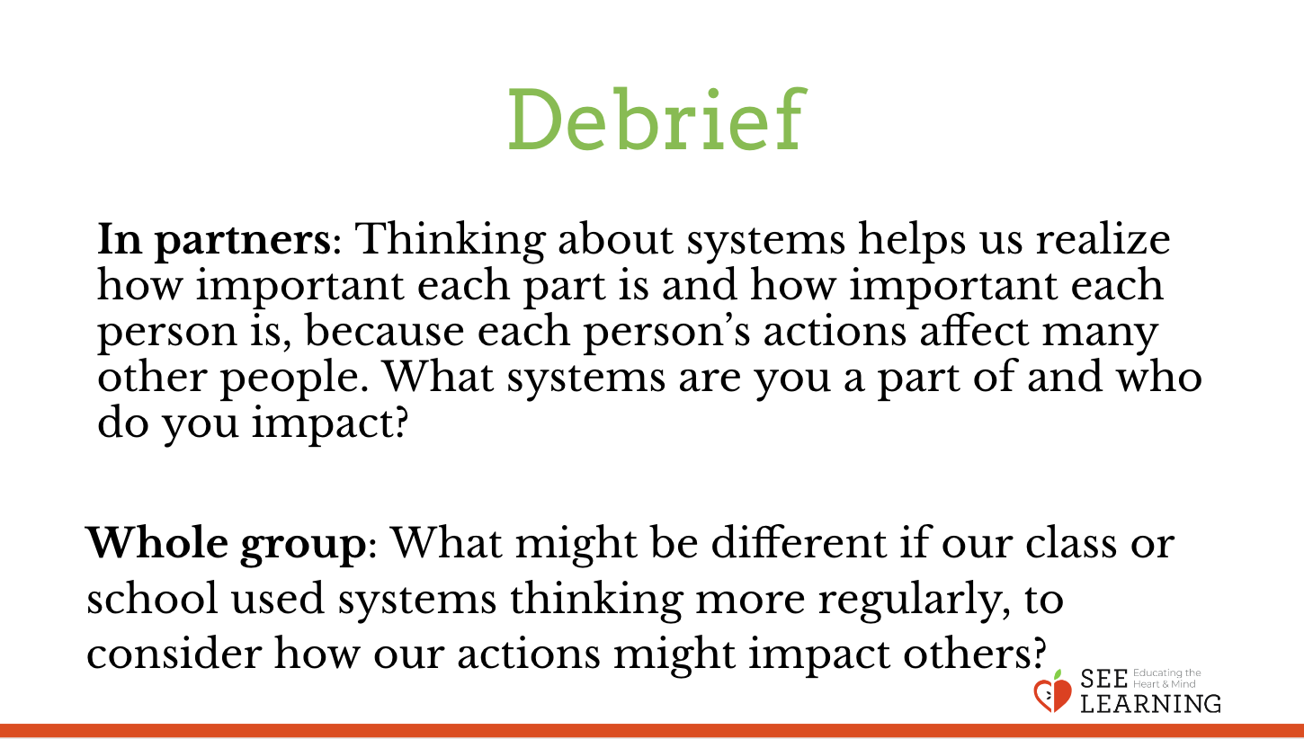 | Sample Script  - Choose one of the following:  - In partners: “Thinking about systems helps us realize how important each part is and how important each person is, because each person’s actions affect many other people. What systems are you a part of and who do you impact?”  - Whole group: “What might be different if our class or school used systems thinking more regularly, to consider how our actions might impact others?”

