Exploring Feedback Loops

Purpose:
In this learning experience, students learn what a feedback loop is through a story. A feedback loop is a circular process that continues and keeps getting stronger unless some internal or external change breaks the cycle. Students explore positive feedback loops (with positive outcomes that strengthen the positive cycle) such as kind actions reciprocated between two people, as well as negative feedback loops, (with negative outcomes that strengthen the negative cycle) such as meanness between two people that escalates

Learning Objectives:  Students will be able to:  - Recognize feedback loops, both positive and negative.  - Explore how kindness and meanness can lead to positive and negative feedback loops.  - Identify ways to change negative feedback loops into positive ones. | Primary Core Component  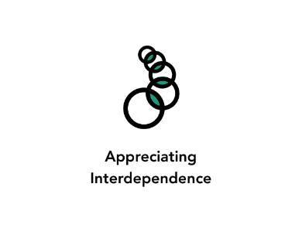
Length  30 Minutes | Materials Required  - The Talent Show story  - Markers  - Whiteboard/chart paper  - Paper  - Markers or crayons for drawing

Check In (3 min)
Slide 2 : Check In   | Sample Script  - “Let’s prepare for a short attention practice. How do we want our body to be?  - First we’ll take a comfortable and upright posture. Then we’ll keep our eyes on the ground or close them.  - Before we strengthen our attention, we’ll do some resourcing or grounding to calm our bodies. Choose one of your resources from your resource kit, or you can choose a new one, or you can imagine one.  - Now let’s just bring our resource to mind. And let’s see if we can just pay attention to our resource with our mind for a few moments quietly. Or if you’d rather do grounding, you can do that too. Whichever you choose, we’re going to rest quietly and pay attention for a few moments. [Pause.]  - What do you notice inside? If you feel pleasant or neutral, you can rest your mind on that.  - If you feel unpleasant, you can shift to a different resource, or you can ground. You can also change your posture but try not to disturb anyone else if you do that. Otherwise, just keep your attention resting with your resource. [Pause.]  - Now let’s become aware of our breathing. Let’s see if we can pay attention to the breath as it enters and leaves our body.  - If you find paying attention to the breath uncomfortable, then feel free to go back to your resource or grounding, or just take a small break, making sure not to disturb anyone else. [Pause for 15-30 seconds.]  - If you ever get distracted, you can just return your attention to the breath. You can also count your breath. [Pause for a longer time, such as 30-60 seconds or longer.]  - You can strengthen your attention by focusing on sensations or by focusing on the breath. It’s your choice - it’s always up to you.  - What did you notice?” [Share aloud.]

Presentation/Discussion: Feedback Loops (14min)
Overview

In this presentation and discussion, students learn about positive and negative feedback loops through a story about two students who act unkindly and kindly towards one another. Through comparing the characters’ actions and responses, students explore how feedback loops can be strengthened by the choices one makes.

Content to be Explored

- A feedback loop is a reinforcing cycle; it will continue with increasing intensity until something or someone stops it or changes its course.
- Feedback loops can be positive or negative.
- Kindness and meanness can lead to positive and negative feedback loops.

Materials
- The Talent Show Story, Parts I & II (included)
- Markers
- Board/chart paper

Instructions
- Tell students you will be reading a very short story, and you will be asking them how they think it will end.
- Read The Talent Show Part 1. End with the question, “How is Teddy likely to respond to this insult from Alice?” Take a few responses from students.
- Ask students what Teddy and Alice might do or say, if they were to continue responding to one another out of hurt feelings.
- Explain that you’re going to create a drawing to depict what happened in the story, and what might happen next. On the board or large chart paper, draw a diagram of a feedback loop like the one provided at the end of this learning experience.
- As you draw the feedback loop, ask the students to help fill in the feelings and actions of Alice and Teddy as the cycle continues. Use the provided questions, and write the feelings and actions of each character into the loop.

- Negative Feedback Loop Questions
  - “How might Alice have been feeling when she entered class?
  - When Teddy insulted Alice how might she have felt then?
  - What happened next?
  - How do you think Teddy might have been feeling then? How else might he have responded?
  - Where do you think they might be in their zones—high zone, low zone, or resilient zone?
  - What might happen if they kept feeling hurt and doing unkind things to each other?
  - How does what we have learned about risky emotions or needs relate to what is going on between Alice and Teddy?”
  - Explain that the circular drawing you have created with students is called a “feedback loop.” You can provide the following definition and explanation for the term:
  - “A feedback loop is a reinforcing cycle; it will continue going around and around, with increasing intensity, until something or someone stops it or changes its course.
  - “Feedback” is a term that means something keeps feeding on itself and growing stronger, because part of its output becomes a new input. When a microphone is placed before a loudspeaker, sometimes it makes a deafening shrill sound. That is feedback, because the output of the loudspeaker is being picked up by the input of the microphone. This very quickly amplifies the signal into a deafening noise until someone points the microphone away from the speaker or turns the speaker down.”
  - Explain that this drawing is called a negative feedback loop because it shows how the actions of each character leads to feelings which lead to more actions that only make things worse:
  - Unkind action Hurt Feelings Unkind action Hurt Feelings
- However, the characters in the story could make other choices. (They could do the equivalent of “turning the microphone in a different direction” or “turning down their speaker.”) Ask students to identify the “choice points” in the scenario; the places where a different choice could have been made by either Alice or Teddy.
- Once students have identified the choice points (they are present during every step in the feedback loop), tell them that you will read a different version of the Talent Show story.
- Read students The Talent Show Part II.
- Explain that this story has a different outcome because the characters made different choices.
- How would we draw another feedback loop, this time a positive one instead of a negative one, to show what happened in this second version of the story?
- Take student suggestions for how to draw the feedback loop, beginning with positive words, and continuing from there.
- Ask students: how might the story and the positive feedback loop continue?
- Finally, place the two feedback loops side by side so that your students can take a look at both, demonstrating what a negative feedback loop is and what a positive feedback loop is.
- Remind your students how feedback loops get stronger as they continue. Feedback loops create patterns because, without intervention, they repeat and can grow into a habit.
- Ask one or both of these questions:
  - What kinds of positive or negative loops have you seen happening at school? Remember to describe the situation without naming any names. (“I know someone who…”)
  - Would anyone be willing to share an example of a time when they felt like they were participating in either a negative or a positive feedback loop? What contributed to being able to stop, or to continue it?

- The Talent Show, Part 1

- “Alice walked into class, feeling tense and looking nervously around at her classmates. The day before Alice was singing in the talent show and had become very nervous when she saw everyone staring at her. She panicked and forgot the words right in the middle of the song and had to start all over again from the beginning. As she took her seat, her classmate Teddy smirked, and sarcastically said, “Nice comedy routine at the talent show yesterday.” Alice’s face became hot and she retorted, “At least I have a talent, and am not a boring nobody like you!”

- [Question:] How is Teddy likely to respond to Alice?”

- The Talent Show, Part 2

- “Alice walked into class, feeling tense and looking nervously around at her classmates. The day before Alice was singing in the talent show and had become very nervous when she saw everyone staring at her. She panicked and forgot the words right in the middle of the song and had to start over again from the beginning. As she took her seat, her classmate Teddy said, “You sounded good yesterday. Way to go.” Alice’s body relaxed. “Thanks!” she said, “That means a lot to me! You sounded good too!”

- [Question:] How is Teddy likely to respond to Alice?”

Slide 3: Presentation/Discussion  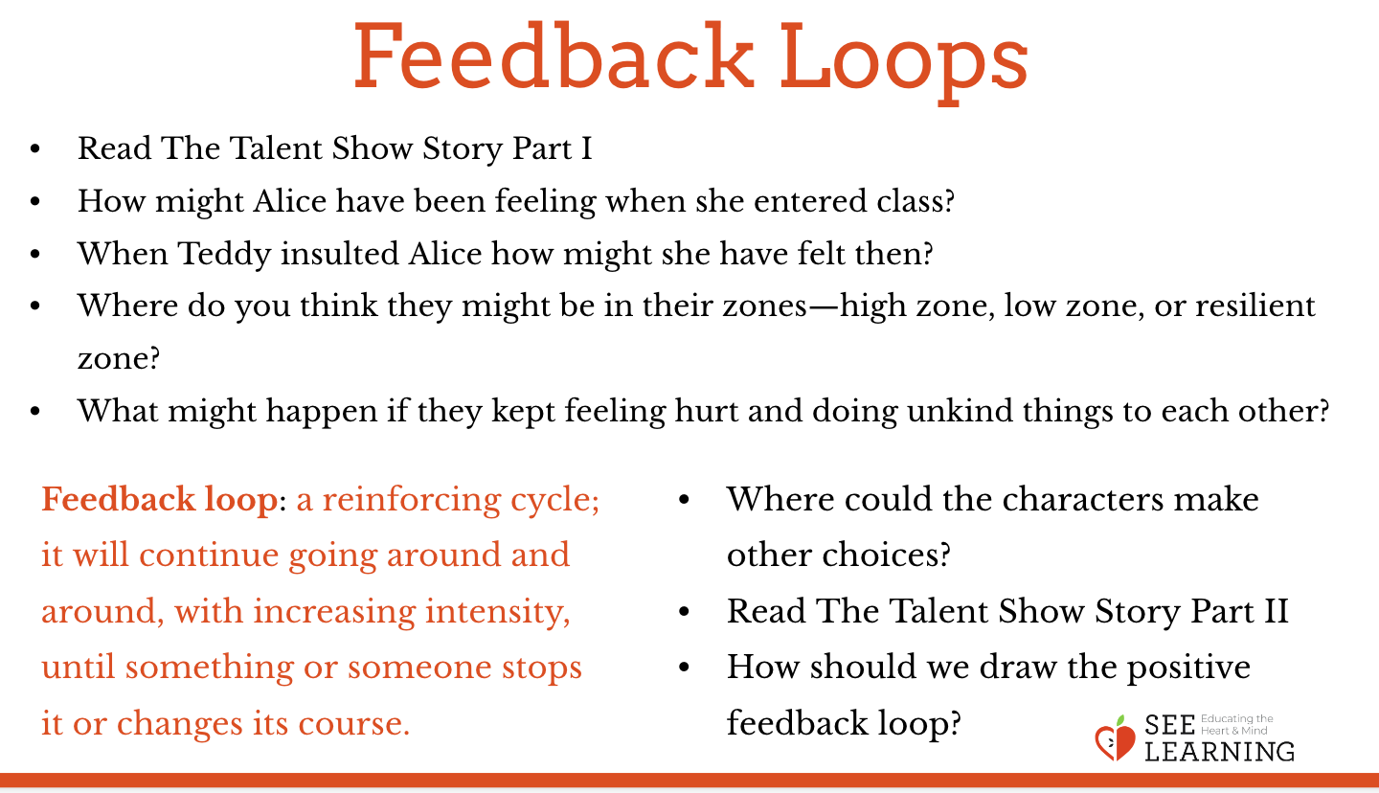 | Sample Script  N/A

Reflective Practice (10 min): Changing a Negative Feedback Loop into a Positive One
Overview
In this reflective practice, students consider the ways they could break a negative feedback loop and change it into a positive one instead. They draw pictures representing both the negative and the positive feedback loops.

Content to be Explored
- Feedback loops that frequently occur can lead to habits, which are patterns of behavior that can be difficult to change.
- People can make choices, and then work to change a negative loop into a positive one

Materials
- Paper
- Markers or crayons for drawing
Instructions
- Let students know that they are to draw a feedback loop that demonstrates a situation or relationship that’s positive in their life.
  - “Think about something you work hard to be good at, or a relationship that’s valuable and positive in your life. Think about what some of the things are that you and others say and do that keep this experience or relationship thriving. Write and/or draw those into a feedback loop format.”
- Once completed, students can share their drawings in pairs, adding in an appreciation for a specific contribution they or someone else makes to this positive feedback loop, that enhances their life and helps them “build the muscle” of choosing to add positivity to a situation.

Slide 4: Reflective Practice  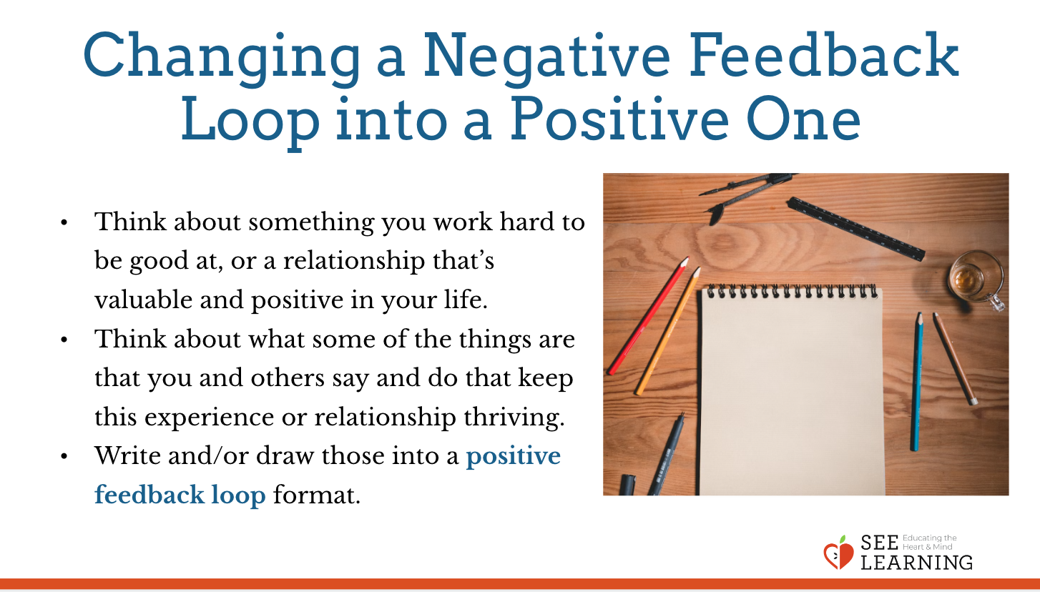 | Sample Script  N/A

Debrief (3 min)
Slide 5: Debrief  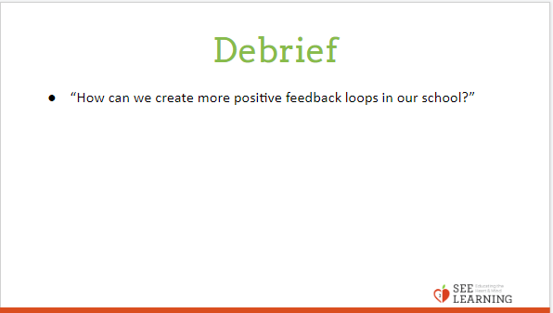 | Sample Script  - “How can we create more positive feedback loops in our school?”

