It Takes a Village

Purpose:
By using the example of a child their age, and identifying the many forms of care and support a child needs from others to arrive at their current age, students will explore interdependence, a vital aspect of systems thinking: the help of family and caregivers, teachers, members of the community, friends, and strangers. In doing so, they will come to see the multitude of ways they have received care and support from others. Recognizing the value and care that one has received and that one still receives on a daily basis helps students realize that they are not alone, that they are valued, and that they can be confident in their future, knowing that others are supporting them.
Learning Objectives:  Students will be able to:  - Enumerate the many acts of kindness, care, and support a child receives while growing up.  - Explore interdependence and systems thinking by examining how an individual depends on and can be affected by many members of a community (the system).  - Identify the ways in which they have been cared for throughout their lives, recognizing the number of people that contribute to their well-being. | Primary Core Component  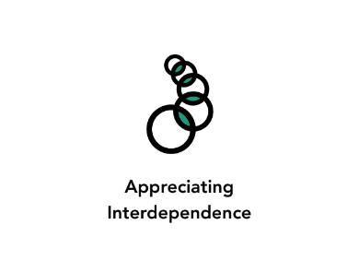
Length  35 Minutes | Materials Required  - Large sheets of paper  - Markers  - Writing utensils  - A sheet of paper for each of the four age levels: pregnancy, baby-2 years, 3-5 years, 6-10 years (enough for as many groups of 2-3 that you will have)

Check In (3 min)
Slide 2 : Check In   | Sample Script  - “Let’s prepare for a short attention practice. How do we want our body to be?  - First we’ll take a comfortable and upright posture. Then we’ll keep our eyes on the ground or close them.  - Before we strengthen our attention, we’ll do some resourcing or grounding to calm our bodies. Choose one of your resources from your resource kit, or you can choose a new one, or you can imagine one.  - Now let’s just bring our resource to mind. And let’s see if we can just pay attention to our resource with our mind for a few moments quietly. Or if you’d rather do grounding, you can do that too. Whichever you choose, we’re going to rest quietly and pay attention for a few moments. [Pause.]  - What do you notice inside? If you feel pleasant or neutral, you can rest your mind on that.  - If you feel unpleasant, you can shift to a different resource, or you can ground. You can also change your posture but try not to disturb anyone else if you do that. Otherwise, just keep your attention resting with your resource. [Pause.]  - Now let’s become aware of our breathing. Let’s see if we can pay attention to the breath as it enters and leaves our body.  - If you find paying attention to the breath uncomfortable, then feel free to go back to your resource or grounding, or just take a small break, making sure not to disturb anyone else. [Pause for 15-30 seconds.]  - If you ever get distracted, you can just return your attention to the breath. You can also count your breath. [Pause for a longer time, such as 30-60 seconds or longer.]  - You can strengthen your attention by focusing on sensations or by focusing on the breath. It’s your choice - it’s always up to you.  - What did you notice?” [Share aloud.]

Presentation/Discussion: What is Caring and How Have We Experienced It? (4min)
Overview

In this discussion, students will talk about what “care” means, concrete examples of things they have cared for, and people who have cared for them.

Content to be Explored

- We tend to care for people and things that we find valuable.
- We need the care of others to grow up and survive.

Materials
None

Instructions
- Using a few concrete examples, discuss the meaning of care. The sample script below provides discussion questions you may ask.

Teacher Tips
- Allow students to guide this discussion.
Slide 3: Presentation/Discussion  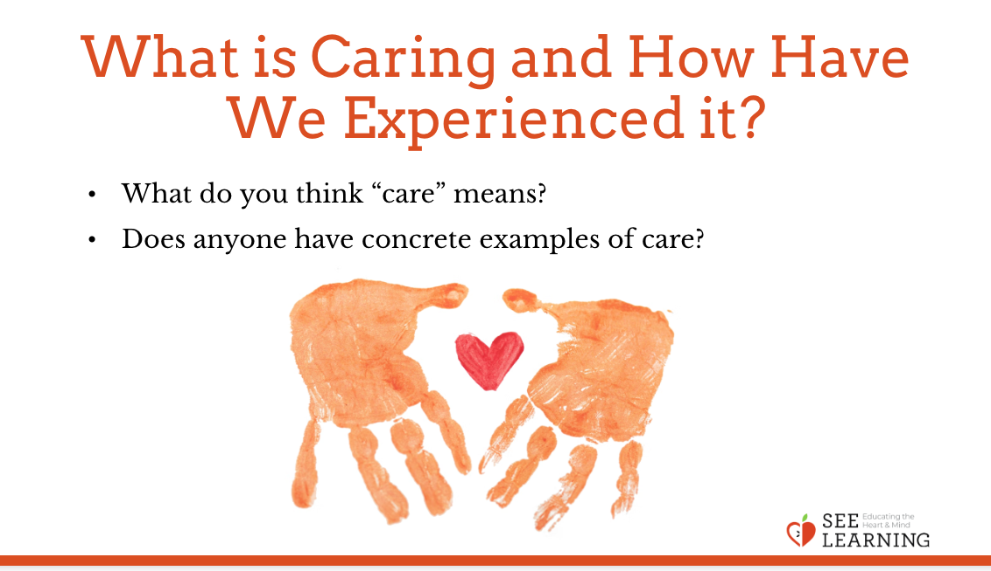 | Sample Script  N/A

Insight Activity 1: Remembering and Drawing Kindness (12 min)
Overview
This insight activity offers students the opportunity to explore how many people care for a child for that child to reach the age of 14 (or choose the age that most of your students are) and the many ways they care for that child.

Content to be Explored
- It takes a great deal of care from many people to raise each single child.
- Everyone has received countless instances of care from many others throughout their life.
- Recognizing the care we’ve received can affect the way we feel about others and ourselves.
- Much of this care is not given in order to receive something back in return.

Materials
- A sheet of paper for each of the four age levels: pregnancy, baby-2 years, 3-5 years, 6-10 years (enough for as many groups of 2-3 that you will have)
- A large sheet of paper or the whiteboard labeled age level 11-14 years with a child of that age drawn in the center

Instructions
- Divide students into groups of 2 or 3. Give each group one age-level sheet. It’s ok if more than one group has the same age level.
- Ask each group to draw a child of that age in the center of the page. Remember, a perfect drawing is not the point here - simply creating a quick representation of a child to help personalize the information is the point.
- Next, ask each group to write or draw all the people that care for a child at that age level.
- Then, ask students to write the kinds of care or support next to each person, what they provide to help the child survive, thrive, and be healthy and happy. Write and draw all the things needed for the child to be provided for, protected, fed, clothed, and cared for and allowed to flourish.
- As they are working on their group sheet, select groups one at a time to take turns coming up to the large sheet or whiteboard with the label age 11-14 years and contribute to this age level in the same way they are with their own poster.
- Once each group has completed their age level sheet and also contributed to the 11-14 age level brainstorm, begin the whole group share.
- Ask the groups that focused on “pregnancy” to begin. One group can share and the other groups that had that age level can agree with and add to what the first group presents. Continue with the remaining age levels in order. You can present the 11-14 years age level. Allow students to add more ideas to this one as well.
- Ask the whole group what observations they have at this point. Did anything surprise them? What seems especially important to note?
- If it does not come up, ask: What is expected back in return from the child for all of this care?
- Tell students that it is the joy and responsibility of the adults to create a caring environment for the child. True, not every child experiences this in the same ways, or as fully or easily as every other child. But the adults in every child’s life love and care for them, the best they can.
- If you have time, discuss the “It Takes a Village” learning experience title with the group.

Teacher Tips
- Keep in mind that among the caring experiences your students have had growing up, some will be universally shared as basic necessities (being fed, clothed, and cared for, etc.) and some not be universally shared (receiving presents, having both parents around, having access to a loving extended family, having a stable income or consistent housing). Some of your students will have experienced separations from family members or other difficult circumstances. This lesson should not be about comparing how some students received more care than others, but rather highlights the basic care that anyone would have had to receive to reach their current age. Try to keep the focus on appreciating that which was received. If difficult emotions arise, always remember that you can use the resilience skills of resourcing, grounding, and Help Now! with your students at any time.
- Drawing may take more time than writing; if you are short on time, have students begin with words and add illustrations as time allows. Balance this observation with your own context, and the needs of Second Language Learners, Special Education students, and others who may feel more confident sharing ideas through art than writing when time is limited. Use the same support strategies you generally employ for your students, helping to caption drawings or partnering students for mutual benefit.
- The whole class share can be done as a gallery walk if you have time and space. In this case you would ask students to tape their sheets of paper on the classroom wall or along a hallway adjacent to your classroom, and then ask students to walk around and take a look at the completed sheets. If they think of something they’d like to add to these sheets, they may do so with sticky notes, adding comments, questions, or compliments to other students’ posters.
Slide 4: Remembering and Drawing Kindness  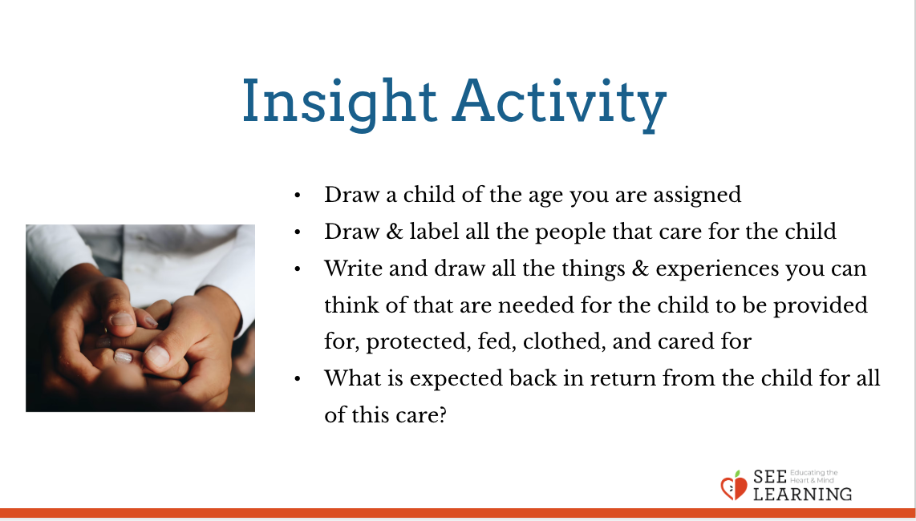 | Sample Script  - Have these steps posted on the board, visible to all once the group work begins.  - “Your group will be given a sheet of paper with a child’s age level noted on it. Everyone in the group will contribute to your poster. The first step will be to draw a simple picture of a baby or child at that age in the center of the paper. Leave room for the words that will be added around this picture.  - Next, you’ll think of all the people who provide some kind of care for a child at this age level. Draw the people and label who those people are.  - Then, write and draw all the things and experiences you can think of that are needed for the child to be provided for, protected, fed, clothed, and cared for, thinking specifically about the kinds of care or support that each of those people provides in order for the baby or child to survive, thrive, and be healthy and happy. What do they do? I’ll check in with you in about 8 minutes, to see how much longer we need. Work together to be sure all voices are heard, all ideas are valued, and that everyone in your group can point to their visible contributions to your poster.  - [As students are working, visit each group and ask them also to come up to the 11-14 year old paper and make some notes on it to create a parallel document to the ones each group is making.]  - Let’s take a look at what you have come up with. [Each group shares verbally or through a gallery walk.]  - Let’s see what we have on the 11-14 year old sheet. [Read the responses aloud]. What else we can add?  - What is expected back in return from the child for all of this care?  - Nothing, from the baby and the child. It is the joy and responsibility of the adults to create a caring environment for the child. True, not every child experiences this in the same ways, or perhaps as fully or easily as every other child. But the adults in every child’s life love and care for them, the best they can. And as each child matures and grows, they too begin to find joy in contributing to their home and in being in relationship with those who care for them.”

Reflective Practice (10 min)
Overview
In this reflective practices, students will make the previous activity more personal. Here, they write or draw to enumerate all of the people who have been involved in caring for them over their whole life. They will come up with the ways they have been cared for by these people. They will notice what sensations they have in their bodies while they do this and then will have the opportunity to share.

Content to be Explored
- It takes a great deal of care from many people to raise each single child.
- Everyone has received countless instances of care from many others throughout their life.
- Recognizing the care we’ve received can affect the way we feel about others and ourselves.
- Much of this care is not given in order to receive something back in return.

Materials
- Access to the age-level posters made by all of the small groups
- Paper and writing utensils for each student Instructions Use the script below to facilitate the reflective practice.

Slide 5 & 6: Reflective Practice  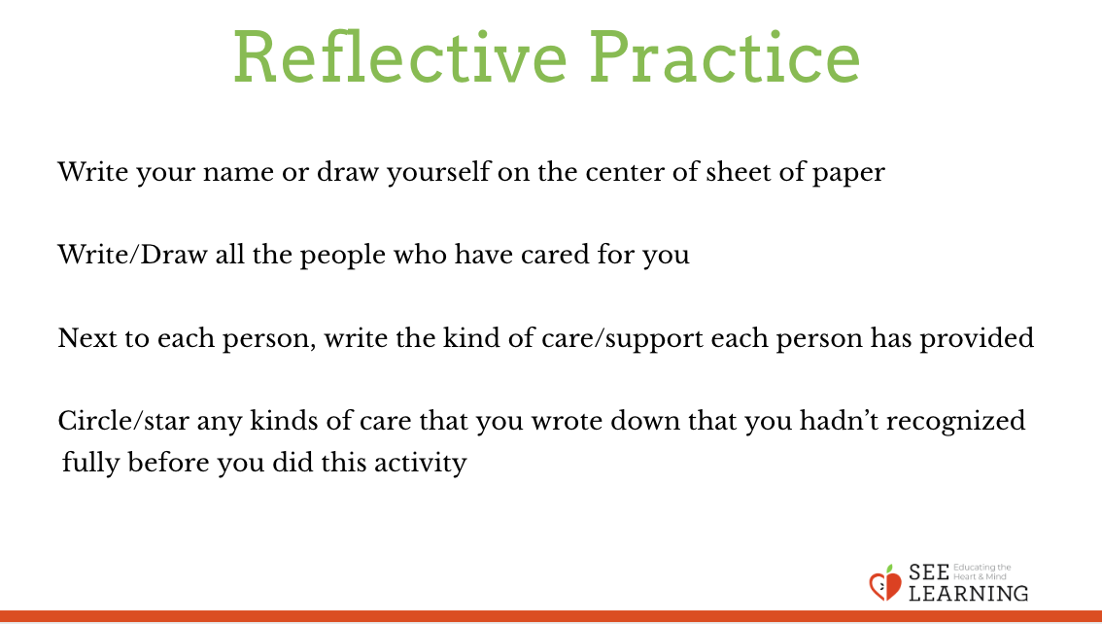  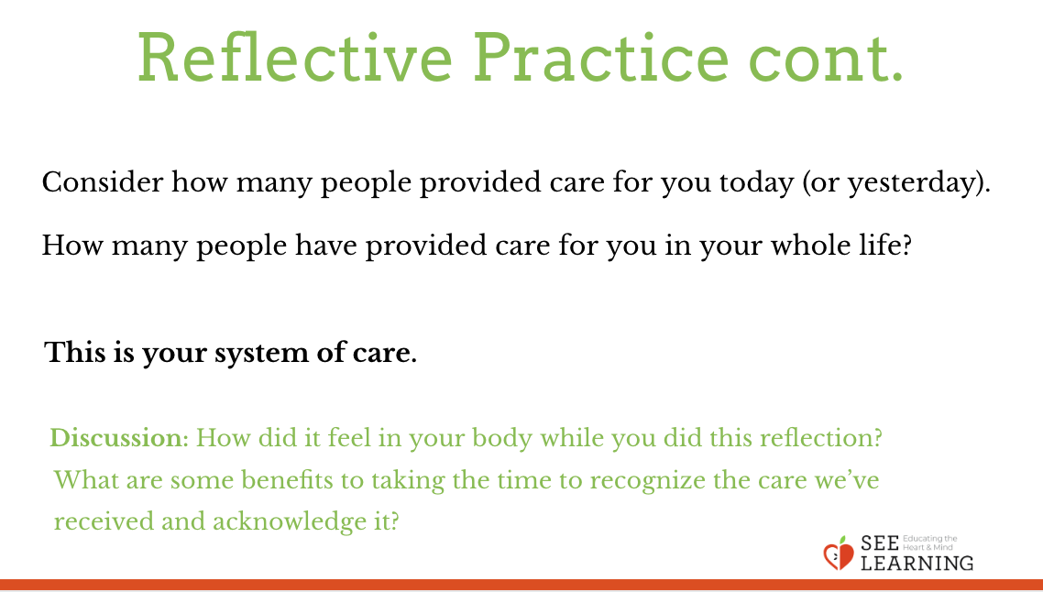 | Sample Script  - “In the center of your sheet of paper, write your name and/or draw a picture that represents you.  - Around this, you’ll write (or draw) all of the people in your life who have cared for you.  - When you think you have listed them all, see if you can think again, and remember one or two more people to add. Have a look at our class’s work for additional ideas.  - Next to each person, you’ll write the kind of care or support they provided or still provide for you. Just words and phrases are fine; sentences aren’t necessary. I’ll put on some music while you work for a few minutes on this reflection activity.  - [As time draws to a close…] Consider how many people provided care for you today (or yesterday). How many people have provided care for you in your whole life... This is your system of care.  - How did it feel in your body while you did this reflection? Did you notice any pleasant or neutral sensations?  - On your paper, circle or put a star next to any kinds of care that you wrote down that you hadn’t recognized fully before you did this activity.  - What would you like to share with the group about your reflection? Do any realizations or ideas come to mind? [If at all possible, precede this whole group sharing invitation with a brief TTYP—turn to your partner— conversation so that all voices are heard.]  - What are some benefits to taking the time to recognize the care we’ve received and acknowledge it?” [Allow time for sharing.]

Debrief (3 min)
Slide 7: Debrief  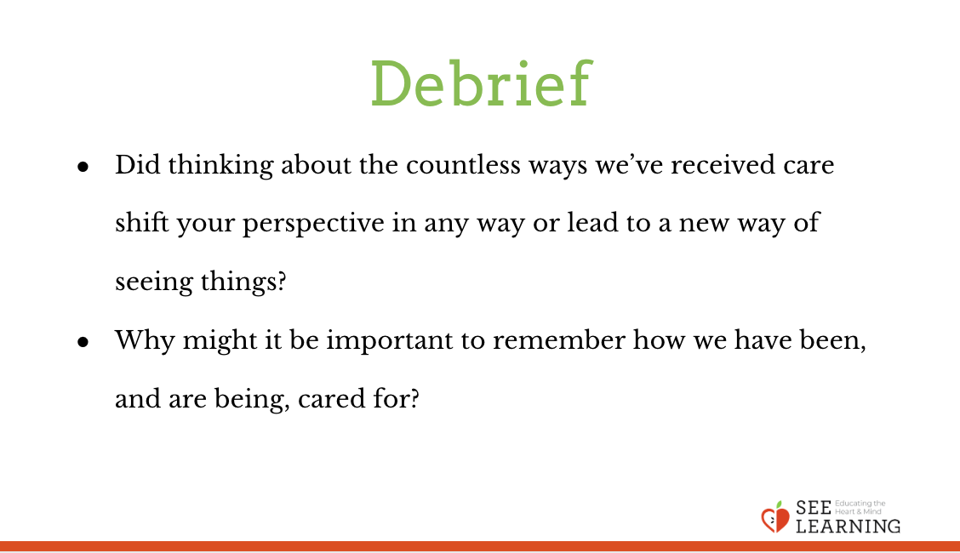 | Sample Script  - “Did thinking about the countless ways we’ve received care shift your perspective in any way or lead to a new way of seeing things?  - Why might it be important to remember how we have been, and are being, cared for?”

