Exploring Active Compassion

Purpose:
In this learning experience students will explore more deeply the concept of active compassion, which involves taking responsibility for another and acting to protect them. Through discussion of a few scenarios, they will explore three main components of active compassion: having affection for someone, understanding their needs and wants, and taking responsibility to help them. They will also explore how active compassion can involve saying no and setting boundaries.
Learning Objectives:  Students will:  - Explore three components of active compassion: affection for someone, understanding their needs and wants, and taking responsibility to help them.  - Explore how compassion sometimes requires saying no or standing up to someone.  - Recognize the difference between being assertive and being aggressive, mean, or unkind. | Primary Core Component  Compassion for Others  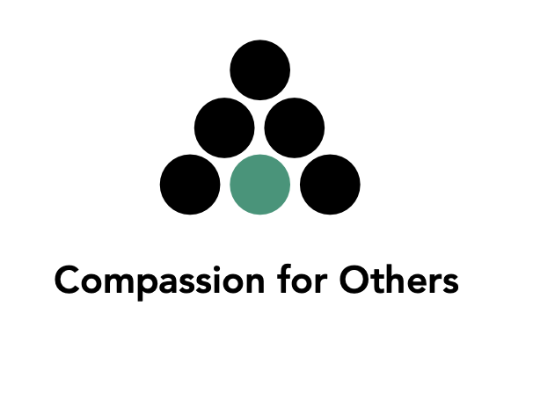
Length  35 Minutes | Materials Required  - Notecards  - Blank paper  - Writing tools  - Insight Activity Handout

Check In (3 min)
Slide 2 : Check In   | Sample Script  - • “Let’s prepare for a short attention practice. How do we want our body to be?  - • First we’ll take a comfortable and upright posture. Then we’ll keep our eyes on the ground or close them.  - • Before we strengthen our attention, we’ll do some resourcing or grounding to calm our bodies. Choose one of your resources from your resource kit, or you can choose a new one, or you can imagine one.  - • Now let’s just bring our resource to mind. And let’s see if we can just pay attention to our resource with our mind for a few moments quietly. Or if you’d rather do grounding, you can do that too. Whichever you choose, we’re going to rest quietly and pay attention for a few moments. [Pause.]  - • What do you notice inside? If you feel pleasant or neutral, you can rest your mind on that.  - • If you feel unpleasant, you can shift to a different resource, or you can ground. You can also change your posture but try not to disturb anyone else if you do that. Otherwise, just keep your attention resting with your resource. [Pause.]  - • Now let’s become aware of our breathing. Let’s see if we can pay attention to the breath as it enters and leaves our body.  - • If you find paying attention to the breath uncomfortable, then feel free to go back to your resource or grounding, or just take a small break, making sure not to disturb anyone else. [Pause for 15-30 seconds.]  - • If you ever get distracted, you can just return your attention to the breath. You can also count your breath. [Pause for a longer time, such as 30-60 seconds or longer.]  - • You can strengthen your attention by focusing on sensations or by focusing on the breath. It’s your choice - it’s always up to you.  - • What did you notice?” [Share aloud.]

Presentation/Discussion: What is Active Compassion? (5 min)
Overview

Using personal examples, students explore how compassion is about looking out for others and doing what is best for them, not just saying yes or giving people what they want without thinking about whether it is good for them.

Content to be Explored

- Explore the meaning of active compassion: thinking about what is best for another person and having a sense of personal responsibility for their welfare, even when it requires actions that are difficult.
- Explore how active compassion sometimes requires standing up to or for another person, including saying no or setting boundaries.

Materials

- Markers
- Whiteboard/chart paper

Instructions
- Review with students what “empathy” and “compassion” mean. Tell them you are going to talk about “active compassion” today.
- Write “active compassion” on the whiteboard or chart paper. Ask what the word “active” could mean in this context.
- Explain to students that active compassion is a term used to refer to a strong kind of compassion that involves taking personal responsibility for another person. Because it drives one to take personal action for others’ well-being, it is called “active.” Active compassion can be difficult—it doesn’t just mean saying yes or giving people what they want without thinking about whether it is good for them. You can write a version of this definition on the board if you like.
- Ask students if anyone can think of an example of a time when they themselves did something that involved standing up to or for someone else and did what was best for them. If no one volunteers to start, you can offer the first example. Record their examples around the phrase “active compassion” on the board.
- Next, ask students if they can think of an example when someone else did something that helped keep them safe, and did what was best for them, even if it was difficult.
- Tell them that you are going to do an activity with compassionate acts and role play.
Teacher Tips

It can be helpful to give an example that differentiates active compassion from empathy or weaker forms of compassion that do not lead to taking personal responsibility to act on behalf of another. An ancient Indian story tells of a boy who fell into a pit while his family was out walking in the woods. While the various relatives stood by crying and showing great concern for his well-being, the boy’s father jumped into the pit and saved him. The other relatives could empathize with the boy, but the boy’s father felt active compassion.
Slide 3: What is Active Compassion?  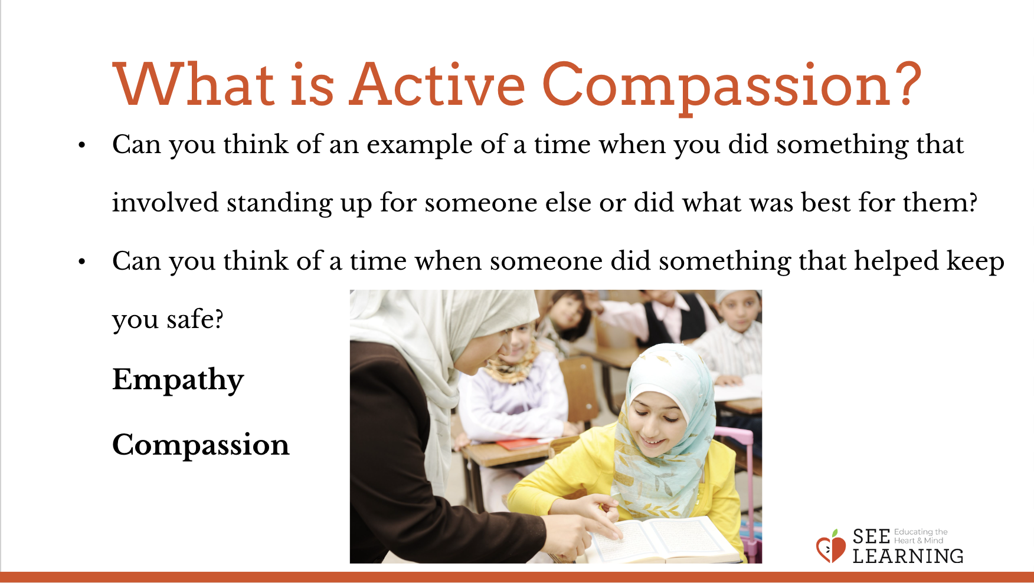 | Sample Script  - “Today we’re going to talk about some more about compassion. Who can remind us what compassion means?  - Yes, it means being kind and also wanting to keep others and oneself safe from harm.  - When people talk about empathy and compassion they talk about different levels of intensity. One can feel empathy or compassion on a very mild level. You see someone suffering and think, “Oh, that’s too bad.” You empathize with them, but you’re not going to do anything about it yourself.  - This is not active compassion, because it doesn’t compel you to take action. You’re not stepping up for the other person. You’re not really willing to inconvenience yourself for that person.  - When compassion is really strong, it’s called “active compassion.”  - When someone has this type of compassion, they’re going to do something. They want to do something. They’re going to take action on the other person’s behalf. In fact, they might not let anything get in their way from helping the person or people who need their help.  - This active compassion is very strong. It’s about keeping others safe and free from danger and doing what’s best for them, even when it’s hard.  - It’s about doing what’s best, not just saying yes or giving people what they want. What gives a person the strength to do this, is that they genuinely care about the other person. It’s not about themselves, it’s about the person they care for.  - Can anyone think of an example of a time when they had active compassion for someone? Or when you saw someone have active compassion? [Write student examples on the board.]  - If you can’t think of a time when you saw this in your own life, can you think of a time when you saw it in a film or a book? Or can you imagine an instance of active compassion?  - Thanks for sharing your ideas. Next we’re going to do an activity where we come up with examples of active compassion that we can act out together.”

Insight Activity : Practicing Active Compassion through Role Play (17 min)
Overview

In this activity, students will come up with their own scenarios and practice what it feels like to say “no” to someone with compassion and kindness and what it feels like to hear that from someone else.

Content/Insights to be Explored

- Explore how compassion sometimes requires saying no or standing up to someone.
- Recognize the difference between being assertive and being mean or unkind.

Materials

- Notecards
- Writing tools
- Insight Activity Handout

Instructions
- Tell students that they are going to work on scenarios of active compassion to share with the class.
- Ask students:
  - “What does it mean to help someone or keep them safe? [Allow time for sharing.]
  - If you saw a smaller child playing near the fire and you tell them to stop, or take them away from the fire, you are keeping them from getting hurt. You’re not doing it to be mean, but to be kind.”
- Divide your class into groups of 3-4 and give them the insight activity handout (provided).
- Give students about 7 minutes to plan their scenario using the handout as their guide. Circulate to hear their ideas and help them be ready to present.
- Have each group present their scenarios. Follow each presentation with the discussion questions below.

Teacher Tips

If there’s not enough time for every group to present their role-play and debrief, extend the lesson to a second session in close proximity to this one.

Discussion Questions for Each Scenario

- What physical or emotional danger (or concern) was present in this situation?
- What is a brave yet safe action that you could take by yourself in a situation like this?
- What are other actions that you could do, or other ways you could help provide what is needed?

Slide 4: Sensations, Emotions, and Thoughts  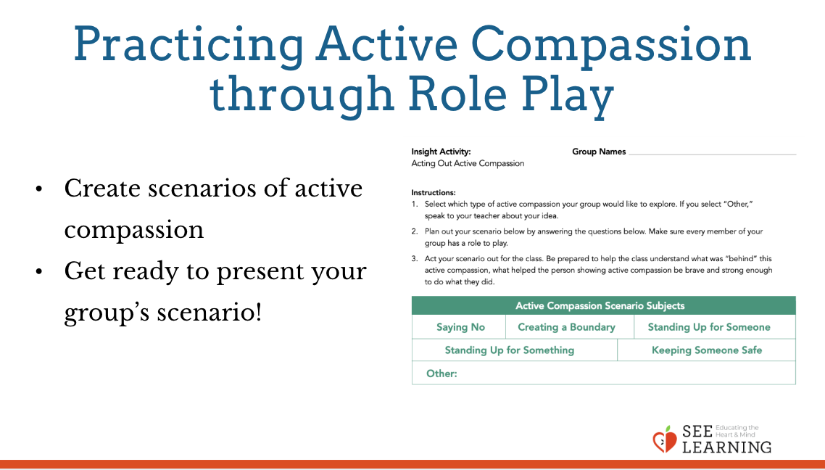 | Sample Script  - No sample script

Reflective Practice: Remembering Active Compassion (8 min)
Overview

Students will take a moment to think of and draw or write about an example of active compassion from their own life or an imagined one.

Content/Insights to be Explored

Explore how active compassion involves recognizing the needs of another and taking responsibility to help and protect them.

Materials

- Paper
- Drawing utensils for each student

Slide 5: Remembering Active Compassion  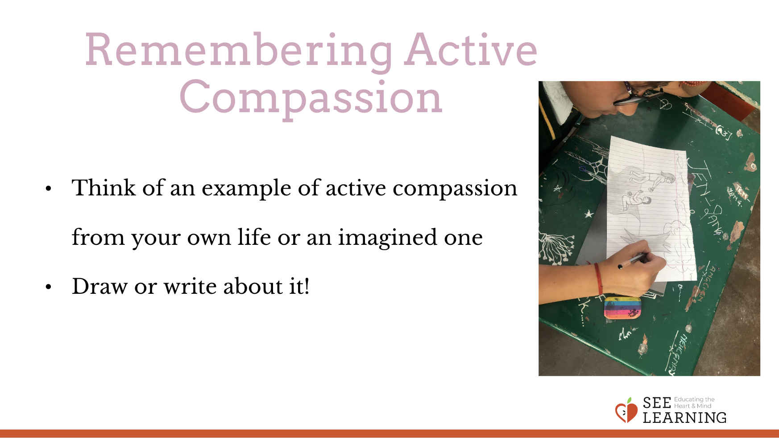 | Sample Script  - No sample script

Debrief (2 min)
Slide 6: Debrief  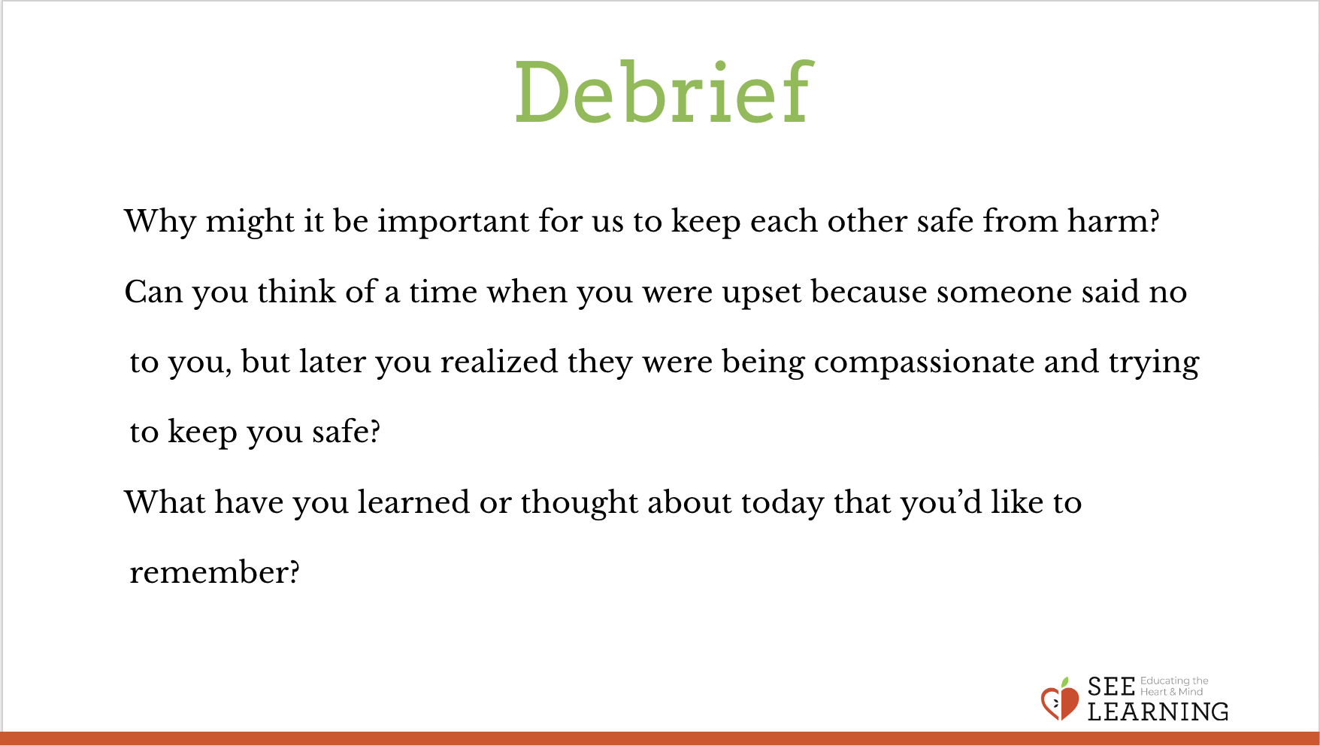 | Sample Script  - “Why might it be important for us to keep each other safe from harm?  - Can you think of a time when you were upset because someone said no to you, but later you realized they were being compassionate and trying to keep you safe?  - What have you learned or thought about today that you’d like to remember?”

