Exploring Self-Compassion

Purpose:
The first learning experience introduces the concept of self-care and self-compassion through prompts for critical inquiry and reflection. In order for students to generate interest and motivation in exploring the topic of self-compassion, it explores (a) what is self-compassion and what is it good for; (b) how students are already exhibiting self-compassion; and (c) areas, where they feel their self-compassion, could grow. It then introduces the concept of inner environments and outer environments: just as we want an outer environment of people exhibiting kindness and consideration to us, so too do we want an inner environment (our own mind, attitudes, perspectives, and emotions) that is conducive to happiness and flourishing.
Learning Objectives:  Students will:  - Explore practices of compassion for others.  - Explore the concept of self-compassion.  - Explore ways in which they are exhibiting self-compassion already.  - Explore areas where their self-compassion could grow. | Primary Core Component:  Self-Compassion  
Length  35 Minutes | Materials Required  - A copy of the Insight Activity handout for each student or pair  - A copy of the Reflective Practice handout for each student  - Writing utensils for each student  - Markers  - Whiteboard or chart paper

Check-In (5 min)
Slide 2: Check In   | Sample Script  - “Let’s prepare for a short attention practice. How do we want our body to be?  - First we’ll take a comfortable and upright posture. Then we’ll keep our eyes on the ground or close them.  - Before we strengthen our attention, we’ll do some resourcing or grounding to calm our bodies. Choose one of your resources from your resource kit, or you can choose a new one, or you can imagine one.  - Now let’s just bring our resource to mind. And let’s see if we can just pay attention to our resource with our mind for a few moments quietly. Or if you’d rather do grounding, you can do that too. Whichever you choose, we’re going to rest quietly and pay attention for a few moments. [Pause.]  - What do you notice inside? If you feel pleasant or neutral, you can rest your mind on that.  - If you feel unpleasant, you can shift to a different resource, or you can ground. You can also change your posture but try not to disturb anyone else if you do that. Otherwise, just keep your attention resting with your resource. [Pause.]  - Now let’s become aware of our breathing. Let’s see if we can pay attention to the breath as it enters and leaves our body.  - If you find paying attention to the breath uncomfortable, then feel free to go back to your resource or grounding, or just take a small break, making sure not to disturb anyone else. [Pause for 15-30 seconds.]  - If you ever get distracted, you can just return your attention to the breath. You can also count your breath. [Pause for a longer time, such as 30-60 seconds or longer.]  - You can strengthen your attention by focusing on sensations or by focusing on the breath. It’s your choice - it’s always up to you.  - What did you notice?” [Share aloud.]

Insight Activity: Practicing Compassion with Friends (10 min)
Overview
In this insight activity, students brainstorm how we might be kind to someone who is discouraged, using positive talk.

Content/Insights to be Explored
- We can talk positively to a friend experiencing difficulties.
- There are specific things we can say and do to encourage and help someone who is discouraged.

Materials
- A copy of the Insight Activity handout for each student or pair
- Writing utensils for each student
- Markers
- Whiteboard or chart paper

Instructions
- Discuss what is positive talk and negative talk.
- In partners or as a whole group, students discuss the provided prompts and questions. Tell them to imagine the prompt is coming from a friend, and when the friend says the prompt, it’s clear that they are feeling pretty down about it.
- Guidelines:
  - Use positive talk that is helpful, compassionate, true, and useful.
  - Try NOT to talk about yourself or your own experiences.
- Invite students to brainstorm for several or all of the prompts. Write the students’ positive talk to friends on the board.
  - “What sensations might they be feeling in their body?
  - What might you say to them that is kind and that may help them feel less sad?
  - How might you help them see the situation differently so that they might feel less discouraged?
  - What kind of tone and body language might you use to be helpful to your friend?
  - If you can’t think of something compassionate and helpful to say, what else could you do to let them know you hear them?”

Prompts
- 1. “Running on the field during recess, I tripped on my shoelaces and fell, ripping the knees in my new jeans. I’m so stupid.”
- 2. “I found out I wasn’t chosen for the basketball team for this season. I’m never going to make it onto a team.”
- 3. “Ms. Duff asked me to pass out graded homework to the class, and I dropped the stack of papers on the floor in the front of the room. When I bent over to pick them up, everybody laughed at me.”
- 4. “I worked on my essay for four hours and thought it was perfect. But my teacher corrected my mistakes and said I have to revise it and resubmit tomorrow. Why is it so much harder for me to write than for everyone else?”
- 5. “In the cafeteria, my tray full of food slipped out of my hands and spilled all over the floor and my shoes. I’m such a clumsy idiot.”

Teacher Tips
As an alternative, you could cut the prompts into strips and have students respond to them with partners, using the mindful dialogue protocol.
Slide 3: Practicing Compassion with Friends  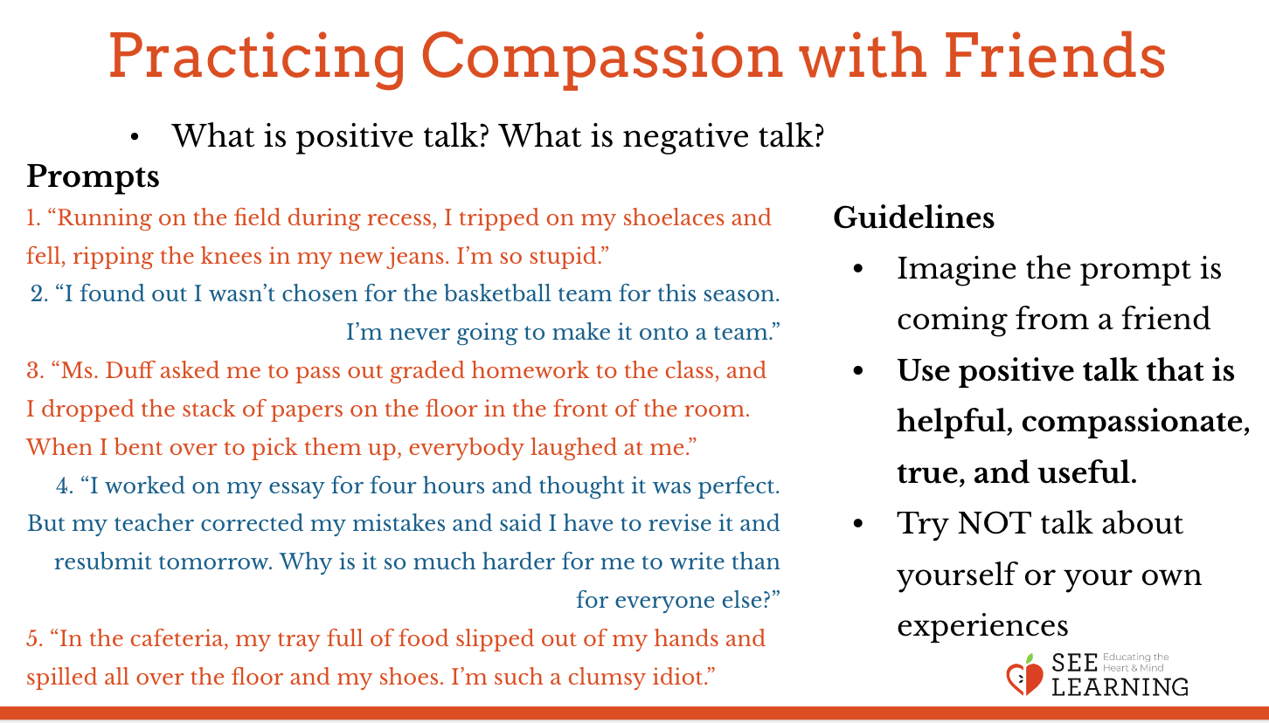 | Sample Script  - “We’ve been learning a lot about why it’s important to show kindness and compassion. And we’ve learned different ways of being kind to each other. Let’s review it a little bit.  - Let’s say we have a close friend or family member and they try to do something but it doesn’t work. Like maybe it was their job to take pictures at a party, but none of the pictures came out right, and they feel really bad about it.  - What might we say to them to be kind and help them to feel less sad? How might we try to encourage them? [Give students a chance to share ideas.]  - We can call saying things that are compassionate, kind, helpful, and true “positive talk.” When we say the word “positive” here, we mean things that are helpful, compassionate, true, and useful.  - Are there any helping actions we’ve learned that could be useful in a situation like this? [Give students a chance to share ideas.]  - If we were to discourage someone or say things that are mean or not helpful to them, we would call that “negative talk.” Negative is the opposite of positive. When we say the word “negative” here, we are talking about things that are unhelpful and unkind.  - Let’s practice positive talk as though we’re talking to a friend. You’ll do this with a partner.  - Take a look at the prompts on the handout. Select one you will say to your partner and decide who will go first.  - The first partner will say their prompt and the second partner will reply using positive talk. Then switch roles, using a different prompt. If you have time, try another prompt each. Then we’ll share the positive talk as a group. [Provide time for students to read over the prompts and practice positive talk with each other.]  - Ok, now let’s share some examples of the positive talk we used.“ [Allow students to share, as you record their positive talk on the board or chart.]

Presentation/Discussion: Self-compassion & Positive Talk (7 min)
Overview
This discussion explores the idea of whether one can be compassionate to oneself and what that might look like. One can learn to recognize negative self-talk and its unhelpful effects. One can also learn to offer oneself the kindness one would offer a friend.

Content to be Explored
- We can talk positively to a friend experiencing difficulties.
- We can talk positively to ourselves when we face difficulties.
- There are specific things we can say and do to encourage and help someone who is discouraged.
- Some of these things we can also say and do for ourselves when we are discouraged.

Materials
- Chart paper or whiteboard
- Markers

Instructions
- Lead a discussion with your students about self-compassion and the difference between positive (helpful, true, kind, encouraging) talk and negative (unhelpful, untrue, unkind, discouraging) talk.
- Encourage students to think about how we are able to have positive self-talk with ourselves when we face difficulties, treating ourselves as kindly as we would a friend.
- Start to explore the relationship between positive and negative self-talk and our perspectives (how we see things).

Slide 4: Self-compassion & Positive Talk  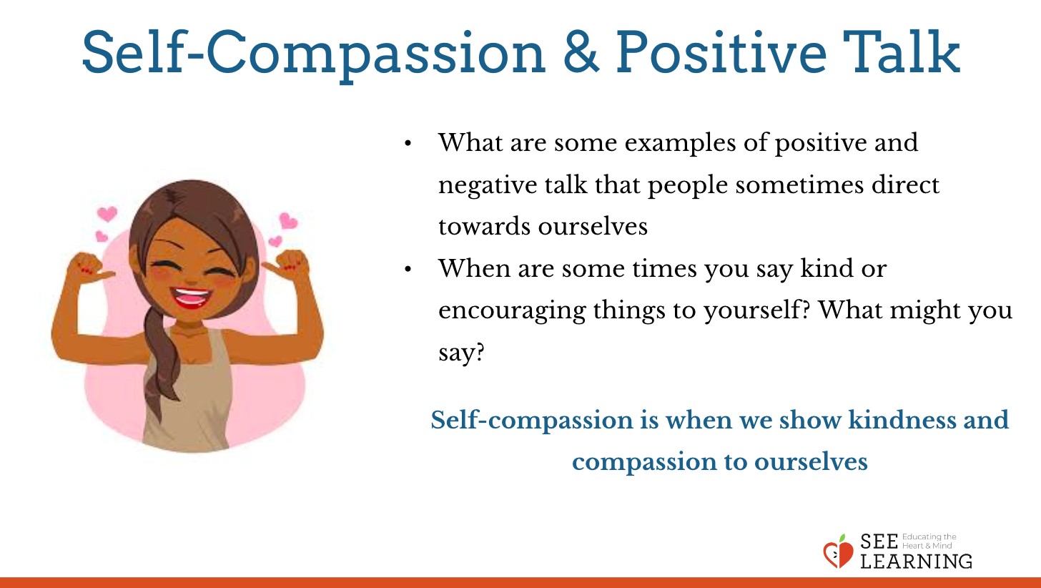 | Sample Script  - “What are some examples of positive and negative talk that people sometimes direct toward ourselves? [Give students a chance to share ideas.]  - When are some times you say kind or encouraging things to yourself? What might you say? [Give students a chance to share ideas.]  - It can take practice to become comfortable saying these things to ourselves. [Ask them to try saying some of the positive talk to themselves about a specific situation.]What does that feel like?  - Self-compassion is when we show kindness and compassion to ourselves.  - You just generated a whole list of ways to support a friend who was feeling sad or discouraged. What if it was us, ourselves, who had not succeeded and we were the ones feeling bad? Like if it was me, I might say or think things to myself, like “I’m no good. I’ll never be able to do this!” And then it might get even worse. I might start to think, “I’m no good at anything!” Then, instead of trying harder or practicing more so that I can succeed, I might just give up. I might even feel like a failure for a while. This can happen for anybody sometimes. What kinds of situations might lead to a person feeling that way? [Give students a chance to share ideas.]  - These aren’t very kind things for me to say to myself. They’re not things I would say to a friend.  - But when I am kind to myself, the way I’m kind to a friend who is having problems, then that is being positive. When I’m kind to myself, when I use positive self-talk, I’m practicing self-compassion.”

Reflective Practice: Being Kind to Ourselves (10 min)
Overview
In this reflective practice, students apply what they have been learning to their own lives by writing and drawing the ways they are already practicing self-kindness when they are discouraged. They then add additional ways they think they could be more kind to themselves.

Content to be Explored
- We already engage in many acts of self-kindness.
- We can learn more acts of self-kindness from others.
- We can add to our tools of how to be kind to ourselves.

Materials
- Tools for writing and drawing

Instructions
- Provide each student with a piece of paper and drawing tools.
- Read the directions on the handout (MS_CH6_LX1_HD2_Payton.pdf)and give them time to work on it.
- Ask for volunteer students to share their ideas, if they are willing.
- Having heard all these ways of being kind to oneself, ask them to return to their drawings and add any new ways they could be kind to themselves in the future. These could be things they have heard from others, or new things that they imagine they could do.
- Collect the reflective practice sheets if you want to. Review them to see how students understood, and responded to, the concept of self-compassion.
Slide 5: Being Kind to Ourselves  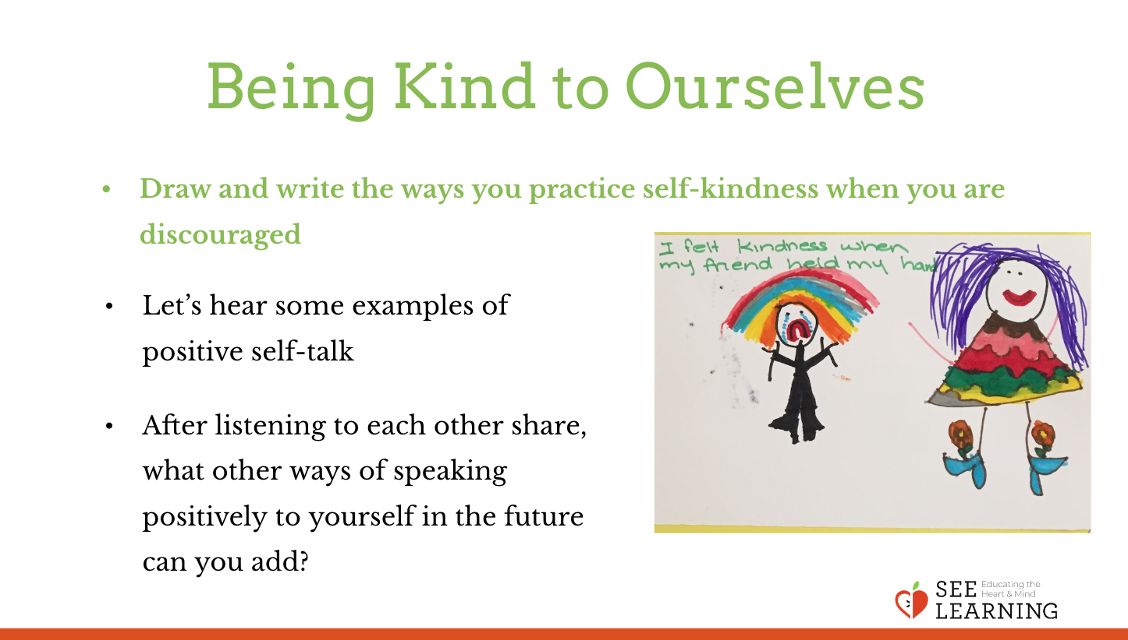 | Sample Script  - “Ok, now we’re going to do our personal reflective practice. This is independent work, so you’ll have your own private time to think, write and draw about your own ideas. I’ll ask for volunteers to share, if you’d like to, in a few minutes.  - Look at the handout I gave you. A volunteer, please, to read the directions out loud?  - Go ahead and get started. I’ll put on some music as you work. [Give students at least 4 minutes to draw/write.]  - [Before soliciting examples in front of the whole group, direct students to turn to a nearby classmate and share their drawings and self-talk examples with each other.] Let’s hear some examples of positive self-talk. Who will get us started? [Allow students to share with the class. Go first if students hesitate.]  - After listening to each other share, what other ways of speaking positively to yourself in the future can you add? Go ahead and do that now. [Allow time to share/draw/write.]  - I’d like to collect your reflective practices unless you’d like to keep yours. It’ll be your exit ticket as you leave class today, so either hand it to me or show it to me and let me know you’re taking yours with you.”

Debrief (3 min)
Slide 6: Debrief  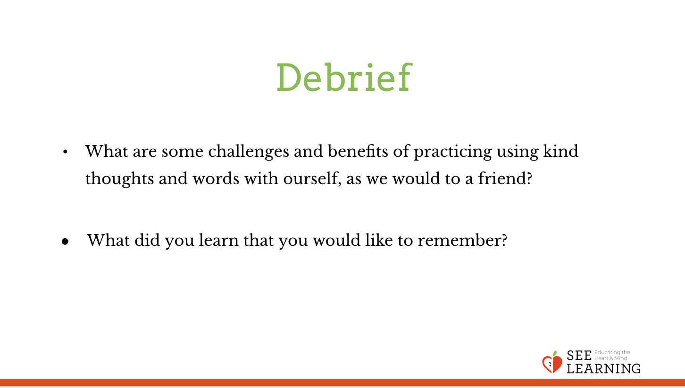  Animated Slide | Sample Script  - “What are some challenges and benefits of practicing using kind thoughts and words with ourselves, as we would to a friend?  - What did you learn that you would like to remember?”

