Exploring Forgiveness

Purpose:
In this learning experience, students explore forgiveness as the letting go of anger and negative emotions towards oneself and others, without necessarily approving of the action that led to harm. Students then reflect on experiences they may have had in which they let go of anger and negative emotions towards others and themselves.
Learning Objectives:  Students will:  - Explore the concept of forgiveness as a releasing of negative emotions towards oneself or another person.  - Explore how seeing another person’s behavior and emotions in context may help us understand that person and have compassion for them. | Primary Core Component  Compassion for Others  
Length  40 Minutes | Materials Required  - Enough space for students to move around an imagined continuum line  - A sign that reads “Total Forgiveness” and one that reads “No Forgiveness” that can be placed on either end of a line (the line can be imaginary or can be created with colored tape on the floor)  - Drawing/writing utensils for each student

Check In (3 min)
Slide 2 : Check In   | Sample Script  - “Let’s prepare for a short attention practice. How do we want our body to be?  - First we’ll take a comfortable and upright posture. Then we’ll keep our eyes on the ground or close them.  - Before we strengthen our attention, we’ll do some resourcing or grounding to calm our bodies. Choose one of your resources from your resource kit, or you can choose a new one, or you can imagine one.  - Now let’s just bring our resource to mind. And let’s see if we can just pay attention to our resource with our mind for a few moments quietly. Or if you’d rather do grounding, you can do that too. Whichever you choose, we’re going to rest quietly and pay attention for a few moments. [Pause.]  - What do you notice inside? If you feel pleasant or neutral, you can rest your mind on that.  - If you feel unpleasant, you can shift to a different resource, or you can ground. You can also change your posture but try not to disturb anyone else if you do that. Otherwise, just keep your attention resting with your resource. [Pause.]  - Now let’s become aware of our breathing. Let’s see if we can pay attention to the breath as it enters and leaves our body.  - If you find paying attention to the breath uncomfortable, then feel free to go back to your resource or grounding, or just take a small break, making sure not to disturb anyone else. [Pause for 15-30 seconds.]  - If you ever get distracted, you can just return your attention to the breath. You can also count your breath. [Pause for a longer time, such as 30-60 seconds or longer.]  - You can strengthen your attention by focusing on sensations or by focusing on the breath. It’s your choice- it’s always up to you.  - What did you notice?” [Share aloud.]

Presentation/Discussion: What is Forgiveness? (7 minutes)
Overview

Students will explore the meaning of the word “forgive” using a word map and examples from their experience.

Content to be Explored

Forgiveness means letting go of the anger and negative emotions we hold towards ourselves and others.

Materials
None

Instructions
- Explain that today your class will explore forgiveness and what it means to forgive someone.
- Write the word “forgive” on the board.
- Ask: “What does this word mean to you, or what are words that could be connected with “forgive?”” Write these words around the word “forgive.”
- Give your own examples of forgiveness, starting with something small, then ask if anyone can share a similar example of someone forgiving another person or being forgiven themselves. In your example, include the consequences of being forgiven or forgiving someone. Ask students to share some of their examples of forgiving or being forgiven.
- Explain there are 2 types of forgiveness. One is external: telling a person you forgive them and possibly could become friends again. Another is internal: letting go of anger and negative emotions towards yourself and others.
- Write these on the board along with your class’s ideas.
- Ask some or all of these questions:
  - “When do you say you’re sorry or apologize? Have you ever said you’re sorry when you didn’t really mean it? Why?
  - How do you know you have truly forgiven someone?
  - What do you need in order to forgive someone? What factors into forgiveness? [time, the act, the person, etc.]
  - How do you know when someone else wants to be forgiven?
  - If you forgive someone, does it mean that what they did was okay?
  - Is forgiveness a choice?”
- Mention how although it’s not always easy to forgive others, research shows that people who are able to let go of their angry feelings actually have a greater well-being themselves, and that truly being able to forgive has positive physical and emotional health benefits for the person who is doing the forgiving.

Teacher Tips
- If you choose to give examples of forgiveness, including examples from your own life, begin with very small things, such as minor inconveniences. Be sure to avoid any major transgressions. Start with forgiveness of another person, and lead up to self-forgiveness as the lesson progresses.
- Try to reinforce the ways people regularly forgive minor transgressions, rather than the times people are unable to forgive. This is a way to adopt a strengths-based approach, rather than a deficit-based approach.
Slide 3: What is Forgiveness?  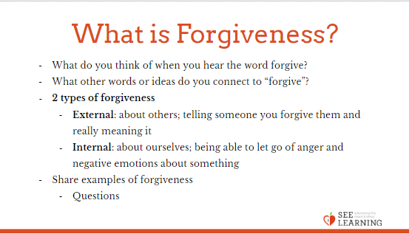 | Sample Script  - “Today we’re going to learn more about forgiveness and what it means to forgive someone. [Write forgive on the board.]  - What do you think of when you hear the word forgive? What other words or ideas do you connect to “forgive”?  - There are two types of forgiveness - external and internal. External is about others, telling someone you forgive them and really meaning it. Internal is about ourselves, and being able to let go of anger and negative emotions about something.  - Here’s an example of forgiveness from my own life… [Share your example here.] As a result of this forgiveness… [Share the consequences of the forgiveness.]  - Does anyone have a story about forgiving someone else? Or about being forgiven? And what happened after? Before you share, think about how you’ll frame the story, according to our agreements about not naming names, but rather describing a situation in a way that helps us understand what happened but not revealing personal information. [pause. Invite student input.]  - What do you need in order to forgive? How does time factor into forgiveness?  - When do you say you’re sorry or apologize? Have you ever said you’re sorry when you didn’t really mean it? Why?  - Is forgiveness a choice? Why or why not?”

Insight Activity 1: The Forgiveness Continuum (20 min)
Overview
Students will hear different scenarios and then will stand on a continuum to indicate how much forgiveness they might feel in such a situation. They will be invited to share their reasons for standing where they are, and then given the opportunity to move on the continuum when they hear more information about the scenario.

Content to be Explored
- Forgiveness means letting go of the anger and negative emotions we hold towards ourselves and others.
- Awareness can make it easier to forgive when we learn new information and see a situation in a broader context.

Materials
- Scenarios MS_CH6_LX3_HD
- Enough space for students to move around an imagined continuum line
- A sign that reads “Total Forgiveness” and one that reads “No Forgiveness” that can be placed on either end of a line (the line can be imaginary or can be created with colored tape on the floor)

Instructions
- Create a continuum on the floor, with one end marked “Total Forgiveness” and the other end marked “No Forgiveness.”
- Explain that you will read a prompt, and then each student should step to a place on the continuum that most accurately reflects the amount of forgiveness they feel for the following prompts. After that, you will invite them to volunteer to share why they chose to stand where they are. Then you will give additional information (using the follow-up prompts under each main prompt) and they can move. They can also move if they hear something shared by another student that makes them feel differently.
- Read one of the prompts below. Ask students to take a place on the line and invite sharing.
- Read one of the extension prompts, and invite students to move if they wish to. These give more information about the situation. Again invite students to share, then use the questions provided after the follow-up prompt.
- Conclude the activity’s discussion with these questions:
  - “Why did we sometimes move as we learned more information? [Understanding the context makes it easier or harder to forgive.]
  - When did we want to forgive?
  - In what ways might forgiveness benefit us?
  - How do we learn to forgive?”

Teacher Tips
- It’s good to ask clarifying questions to invite your students into deeper reflection. Remember that there are no “right” or “wrong” responses to the prompts, however. Your intention is to invite dialogue, not to tell them how they should be thinking or feeling. You can be a neutral listener during the activity to allow for differences of opinion, and to create a safe space for this, and future, conversations.
Slide 4: The Forgiveness Continuum  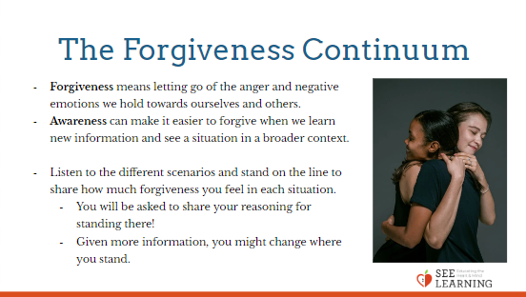 | Sample Script  - You are waiting to be picked for a team game and a student new to your school keeps jokingly picking on you in front of everyone, saying you’re no good and will be the last to be chosen.  - You find out this new student was teased last year and that’s why they changed schools.  - What would you need to move toward forgiveness at this point?  - What if you don’t get what you want/need (apology, etc.)? What might happen?  - At lunch your close friend loses their temper and yells at you in front of everyone in the cafeteria.  - You find out that this friend got a very low grade on a test that morning.  - Later, they apologized.  - What would you need to move toward forgiveness at this point?  - What if you don’t get what you want/need (apology, etc.)? What might happen?  - Everyone in your class got invited to a party on Friday, but you didn’t get an invitation.  - You find an invitation in your backpack on Sunday.  - Your best friend asked why you weren’t at the party and tells you they put the invitation in your backpack for you.  - What would you need to move toward forgiveness at this point?  - What if you don’t get what you want/need (apology, etc.)? What might happen?  - You lend your watch to a friend, but they lose it. Instead of apologizing, they just act like it’s no big deal.  - You find out that they lent it to another friend, who lost it.  - You find out that they’ve lost many items given to them by friends in the past.  - What would you need to move toward forgiveness at this point?  - What if you don’t get what you want/need (apology, etc.)? What might happen?  - A teacher uses sarcasm and belittling language when asking, in front of the whole class, why your project wasn’t finished on time.  - The teacher apologizes to you privately, saying there was no excuse for their behavior and saying they feel badly about embarrassing you.  - What would you need to move toward forgiveness at this point?  - What if you don’t get what you want/need (apology, etc.)? What might happen?  - The teacher apologies to you, very sincerely, in front of the class, saying there was no excuse for treating you, or anyone else, that way and saying they’re working on never speaking to another student like that again.  - What would you need to move toward forgiveness at this point?  - What if you don’t get what you want/need (apology, etc.)? What might happen?

Reflective Practice: Recalling a Time of Forgiveness (7 min)
Overview
Students will draw and/or journal about a time when they witnessed forgiveness, either in their own life or in someone else’s. They then do resourcing and tracking to notice sensations in their bodies and emotions when thinking about this act of forgiveness.

Content to be Explored
- We can recall moments of forgiveness, and doing so can have an effect on our minds and bodies.

Materials
- Paper
- Drawing/writing utensils for each student

Instructions
- Start with a brief grounding exercise of 1 to 2 minutes to settle yourself and your students.
- Ask your students to take a moment (30-60 seconds) to silently recall a time when they witnessed forgiveness, either in their own life or in someone else’s.
- If they cannot think of something in their own life, they can think of something they read in a book or saw in a movie, or they can imagine a moment of forgiveness.
- Ask them to draw or write about the moment they recalled or imagined.
- After 3-4 minutes of drawing, ask them to pause, and look at the image they drew or words they wrote.
- Ask: “What sensations or feelings do you notice on the inside, as you look at your moment of forgiveness?”
- Allow for voluntary sharing.
Slide 5: Recalling a Time of Forgiveness

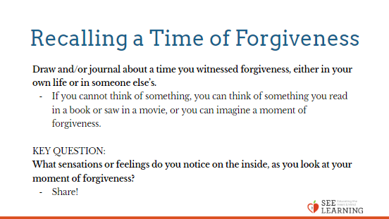

Debrief (3 min)
Slide 6: Debrief  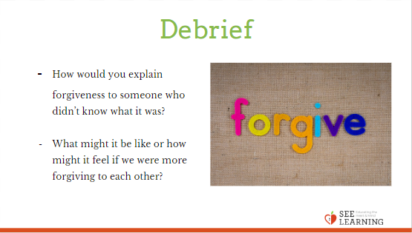 | Sample Script  - “How would you explain forgiveness to someone who didn’t know what it was?  - What might it be like or how might it feel if we were more forgiving to each other?”

