Exploring Empathy

Purpose:
This learning experience introduces a story to explore the concept and importance of perspective-taking and empathy. Empathy has two main components: being able to take another’s perspective (cognitive empathy) and being able to feel an emotional resonance with them (affective empathy). Without perspective-taking we can misinterpret the motivations and actions of others. Through sharing the perspectives of the characters and listening to their peers, students will experience the complexity of one person’s perspective, which is an expression of their needs, feelings, and thoughts. Listening to and appreciating different perspectives as valid can lead to better problem-solving and more positive relationships
Learning Objectives:  Students will be able to:  - Explore the meaning and components of empathy.  - Practice perspective-taking by wondering about a character’s needs, feelings and thoughts.  - Practice listening to different points of view.  - Consider the value of perspective-taking in building positive relationships and solving problems | Primary Core Component  Interpersonal Awareness  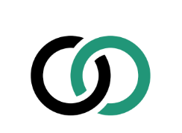
Length  40 Minutes | Materials Required  - The story provided  - Per group: 1 set of 6 sheets of paper with the one role/character name written on each paper  - Timer  - Chime that all students can hear

Check-In (4 min)
Slide 2: Check-In   | Sample Script  - “Let’s prepare for a short attention practice. How do we want our body to be?  - First we’ll take a comfortable and upright posture. Then we’ll keep our eyes on the ground or close them.  - Before we strengthen our attention, we’ll do some resourcing or grounding to calm our bodies. Choose one of your resources from your resource kit, or you can choose a new one, or you can imagine one.  - Now let’s just bring our resource to mind. And let’s see if we can just pay attention to our resource with our mind for a few moments quietly. Or if you’d rather do grounding, you can do that too. Whichever you choose, we’re going to rest quietly and pay attention for a few moments. [Pause.]  - What do you notice inside? If you feel pleasant or neutral, you can rest your mind on that.  - If you feel unpleasant, you can shift to a different resource, or you can ground. You can also change your posture but try not to disturb anyone else if you do that. Otherwise, just keep your attention resting with your resource. [Pause.]  - Now let’s become aware of our breathing. Let’s see if we can pay attention to the breath as it enters and leaves our body.  - If you find paying attention to the breath uncomfortable, then feel free to go back to your resource or grounding, or just take a small break, making sure not to disturb anyone else. [Pause for 15-30 seconds.]  - If you ever get distracted, you can just return your attention to the breath. You can also count your breath. [Pause for a longer time, such as 30-60 seconds or longer.]  - You can strengthen your attention by focusing on sensations or by focusing on the breath. It’s your choice - it’s always up to you.  - What did you notice?” [Share aloud.]

PRESENTATION & DISCUSSION: What is Empathy? (8 minutes)
Overview

Students will discuss the meaning of the word empathy and then discuss a story in which misunderstandings arise.

Content/Insights to be Explored
- Each person has a unique perspective, which consists of their needs, feelings, thoughts, and more.
- We can’t fully know someone else’s perspective, but we can imagine what we might need, think, or feel if we were in their shoes.
- Empathy involves knowing what another person is feeling (cognitive empathy) as well as caring about what they are feeling (affective empathy).
- Our empathy can be accurately or inaccurately based (empathic accuracy), and we can misinterpret others’ intentions, especially when we are unaware of their perspective.

Materials
- The story provided below

Instructions
- Write the word “empathy” on the board and ask students what they know about the term. Allow time for sharing.
- Explain that empathy has two main components: the first is knowing how someone else feels, and is linked to perspective-taking. The second is caring about how they feel and “feeling with” them. Come up with an agreed upon definition that is along the lines of: “Empathy is knowing how someone else feels and caring about how they feel.” Solicit examples of when one might have one of these two elements but not the other.
- Ask if sometimes we might be inaccurate about how another person feels. This is called “empathic accuracy.”
- Tell students you are going to read a short story together and then discuss it for instances of empathy, including empathic accuracy.
- Read the story to your students, followed by the discussion questions below.

Teacher Tips
- If more appropriate, change the debate team in the story to another type of co-ed team or group at your school.
Slide 3: What is Empathy?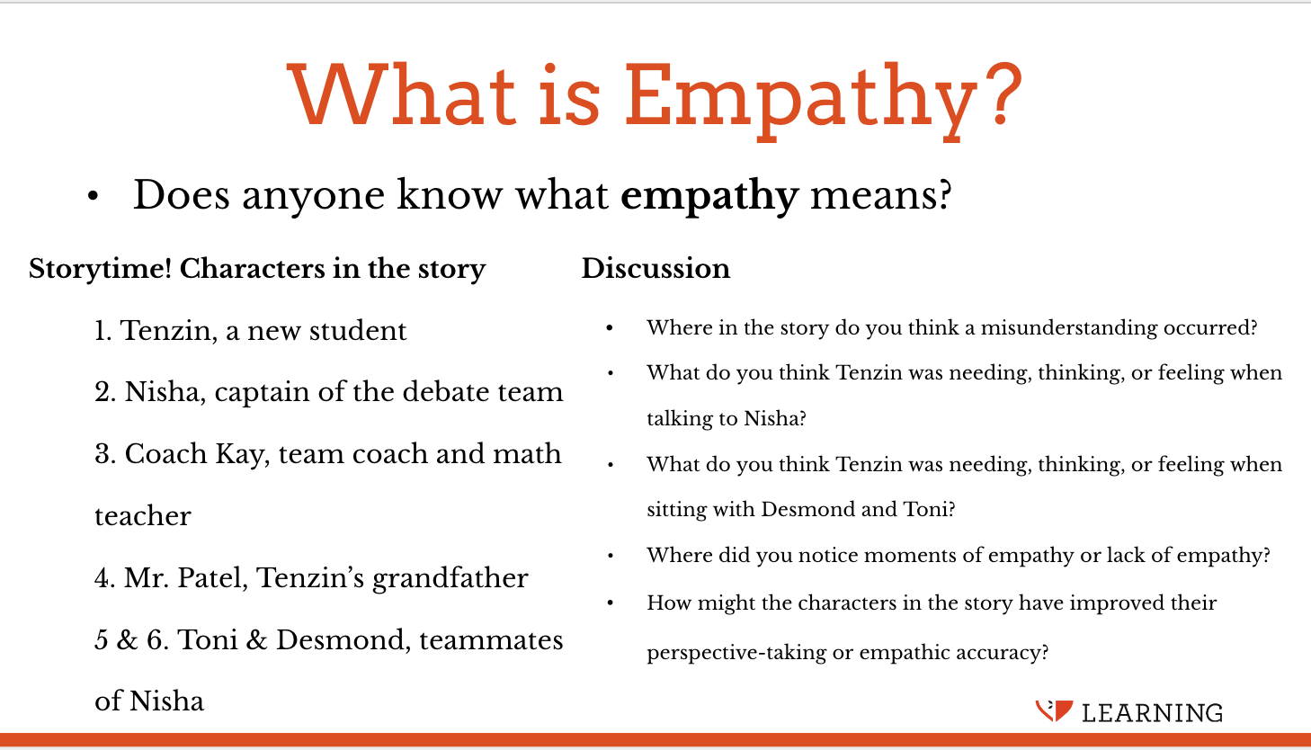 | Sample Script: Story  - Characters in the story:  1. Tenzin, a new student  2. Nisha, captain of the debate team  3. Coach Kay, team coach and math teacher  4. Mr. Patel, Tenzin’s grandfather  5. Toni, teammate of Nisha and Desmond  6. Desmond, teammate of Nisha and Toni  - STORY | Tenzin and the Debate Team  - “Nisha, the captain of the debate team, hears that a new student at the school, Tenzin, might be great for their team. At school, Nisha approaches Tenzin and says, “Tenzin! I hear you were on the debate team of your old school.”  - “That’s right,” says Tenzin.  - “Great!” says Nisha. “You should join our debate team here then. You could even help us win the championship this year! Joining the team will help you make lots of friends.”  - “Thanks, I guess so,” says Tenzin.  - Nisha tells their team coach, Coach Kay, that Tenzin is interested in joining and would be a great recruit for the team. Coach Kay says to Nisha, “Sure, that sounds like a good idea. Why don’t you and your teammates talk to Tenzin? You can invite Tenzin to our next match to observe, too.”  - Tenzin goes home, where his grandfather, Mr. Patel, is waiting. “How is the new school?” Mr. Patel asks  - Tenzin says, “It’s okay. The captain of the debate team really wants me to join the team, but I already tried debate at my last school and I wasn’t very good. I really want to join the art club instead. I think that art is my true passion.”  - Mr. Patel, thinking of his own schooldays, says, “It’s important to try new things, Tenzin. You may feel conflicted, but it seems you really want to experience the art club instead, and I support you. Follow your heart.”  - Tenzin returns to school the next day and sees Coach Kay, who is also Tenzin’s math teacher. Coach Kay says, “Hello, Tenzin! Nisha tells me that you want to join the debate club. We are looking forward to having you at our next match!”  - At lunch, team members Toni and Desmond invite Tenzin to sit with them and offer Tenzin candy they brought from home. Tenzin starts to get nervous. It seems there might have been a misunderstanding.”  - Discussion Questions  - Where in the story do you think a misunderstanding occurred? Why do you think so? [Encourage the class to generate a list of points of misunderstanding.]  - What do you think Tenzin was needing, thinking, or feeling when talking to Nisha?  - What do you think Tenzin was needing, thinking, or feeling when sitting with Desmond and Toni?  - Where did you notice moments of empathy or lack of empathy?  - How might the characters in the story have improved their perspective-taking or empathic accuracy?

INSIGHT ACTIVITY: Circle of Truths (20 minutes)

Overview

In this insight activity, students take the perspectives of each of the characters in the story in order to practice using their imagination and empathy to consider what each person might be feeling or thinking. They will have the opportunity to share a thought, feeling, or need from each character’s point of view. This activity format is similar to the mindful dialogue previously introduced to students, because instead of discussion there is focused sharing and listening. The activity focuses specifically on perspective-taking.

Content/Insights to be Explored
- We can’t fully know someone else’s perspective, but we can imagine what they might need, feel, or think if we were in their shoes.
- Listening to the perspectives of others can bring us to a deeper understanding about a conflict or issue.
- There can be obstacles to perspective-taking (such as strong emotions, stress, lack of safety, inattention, and poor communication skills). Often, these obstacles can be overcome by intentionally using skills we’ve already learned.
- Listening to the perspectives of others can help us show respect and build positive relationships.

Materials
- Timer
- Chime that all students can hear
- Per group: 1 set of 6 sheets of paper, each of which has one role/character name written on it

Instructions
- Explain to students that they will be doing an exercise to explore empathy and perspective-taking.
- Explain that the format for this exercise will be similar to mindful dialogues, except in small groups. There will be listeners and speakers, but no back-and-forth conversations.
- Model how this format will work with 5 student volunteers. Explain the process (below) then and model a few example comments with appropriate thoughtfulness and depth. Then show everyone how when the chime sounds, participants rotate one spot on the circle, leaving their “character sheet” in place. Provide 30-60 seconds of private think time again, about how they would feel with their new role.
- Students will form groups of six, standing in a circle. Each person will have one paper, on which a character’s name is written. That will be the character whose perspective they will speak to during the first round.
- Each round begins with a 30-60 second private think time, during which students consider the thoughts, needs, and feelings of their assigned character. Each student develops one sentence explaining their perspective that they will share with the group, once the sharing time begins.
- Following the private thought time, students will take turns around the circle, sharing one sentence that explains their needs, feelings, or thoughts from that character’s point of view at a particular point in the story of their choice. Students should speak in the first person, as if they are the character themselves.
- There is no discussion (no questions, comments, or replies to what someone else said) during the sharing time. Each student simply shares their sentence with the group, with the intent that this character will be better understood.
- Once every student has shared, ring the chime again and instruct students to rotate clockwise one spot, leaving the character’s paper in place. Each student now takes on the role of their new character. The next round begins with another 30-60 seconds of silence, as students consider their feelings/thoughts from that character’s perspective, and come up with another sentence to share.
- Ring the chime and let students know it’s sharing time again.
- After the third round, encourage students to try to share a perspective from their assigned character that they have not heard yet.
- Repeat this cycle so that each student takes on each of the roles, as time permits. Groups with fewer than six members can repeat the original round if need be. The value lies in taking multiple perspectives on the same situation, so build in time for at least three turns.
- Debrief the experience with a group discussion (questions below).

Teacher Tips
- Depending on the size of your group, you can also consider doing this activity as a fish bowl, where one group of 6 students engages in the activity while the other students act as observers. If you choose this method, prepare the outside circle (observers) to each have a focus student to whom they’ll give written and/or verbal feedback related to the discussion norms the class already holds, and about the content of the focus student’s responses.
- Circulate around the room to listen to the small group sharing during the activity so that you can support students as needed.
- Students may need a reminder to not have discussions and to follow the protocols of this activity.
- Students may need a reminder to speak from their assigned character’s point of view, as if they were that character. Set the tone with your students about how to do this, bringing forward their character’s feelings and ideas, without using a different kind of voice or “acting.” Help build an environment that is respectful of demonstrating the variety of perspectives in a personal way, using one’s own voice, to show it’s possible to relate to another person’s view of a situation even when it is not your own. Model the appropriate thoughtfulness and depth of response. This can be achieved by encouraging students to use complex sentences that use the word “because.” For example, “I feel...because…” or “I think that...because...and I.”
Slide 4: Circle of Truths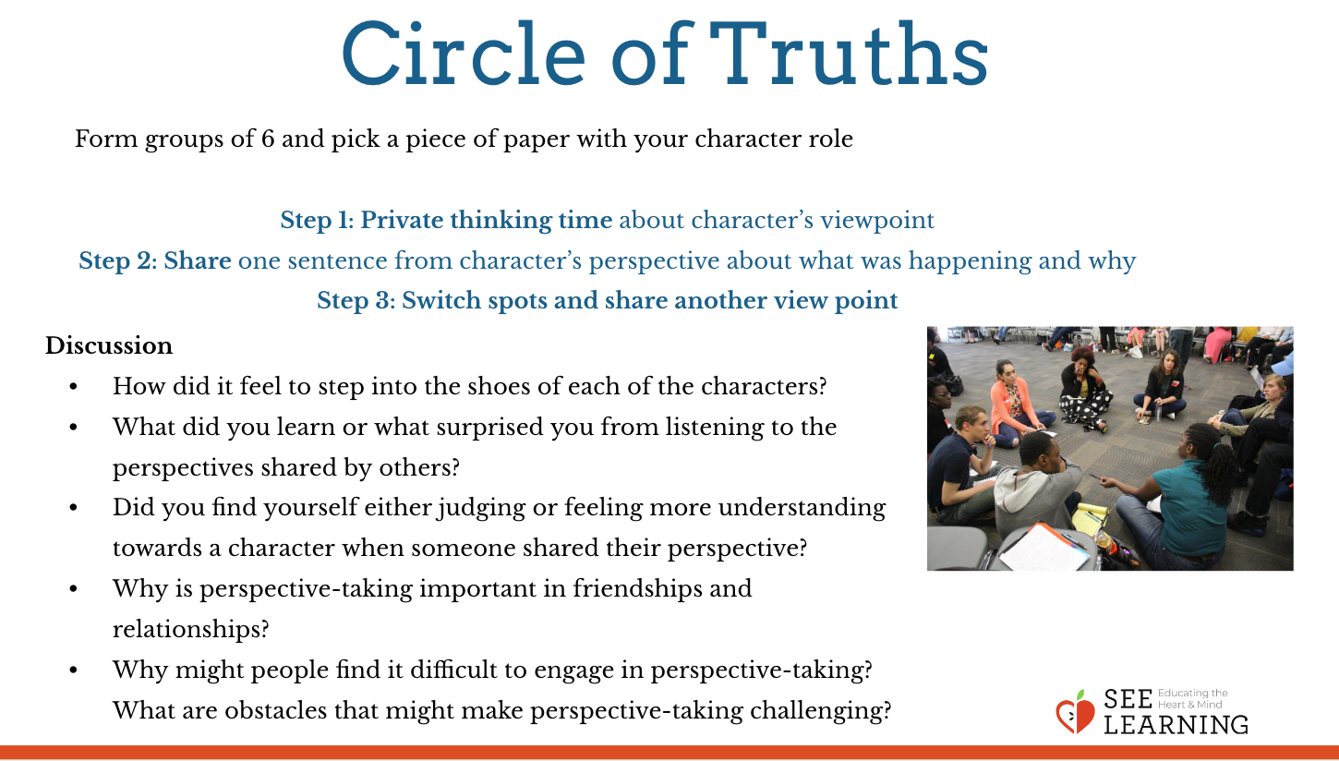 | Sample Script  - “The next activity is a perspective-taking exercise, using the story we just listened to. As we just explored, taking someone’s perspective means you place yourself in their shoes and imagine what they might need, or how they might feel or think. We talked a lot about Tenzin, but there were five other characters in this story, each with their own perspective.  - This activity will be done in small groups, standing in a circle. Your group will get a set of papers that each has one of the character’s names on it. The paper you get will be your first role, the one that you’re going to speak for, sincerely sharing what you believe that person might have been thinking or feeling at a particular moment in the story. We will do multiple rounds so that each person in your group can get to experience different roles. We’ll begin with a minute or so of private think time, so you can reflect on how you imagine that character would feel or was thinking at some action point in the story. Decide on one sentence that explains the perspective, from that person’s point of view, of what was happening and why. Then, I will ring the chime and each of you will share your sentence, one at a time around your circle. There is no discussion during this activity. You will each simply share your perspective in one sentence while the others listen with an open mind, and then that round will end. When you hear the chime that says it’s time for the next round to begin, everyone will rotate one spot clockwise, so that each of you is standing in front of a new role. You will have about a minute of private think time again to think of a sentence to share. Then, I will ring the chime and it will be sharing time again within your circle.  - Can I have 5 volunteers so we can quickly demonstrate how to do this? [Do not demonstrate a full round here, but have students place themselves in a circle, and use a timer to give everyone 30-60 seconds to consider their perspective. Then, ring the chime and, after modeling by sharing a sentence from your character’s perspective, ask one or two of the volunteer students to share what they might say from their character’s perspective. Remind them, and demonstrate yourself, that each person is speaking as if they are the person whose role they have been assigned, not acting or using a different voice. Speaking directly from the character’s perspective shows that you are taking on that way of seeing the experience, not pretending. It demonstrates that even if you haven’t shared that experience or feeling, you can understand how someone else could.]  - You can encourage students to use complex sentences, such as “I am feeling frustrated because I put so much work into this project and now we have a new group member to deal with.” Then demonstrate ringing the chime and everyone rotating one place, giving time again to consider their next role.  - Now let’s get into groups of 6. It’s ok if we have some groups of 5.  - Is everyone standing in front of your assigned role? [Check to see that groups are arranged in circles with the roles laid out on the floor at their feet.]  - I will ring the chime and you will have time to silently consider the perspective of your character. You will have a minute or so to come up with a sentence that describes your perspective, which might include your needs, feelings, or thoughts, at some point in the story. Your goal is to, with best intentions, help the others in your circle truly understand what was in the heart or on the mind of your character.  - Ok, silent thinking. [Ring chime. Set timer for 60 seconds.]  - [Ring chime] Ok, now it is sharing time. Whoever is speaking for (character name), will start each round. Please begin.  - [When you see that the groups have had a chance for everyone to share their sentence, ring the chime again.] Now, rotate one place, going clockwise, and consider your next role. You will have about a minute again to put yourself into the shoes of that character. When you hear the chime again, we’ll begin the next round. [Set timer.]  - [Ring chime.] Ok, now it’s sharing time. Please begin.”  - [Repeat the movement—private think time— sharing cycle for several rounds, considering time and engagement level. As students are about to begin their third round of private think time, encourage them to try to share a perspective from this new role that they have not heard yet.]  Group Discussion Questions  (Debrief with one or more, as time permits)  - “How did it feel to step into the shoes of each of the characters, to try to truly understand what they were thinking and feeling?  - What did you learn or what surprised you from listening to the perspectives shared by others?  - Did you find yourself either judging or feeling more understanding towards a character when someone shared their perspective?  - Now, imagine yourself stepping into the story. How might understanding these perspectives help you solve this problem at different points in the story?  - Why is perspective-taking important in friendships and relationships?  - Why might people find it difficult to engage in perspective-taking? What are obstacles that might make perspective-taking challenging? (Strong emotions; not being in one’s resilient zone; lack of communication; prejudice or fixed ideas; inattention; poor communication skills; etc.)  - How can these obstacles be addressed?”

REFLECTIVE PRACTICE: A Time When Empathy Helped (6 minutes)

Overview
In this reflective practice, students will recall a case from their own life in which perspective-taking and empathy helped or could have helped.

Content to be Explored
• Empathy and perspective-taking can play an important role in misunderstandings and clearing them up.

Materials
• Paper and drawing tools for each student

Instructions
- Write these questions on the board:
  - How was empathy or perspective-taking happening or not happening?
  - What helped or would have helped the people involved be able to empathize better?
- Ask students to take a moment to recall a small misunderstanding that they have seen or participated in where perspective-taking helped or could have helped.
- Ask them to draw and/or write about the scenario in silence individually, as a way to personally reflect on this idea. Let them know sharing with the group will be optional, not required.
- Invite a few volunteers to share but do not require anyone to share who doesn’t want to.
Slide 5: A Time When Empathy Helped  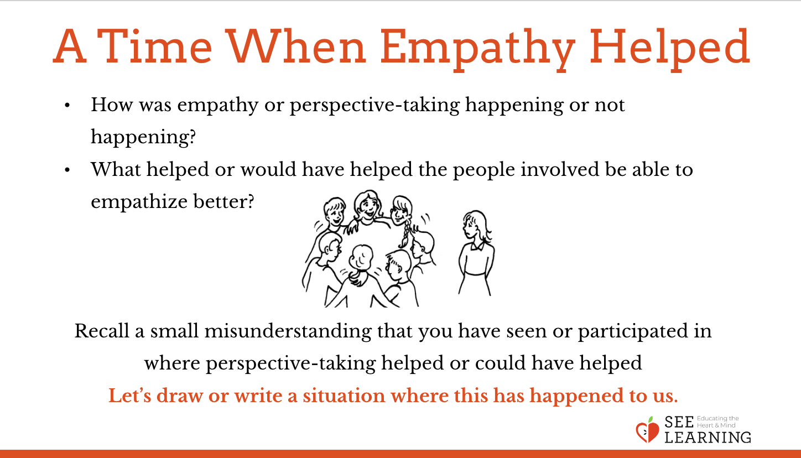 | Sample Script  - N/A

Debrief (2 min)
Slide 6: Debrief  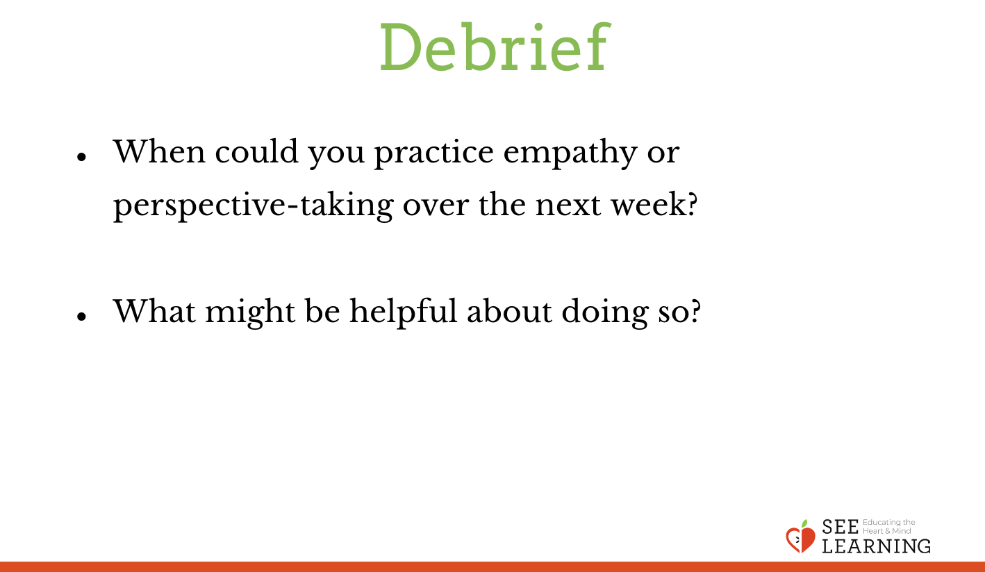 | Sample Script  - “When could you practice empathy or perspective-taking over the next week?  - What might be helpful about doing so?”

