Appreciating Diversity & Commonalities

Purpose:
This learning experience invites students to explore diversity and commonalities. Through an insight activity, students discover that although they are individually unique, being unique is also something they share in common with all other human beings. Through engaging in mindful dialogues about diversity and respect, students can deepen their understanding of the ways in which the experience of “difference” is a common human experience. Appreciating diversity as part of humanity can help students accept their own and others’ uniqueness.
Learning Objectives:  Students will be able to:  - Explore things we all have in common as human beings.  - Recognize things we think might be common or true for all people might not actually be.  - Recognize that one thing we share is that we are each unique | Primary Core Component  Interpersonal Awareness  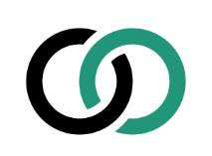
Length  35 Minutes | Materials Required  - Markers  - Post-it notes  - Paper  - Large chart paper or areas on the whiteboard labeled “Things We Have in Common” and “Each of Us Is Unique”

Check-In (5 min)
Slide 2: Check-In   | Sample Script  - “Let’s do a short attention practice. How do we want our body to be?  - First we’ll take a comfortable and upright posture. I’ll be keeping my eyes open, but you can close yours or look at the ground.  - Now choose one of your resources from your resource kit, or you can think of a new resource if you like: something that makes you feel better, safer, happier.  - Let’s bring our resource to mind and focus on it for a few moments quietly. You can also do grounding if you prefer. [Pause.]  - What do you notice inside? If you feel pleasant or neutral, you can rest your mind on that. If you feel unpleasant, you can shift to a place in your body that feels better. [Pause.]  - Now let’s become aware of our breathing. Let’s see if we can pay attention to the breath as it enters and leaves our body.  - If you find paying attention to the breath uncomfortable, then feel free to go back to your resource or grounding. [Pause for 15-30 seconds.]  - If you ever get distracted, you can just return your attention to the breath. You can also count your breath. [Pause for a longer time, such as 30-60 seconds or longer.]  - Now let’s end the practice and open our eyes. What did you notice? ” [Share aloud.]

PRESENTATION & DISCUSSION: What Do We Have in Common? (20 minutes)
Overview

In this activity, students explore what they have in common with each other.

Content/Insights to be Explored
• As human beings, we all have things in common that we share.
• Some things we think might be common or true for all people might not actually be.
• One thing we share is that we are each unique.

Materials
- Markers
- Post-it notes
- Paper for each group
- Large chart paper or areas on the chart paper/ whiteboard labeled “Things We Have in Common” and “Each of Us Is Unique”

Instructions
- Explain to students that you’ll be exploring commonalities and differences together.
- Ask students to turn to a classmate and ask how they might define the word, “diversity.” Then, take a few responses and very briefly discuss. (Diversity means having a high degree of variation or differences within a group. But this doesn’t mean that the group members don’t share important things in common.)
- Explain that your class’s exploration of diversity will begin with an exploration of commonalities.
- Provide an example to students of something that some people have in common, for example having, or wishing they had, a pet. Ask students to name something related to having a pet that fewer people have in common (for example, people who have a dog). Then, have them think of something related to having a dog that very few people have in common- for example, having a spotted puppy.
- Discuss another example with the class, perhaps focusing on something related more closely to identity (ethnicity, religion, etc.) Note: If you know there is sensitivity or conflict around a particular identity issue in your class, do not use that issue as the example.
- Examples are below:
- Many people enjoy some aspects of sports; many enjoy watching some type of sports. Fewer people may have in common that they actually play the sport. And even fewer than that are the people who train, and have the opportunities and gifts, to become highly competitive (Olympics, pro team) in that sport.
- All people experience emotions. Many people notice and are able to describe times when they feel happy or sad or angry. Fewer people have grown their ability to recognize a wide range of emotions and are skilled at knowing what is contributing to them feeling that way. Fewer people than that have practiced being able to consistently recognize their feelings in the moment, name them, and “pause” (stop before acting) in a way that helps them take care of themself and interact with others in healthy and productive ways. Everyone has the potential to be in that last group, which means someday that may be the “Many people…” part of an example like this!
- Many people have a religion or faith. Some people are Hindu. Some people are Christian. Some practice one of many other faith traditions. Some people follow dietary guidelines because of their faith. Some people go to Temple or church on holy days. Some people have parents, or know adults, who practice different faiths.
- Divide the class into groups of three or four. Give each person a post-it note and each group a sheet of paper.
- Ask each group to write a title at the top of the paper, “Things We Have in Common.” Then, ask students to fold the paper in half lengthwise, then unfold it, and draw a line down the middle crease to divide the paper into two columns.
- Ask students to label the left hand side “With Many People” and the other “With Fewer People.”
- In a short amount of time, ask each group to come up with things everyone in their group has in common with many people. Groups can write their ideas on the left side column of their paper.
- Next ask each student to take a few minutes to come up with three things related to the topics they already discussed, that they have in common with very few other people, or that they think are unique to them. Each student should write each of their three things on a separate post-it note and place it on the right hand side column of their group paper, labeled, “With Fewer People.”
- Invite each group to share out loud what they have on their list of “Things We Have in Common.”
- As groups share, write down the students’ responses on a large sheet of chart paper or whiteboard. While doing so, check to see if everyone agrees that the items are indeed things that many people have in common with many other people. Only include the items that everyone agrees on. Write the items that the groups decide are less universally shared under the heading “With Fewer People.”
- After each group has shared, ask students if they notice anything about the list that has been created.
- Next, ask if there are any items that everyone has in common that are not yet on the list. Prompt students to think of the things that have been discussed previously, such as: feelings, needs, the desire to be treated with kindness, having a nervous system, etc.
- Next, invite students to share one of the three things they wrote on their post-it notes that is unique about themselves, or that they believe they don’t have in common with many people.
- As each student shares, have them place their post-it note on a large sheet of chart paper, labeled “Each of us is unique.”
- Discuss with students if anything surprised them and how it felt to explore commonalities and diversity.

Teacher Tips
- You could facilitate a modified version of the Step In/Step Out activity and use the students items on the lists as the categories to step in or step out. (See Chapter 1, Learning Experience 1)
- If you write down all the things students have in common with many other people on a large sheet of chart paper, you can hang this in the classroom as a reminder about their commonalities.

Slide 3: What Do We Have in Common?  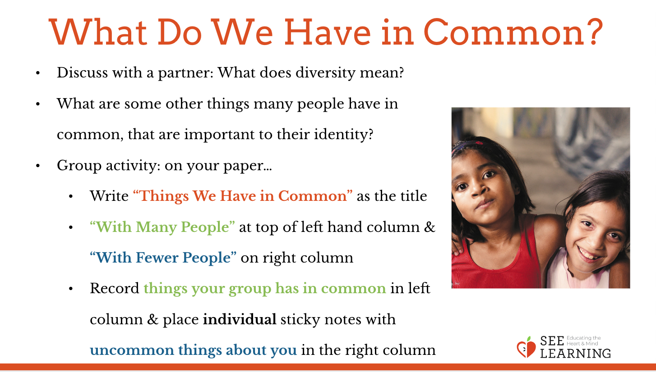 | Sample Script  - “Today we’ll be exploring commonalities and difference together.  - Turn to a classmate and discuss for one minute: What does diversity mean? How would you define that word? [Take responses. Note that diversity can be defined as the condition of having or being composed of different elements, or the inclusion of different types of people in a group.]  - To explore diversity, we’re also going to consider our commonalities. We’ll find out more later about how these are related.  - What are some examples of things many people have in common? Let’s start with an example. For instance, many people have a pet. What is something related to having a pet that fewer people have in common? [They have a dog.] What is something related to having a dog that very few people have in common? [They have a spotted puppy.]  - “Let’s try another example. What are some other things many people have in common, that are important to their identity? [Pause for student input. It’s ok for students to mention things like ethnicity. However, if you’re aware that there is a sensitivity or conflict among your students regarding a particular identity issue, don’t have them focus on that for the example or activity.]  - We’re going to do an activity in small groups. [Divide the class into groups of three or four, giving each group a large sheet of paper to share and three post-it notes for each person.]  - One person in each group, please write “Things We Have in Common” at the top of your group’s paper.  - Next, fold the paper in half lengthwise, and unfold it. Draw a line down the middle crease to divide your paper into two columns [Demonstrate this with your own paper.]  - Please write “With Many People” at the top of the left hand column and “With Fewer People” at the top of the right hand column.  - You have 3 minutes to think of things that everyone in your group has in common with one another, and maybe with many other people. Please record those things in the left column of your group paper. [Time 3 minutes, then use your regular attention signal to bring the group together for the next direction.]  - Ok, now we have another task. Each of you should think about what you personally have in common with very few other people. These are things that are unusual about you, or shared by few other people. You can get help from one another as you think about this. Try to think of three things each and write each of them down on a separate post-it note. When you’re done, you can place the notes on the right side column of your paper. [Provide 3-5 minutes.]  - Let’s share now what your group came up with, first for the column “Things We Have in Common - With Many People” [Ask groups to share, and record their responses on the whiteboard or large chart paper.]  - [After all the groups have shared, ask:] What do you notice about the list we made?  - Are there any items that everyone has in common that are not yet on the list? What about some of the things we have been exploring together during SEE Learning? [You may prompt students to think about: feelings, needs, the desire to be treated with kindness, having a nervous system, etc. Take responses.]  - What are some things that you share with only a few, of any people? You can share what you’ve written on your post-it note and then come place it on here on the “Each of Us is Unique” poster. Were you surprised by any of the things that you have in common with each other? Were you surprised by any of the differences? How does it feel to discuss commonalities and differences?” [If a student does not mention it, note that, one similarity we each have is that we’re each unique.]

REFLECTIVE PRACTICE: Mindful Dialogue on Diversity and Respect (7 minutes)

Overview
In this reflective practice, students will share their experiences with their own uniqueness, and their experiences of respecting diversity.

Content to be Explored
• We each are unique and appreciate it when our uniqueness is respected.

Materials
None

Instructions
- Remind your students how to engage in mindful dialogue practice. Refer to the description in the previous learning experience as a guide.
- Lead your students in a mindful dialogue using the following questions. Give them 2-3 minutes for the first speaker to respond to the series of questions. Then, switch roles as the listener and the speaker and give the same amount of time for the second speaker.
Slide 4: Mindful Dialogue on Diversity and Respect  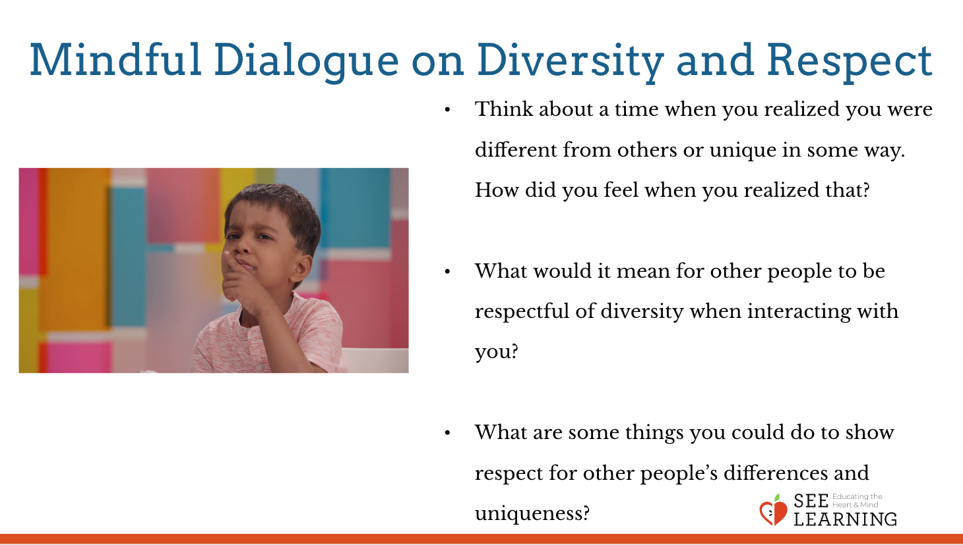 | Questions  - Think about a time when you realized you were different from others or unique in some way. How did you feel when you realized that?  - What would it mean for other people to be respectful of diversity when interacting with you?  - What are some things you could do to show respect for other people’s differences and uniqueness?

Debrief (3 min)
Slide 5: Debrief  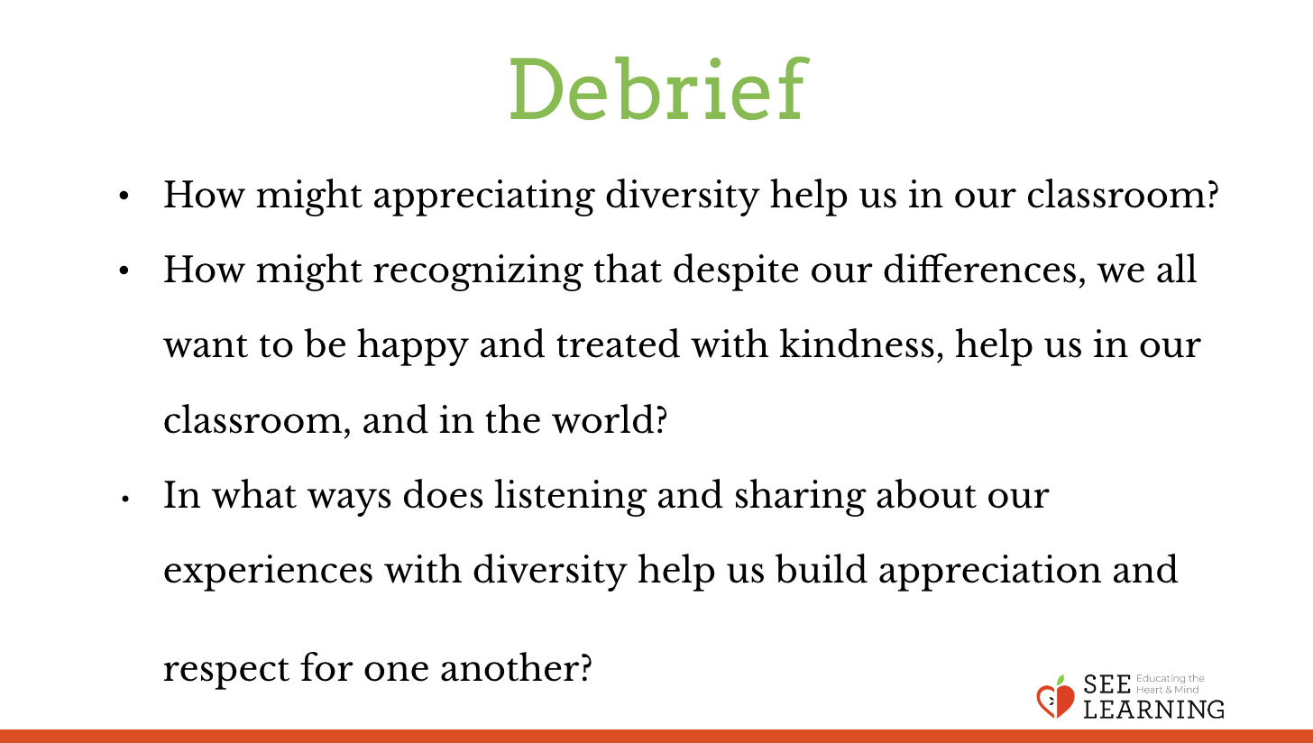 | Sample Script  - “How might appreciating diversity help us in our classroom?  - How might recognizing that despite our differences, we all want to be happy and treated with kindness, help us in our classroom, and in the world?  - In what ways does listening and sharing about our experiences with diversity help us build appreciation and respect for one another?

