Mindful Dialogues

Purpose:
This learning experience introduces “mindful listening” and “mindful dialogues.” “Mindful listening” means to listen respectfully and empathically with full attention, without interrupting the other person, without being distracted, and without focusing on oneself, one’s judgments, and what one wants to say. “Mindful dialogues” use this technique of mindful listening to support a dialogue between two students around sets of questions. The mindful dialogues format allows each student to both reflect personally on what they are learning and how it applies to their own life, and also to briefly share their thinking with another student. Mindful dialogues can help students achieve critical insights and deepen their understanding while learning about and from each other.
Learning Objectives:  Students will be able to:  - Practice the skill of listening mindfully without interrupting or shifting the focus to oneself.  - Practice using the mindful dialogue format | Primary Core Component  Attention & Self Awareness  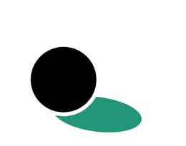
Length  35 Minutes | Materials Required  - Two pieces of chart paper for notes on mindful listening, each with two columns:  - “Not Being Listened to Feels Like...” and “Being Truly Listened to Feels Like...”  - “Mindful listening is... “ and “In a Community Where People Truly Listen to Each Other…”  - Pieces of chart paper with the mindful dialogue questions written on them  - Markers  - A practiced attention signal such as a chime

Check-In (5 min)
Slide 2: Check-In   | Sample Script  - “Let’s do a short attention practice. How do we want our body to be?  - First we’ll take a comfortable and upright posture. I’ll be keeping my eyes open, but you can close yours or look at the ground.  - Now choose one of your resources from your resource kit, or you can think of a new resource if you like: something that makes you feel better, safer, happier.  - Let’s bring our resource to mind and focus on it for a few moments quietly. You can also do grounding if you prefer. [Pause.]  - What do you notice inside? If you feel pleasant or neutral, you can rest your mind on that. If you feel unpleasant, you can shift to a place in your body that feels better. [Pause.]  - Now let’s become aware of our breathing. Let’s see if we can pay attention to the breath as it enters and leaves our body.  - If you find paying attention to the breath uncomfortable, then feel free to go back to your resource or grounding. [Pause for 15-30 seconds.]  - If you ever get distracted, you can just return your attention to the breath. You can also count your breath. [Pause for a longer time, such as 30-60 seconds or longer.]  - Now let’s end the practice and open our eyes. What did you notice?” [Share aloud.]

PRESENTATION & DISCUSSION: Mindful Listening* (10 minutes)
Overview

In this activity students will discuss what they think would be involved in “mindful listening.”

Content/Insights to be Explored
• There is a difference between listening without much attention and mindful listening.
• This difference can affect us as speakers, listeners, and as a whole community.

Materials
- Chart paper
- Markers
- Chime

Instructions
- Explain that today you will talk about what it means to really listen to someone.
- Ask for examples of what it feels like when someone isn’t really listening to you when you really wish they were. Write student suggestions on a piece of chart paper under the heading “Not Being Listened To Feels Like...”
- Ask for student ideas of what it is like when you are really listened to with full attention and without judgment. Write their ideas on a piece of chart paper under the heading “Being Truly Listened To Feels Like...”
- Take a moment to note with them the differences between the two lists.
- Ask what it would look like, sound like and feel like for us to listen to someone else with full attention. Explain that you will call that “Mindful Listening” in class. Write their ideas down under the heading “Mindful Listening is...”
- Ask what it would be like if the whole class or community were good at doing mindful listening. Write their ideas under the heading “In a Community Where People Truly Listen to Each Other…”
- Explain that you will now do an activity that involves mindfully listening to each other.

Teacher Tips
- In SEE Learning, mindful listening means to listen attentively without interrupting, without being distracted, without giving advice, and without turning the conversation towards ourselves. Often when listening to others, we are only partially paying attention to the other person and what they are saying; part of our attention is on our own reactions, our thoughts, and what we are going to say once the other person finishes or gives us a chance to speak. Mindful listening involves noticing all of that, and then intentionally setting it aside, turning with full attention and without judgment to what the other person is saying. Just like compassion, mindful listening is other-focused, rather than self-focused.
Slide 3: Mindful Listening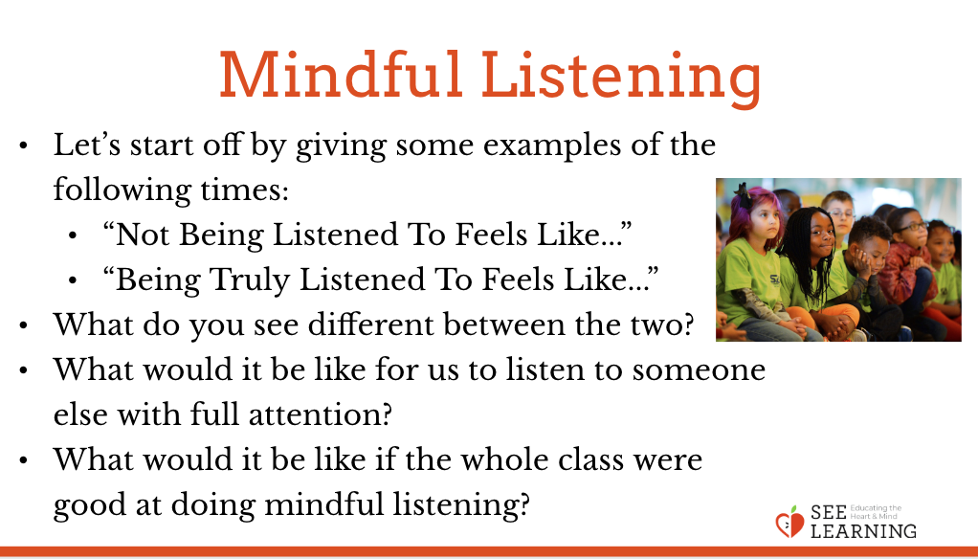 | Sample Script  - “Today we’re going to investigate what it means to truly listen to someone.  - We’re always talking to people and people are always talking to us. But have you ever felt that you were talking to someone but they weren’t really listening? What does that feel like? [Ask for student ideas and write them on a piece of chart paper under the heading “Not Being Listened To Feels Like...”]  - What is it like when someone truly listens to what you have to say fully, without judging you or correcting you or criticizing you? Is there someone in your life who listens to you that way? [Pause.] What is that experience like? [Ask for student ideas and write them on a piece of chart paper under the heading “Being Listened To Feels Like...”]  - Let’s look at these two lists we made. What are the main differences we notice?  - What about our own behavior when someone is talking to us? What does it mean to listen to someone with our full attention? What would that look, sound, and feel like? We’ve already learned about mindfulness so we’re going to call this “mindful listening.” [Ask for student ideas and write them on a piece of chart paper under the heading “Mindful Listening Is...”]  - What about if we expand our thinking to not just two people, but a whole community, like our classroom or our school. If we as a school community knew how to listen to each other with full attention, and if we practiced that until we got good at it, and it happened all of the time, how would that impact our school community? What might be different? [Ask for student ideas and write them under the heading “In a Community Where People Really Listen to Each Other…”]  - Just like we can strengthen our attention like a muscle, we can also strengthen our ability to listen mindfully. Today we’re going to learn a practice that involves us listening to each other with full attention and without judgment. It’s called having a “Mindful Dialogue.””

REFLECTIVE PRACTICE: Mindful Dialogues* (17 minutes)

Overview
In this reflective practice students form pairs and use guiding questions to engage in personal reflection and to experience listening and speaking mindfully.

Content to be Explored
• We can learn to listen mindfully with full attention, withholding judgment.
• We can learn a great deal about each other in a short amount of time if we listen mindfully.
• Being listened to mindfully can make us feel “heard” and “seen” and can strengthen relationships.
• Being able to express our thoughts and feelings to someone who is listening mindfully can help us reflect more deeply and gain insight.

Materials
None

Instructions
- Explain the format of the mindful dialogue.
- a. A mindful dialogue involves the class dividing into pairs. Each pair decides who will go first. That person will be the questioner and will also be the person who will first practice mindful listening. The other student in the pair is the responder. The questioner asks a set of questions, which you can put on the board or on a piece of chart paper where everyone can see them. The responder answers each question one by one, taking as much of the allotted time as they like. The questioner listens mindfully while the respondent speaks; the questioner doesn’t speak except for asking the questions. Once the responder has finished, the questioner thanks the responder and moves on to ask the next question.
- b. Explain in advance that it’s okay if the questioner has not had time to ask all three questions by the time the chime sounds. Alternatively, if the responder has finished early, the pair can just sit quietly in silence until they hear the chime. Encourage the questioner to notice if they find it difficult to not speak, remind them that their goal is to focus on what their partner is expressing, and that they’ll have an opportunity to speak when the time comes to switch.
- c. Before one actually begins a mindful dialogue, it’s important that people have time to read and think about the questions they will be answering.
- d. Mindful dialogues are confidential. Whatever you hear should not be shared with the class. Also, if you are asked a question and you don’t want to respond to it, you can respond to a question you wish had been asked instead.
- Model a mindful dialogue with one of your students as a volunteer. Have the questions for this mindful dialogue visible for all to see on a piece of chart paper. Give everyone a few moments to read and think about the questions. Then begin the mindful dialogue using these questions:
  - 1. Please tell me about one of your personal resources.
  - 2. Thank you. What sensations do you notice when you think about your resource?
  - 3. Thank you. What else would you like to share about your resource or how you’re feeling?
- To model the mindful dialogue, have a student ask you the same questions and answer them in front of the class, modeling appropriate disclosure. When you and your student partner have both taken your turns in front of the class and completed modeling the mindful dialogue, ask the observing students what they noticed about your dialogue.
- Next, have the students practice with each other by dividing the class into pairs and having them stand or sit side-by-side such that everyone can see the mindful dialogue questions, turning to face each other when they begin. Explain that they will wait until they hear the chime to begin. When they hear the chime again, it will mean to stop and switch, with the responder becoming the questioner. When they hear the chime again, it means to stop.
- Explain that mindful dialogues are meant to be safe, so if they don’t want to answer a particular question, they can answer a question they wish the other person had asked instead, or stay in comfortable silence together.
- Ring the chime to have them begin. Pay attention to the time and allow them to engage in the activity for 60 to 90 seconds, depending on how you perceive the group’s comfort level and engagement to be. After that time has elapsed, ring the chime and ask them to switch. Remind them that it’s okay if they didn’t finish all the questions. Also reinforce the skills being built, reminding everyone what it means to mindfully listen. Give them the same amount of time as the first round to complete the activity after they have switched, then ring the chime to signal the end of the mindful dialogue. If you like and have time, repeat the whole activity a second time with new partners. Note that the 60 to 90 seconds are for all three questions and it’s okay if they do not complete all the questions in time. This way an entire round of a mindful dialogue lasts only 3 minutes or so, with each person being responder and questioner for one set of three questions.
- Conclude by asking what students experienced from doing the mindful dialogues.
  - a. “What did you notice as you were the listener? What did you notice as you were the speaker?
  - b. When during the day do you feel you are listening to someone mindfully?
  - c. When do you feel someone else is listening to you mindfully?
  - d. What sensations on the inside did anyone notice when they were listening or being listened to?
  - e. How or why might being listened to make our bodies feel safer and more in the resilient zone?”
Teacher Tips
- It is often helpful to precede the actual mindful dialogue with a moment of reflection or an activity, (such as drawing) on the given topic of the dialogue. This provides think time for students prior to the actual dialogue and can make the sharing richer. For example, prior to doing a mindful dialogue on students’ resources, you might have them draw or think about a resource they already have identified as valuable, or a new resource. Prior to having them do a mindful dialogue on kindness, you might have them spend a minute thinking of a moment of kindness they saw recently.
- Mindful dialogues, as done in SEE Learning, are brief yet concentrated. Each round should only last 2-3 minutes. You can use this mindful dialogue technique to explore a range of questions, but since mindful dialogues can be personal and intense, always be sure to remind students that if they feel uncomfortable answering a question, they can instead answer a question they wish had been asked, or stay together in comfortable silence. Mindful dialogues can be great ways to prompt reflection and the personalization of knowledge in students.
- If you are unfamiliar with this type of practice, it can be helpful to practice it with another adult first, outside of class, to see how it feels and how the timing works. Although it may take one or two tries for your students to get used to the format of a mindful dialogue done in this way, it will create an effective practice that you can continue to use to reflect on other materials as the SEE Learning curriculum progresses.
Slides 4 & 5: Mindful Dialogues  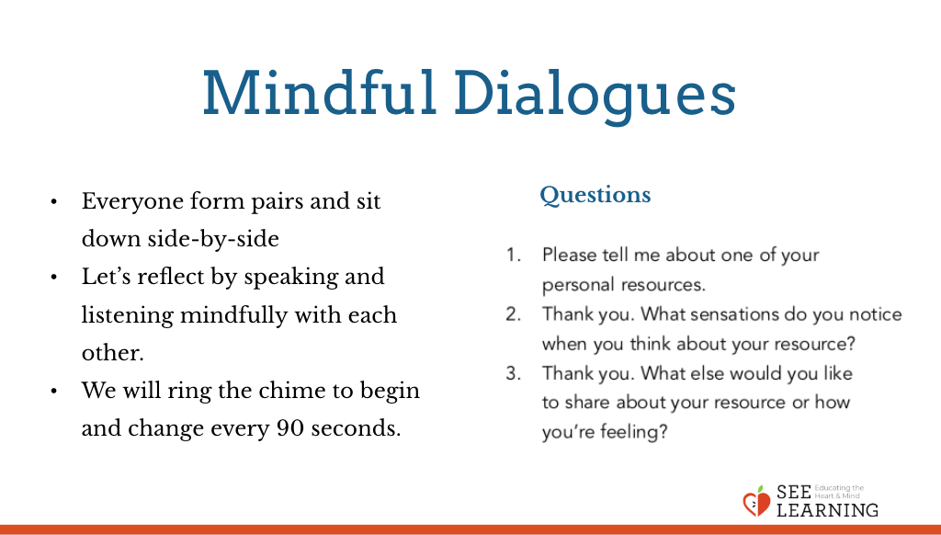  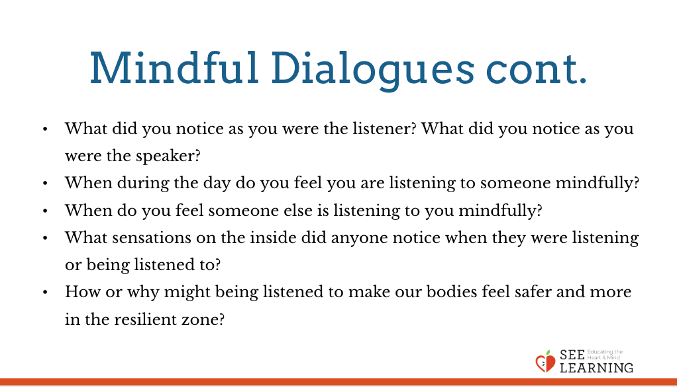 | Sample Script  - “Now that we know what mindful listening is, we can practice it. We’re going to practice listening in a mindful dialogue. A dialogue means two or more people are taking turns speaking to one another using mindful listening.  - Can I have a volunteer to practice with? We’ll model this mindful dialogue process for the class, using these same questions that everyone will use when we connect in partnerships.  - [Student’s name] and I are going to demonstrate how to do a mindful dialogue. Here are three questions. I’ll be the questioner and you will be the one who answers. Then we’ll switch. So I’m going to ask you them first, one by one. Then when we switch, you can ask me.  - When I ask you, I’m going to listen mindfully to your responses, and not interrupt. Then when it’s your turn to ask me, you’ll do the same. Everyone else, please watch; you’ll have an opportunity to do this next.  - Let’s first take a moment to read the questions in silence.  - Okay let’s start now. [Name], please tell me about one of your personal resources. [Listen and model mindful listening while the student shares, nodding and paying full attention but not interrupting.]  - Thank you. What sensations do you notice on the inside when you think about your resource? [Listen mindfully.]  - Thank you. Is there anything else you’d like to share about your resource or how you’re feeling? [Listen mindfully. When the student has finished, ring the chime.]  - The chime means we’re going to switch. Now you ask me the same three questions one by one. When I’m sharing, you’ll be doing mindful listening. When I finish each response, you say “Thank you” and then you ask me the next question. Okay? [Engage fully.]  - What did you all notice about the mindful dialogue?  - What did you notice about our mindful listening?  - How do you think mindful listening is a way of being kind to someone? What contributes to that?  - How might mindful listening affect our sense of safety or our nervous system?  - What if I hadn’t want to answer a question. Let’s say I felt uncomfortable about answering one of the questions. What could I have done? [Allow for suggestions, or provide a model by demonstrating this with your partner.]  - Because mindful dialogues are designed to be safe, if I don’t want to answer a question, then I can answer a question I wish the other person had asked. I can say, “I wish you had asked me about something else, so I’m going to share that instead.” And then you can share. So in that way too, we can see that mindful dialogues are all about practicing kindness and respect in the way we talk to and listen to each other.  - Let’s all practice this mindful dialogue now. As you find a partner to stand with, make sure you can see the questions here on the chart paper.  - Decide which of you will go first. The person who goes first will be the questioner. Raise your hand if you’re going to be the questioner. Remember both of you will get to be the questioner—this hands up shows who will ask first. If you’re the questioner, you’re going to ask these questions and practice mindful listening while the other person shares.  - When I ring the chime you will begin. The questioner will ask the first question and then will mindfully listen. When the person answering is done, the questioner will say “Thank you,” and will then ask the next question.  - The next time you hear the chime, it’ll be time to switch. Don’t worry if you’re not done with all the questions yet. That’s okay. Everyone will be answering at their own pace. Any questions?  - Turn and face each other. Let’s begin! [Ring the chime.]  - [When the round is finished and both people have had the chance to share and listen mindfully, debrief the activity with one or more of the following questions:]  - What did you notice as you were the listener? What did you notice as you were the speaker? • When during the day do you feel you are listening to someone mindfully?  - When do you feel someone else is listening to you mindfully?  - What sensations on the inside did anyone notice when they were listening or being listened to?  - How or why might being listened to make our bodies feel safer and more in the resilient zone?”

Slide 6: Debrief (3 min)  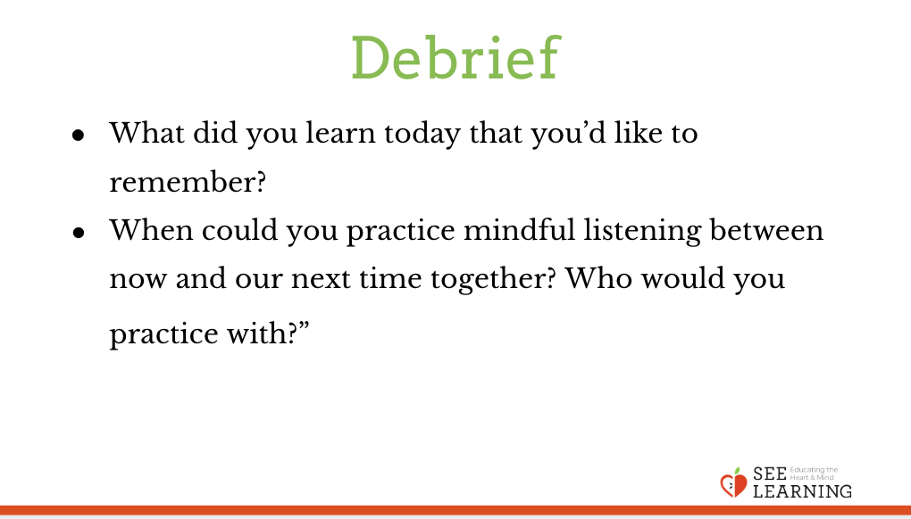 | Sample Script  - What did you learn today that you’d like to remember?  - When could you practice mindful listening between now and our next time together? Who would you practice with?

OPTIONAL EXTENSIONS
Slide 7: Optional Mindful Dialogue Questions  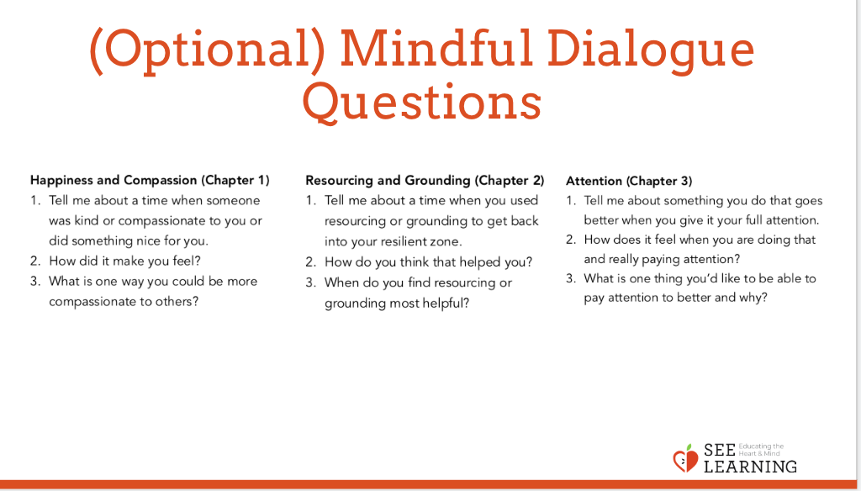 | Instructions  - As time allows, repeat this practice with new mindful dialogue questions, such as those suggested below. You may also choose to create your own mindful dialogue questions to facilitate learning and reflection. Each of the following sets of questions reinforces learning that has been introduced in this and previous chapters.  - Happiness and Compassion (Chapter 1)  - 1. Tell me about a time when someone was kind or compassionate to you or did something nice for you.  - 2. How did it make you feel?  - 3. What is one way you could be more compassionate to others?  - Resourcing and Grounding (Chapter 2)  - 1. Tell me about a time when you used resourcing or grounding to get back into your resilient zone.  - 2. How do you think that helped you?  - 3. When do you find resourcing or grounding most helpful?  - Attention (Chapter 3)  - 1. Tell me about something you do that goes better when you give it your full attention.  - 2. How does it feel when you are doing that and really paying attention?  - 3. What is one thing you’d like to be able to pay attention to better and why?

