Exploring Our Social Identity

Purpose:
This learning experience provides students with an opportunity to shift their attention toward others and become more aware of their social realities. It does this through two activities that explore what they know and don’t yet know about each other. These lead to reflecting on identity and the assumptions we make about one another

Learning Objectives:  Students will be able to:  - Explore their assumptions about others and how those assumptions can be incorrect.  - Recognize that there are many things we don’t know about one another until we take the time to find out.  - Explore how every person, including themselves, has a vast number of identities, most of which are not visible upon first seeing or meeting a person. | Primary Core Component  Interpersonal Awareness  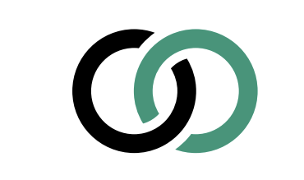
Length  35 Minutes | Materials Required  - Writing utensil  - Notecards or paper  - A chime (optional)

Check-In (5 min)
Slide 2: Check-In   | Sample Script  - “Let’s do a short attention practice. How do we want our body to be?  - First we’ll take a comfortable and upright posture. I’ll be keeping my eyes open, but you can close yours or look at the ground.  - Now choose one of your resources from your resource kit, or you can think of a new resource if you like: something that makes you feel better, safer, happier.  - Let’s bring our resource to mind and focus on it for a few moments quietly. You can also do grounding if you prefer. [Pause.]  - What do you notice inside? If you feel pleasant or neutral, you can rest your mind on that. If you feel unpleasant, you can shift to a place in your body that feels better. [Pause.]  - Now let’s become aware of our breathing. Let’s see if we can pay attention to the breath as it enters and leaves our body.  - If you find paying attention to the breath uncomfortable, then feel free to go back to your resource or grounding. [Pause for 15-30 seconds.]  - If you ever get distracted, you can just return your attention to the breath. You can also count your breath. [Pause for a longer time, such as 30-60 seconds or longer.]  - Now let’s end the practice and open our eyes. What did you notice?” [Share aloud.]

Insight Activity 1: Two Facts and a Fiction (15 min)
Overview

In this insight activity, students share two things about themselves that are true, and one that is not true.

Content to be Explored
• We can learn about one another and from one another.
• There are many things we don’t know about one another until we take the time to find out.
• Often our assumptions about others are incorrect or incomplete.

Materials
- Writing utensils
- Paper or note cards

Instructions
- Take a poll: ask students how well they think they know others in the group.
- Tell students you are going to play a game called Two Facts and a Fiction. The challenge is to see if others can figure out which items are true and which are false.
- Make sure they understand what is meant by “fact” (something that is true) and “fiction” (something that is false).
- Write the words “Something someone might not know about me is…” on the board or a piece of chart paper.
- Tell students to write two true things (facts) and one false thing (fiction) about themselves on a note card or piece of paper. They should be written as statements, like “I am a vegetarian.” Tell them to put them in a random order and to select items that are not visible or obvious to someone just from looking at you. You, the educator, should participate also by filling out three things about yourself.
- Have each person share their three items, one at a time. After each student shares, the rest of the class can discuss which statements they think are true and which one is false:
- “Which two do you think are true and which is false? Why do you think that? What are you basing your guess on?”
- After one or two classmates have guessed, allow the student to reveal which were the facts and which was the fiction.
- Once all students have taken their turn, debrief the activity, asking one or more of the following questions:
- “What was that activity like for you? What surprised you?
- Let’s talk about assumptions. How might this activity relate to the assumptions we make about each other?
- What happens when we make assumptions based on our first impression of someone?
- What happens when we get to know each other better?
- What are some other ways we might get to know each other better?”

Teacher Tips
- Students may know this activity as the game “Two Truths and a Lie” and may have already played it before. That is fine, since there are endless facts and fictions that can be used in this game.
- You may have students read each other’s facts and fictions to add some variety. If you do this, you’ll want students to put their names on their cards.
- To save time, you can also demonstrate the activity once with a volunteer and then have students do the activity in pairs or quads. Have them switch partners between rounds, and do the activity for 2-3 rounds, followed by the group debrief.
Slides 3 & 4: Two Facts and a Fiction  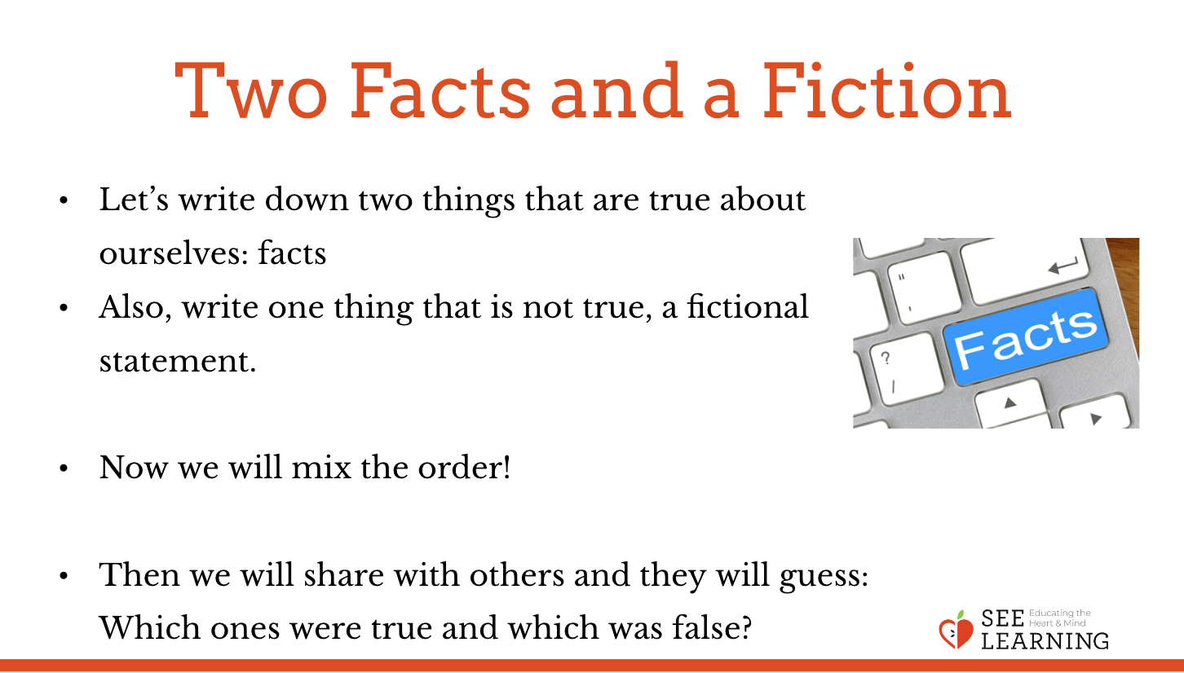  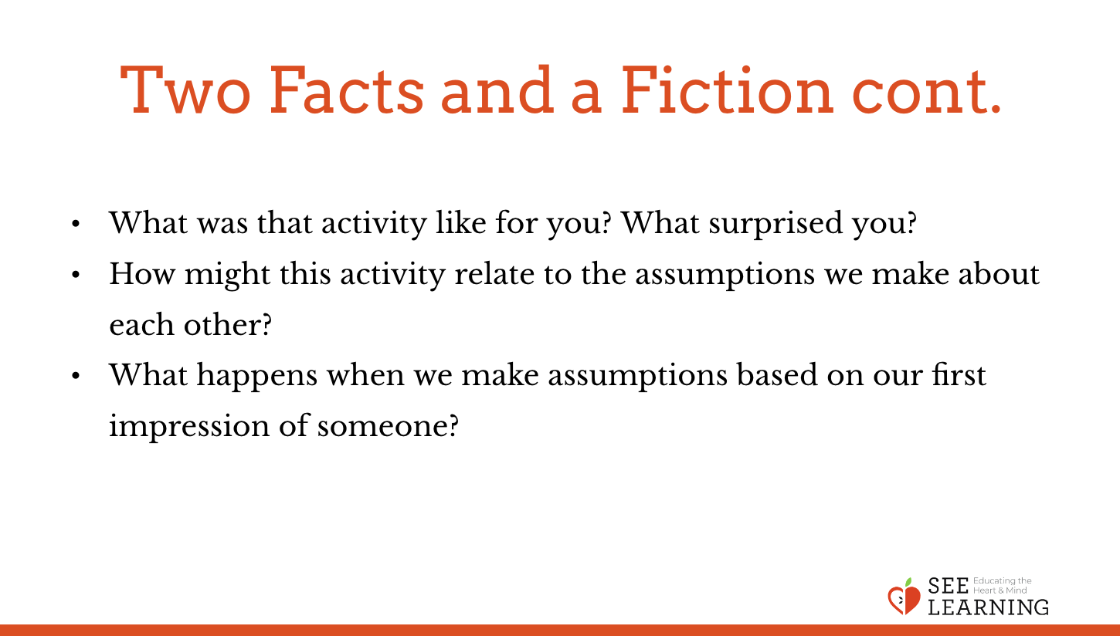 | Sample Script  - “We’re going to do an activity called “Two Facts and a Fiction.” This is a game that some of you may have already played before. It’s for learning about each other.  - How much do you think we already know about each other? Do you think there are a lot of things we don’t know about each other?  - In this game we write down two things that are true about ourselves, facts, and one thing that is not true, a fictional statement. Then the rest of the class will guess which things are true and which one is not true.  - Now, we don’t want it to be super easy. We want to think of things that are less obvious. Things that other people might not know about us. Things that are parts of our identity but are not visible from the outside.  - (Point to the board or poster with the prompt on it…) “Something someone might not know about me is…”  - Each of us will write three things that answer this question: two that are true and one that’s false, but in mixed up order. Then we will share and other people will have to guess which ones are true and which is false. And after they have guessed, we will reveal which ones were true and which is false.  - Do you have questions about how to play this game?  - Let’s take a few minutes to write down our three statements now. [Give them a few minutes.]  - Now who would like to share first? What three things did you write? [Have a student share their three statements.]  - What do the rest of you think? Which ones are true and which is false?  - Now let’s find out if we are right. Which ones were true and which was false? [Let the student reveal.]  - Okay let’s hear from the next person. [Continue through all students until everyone has had their turn.]  - [Then debrief, asking one or more of the following questions as time allows:]  - What was that activity like for you? What surprised you?  - What did you learn about the people in our group?  - Let’s talk about assumptions. How might this activity relate to the assumptions we make about each other?  - What can happen when we make assumptions based on our first impression of someone?  - What happens when we get to know each other better?  - Can you think of other ways we might get to know each other better?”

Insight Activity 2: Who are you?* (12 minutes)
Overview
In this insight activity students will explore the multiplicity of their own identities and learn about others’ identities.

Content to be Explored
• Every person has many aspects to their identity, most of which are not visible upon first seeing or meeting them.
• There are many things we don’t know about one another until we take the time to find out.

Materials
Printouts of the “Happiness” sheet found at the end of this learning experience – one for each student

Instructions
- Tell students you will all be playing a game that involves learning about others and about ourselves. Tell them that you’ll all be sharing what you learn about each other during the debrief, so keep that in mind as they share with your partners.
- Organize students so everyone is standing and has a partner. You should participate if there is an odd number of students.
- Explain the rules of the game. Students will take turns asking each other one question “Who are you?” for 30 seconds.
- Partner 1 says “Who are you?” and listens to the answer from Partner 2. Then Partner 1 says, “Thank you. Who are you?” asking the question again. Partner 2 responds with a different answer. Partner 1 again says “Thank you. Who are you?” This is repeated until 30 seconds pass whereupon they will switch roles. The challenge is for the responding partner to never repeat the same response.
- Either model the activity first, playing the part of the respondent, or provide a few examples of how someone might answer the “Who are you?” question, including both trivial responses and more revealing ones, to show that students can answer in a variety of ways. (I am a person who likes the color blue. I’m scared of heights. I’m proud of my Italian heritage.)
- Ask students to face their partners and choose who will go first as the questioner. Tell them that when you ring the chime, Partner 1 should begin asking “Who are you?” and repeat it, beginning with “Thank you,” as many times as possible until time is called.
- Let them do this for 30 seconds, then ring the chime when time is up. Have them switch roles.
- After another 30 seconds, ring the chime again. Explain that they should now find a new partner. Remind them that the challenge is to never repeat an answer, even with new partners.
- Repeat the activity with new partners. Do this for three rounds, as time permits. After the rounds are complete, invite them to return to their seats and debrief with some or all of the following questions:
- “What was this activity like for you? [Be prepared to receive comments from those who did and did not find this a comfortable experience. Anticipate that it may be challenging for people who identify as introverted; who find it stressful to reach out to make partnerships; who don’t like having their interaction interrupted or who don’t prefer structured protocols. That’s okay. You are asking this question to surface whatever comes up for participants, not as a judgment of the value of the activity. Notice, nod, “Thank you for your idea.”]
- Who learned something you didn’t know about someone else? Did anything surprising happen?
- Was it hard to keep going? Why?
- What are some things you think this game shows about our identities?
- What did you notice about how many identities or aspects of our identity we have?
- How many of our identities do people see when they first see or meet us? What about when we see others? What are some differences between what others might think they can tell about us when they first see us, and our actual identities?
- What difference did it make that we said “Thank you” in between asking “Who are you?” How did that affect you as the question asker? As the person answering “Who are you?”
- What might we learn if we continued with this activity at other times?”

Teacher Tips
- It can be beneficial to briefly model the activity in front of the group with your co teacher or a student volunteer so that they can learn the protocol of saying “Who are you? Thank you. Who are you?”
- This activity can be repeated at different times in the school year.
- If you do not have a chime, you can use the technique of raising your hand up high and explaining that anytime anyone sees you or someone else raise their hand, they should stop talking and raise their own hand. In this way, eventually everyone in the class sees the upraised hands and stops talking.
Slides 5&6: Who are you?  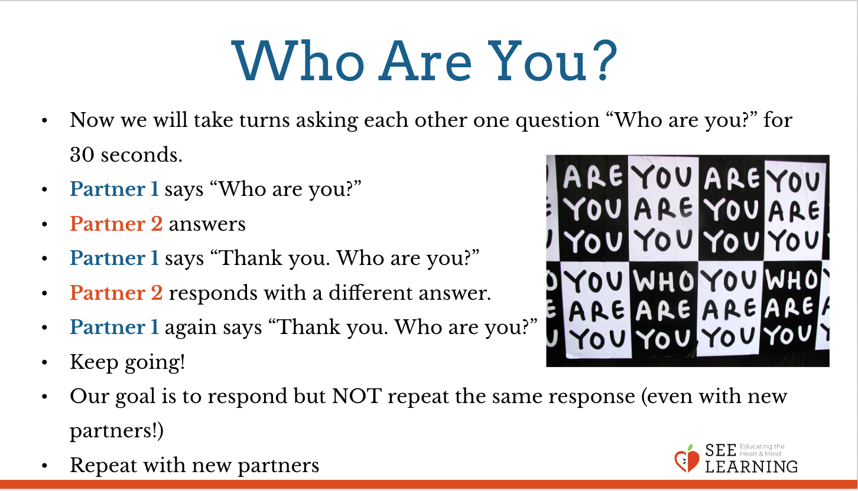  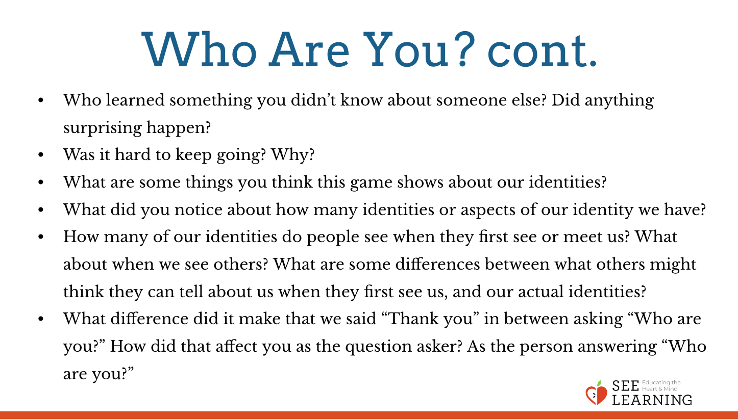 | Sample Script  - “Now we’re going to play a game that helps us learn about each other and ourselves. It’s called “Who are you?”  - After I explain the directions, we’ll all stand and find a partner. Partner 1 will be the questioner. The questioner will ask “Who are you?” to their partner. Partner 2 will then answer by saying something about themselves.  - When they’re done. Partner 1 will say “Thank you. Who are you?”  - Partner 2 gets to answer again, but this time giving a different answer. We can’t repeat something we’ve already said.  - Then Partner 1 says again, “Thank you. Who are you?” Partner 1 doesn’t comment on the responses or make additional conversation. They are in the listening role only. • You’ll do this for 30 seconds until I ring the chime. Then you’ll switch roles, and the person who was asking the question, “Who are you?” will get to be the one who answers  - Remember to say “Thank you” each time, before asking “Who are you?” again.  - Let’s practice by you all together asking me “Who are you?” and I’ll respond. Ask me “Who are you?” [Have them all ask you this question as a class, then respond by saying something about yourself.]  - Now say, “Thank you. Who are you?” [Have them ask you, and reply again.]  - That’s it. Sounds good!. Any questions?  - I’ll ring the chime now to begin. When I ring the chime again, you’ll switch roles. [Ring chime to begin. Wait 30 seconds. Ring chime to switch roles. Wait 30 seconds. Ring chime to end the round.]  - Now please find a new partner and we’ll do round two. Remember we can’t repeat anything we’ve said earlier. Start when I ring the chime. [Ring chime as before. Continue to do the third round.]  - Okay that was the final round. Now let’s take our seats and debrief.  - [Debrief with some or all of the following questions:]  - Who learned something you didn’t know about someone else? Did anything surprising happen?  - Was it hard to keep going? Why?  - What are some things you think this game shows about our identities?  - What did you notice about how many identities or aspects of our identity we have?  - How many of our identities do people see when they first see or meet us? What about when we see others? What are some differences between what others might think they can tell about us when they first see us, and our actual identities?  - What difference did it make that we said “Thank you” in between asking “Who are you?” How did that affect you as the question asker? As the person answering “Who are you?”  - What might we learn if we continued with this activity at other times?”

Debrief (3 min)
Slide 7: Debrief  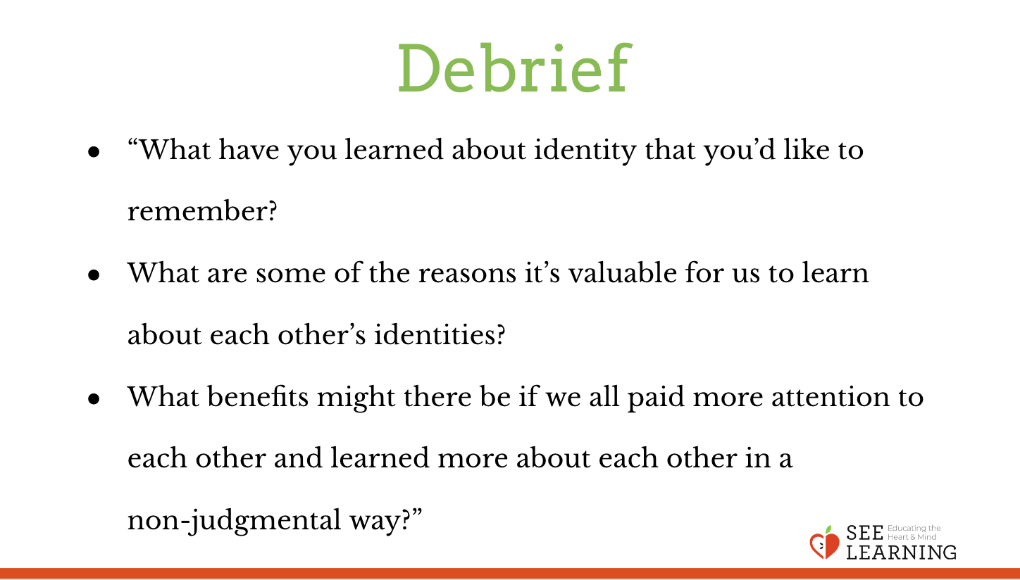 | Sample Script  - “What have you learned about identity that you’d like to remember?  - What are some of the reasons it’s valuable for us to learn about each other’s identities?  - What benefits might there be if we all paid more attention to each other and learned more about each other in a non-judgmental way?

