Dealing with Difficult Emotions and Exercising Restraint

Purpose: The purpose of this learning experience is for students to learn to identify when emotions provoke behaviors that harm oneself or others, and to recognize which emotions are particularly difficult or “risky” for them for this reason, using the “feeling tone/activation” chart. Students will learn that while all emotions are natural, heedfulness and caution with regard to certain emotions can be combined with strategies for navigating them. This is called emotional hygiene. The learning experience ends by introducing the idea of an “ethics of restraint” (meaning an ethical stance against causing unnecessary harm to others). Restraint comes not from suppressing emotions, but rather by learning to more skillfully navigate them.
Learning Objectives:  Students will be able to:  - Identify characteristics that can make certain emotions “risky.”  - Identify strategies for use with risky emotions.  - Explore the idea of an “ethics of restraint” (limiting behaviors that are harmful to self and others). | Primary Core Component  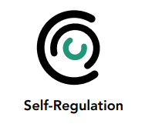
Length  40 minutes | Materials Required  - The emotion families charts created earlier for display  - Students’ individual activation/feeling tone charts  - Copies of the “Strategies for Dealing with Risky Emotions ” for each student  - Copies (or one large copy) of the “Investigating Risky Emotions Worksheet”

Check-In (4 min)

Slide 2: Check-In   | Sample Script  - “Let’s prepare for a short attention practice. How do we want our body to be?  - First we’ll take a comfortable and upright posture. Then we’ll keep our eyes on the ground or close them.  - Before we strengthen our attention, we’ll do some resourcing or grounding to calm our bodies. Choose one of your resources from your resource kit, or you can choose a new one, or you can imagine one.  - Now let’s just bring our resource to mind. And let’s see if we can just pay attention to our resource with our mind for a few moments quietly. Or if you’d rather do grounding, you can do that too. Whichever you choose, we’re going to rest quietly and pay attention for a few moments. [Pause.]  - What do you notice inside? If you feel pleasant or neutral, you can rest your mind on that.  - If you feel unpleasant, you can shift to a different resource, or you can ground. You can also change your posture but try not to disturb anyone else if you do that. Otherwise, just keep your attention resting with your resource. [Pause.]  - Now let’s become aware of our breathing. Let’s see if we can pay attention to the breath as it enters and leaves our body.  - If you find paying attention to the breath uncomfortable, then feel free to go back to your resource or grounding, or just take a small break, making sure not to disturb anyone else. [Pause for 15-30 seconds.]  - If you ever get distracted, you can just return your attention to the breath. You can also count your breath. [Pause for a longer time, such as 30-60 seconds or longer.]  - You can strengthen your attention by focusing on sensations or by focusing on the breath. It’s your choice - it’s always up to you.  - What did you notice?” [Share aloud.]

PRESENTATION/DISCUSSION: Difficult or “Risky” Emotions
(10 min)
Overview
This discussion introduces the concept of “risky” emotions: emotions that can cause problems for ourselves and others if they get out of hand. Students then come up with a list of risky emotions in pairs, using the “Investigating Risky Emotions Worksheet.”

Content to be Explored
- Some emotions are more risky than others, in that they can prompt behaviors that harm ourselves and others when they get out of hand.
- We can identify risky emotions by analyzing them according to their characteristics.
- Some risky emotions are commonly shared; others may be risky for one person but not another person.
- Risky emotions have implications that go beyond the individual.
- Once we identify risky emotions, we can be heedful (exercise caution) of them.

Materials
- The emotion families charts created earlier for display
- Students’ individual activation/feeling tone charts
- A copy of the “Investigating Risky Emotions Checklist” for each pair of students (or write a large single copy on the board or a piece of chart paper for your whole class to see)

Instructions
- Ask students if there are emotions that cloud our minds the stronger they get and that can become risky if we are not careful.
- Take out the emotion families charts and ask them to take out their own core affect charts. Ask them to re-examine them, looking for which emotions might be risky.
- We can determine if an emotion is risky by investigating it critically by asking the following questions from the “Investigating Risky Emotions Worksheet” (This list is provided at the end of this learning experience, and you may wish to write it on the board or use it as a handout):
  - Could this emotion become a dangerous forest fire?
  - Does this emotion tend to cause stress for myself or others?
  - Could this emotion make me want to harm myself or others?
  - What would happen if everyone [in our class, in our school] had a lot more of this emotion? Would it make things better?
  - What if everyone had a lot less of this emotion?
- You may choose to ask students to pair-share with these questions before you facilitate a group discussion, or you can explore them all as a whole class from the start.
- Remind students about heedfulness. While all emotions are natural, risky emotions are those that we need to be heedful of or careful about. Heedfulness is one strategy that can be used to deal with risky emotions.

Teacher Tips
- Be attentive in case students feel that risky emotions are “bad” or that they need to fear or suppress them. There are many things in life that we need to be heedful of, and exercise restraint around, such as fire, electronics, or valuable and fragile objects. Restraint does not mean repression, but implies dealing with something constructively to prevent harm to self and others. The purpose of identifying risky emotions and strategies for dealing with them is for students to learn to navigate emotions constructively without having to suppress or repress them.
- The purpose of the “Investigating Risky Emotions Worksheet” is to get students to think for themselves about how to analyze thoughts and emotions in terms of the benefit or potential harm they can bring. Its purpose is not to provide a definitive tool for determining which emotions are risky or not. Your students may want to change the questions or add new questions to the checklist, which is to be encouraged.
- To add more movement to this learning experience, emotion families charts could be hung. There could be a check-in, followed by the idea of “risky” emotions, then students could be given a notecard and invited to walk past each chart, jotting down their response to the relative riskiness (for them) of the emotions in that family.
Slide 3: Difficult or “Risky” Emotions  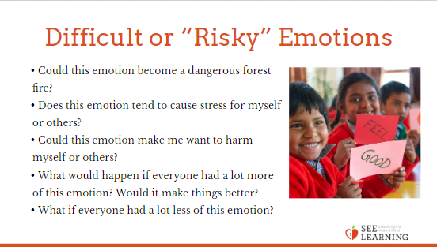 | Sample Script  • “Some emotions seem to cloud our minds the stronger they get. These emotions can be “risky” because if we are not careful, they can lead to behaviors that cause problems for ourselves and others. They can also increase our stress.  • If an emotion makes us want to harm ourselves or others, then we would call that a risky emotion. In other cases, the emotion might just not be appropriate or helpful for the situation.  • Often we can’t help the emotions from arising, but we can use our attention and awareness to notice the emotion and see if it’s a spark that could become a forest fire.  • Being risky doesn’t mean the emotion is bad, because all emotions are natural, and we all experience emotions.  • Being risky also doesn’t mean we have to suppress that emotion, because we can use strategies to transform it into something productive.  • Instead of suppressing it, if an emotion is risky, we want to just make sure it stays under control or that it stays within certain limits and doesn’t get out of hand. This is called “restraint.” [Write the word “restraint” on the board if you feel it would be helpful.]  • Let’s take out the emotion families charts and the core affect charts that we created earlier.  • Let’s see which of these emotions might be risky. We don’t all have to agree. Some emotions we might all agree are risky. But for some we might not. It’s important for us to decide for ourselves.  • The way we investigate is by asking questions about the emotion: (Write these questions on the board)  • Could this emotion become a dangerous forest fire?  • Does this emotion tend to cause stress for myself or others?  • Could this emotion make me want to harm myself or others?  • What would happen if everyone [in our class, in our school] had a lot more of this emotion? Would it make things better?  • What if everyone had a lot less of this emotion?  • Let’s first discuss this in pairs and then we’ll share with the whole class. With your partner, go through these questions and identify which emotions you both feel might be risky. [Ask students to talk to a partner first and then share out with the whole group.]  • Which emotions did you decide might be risky? Why? [Allow each pair to share.]  • Remember the concept of heedfulness? Do you think that is a strategy that can be used with risky emotions?  • Being heedful doesn’t mean being scared, but it does mean being cautious and careful. It means paying attention to something that could be a problem if you’re not careful. By being heedful, we save ourselves from trouble. And fortunately, heedfulness is something we can practice and get better at.  • We’re all heedful of things. What are the benefits of being heedful of risky emotions?  • Heedfulness is just one strategy we can use. Now we’re going to explore some other strategies we might use to deal with risky emotions.”

Insight Activity: Identifying Risky Emotions and Strategies for Dealing with Them (15 min)
Overview
Students fill out a handout in groups of two or three to identify potentially risky emotions and possible strategies for dealing with each one.

Content to be Explored
- We can come up with a number of possible strategies for navigating risky emotions.
- Some strategies are common for all or most risky emotions, some are particular to individual emotions.
- Navigating risky emotions allows us to practice an “ethic of restraint.”

Materials
- Copies of the “Strategies for Dealing with Risky Emotions” handout, provided at end of learning experience
- Writing utensils for each student

Instructions
- Ask students to look at their personal core affect charts that they made in the previous learning experience.
- Ask them to look at the emotions they charted and identify those which are potentially risky, marking them with a star.
- Divide students into groups of 2 or 3. Together they will explore what strategies could be used to deal with these risky emotions.
- Each group will choose a risky emotion and then fill out the handout at the end for their risky emotion. If they finish before other groups, they can start with a new emotion.
- After each group has had a chance to fill out at least one of these handouts, stop all the groups and ask each group to share their results to the entire class.
- After each group has shared, ask a few summarizing questions.
- Were there any strategies that seemed common across the emotions we examined? Which strategies seemed specific to a particular emotion? Which strategies that we have discussed together may be helpful with dealing with risky emotions? (For example, resourcing, grounding, Help Now!, mindfulness, awareness, heedfulness, focusing on the breath, etc.)
- At the end of the activity, collect all the core affect charts and explain that you are going to make a chart of emotions based on all of them. This “master chart” will show all the emotions, which ones are usually opposed to each other, and which ones could be risky in certain situations.
- Conclude by introducing the idea of an “ethics of restraint.” This means deciding what is beneficial and harmful for ourselves and others (ethics) and choosing to limit what is harmful in our own behaviors (restraint). Ask your students: How does knowing risky emotions and having strategies to deal with them allow us to practice “restraint” and keep the class agreements we made?
Slide 4: Identifying Risky Emotions and Strategies for Dealing with Them  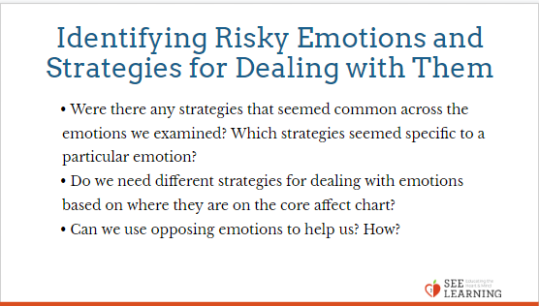 | Sample Script  • “Here’s a handout that I’m going to give to you in pairs.  • Each pair will choose one emotion that you feel could be risky.  • Discuss among yourselves and fill out the handout together. Then we’ll share. Feel free to ask me if you have any questions. [Allow time for each pair to discuss and fill out at least one handout. If one pair finishes early, they can start on a second emotion.]  • Now let’s share. Let’s have each pair share what emotion they worked on and what they decided about it. [Let each pair share.]  • Were there any strategies that seemed common across the emotions we examined? Which strategies seemed specific to a particular emotion?  • Do we need different strategies for dealing with emotions based on where they are on the core affect chart?  • Can we use opposing emotions to help us? How?  • I’m going to collect your core affect charts so I can make a class chart of emotions based on all of them. This chart will show all the emotions, which ones are usually opposed to each other, and which ones could be risky in certain situations.  • If we know which emotions are risky for us and we know strategies for dealing with them, this allows us to practice “restraint.” Restraint means to set limits or to exercise control.  • If we choose to practice restraint with regard to hurting others or ourselves, we are setting a limit. We are saying “I’m going to be careful when it comes to emotions, feelings, or thoughts that could harm myself or others.”  • If we do this, we are also practicing an “ethics of restraint.” “Ethics” means the choices we make about what is right or wrong for ourselves and others, and what will be beneficial or harmful for ourselves and others. [If helpful, write the words “ethics of restraint” on the board or chart paper.] This is not an ethics of other people telling us what to do. It is about our own decisions and choices.  • All the practices we have been learning up to now to manage our nervous system, our attention, and our emotions are strategies that combine to help us practice this ethics of restraint.  • Let’s finish by looking at our class agreements again. Does identifying risky emotions and how to deal with them help us keep our class agreements?  • What about practicing an ethics of restraint— is that connected to our class agreements?  • Remember that all of us want kindness and compassion from others, not meanness. We don’t want others to hurt us. And reciprocity means that if we want that for ourselves, we need to practice that towards others. This is the value of an ethics of restraint. We stop ourselves from harming, because we want a classroom and a community that is free from harm in general.”

Reflective Practice: Mapping with Attention Practice (7 min)
Overview
- The reflective practice in the previous learning experience integrated mapping with tracking and interoception (attending to sensations and the internal state of the body) by using the resilient skills of grounding and resourcing. This reflective practice does the same, but integrates mapping with attention practice and metaawareness (noticing thoughts and emotions).
- As before, students will map their current state using the activation/feeling tone chart by tracking while engaging in a grounding/ resourcing practice. They will then engage in a brief attention practice. They will then update the chart to see if any changes have taken place in their body or emotional state.
- You are encouraged to repeat this activity a few times in other sessions.
Slide 5: Mapping with Attention Practice  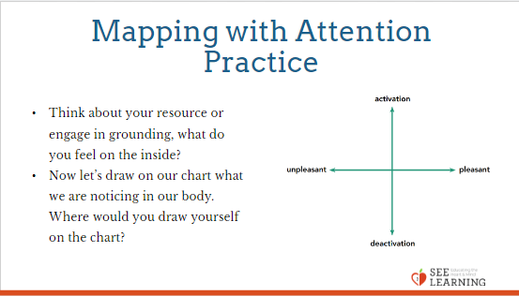 | Sample Script  - “Let’s use the activation/feeling tone chart as a tool to see what happens when we practice our attention and awareness skills.  - Let’s start by doing a brief moment of resourcing or grounding.  - As you think about your resource or engage in grounding, what do you feel on the inside? Let’s take a brief moment to quietly notice. [Pause for 30 seconds.]  - Now let’s draw on our chart what we are noticing in our body. Where would you draw yourself on the chart? You can also write or draw any sensations or emotions you are noticing and where they might be on the chart.  - Let’s now take a few moments to practice cultivating our attention.  - We can focus on our breath or we can just be aware of whatever arises in our mind without reacting to it.  - If you focus on your breath, you can count your breaths if you wish.  - If you find paying attention to the breath uncomfortable, then feel free to go back to your resource or grounding, or just take a small break, making sure not to disturb anyone else.  - Let’s practice. [Pause for 30-60 seconds.]  - Thank you. Now let’s update our charts.  - Where would you draw yourself on the chart? You can also write or draw any sensations or emotions you feel right now and where they might be on the chart.” Allow students to update their charts, and then invite them to share if they are willing to. Some students’ emotional states may have changed, while others may have stayed the same.  - Again, note that some students may report that their emotional state got worse or felt worse after the practice. If they are becoming aware of their emotions, they may still be benefiting from the practice. However, if a student repeatedly notes that they feel worse after a practice, then you can encourage them to choose a different form of practice (a different resource, a different form of grounding, or a different form of attention training). Also remind them that they can opt out of any practice that makes them uncomfortable.

Debrief (4 min)
Slide 6: Debrief  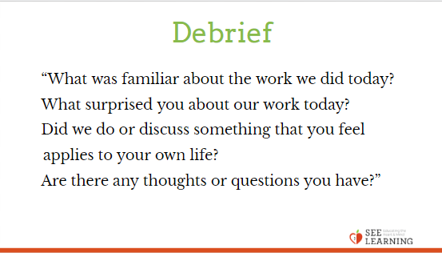 | Sample Script  - “What was familiar about the work we did today?  - What surprised you about our work today?  - Did we do or discuss something that you feel applies to your own life?  - Are there any thoughts or questions you have?”

