Mapping Emotions

Purpose: This learning experience shows students that emotions can take place across a range of levels of activation and feeling tone in the body and mind (often called “core affect” in psychology). Using a two-dimensional chart that shows the level of activation (high energy vs. low energy) in the body on one axis, and a continuum of feeling from unpleasant to pleasant (called “valence” in psychology) on the other, students will learn that even a single emotion can exist along a range, and that emotions may overlap in terms of how they feel or may differ dramatically or may even appear incompatible with each other. Mapping emotions this way creates a visual and conceptual tool that reinforces the direct examination of emotions and body states through meta-awareness and interoception. It also allows further exploration of how emotions relate to each other and in some cases oppose one another
Learning Objectives:  Students will be able to:  - Describe how the “activation/feeling tone” chart works.  - Clarify where emotions can be labeled on the “activation/feeling tone” chart.  - Explore which emotional states may be more or less compatible with others. | Primary Core Component  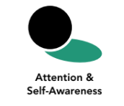
Length  40 minutes | Materials Required  - Printouts of the “activation/feeling tone chart” (one copy per student) and one set of “feeling cards” (provided at the end of this learning experience)  - Markers or pens for each student; the emotion families charts created earlier for display  - Rope, string, or colored tape to create the “activating / feeling tone chart” on the floor

Check-In (4 min)
Slide 2: Check-In   | Sample Script  - “Let’s prepare for a short attention practice. How do we want our body to be?  - First we’ll take a comfortable and upright posture. Then we’ll keep our eyes on the ground or close them.  - Before we strengthen our attention, we’ll do some resourcing or grounding to calm our bodies. Choose one of your resources from your resource kit, or you can choose a new one, or you can imagine one.  - Now let’s just bring our resource to mind. And let’s see if we can just pay attention to our resource with our mind for a few moments quietly. Or if you’d rather do grounding, you can do that too. Whichever you choose, we’re going to rest quietly and pay attention for a few moments. [Pause.]  - What do you notice inside? If you feel pleasant or neutral, you can rest your mind on that.  - If you feel unpleasant, you can shift to a different resource, or you can ground. You can also change your posture but try not to disturb anyone else if you do that. Otherwise, just keep your attention resting with your resource. [Pause.]  - Now let’s become aware of our breathing. Let’s see if we can pay attention to the breath as it enters and leaves our body.  - If you find paying attention to the breath uncomfortable, then feel free to go back to your resource or grounding, or just take a small break, making sure not to disturb anyone else. [Pause for 15-30 seconds.]  - If you ever get distracted, you can just return your attention to the breath. You can also count your breath. [Pause for a longer time, such as 30-60 seconds or longer.]  - You can strengthen your attention by focusing on sensations or by focusing on the breath. It’s your choice - it’s always up to you.  - What did you notice?” [Share aloud.]

Presentation/Discussion: The Activation/Feeling Tone Chart (10 min)
Overview
In this interactive presentation, students will learn to use the activation/feeling tone chart as a tool for mapping emotions.

Content to be Explored
- Emotions vary in terms of the level of activation in our body (high energy, neutral, or low).
- Emotions vary in terms of feeling tone (whether they feel pleasant, neutral, or unpleasant).
- By tracking our level of activation and sensations, we can learn about our emotional state.
- A single emotion can exist across different levels of activation and feeling tone.

Materials
- Rope, string, or colored tape
- A set of “feeling cards” (provided at the end of the learning experience)
Instructions
- Create the chart on the floor with rope, string, colored tape, or some other material. The chart should have two intersecting axes (like the “activation/feeling tone chart” at the end of this learning experience) so that it looks like a giant plus sign (+). It should be large enough that multiple students can stand at various positions in the chart at the same time (2m x 2m or larger).
- Place the first five cards on the chart. (Lots of Energy at the top, Very Little Energy at the bottom, Very Unpleasant on the left, Very Pleasant on the Right, and Neutral in the middle where the two axes intersect).
- Ask for volunteers to stand where these first five cards are. These will be static positions for this activity.
- Tell students that this chart is a way to help us understand our emotions and how they feel in the body. An experience of an emotion can fit anywhere on the chart and every emotion can fit on the chart.
- Explain that the line going up and down is the “activation axis,” which shows how much activation there is in our body or how much energy we have when we feel that emotion. The line going left to right is “feeling tone,” showing how pleasant or unpleasant we feel when we have that emotion.
- Explain that the remaining cards indicate emotions and feelings.
- Choose one of the four quadrants (upper right, lower right, upper left, or lower left) and ask for a volunteer to select a feeling card from the set that would fit that quadrant. Allow them to share why they chose that feeling for that quadrant. Then ask for another volunteer to stand in that quadrant, posing as that emotion.
- Repeat for the remaining three quadrants.
- Allow the students to relax from their poses. Ask the group if any of the emotions could be in any other quadrants or any other parts of the quadrant they are already in. Discuss.
- When the four quadrants are filled, you can clear the quadrants and do it again, or you can end the activity.
Teacher Tips
- If it better suits your group, you can present the information in this activity as a mini-lecture while drawing the chart on the board. Instead of asking volunteers to pose as emotions, you can ask students to offer a shape that could stand for the emotion on the chart.
- Alternatively, you could create a large chart of the quadrants and a stick figure of a person that is big enough that they could be in different quadrants at the same time.
Slide 3: The Activation/Feeling Tone Chart  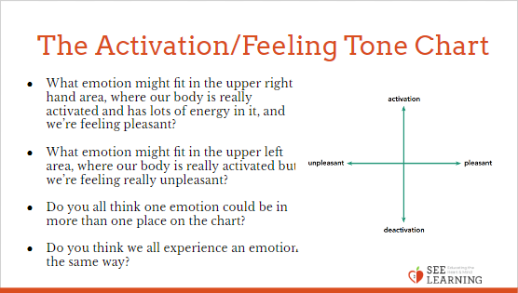 | Sample Script  - “This is a way for us to understand our emotions and how they feel in the body. It’s a chart. We can put an experience of an emotion anywhere on this chart.  - From up to down the chart shows how activated our bodies are or how much energy we have. This shows the level of energy. If we’re really excited or agitated or super anxious, we may have a lot of energy in our bodies, so we’d be up at the top. If we’re feeling really tired or low-energy, we’d be down at the bottom. The middle is neutral.  - From left to right the chart shows how unpleasant or pleasant the experience is for us. All the way on the left is really unpleasant. The middle is neutral. All the way on the right is really pleasant.  - Can I have four volunteers to stand at the ends of each line? And one to stand right in the middle, where it says neutral?  - We’re each going to use this chart to map out some emotions. But first let’s make sure we all understand the chart. Let’s try to pick some emotion words together that might fit in each of the four areas of the chart.  - What emotion might fit in the upper right hand area, where our body is really activated and has lots of energy in it, and we’re feeling pleasant? Here’s our set of emotion and feeling cards. Can someone find a card that would fit in that area? [When someone has volunteered, ask:] Can you place the card where you would like in that area and then explain why you chose that card?  - Now I wonder if I can have a volunteer to stand there and pose as that emotion or feeling. [Ask the volunteer to strike a frozen pose of that emotion or feeling while standing in the appropriate part of the chart.]  - What emotion might fit in the upper left area, where our body is really activated but we’re feeling really unpleasant? [Repeat the activity as above, asking for an explanation and then another volunteer to pose as the emotion in that area of the chart.]  - What about the bottom right (low activation, pleasant)? What about the bottom left (low activation, unpleasant)? [Repeat until the chart is filled in all four areas.]  - Now you can all relax your poses.  - Do you all think one emotion could be in more than one place on the chart?  - For example, could fear be a low level fear or a really anxious fear? Could it be slightly unpleasant or really unpleasant? How would we represent that?  - Or could happiness involve a lot of activation in our body or less activation? Could it be slightly pleasant or really pleasant? How would we represent that? It might not always just be in one place. [Invite one or more of the volunteers representing emotions to lie down to touch more than one quadrant.]  - Do you think we all experience an emotion the same way? Might one person experience it differently than another? Might we each experience the same emotion differently at different times?  - Next you’re going to draw your own charts for your own emotions.”

Insight Activity: Mapping Emotions on the Activation/Feeling Tone Chart (15 min)
Overview
In this activity, students will choose one emotion term from each emotions family chart and will map that emotion on their own personal activation/feeling tone chart.

Content to be Explored
- Emotion families contain emotions that vary in terms of activation and feeling tone.
- Some emotions tend to be more or less compatible with each other than others.

Materials
For each student:
- A copy of a blank chart (provided at the end of the learning experience)
- Markers or pens
Instructions
- Tell students to select one emotion term from each emotions family chart. Tell them to draw it as a point or as a larger shape that shows the area that that emotion term might cover. They want to make sure to illustrate the range of the emotion.
- They can also illustrate their charts with emojis or other art depictions.
- Allow enough time for each student to choose and map one emotion term from each of the emotion families you created earlier (i.e., they should have one from compassion, happiness, fear, anger, sadness, and jealousy)
- If some students finish before others, allow them to continue by mapping more emotion terms from the emotion families as they see fit.
- When all the students have mapped at least one term from each emotion family, invite them to share by holding up their activation/ feeling tone chart and explaining why they placed the emotion terms where they did. Depending on how many are in your group, you may want to be clear on how much each should share, for time’s sake.
- Ask your students to look at their activation/ feeling tone charts and the emotion families charts and see if they can find any emotions that tend to oppose each other. That is, they seem to be opposite or not very compatible with each other. This means, “If I feel this one emotion, it is usually harder to feel this other emotion.” (Typical examples might be happiness and sadness, anger and affection, love and hate, excitement and boredom. Note that even if two emotions tend to be opposed, that does not necessarily mean they are never experienced as happening together.)
- Have them add in emotion terms that tend to be opposing of the ones they charted and place them on the activation/feeling tone chart. Ask them to draw arrows between any two emotions that seem like they could be opposed to each other.
- After they have had a few minutes to do this, invite sharing again.
Teacher Tips
- It could be helpful for you to have completed an activation/feeling tone chart for yourself before facilitating this activity both for your own personal practice with the material and so you would have your sample to use as an example if necessary. You would then be able to participate in the share, which would be helpful both as a model and for community building.
- Instead of copying the blank chart, students could draw the chart on their own paper.
Slide 4: Mapping Emotions on the Activation/Feeling Tone Chart  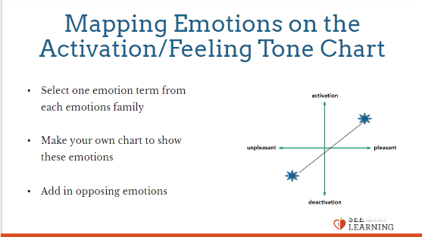 | Sample Script  - “To begin your personal chart, select one emotion term from each emotions family. Draw it as a small or large shape depending on how much space on the chart it should take up. So, each person should aim to plot 6 terms.  - [Allow enough time for each student to choose and map one emotion term from each of the emotion families you created earlier.]  - Who would like to share one of the emotion terms they drew on their chart and how and why they placed it where they did? [Allow a few students to share.]  - Some emotions tend to go together, like loneliness and sadness. Others tend to not go together, like happiness and sadness. We can call the ones that don’t tend to go together “opposing emotions.”  - Let’s see if we can find any opposing emotions. For example, if you feel one emotion, it’s usually harder to feel another emotion. You may have some opposing emotions on your chart already. Who already has some opposing emotions? [Allow a few students to share.]  - Let’s add in opposing emotions to our charts for the emotions we’ve already put down. Draw arrows between any two emotions that seem like they could be opposed to each other.  - We might not be able to think of an opposing emotion for every emotion. That’s okay. We might also come up with multiple opposing emotions for a single emotion!  - Let’s share with each other now.  - What did you notice as you did this? What questions do you have?”

Reflective Practice: Mapping with Grounding and Resourcing (7 min)
Overview
- Students will map their current state using the activation/feeling tone chart by tracking while engaging in a grounding/resourcing practice.
- They will then update the chart after a few minutes of grounding or resourcing, to see if any changes have taken place in their body or emotional state.

Content to be Explored
- We can notice our own level of activation and feeling tone at any moment
- Noticing our level of activation and feeling tone gives us information about our emotional state
- Our emotional state is always in flux
- Grounding, resourcing, and other practices can affect our emotional state

Materials
A copy of a blank activation/feeling tone chart for each student and a writing utensil.
Instructions
- Give each student a blank activation/feeling tone chart and a writing utensil.
- Begin a resourcing/grounding practice.
- Ask students to draw where they are on their individual charts.
- Engage in resourcing and grounding for a few minutes more in silence.
- Ask them to update their charts based on what they are feeling now.
- Invite them to share if they are willing.
Teacher Tips
- Note that some students may report that their emotional state got worse or felt worse after the practice. If they are becoming aware of their emotions, they may still be benefiting from the practice. However, if a student repeatedly notes that they feel worse after a practice, then you can encourage them to choose a different form of practice (a different resource, a different form of grounding, or a different form of attention training). Also remind them that they can opt out of any practice that makes them uncomfortable.
- You are encouraged to repeat this activity a few times in other sessions.
Slide 5: Mapping with Grounding and Resourcing  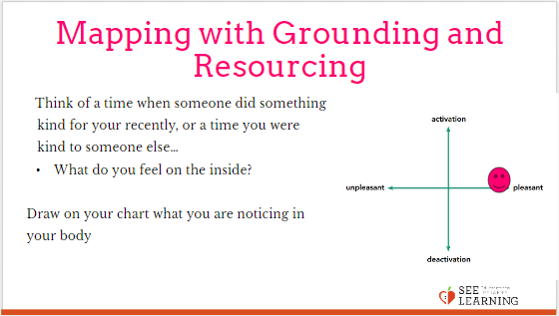 | Sample Script  • “Let’s use the activation/feeling tone chart as a tool to see what happens when we practice our resiliency skills like grounding or resourcing.  • Let’s imagine one of our resources.  • If someone did something kind for your recently, or if you were kind to someone else, you can feel free to use that as your resource.  • If you’d rather do grounding, you can find a comfortable way to sit or something comfortable to hold or touch.  • As you think about your resource or engage in grounding, what do you feel on the inside? Let’s take a brief moment to quietly notice. [Pause for 30 seconds.]  • Now let’s draw on our chart what we are noticing in our body. Where would you draw yourself on the chart? You can also write or draw any sensations or emotions you are noticing and where they might be on the chart.  • Now let’s now take a few moments to do grounding or resourcing in silence. [Pause for 30-60 seconds.]  • Now let’s do tracking and pay attention to the sensations inside our bodies.  • If you find a pleasant or neutral sensation just pay attention to that and watch it. See if it changes or stays the same. [Pause 10-15 seconds.]  • If you haven’t found a pleasant or neutral sensation, see if you can shift to another part of your body to find a place that feels better. [Pause 10-15 seconds.]  • Thank you. Now let’s update our charts.  • Where would you draw yourself on the chart? You can also write or draw any sensations or emotions you feel right now and where they might be on the chart.  • Did anyone notice a change between the first time you did your chart and the second time? [Invite them to share.]  • Did anyone stay the same?”
Debrief (3 min)
Slide 6: Debrief  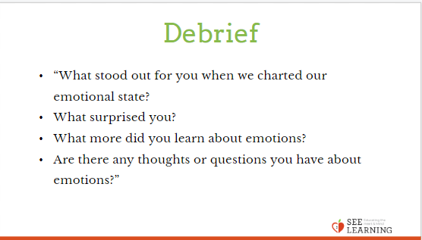 | Sample Script  - “What stood out for you when we charted our emotional state?  - What surprised you?  - What more did you learn about emotions?  - Are there any thoughts or questions you have about emotions?”

