Emotion Timelines in Action

Purpose:
By acting out scenarios across the emotion timeline, students will learn that emotions (and the behaviors they can lead to) unfold along a process, even if they often seem automatic and instantaneous. Understanding emotion timelines will help them learn how they notice, and potentially intervene at, different stages of the process, thereby turning potentially problematic outcomes into more beneficial ones.
Learning Objectives:  Students will be able to:  - Explore the process of emotion timelines experientially.  - Develop their understanding of the ways emotions are generated and unfold.  - Explore stages at which they may be able to intervene in the unfolding of emotions and behaviors | Primary Core Component  
Length  30 Minutes | Materials Required  - Sample emotion timeline provided at end of learning experience (3 per student)  - Scenarios, provided below  - Resource kits for students to place timelines in after the reflective practice

Check In (4 min)
Slide 2 : Check In   | Sample Script  - Let’s prepare for a short attention practice. How do we want our body to be?  - First we’ll take a comfortable and upright posture. Then we’ll keep our eyes on the ground or close them.  - Before we strengthen our attention, we’ll do some resourcing or grounding to calm our bodies. Choose one of your resources from your resource kit, or you can choose a new one, or you can imagine one.  - Now let’s just bring our resource to mind. And let’s see if we can just pay attention to our resource with our mind for a few moments quietly. Or if you’d rather do grounding, you can do that too. Whichever you choose, we’re going to rest quietly and pay attention for a few moments. [Pause.]  - What do you notice inside? If you feel pleasant or neutral, you can rest your mind on that.  - If you feel unpleasant, you can shift to a different resource, or you can ground. You can also change your posture but try not to disturb anyone else if you do that. Otherwise, just keep your attention resting with your resource. [Pause.]  - Now let’s become aware of our breathing. Let’s see if we can pay attention to the breath as it enters and leaves our body.  - If you find paying attention to the breath uncomfortable, then feel free to go back to your resource or grounding, or just take a small break, making sure not to disturb anyone else. [Pause for 15-30 seconds.]  - If you ever get distracted, you can just return your attention to the breath. You can also count your breath. [Pause for a longer time, such as 30-60 seconds or longer.]  - You can strengthen your attention by focusing on sensations or by focusing on the breath. It’s your choice - it’s always up to you.  - What did you notice?” [Share aloud.]

Insight Activity: Acting Out Emotion Timelines (17 min)
Overview
- In this activity, students will get into groups to chart out a given scenario on a blank emotion timeline sheet.
- They will then act out the scenario for the rest of the class, followed by a discussion of what happened in the scenario at different stages of the timeline.

Content to be Explored

- Each emotion is a process
- The process has stages (stimulus, appraisal, emotion, behavior, consequence)
- The process takes place in a context
- Having more or less awareness can change the course of emotions and behavior

Materials
- Print-outs of the “Emotion Timeline Scenarios,” provided at the end of this learning experience
- Sample Emotion Timeline Diagram (blank), provided at the end of this learning experience, 2 per student

Instructions
- Remind students of the last activity you did together in which they explored the emotion timeline with Albert and Alice.
- Divide your students into groups of 3 or 4 and give each group a scenario.
- First, each group will fill out the emotion timeline using the provided “emotion timeline scenarios.” They will do this twice: first to show how the scenario might play out if the main character has more awareness of their emotions; and second to show how the scenario might play out if the main character had less awareness of their emotions. (Allow them 4 or more minutes for this).
- Next, each group will plan to act out the more awareness scenario for the rest of the class, keeping the stages of the timeline in mind (Allow them 4 or more minutes for this). Students can “play” the characters in the scenario, but they can also “play” sensations, emotions, or thoughts.
- Bring the class back together and invite each group to act out their skit, while others observe.
- Only if you feel the acting may have been unclear, read the scenario aloud for the class so that it’s clear what happened.
- Ask the students who were watching to explain what happened at each point on the timeline, using some or all of the following questions:
  - What was the stimulus?
  - What was the context?
  - What was the appraisal (evaluation or judgment)?
  - Which emotion families were involved?
  - Which particular emotions do you think came up?
  - What physical sensations might the main character have had in his or her body?
  - What might have happened if the character had had less awareness of their emotions?
  - What emotional state do you think the character was in at the end of the scenario?”
- Move on to the next group, asking them to act out their scenario, followed by questions, and repeat.

Teacher Tips
- The emotion timeline scenarios are also provided at the end of this learning experience in card form for ease of printing so you can hand one to each group.
- Remember to alter the names of the characters in the scenarios if they are the same as any of your students.
- Write the questions on the board or a piece of chart paper if that is helpful.
- Blank scenario cards are provided if you want to create your own emotion timeline scenarios, or you can allow your students to create their own custom scenarios for a particular emotion family.
Slide 3 & 4: Acting Out Emotion Timelines  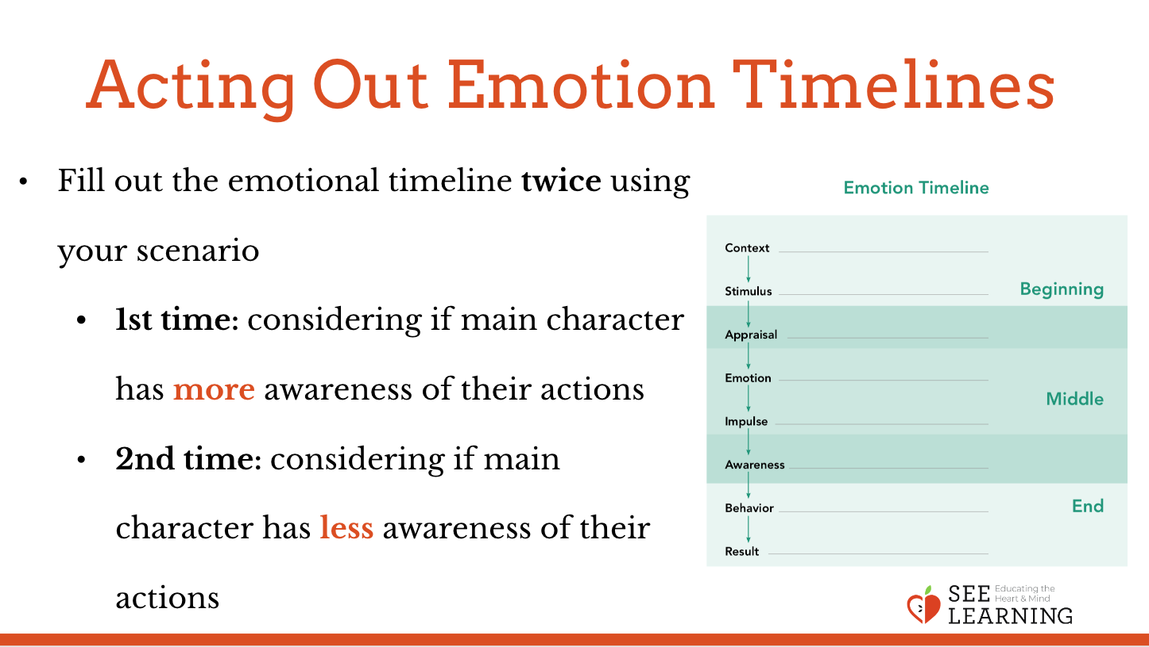  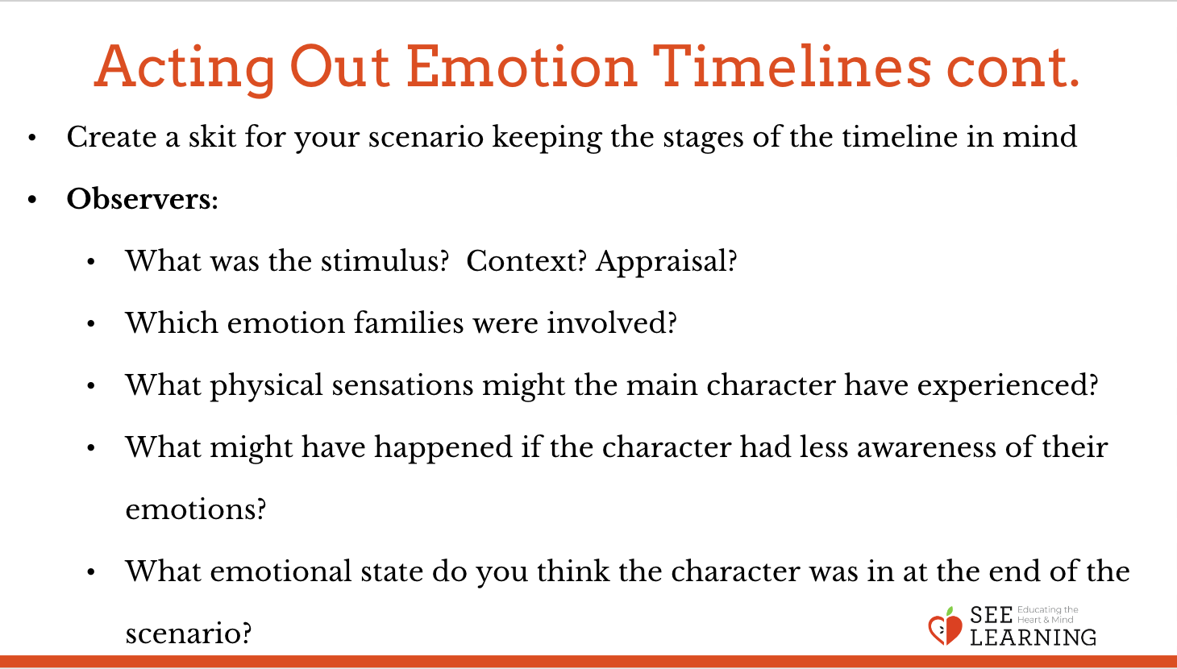 | Emotion Timeline Scenarios  (These are also provided at the end of this learning experience as cards that you can print out.)  1. On his 13th birthday, Desmond comes home after school. He’s feeling a bit low because no one wished him happy birthday during the day at school. When he opens the door and walks into his house, suddenly his whole family and a lot of his friends shout “SURPRISE!” He looks around and sees they have planned a big party for him.  2. Imani sees a group of girls she doesn’t know playing a game that looks interesting. “Can I join you?” she asks. “Of course!” they say, and invite her over.  3. During recess, a classmate with muddy shoes steps on Marianne’s foot, dirtying her brand new shoes. Her family doesn’t have much money, but her father had bought her these shoes just last week as a present.  4. Leonard loves his little sister Lisa very much. Lisa has been teased badly at school. One day, Leonard sees a kid the same age as his sister being teased during lunch and Leonard feels his chest tighten.  5. Kimball is very excited for a trip his family is going on to see relatives. A few days before they are supposed to leave, his parents tell him that the trip has been canceled and they aren’t going, but they don’t explain why.  6. Walking to school each day, Lewis passes a man asking for money for food. One day Lewis sees that the man has a crutch and a cast on his leg. Lewis feels tears come to his eyes. He brings his mother to the man and they give the man several sandwiches and water.  7. Michelle’s parents have been arguing lately. This morning on her way out of the door, she heard her dad say he’s going to work late tonight. She’s never heard him say that before, so she is not sure what that means and she notices a chill go through her body.  8. Carlos’s group of close friends are used to going to the movies every Friday night. This Friday, though, Carlos’s mom says it’s getting too expensive so he can’t go with them. He has to stay at home, knowing his friends are at the movies.

Reflective Practice (6 min)
Overview
- Using the emotion timeline sheet, students will recall a time when they experienced a stimulus or an emotion that could have caused them to act in an inappropriate way, but they were able to respond appropriately.

Content to be Explored
- Awareness allows us to prevent stimuli from leading to automatic responses.
- We already have awareness, and we can develop it further.

Materials
- One blank emotion timeline sheet per student.
- Resource kits for students to place timelines in after the practice.

Instructions
- Give an emotion timeline sheet to each student and explain that they will do this activity in silence to help with concentration.
- Explain that this is a private reflective activity, so sharing is optional.
- Ask students to recall a challenging time when they experienced a stimulus or an emotion that could have caused them to act in an inappropriate way, but they were able to respond appropriately.
- Provide examples to help stimulate thinking.
- If they cannot remember such a time, allow them to imagine a scenario where something challenging happens to them, and instead of acting out from a negative emotion, they are able to use awareness and respond in a beneficial way.
- Allow students to chart out the experience they are remembering on the emotion timeline (3+ minutes)
- Invite anyone who wishes to share to do so.
- Allow them to put their sheets in their resource kit or to pass it to you if they wish to. Remind them that you will keep all these reflective practices confidential.

Teaching Tips
- Reflective practices can always be preceded or followed by grounding or resourcing. If you find that students share things that are emotionally activating for themselves or other students, you are strongly encouraged to engage in a few minutes of grounding or resourcing to help them settle their bodies and minds again before you conclude the learning experience or move on to another activity.
Slide 6: Reflective Practice  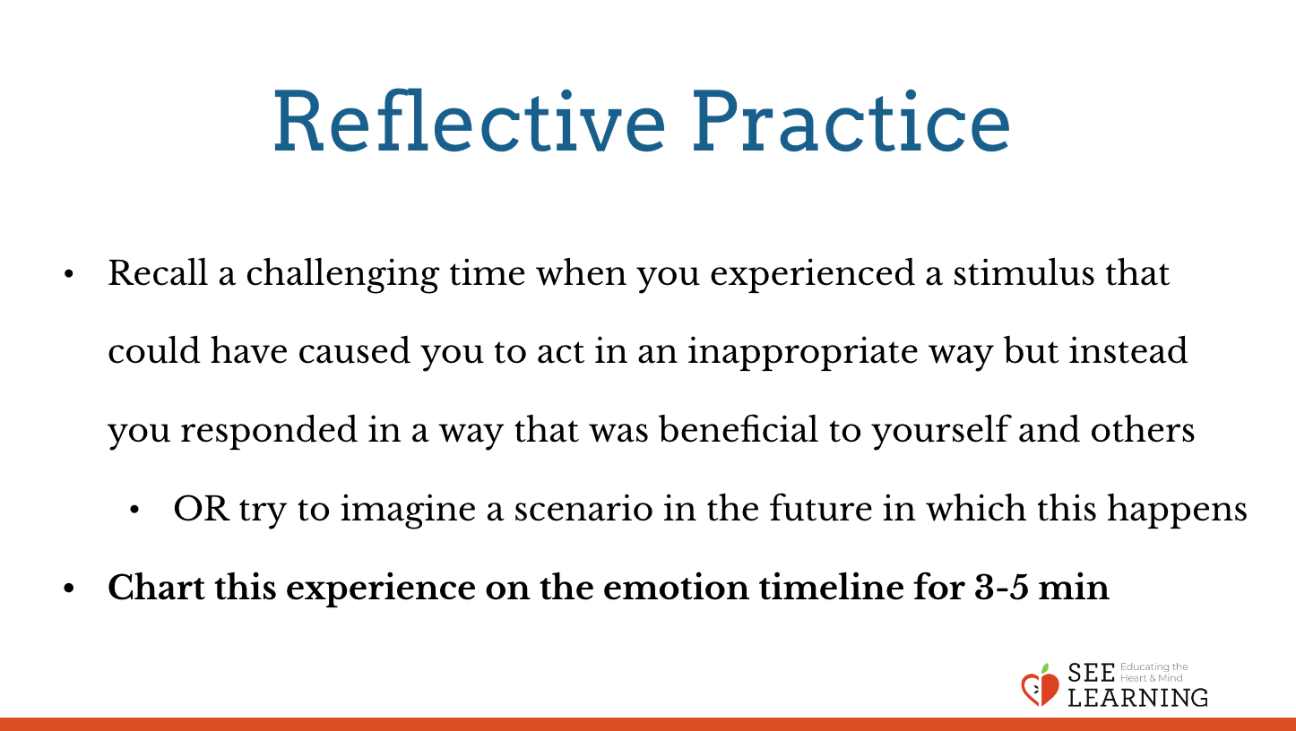 | Sample Script  - Now we are going to do a reflective practice using the emotion timeline. You will do this activity in silence so you can concentrate on it. You will have the chance to share at the end if you want to, but this is a private activity, so sharing aloud is optional.  - Here is another copy of the emotion timeline sheet. Don’t write on it yet. Listen first, please.  - If you feel comfortable doing so, please close your eyes or lower your gaze to the floor, not looking at anything in particular. My eyes will be open.  - As you rest there, I invite you to recall a challenging time when you experienced a stimulus or an emotion that could have caused you to act in an inappropriate way but instead you found yourself able to respond in a way that was appropriate, constructive, and beneficial to yourself and others.  - For example, perhaps you were really hungry and someone cut in front of you in the line in the cafeteria. Maybe you felt a surge of an emotion and the desire to move that person out of your way. However, you did not do that - rather, you ended up taking a deep breath and ignoring them or maybe you kindly asked them to move to the back of the line. You responded in an appropriate way that did not cause harm to yourself or someone else.  - If you cannot remember a time like that, try to imagine a scenario in the future in which something challenging happens to you and instead of acting out from a negative emotion, you are able to use awareness and respond in a way that is helpful to yourself and others.  - If you are ready, take a look at the blank emotion timeline in front of you. Begin charting the experience you were just thinking of. We’ll work silently for about 3-5 minutes. [When there is 1 minute left of work time, alert students of this.]  - Now we have a little bit of time to share. Who would like to share something about their timeline or about the experience of charting it out. [Allow for sharing as time allows.]  - Ok, thank you all for your thoughtfulness during the reflective practice. I invite you to put your timeline in your resource kit or to pass it to me if you would like me to see it.

Debrief (3 min)
Slide 6: Debrief  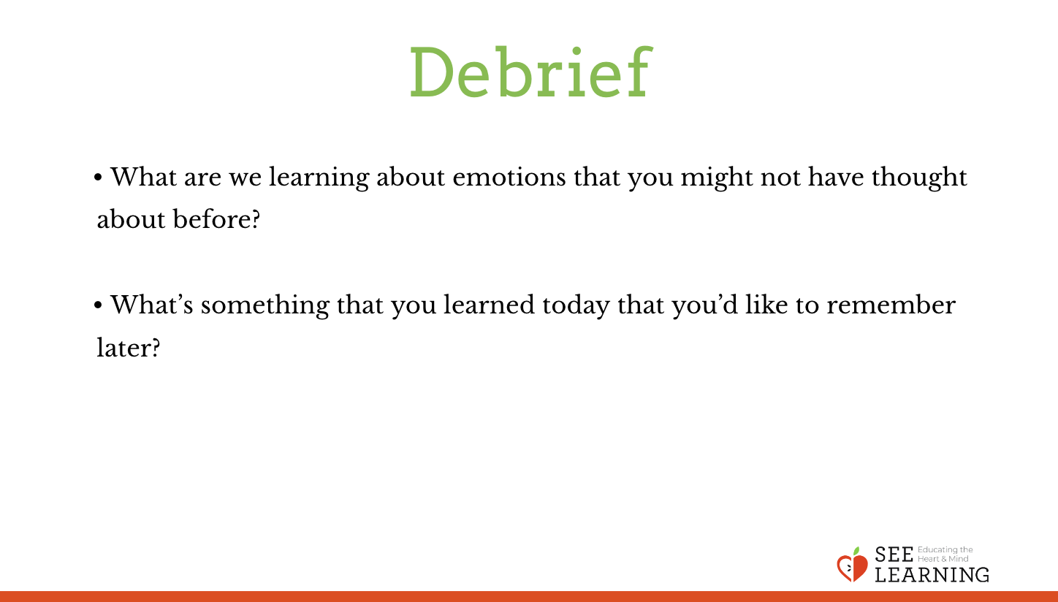 | Sample Script  - What are we learning about emotions that you might not have thought about before?  - What’s something that you learned today that you’d like to remember later?

Optional Insight Activity: Multiple Sessions Creating Our Own Emotion Timeline
Overview
- N/A

Content to be Explored
- N/A

Materials
- Large sheets of paper, enough for 1 per group of 3-4 students
- Markers
- Handout provided at end of learning experience
- Optional: emotion families posters the class made previously

Instructions
- Divide into groups of 3-4 students. Have each group pick an emotion family that they would like to create a timeline for. Provide each group with a large piece of chart paper.
- Each group is going to create their own illustrated emotion timeline for that emotion family.
- Ask them: If you wanted to explain to other students what an emotion timeline is for this particular emotion family, how would you do it?
- Ask them to include each item on the sample (such as context, stimulus, emotion, etc.) They should also come up with example scenarios that fit in the timeline. These examples should show what happens when people employ their tools of mindfulness, awareness, heedfulness, tracking, etc., as well as what happens when people are not using such tools. (Provide a handout for each group to ensure they know what to include on their timelines or simply write the requirements on the board.)
- When each group has finished creating their timeline, allow them to present their timeline and share it with the rest of the class. Then you can hang the timelines up on the classroom walls or elsewhere in the school.

Teaching Tips
- If necessary, you can have your students do this is in a single sitting if you give them 10- 15 minutes for each group to work on their timeline. It is better, however, if you allow them more time and spread this out over multiple sessions. For example, you could have them do this activity over three sessions of 20-30 minutes each. This will allow them to spend more time thinking about their timeline and illustrating it, as well as coming up with specific examples.
Slide 7: Creating Our Own Emotion Timeline  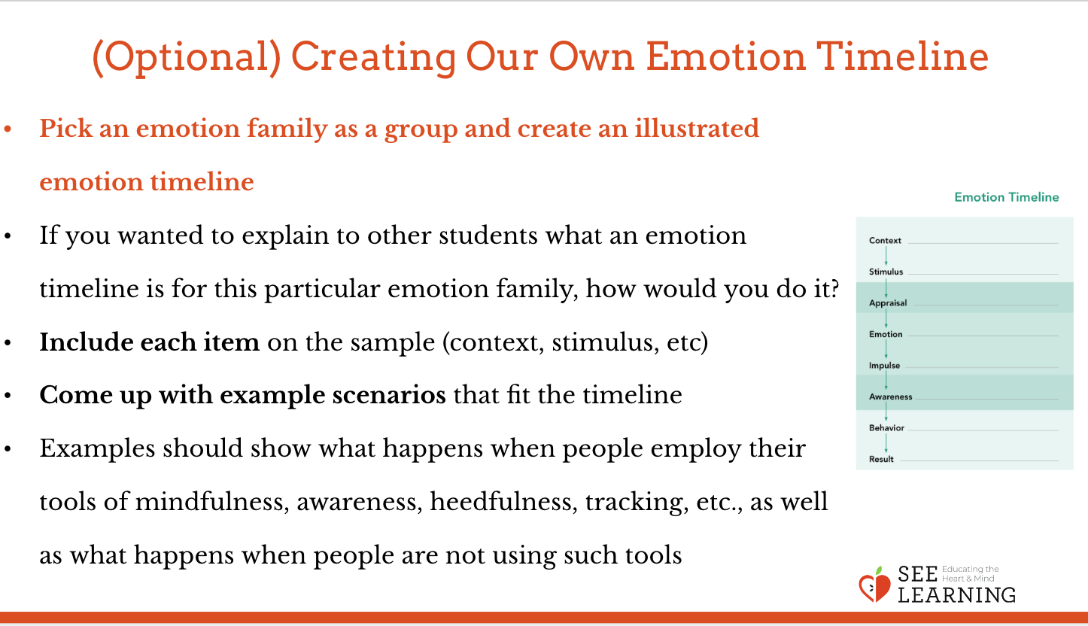 | Sample Script  - N/A

Optional Insight Activity: Atlas of Emotions Timeline

Slide 8: Optional Insight Activity  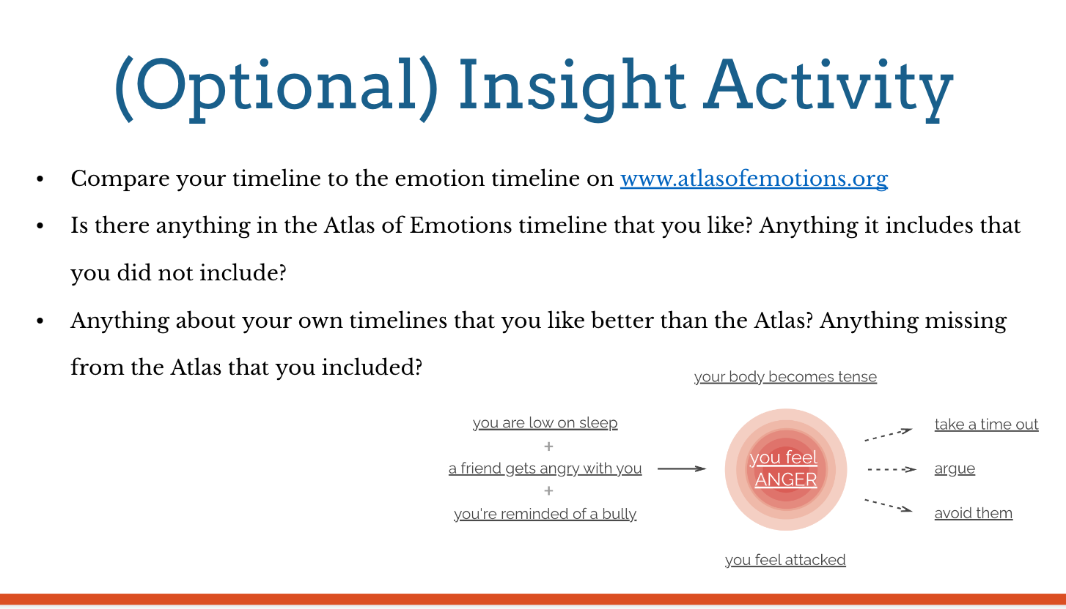 | Instructions  - If you have internet access, you can compare the timeline your students develop to the emotion timeline on the Atlas of Emotions website as a resource (www.atlasofemotions.org).  - Ask your students:  - Is there anything in the Atlas of Emotions timeline that you like? Is there anything it includes that you did not include?  - Is there anything about your own timelines that you like better than the Atlas? Is there anything missing from the Atlas that you included?”

