Emotion Timelines

Purpose:
The purpose of this learning experience is to introduce the idea that although emotions often seem instantaneous and automatic, they actually take place as part of a process that occurs along a timeline. Learning the stages of this timeline allows students to map the stages of emotions and recognize where they can build greater awareness that can allow them to intervene in the emotion timeline should they wish to do so.
Learning Objectives:  Students will be able to:  - Learn that emotions occur as part of a process.  - Learn the stages of emotion processes.  - Learn how awareness can create a “gap” between stimulus and response. | Primary Core Component  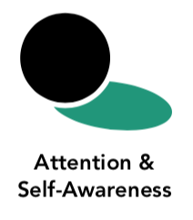
Length  30 Minutes | Materials Required  - Print-outs of the “Emotion Timeline” handout provided- 3 copies for each student  - Copies of the Albert and Alice story for each group of 3-4 students (at the end of Learning Experience 3)

Check In (3 min)
Slide 2 : Check In   | Sample Script  - “Let’s prepare for a short attention practice. How do we want our body to be?  - First we’ll take a comfortable and upright posture. Then we’ll keep our eyes on the ground or close them.  - Before we strengthen our attention, we’ll do some resourcing or grounding to calm our bodies. Choose one of your resources from your resource kit, or you can choose a new one, or you can imagine one.  - Now let’s just bring our resource to mind. And let’s see if we can just pay attention to our resource with our mind for a few moments quietly. Or if you’d rather do grounding, you can do that too. Whichever you choose, we’re going to rest quietly and pay attention for a few moments. [Pause.]  - What do you notice inside? If you feel pleasant or neutral, you can rest your mind on that.  - If you feel unpleasant, you can shift to a different resource, or you can ground. You can also change your posture but try not to disturb anyone else if you do that. Otherwise, just keep your attention resting with your resource. [Pause.]  - Now let’s become aware of our breathing. Let’s see if we can pay attention to the breath as it enters and leaves our body.  - If you find paying attention to the breath uncomfortable, then feel free to go back to your resource or grounding, or just take a small break, making sure not to disturb anyone else. [Pause for 15-30 seconds.]  - If you ever get distracted, you can just return your attention to the breath. You can also count your breath. [Pause for a longer time, such as 30-60 seconds or longer.]  - You can strengthen your attention by focusing on sensations or by focusing on the breath. It’s your choice - it’s always up to you.  - What did you notice?” [Share aloud.]

Presentation/Discussion: The Emotion Timeline (17 min)
Overview

- In this activity you will show the emotion timeline and explore the idea of emotions as processes.
- You will introduce the different stages of the emotion timeline and its terminology.
- Students will then form groups to fill out an emotion timeline using a provided story.

Content to be Explored

- Emotions occur as part of a process
- The process has stages that we can identify
- Awareness during the process can create a “gap” between stimulus and response
- With greater awareness, we can influence the process and change its outcome
- With less awareness, strong emotions may lead us to act in ways that harm ourselves or others

Materials
- Sample emotion timeline provided at end of learning experience, one for each student pair or trio to write on
- Copies of the Albert and Alice story for each group of 3-4 students.

Instructions
- Show your students the sample emotion timeline.
- Tell them that a timeline is a way of understanding the stages of a process. In this case the process is how an emotion arises and influences behavior. Like most timelines, this one has a beginning, a middle, and an end.
- Discuss any terms in the emotion timeline that they may not understand.
- Divide students into groups of 3 or 4 (or do this activity as a whole class).
- Ask students to speak with their group about what they notice about the diagram of the timeline. Then ask them to share with the whole class.
- Remind them of the provided scenario of Albert and Alice and re-read it to them (or provide a different scenario of your own design).
- Create an emotion timeline for Albert, filling out each section of the emotion timeline.
- Then fill out the emotion timeline for Alice. Notice and discuss any similarities or differences between the two.

Teacher Tips
- You can choose to do this activity as a whole class or arrange for students to do it in pairs or trios and share out afterwards. Alternatively, you could have half the class work on Albert’s timeline and the other half work on Alice’s. Then for whole class discussion, begin with one group sharing about Albert and the other sharing about Alice.
- Here is some terminology to help you with instruction. Consider how much of this terminology you wish to include, depending on the level of your students. You may wish to introduce these terms gradually over the course of several days or weeks:
- Emotions begin with a stimulus. A stimulus means anything that provokes a response. Usually this is something novel in the environment (like seeing something, or hearing someone saying something), but stimuli can also be internal (thinking about something or remembering something). The stimulus can also be called a trigger (but this word is more specific and is generally only used for negative stimuli).
- The stimulus takes place within a context. The context can include: a person’s unmet needs; the person’s state of the autonomic nervous system (where the person is in the three zones, for example); the person’s mood; the person’s understanding (or lack of understanding) of a situation; and things that may have happened in the past that have conditioned a person to react in a certain way.
- The person evaluates or judges the stimulus, usually along a spectrum of positive, negative, or neutral. This is the appraisal (Appraisal means to assess, judge, or evaluate a situation.) Appraisals can be conscious or unconscious, and can happen so fast that they seem automatic.
- If the appraisal is negative or positive, it can result in an emotion. If the appraisal is neutral, it may not elicit any strong emotion.
- If the emotion is strong, it can result in an impulse, which is a compulsion to act in a certain way. (For positive emotions, sometimes the impulse is just to enjoy or bask in that emotion.)
- The person can have more or less awareness of the emotion and its impulse or not. This awareness can include heedfulness with regard to behaving in a way that might harm oneself or others. Greater awareness can create the sense of a “gap” between the stimulus and response. Less awareness can mean that a stimulus leads to an automatic or almost automatic response with little or no gap for intervening.
- The impulse can lead to a behavior or response. If the person doesn’t have awareness or heedfulness, they may engage in the action that was compelled by the emotion. If they did have awareness and heedfulness, they may have chosen a different behavior. If the person chooses not to act outwardly, that choice is still an action.
- The behavior leads to a result or outcome that depends on what the behavior was. For example, getting angry and shouting at someone harshly may affect how that person views you, while restraining oneself and responding calmly leads to a different result.
- It may be helpful to put the terms above on card stock and hold them up, or have students hold them up, as you read a scenario aloud.
- If you feel this terminology is too challenging, consider at first just using the terms “beginning,” “middle” and “end” to refer to the initial stimulus and appraisal (beginning), the emotion and impulse (middle), and the response/behavior and result (end). Sample Scenario (Note that this is the same story used in Chapter 4, Learning Experience 3. You can find a handout there to copy for your students if you wish.) “Albert and Alice are two children who go to the same school. One day they hear a dog barking. Alice has a dog at home whom she loves to play with very much. So when she hears the barking, her heart starts beating faster, thinking there may be a dog nearby for her to play with. But Albert was once bitten by a dog. When he hears the barking his heart also starts beating faster and his body goes stiff, thinking there might be a dog nearby.”
Slides 3: The Emotion Timeline  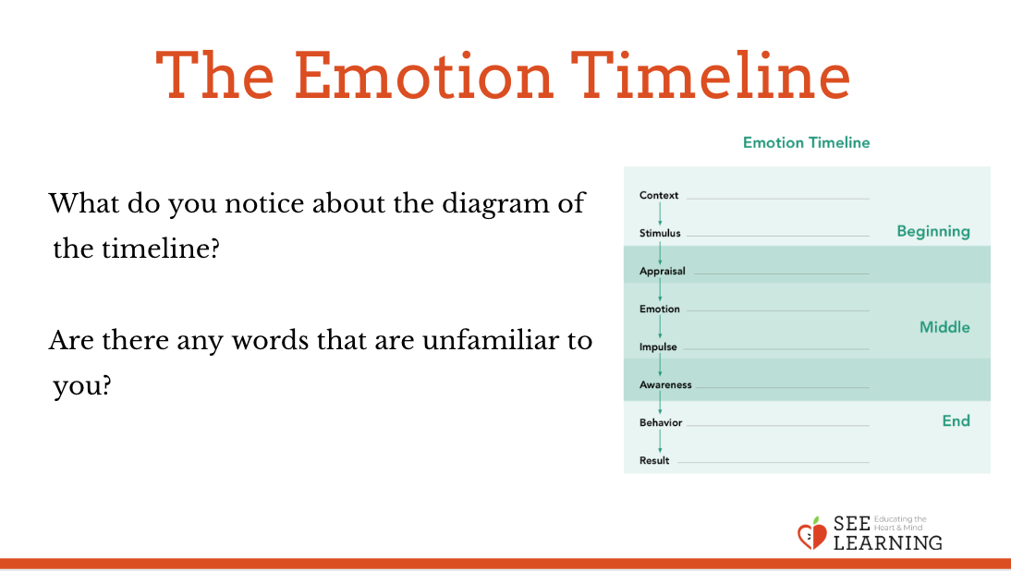  Slide 4: The Emotion Timeline  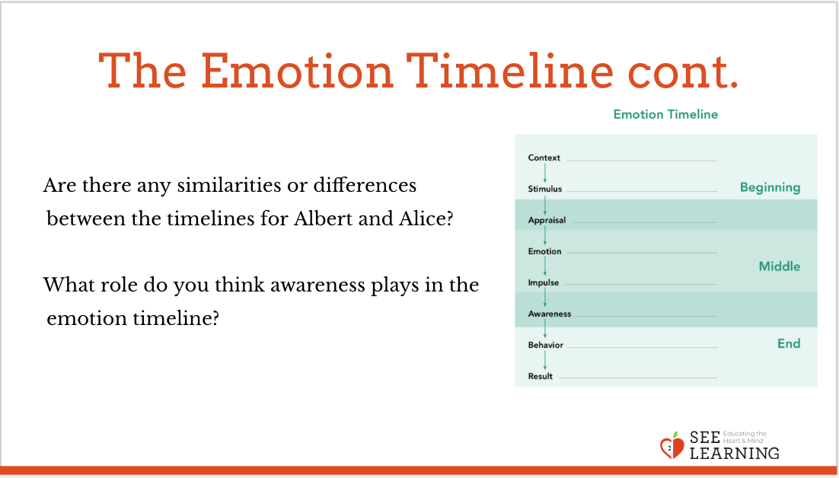 | Sample Script  - “Today we’re going to be looking at a timeline. What do you already know about timelines?  - Timelines are helpful for understanding something that is a process. A process is something that has stages and that takes place over time.  - Do you think emotions are a process or part of a process that takes place over time? [Allow for sharing to stimulate thinking. There is no need to correct answers or ideas at this point.]  - We’re going to examine emotions as part of a process and slow that process down a lot so that we can look at each stage. It’s as if we were placing an emotion under a microscope to investigate it.  - Let’s take a look at this emotion timeline. Take 15-30 seconds to silently examine it by yourself, seeing what you notice and what you wonder about. [Ring the chime after 15-30 seconds.]  - What do you notice? What do you wonder about? Are there some words that are unclear or unfamiliar to you? [Allow time for sharing.]  - Before we begin the activity, let’s talk about just a couple of the terms here that I thought might be new to you.  - Who has heard of the word “stimulus”? What is a stimulus?  - A stimulus means something that causes a response. One day, I heard a loud sound, and I jumped up in fright and surprise. What was the stimulus? What was my response?  - Who has heard the word “context” before? Does anyone have an idea of what “context” might mean in terms of the emotion timeline? [Allow time for sharing.]  - Context here means the current state of things based on what’s come before. [You may choose to write the definition on the board.] We have an inner context and an outer context. The inner context might be how we’re feeling that day or what just happened or what happened a long time ago. The outer context is what’s going on around us at that moment.  - Let’s think about my story. After I looked around I saw the loud sound came from some nearby construction workers. Then I heard the loud sound again, but I didn’t jump this time and I wasn’t afraid. Why? That’s because of context. Now I already knew what it was and that it was nothing to be afraid of. So the stimulus was the same, but the context was different, so my response was different.  - Who found the word “appraisal” new to them? This may seem like a strange word, but it’s very important for understanding emotions. Based on where it is in the timeline, what do you think it means? It comes between “stimulus” and “emotion.”  - [Allow time for sharing.]  - Appraisal means to assess, judge, or evaluate a situation. [You may choose to write the definition on the board.] In the context of emotions, appraisals often happen really fast, so we’re going to slow the process down and really think about that as we look at the story.  - So the first time when I heard the loud sound, my appraisal was it could be dangerous. So I got scared. But the second time I heard the sound, I was aware that it was construction work. So my appraisal was that it was not dangerous. And I didn’t get scared. Since I didn’t get scared, I didn’t jump. I had a different response.  - Let’s go back to the story about Albert and Alice and the barking dog. Let’s see if you can work in groups and use the emotion timeline to investigate what’s happening in that story.  - Let’s first do the emotion timeline for Albert. Then we’ll do it for Alice.”  Distribute copies of the story to each group or have it in large font up in a place where everyone can see it. Depending on how you choose to have your group work on this, allow enough time for them to work. Let them grapple with the Albert timeline, monitoring progress. When it seems like everyone has completed most of the timeline, return to a whole group to discuss. Repeat the process for Alice.  - “Now that we have completed timelines for both kids, what is similar and what is different about them? [Allow time for sharing.]  - Why are there differences? [Allow time for sharing. There are differences because they have different contexts; because they have different prior experiences; because they have different personalities; etc.]  - Why are there similarities? [Allow time for sharing. There are similarities because they are both human beings; they both have bodies and nervous systems; they are both children; etc.]  - What do you think it might this idea of making an emotion timeline? Is there anything that you found interesting or new?” [Allow time for sharing.]  - Earlier we’ve talked about awareness: being aware of what’s happening in our bodies and in our minds. What role do you think awareness plays in the emotion timeline?

Reflective Practice (6 min)
Overview
- Students will use a blank emotion timeline to describe a moment when they experienced happiness, kindness, or compassion.
- They will then engage in a resourcing or grounding practice.

Content to be Explored
- Positive experiences can also be mapped on the emotion timeline.
- Examining our experiences of emotions can deepen them and we can feel this in the body.

Materials
- One blank emotion timeline for each student

Instructions
- Provide each student with a blank emotion timeline.
- Explain that you will do a reflective practice in silence using a memory of a moment of happiness, kindness, or compassion that they experienced, and then mapping that to the timeline. • Allow them a moment to remember such a moment. Explain that they can imagine such a moment also.
- Allow them a few minutes to map the experience to the timeline.
- Follow this by a brief 1-minute resourcing practice using the experience they just mapped. They can always do grounding as an alternative instead.
- Allow for sharing, first asking what sensations they notice on the inside, then what experience they mapped.

Teaching Tips
- None
Slide 5: Reflective Practice  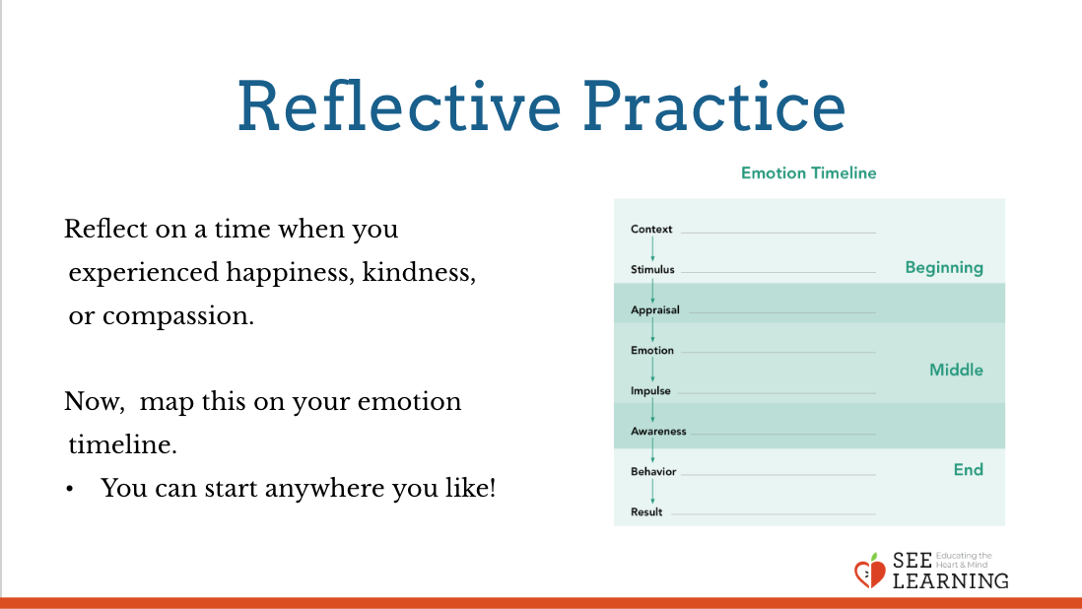 | Sample Script  - “Let’s now do a reflective practice in silence using the emotion timeline.  - First let’s take a moment to reflect on a time when we experienced happiness, kindness, or compassion. It could be something recent or something a long time ago. We’re going to use this as our resource.  - We can also imagine something happening that we would really like. [Pause 15-30 seconds.]  - Let’s now map this on our emotion timeline.  - You can start anywhere you like. Maybe it’s easiest to start with the emotion you felt and then work backwards.  - Was there a stimulus or something that happened?  - Was there an appraisal? When nice things happen to us, our appraisal might be just thinking or feeling, “This is good” or “This is positive” or “I really like this.” Or you can just put a “plus” sign by the appraisal if you felt what happened was positive.  - Did you do anything after that emotion? Was there an impulse or a behavior? Sometimes there isn’t, and that’s okay. [Allow a minute or two of silence while the students map their experience to the timeline.]  - Now let’s sit for a moment and use this as our resource. Or if you can prefer, you can do grounding.  - We’ll do this by tracking any sensations in our bodies, particularly positive or neutral ones. [Pause 30-60 seconds.]  - What do you notice on the inside right now?  - Would anyone like to share the experience they mapped on the timeline?”

Debrief (3 min)
Slide 6: Debrief  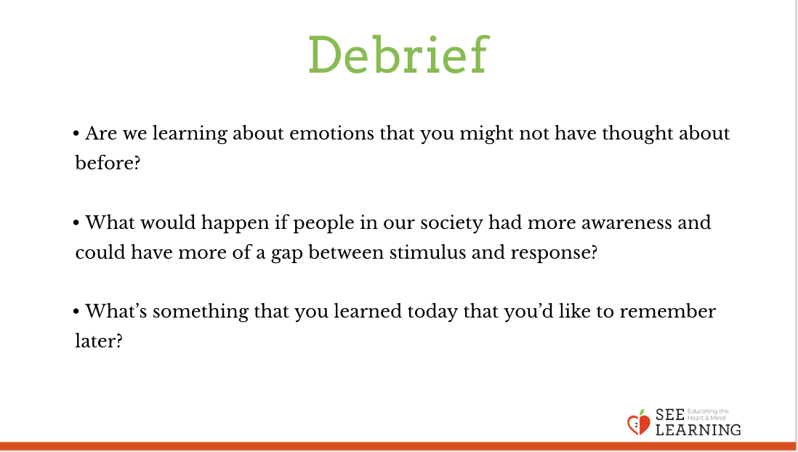 | Sample Script  - “Are we learning about emotions that you might not have thought about before?  - What would happen if people in our society had more awareness and could have more of a gap between stimulus and response?  - What’s something that you learned today that you’d like to remember later?”

