Navigating Emotions

Purpose:
The purpose of this learning experience is to allow students to explore the relationship between needs and emotions, since emotions often arise as a result of our needs being met or going unmet. Seeing this relationship can help students make sense of their own and others’ emotions and is an important precursor to developing greater empathy and compassion both for oneself and others.
Learning Objectives:  Students will be able to:  - Describe their emotions and explore underlying needs  - Explore how difficult feelings, setbacks, and limitations are common features of everyone’s life. | Primary Core Component  Attention & Self-Awareness  
Length  35 Minutes | Materials Required  - A copy of the handout at the end of this learning experience “Our List of Shared Needs”  - Whiteboard or chart paper and markers  - A copy of the “Nelson’s Difficult Day” story for each pair or trio to read and mark-up  - An index card or small piece of paper for each student  - Writing utensils for each student

Check In (4 min)
Slide 2 : Check In   | Sample Script  - “Let’s prepare for a short attention practice. How do we want our body to be?  - First we’ll take a comfortable and upright posture. Then we’ll keep our eyes on the ground or close them.  - Before we strengthen our attention, we’ll do some resourcing or grounding to calm our bodies. Choose one of your resources from your resource kit, or you can choose a new one, or you can imagine one.  - Now let’s just bring our resource to mind. And let’s see if we can pay attention to our resource with our mind for a few moments quietly. Or if you’d rather do grounding, you can do that too. Whichever you choose, we’re going to rest quietly and pay attention for a few minutes. [Pause.]  - What do you notice inside? If you feel pleasant or neutral, you can rest your mind on that.  - If you feel unpleasant, you can shift to a different resource, or you can ground. You can also change your posture but try not to disturb anyone else if you do that. Otherwise, just keep your attention resting with your resource. [Pause.]  - Now let’s become aware of our breathing. Let’s see if we can pay attention to the breath as it enters and leaves our body.  - If you find paying attention to the breath uncomfortable, then feel free to go back to your resource or grounding, or just take a small break, making sure not to disturb anyone else. [Pause for 15-30 seconds.]  - If you ever get distracted, you can just return your attention to the breath. You can also count your breath. [Pause for a longer time, such as 30-60 seconds or longer.]  - You can strengthen your attention by focusing on sensations or by focusing on the breath. It’s your choice - it's always up to you.  - What did you notice?” [Share aloud.]

Insight Activity 1: Emotions and Needs (8 min)
Overview
- In this activity, students will get into groups to fill out a list of “shared needs.” These are basic needs that are common for most or all people.
- They will then explore which emotions might arise if particular needs are met or unmet.

Content to be Explored
- We all have needs.
- Although some of our needs may be specific to ourselves, many are shared among ourselves and others.
- We often experience emotions when our needs are met or go unmet.

Materials
For each student:
- A copy of the handout at the end of this learning experience “Our List of Shared Needs”
- Writing utensils for each student
- Whiteboard or chart paper
- Markers

Instructions
- Divide students into groups of two or three and provide each group with a copy of the handout called “Our List of Shared Needs,” provided at the end of this learning experience.
- Tell students that these shared needs listed are a starting point for your conversation about needs. There may be other needs they want to add to this list.
- Tell students to write in additional shared needs using the categories provided (or “Other” for needs that do not fit under any category). If helpful, you can instruct them to first brainstorm by looking for synonyms or related words to category titles.
- When they have added needs to each category, ask each group to pick two needs from the list and come up with an example for each of what emotions might arise if it is unmet. Reconvene as an entire class for sharing.

Teacher Tips
- After this activity is finished, collect the list of shared needs from each group. Compile this into a single “Shared Needs List” that you can put on a larger piece of chart paper to refer to later, or hand it on the classroom wall. You may choose to write on the chart paper as students share, but this will take considerably more time.
- A sample list of shared needs is provided at the end of this learning experience after the blank one. This is for your reference, although you can also show this to the students to see if there are any needs on the sample list that they would like to add to their own “Shared Needs List” for the class.
Slide 3: Emotions and Neds  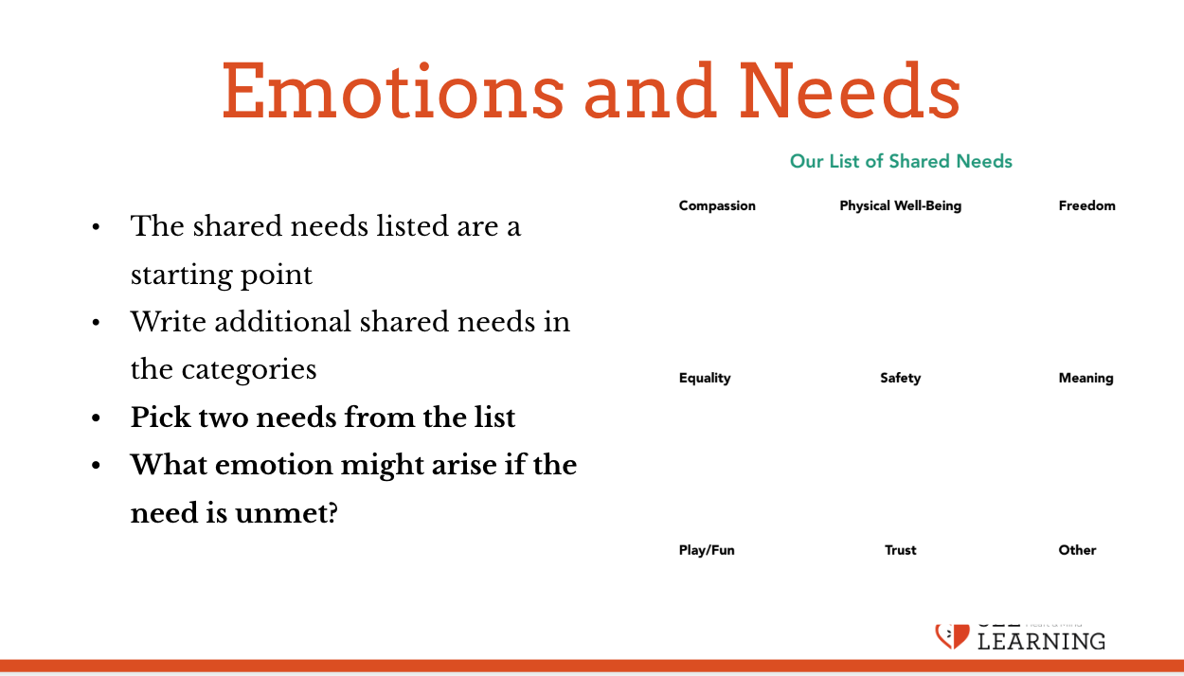 | Sample Script  - “Today we’re going to talk about needs. These are things that we need as human beings to survive, to flourish, and to be happy. Take a look at the handout I gave you. What do you notice or wonder? [Allow time for sharing.]  - This list is just a starting point for us. We’re going to add additional needs to this list.  - We’re going to work in small groups to brainstorm additional needs that we can put under each category. If we think of a need that doesn’t fit under any of these categories, we’ll put it in “Other.”  - It may be helpful for you to first think of synonyms or related words the words already provided. That can help with brainstorming.  - Try to add at least a few needs to each category.”  Allow students to work for some time. Check on progress. When each group has a few additional needs for each category, move on to the next step below.  - “Now let’s see how needs are related to emotions. Each group will select two needs from your list. Looking at the need, ask “What emotions might arise if this need is met?” and list those emotions. Then we’re going to ask, “What emotions might arise if this need is unmet?” and list those.  - Let’s do one together first. We’ll try “safety.” I have a need for safety, and if my need for safety is not met and I feel unsafe, what emotions might I experience? [fear, anxiety] If my need for safety is met and I feel safe, what emotions might I experience?[contentment, happiness, joy]  - Now select the two needs your group would like to think about and what emotions might come up if that need is met or unmet.”  Allow students to work for some time. Check on progress. When you feel enough time has passed, ask each group to share.  - “What do we notice about needs and emotions?  - If someone who didn’t study emotions said to you “Emotions just come and go. I don’t think there’s any relationship between my emotions and my needs,” what might you say to them?”

Insight Activity 2: Exploring Needs (13 min)
Overview
In this activity, students will re-read “Nelson’s difficult Day,” but this time they will examine Nelson’s needs and how those needs being met or unmet are related to his emotions.

Content to be Explored
We can often understand our own or another person’s emotions better if we consider needs.

Materials
- A copy of the “Nelson's Difficult Day” story for each pair or trio to read and mark-up
- List of shared needs - either the handout or the class poster

Instructions
- Tell students that you will re-read the story “Nelson’s Difficult Day.” remind them that the last time you read the story, you noticed and discussed sparks. Tell them this time, they can notice those sparks and emotions that go with them, but they will focus on looking for needs that Nelson has that are or aren’t being met.
- Assign students to groups of four and give each group a copy of the story. (Alternatively, you can do this as a whole-class activity.)
- Tell them to re-read the story together and underline parts where they can see Nelson having a need that is or isn’t being met or addressed or tended to.
- Tell them to label each place they underline with the specific need Nelson is having.
- Have students move back into a large group and invite each group to share out one of Nelson’s needs, the emotional response he had to it, and what (if anything) he did to address it.
- Have them find which needs arise that are already on the shared list of needs created earlier, and which are not. If they identified a need not on the list, is it covered already by one on the list? If so, point that out. If not, you can add the new need to the shared needs list.

Teacher Tips
- None
Slide 4: Exploring Needs  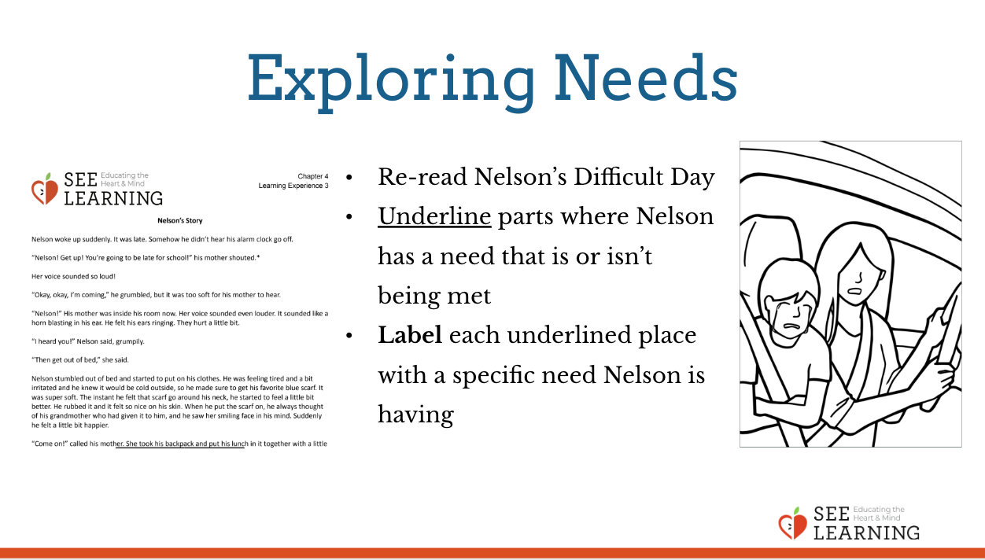 | Sample Script  - “Who remembers the story of Nelson we read recently? What was the activity we did with that story last time? Yes, we looked for sparks and discussed how he moved through the zones.  - We’re going to re-read the story of Nelson’s day and the small moment of stress he experienced. This time, we are going to focus on looking for the needs that Nelson has that are or aren't being met. We’re going to then connect to those needs to the emotions he feels.  - Each of your groups has a copy of the story. Please select one person in your group to read the story aloud slowly. The rest of you will raise your hand to stop the speaker whenever you notice a need that is being met or unmet. Underline 3-5 words that reference the need. Do this for the whole story.  - [Give students time to process the story this way. Once they have finished, move on to the next step.]  - Ok, now, look at the list of shared needs and discuss with your groups:  - Which needs are on the list? Which needs are not?  - Select one need Nelson had and determine what emotion came up for him in relation to that need. Talk to your group about your ideas. Listen to your group about their ideas.  - Let’s come back together as a whole group. Let’s have each group share one of Nelson’s needs, the emotion that came up for him, and what he did to take care of himself (if anything). [Give students time to share.]  - That was great. You all noted many needs present in the story and you talked about Nelson’s emotional response to some of those needs and what he did or could not do to those in need and what he did or could do to take care of himself. Thank you for your deep thinking about needs and emotions today.”

Reflective Practice: My Needs (7 min)
Overview
- Students will do a brief reflective practice on what need they feel is most important to them right now, what is helping them meet it, and what it would feel like if their need was completely met.
- They will combine this with the tracking of sensations in the body.

Content/Insight to be Explored
- What needs are most important can vary from person to person, or from time to time.
- Thinking about our needs being met or unmet affects our emotional state and our nervous system.

Material Required
- Shared needs list for viewing
- An index card or small piece of paper for each student
- Writing utensils

Instructions
- Ask students to put their name on the index card.
- Ask them to identify for themselves a particular need that they feel is especially important to them right now and write it on their index card. It can be from the shared needs list or a need they feel that is not on the list.
- Explain this is a private practice and they won't have to share what they write with anyone, unless they want to.
- Ask them to reflect silently on what things in their life are helping them meet this need, and to write these down on the card. If they can’t think of anything helping them meet their needs, ask them to write what they could imagine happening that would help them meet it.
- Ask them to reflect on what it would feel like to have their needs met completely. Then ask them to notice what this feels like on the inside (tracking). Give them the opportunity to ground or resource if they notice unpleasant sensations.
- Invite anyone who wants to share to do so.
- Invite them to put their index card in their resource kit or hand it in so you can read it privately.

Teaching Tips
If students choose to give you their cards, this can provide valuable information on their current state.

Slide 4: Reflective Practice  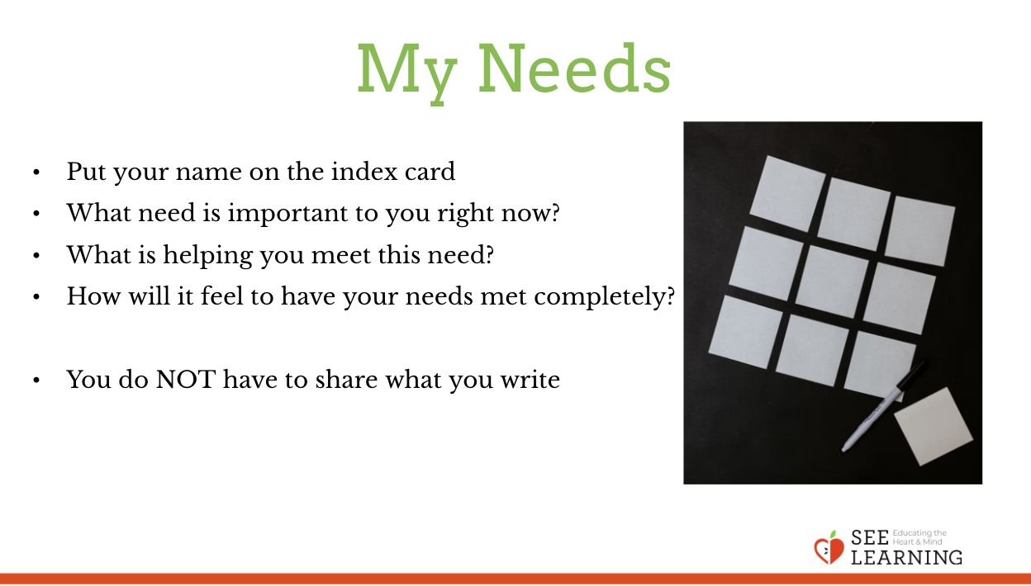 | Sample Script  - “Now let’s do a brief reflective practice in silence.  - Let’s each take a look at our shared needs list.  - Choose a particular need that you feel is especially important to you right now and circle it.  - Or if you feel a need that is not on the list, add it to the list and then circle it.  - We’re going to do this privately, so no one will see what you circle or write, and you won’t have to share it with anyone.  - Now let’s take a moment to think. What are things in your life that help you meet this need? You can write these things down if you like.  - If you can’t think of anything that is helping you meet this need, then think about what could happen that would help you meet this need. Write this down if you like. [Pause 30-60 seconds.]  - Now let’s take a moment to think: What would it feel like to have this need completely met? Take a moment to imagine this. [Pause 30 seconds.]  - Now take a moment to check what you notice on the inside. If you notice any unpleasant sensation, remember you can always shift to a place in your body that feels better, or you can do grounding or resourcing. [Pause 30 seconds.]  - Thank you. Would anyone like to share? You don’t have to.  - Now you can place your card in your resource kit. Or if you want to share it with me, you can hand it to me. I will keep them private.”

Debrief (3 min)
Slide 5: Debrief  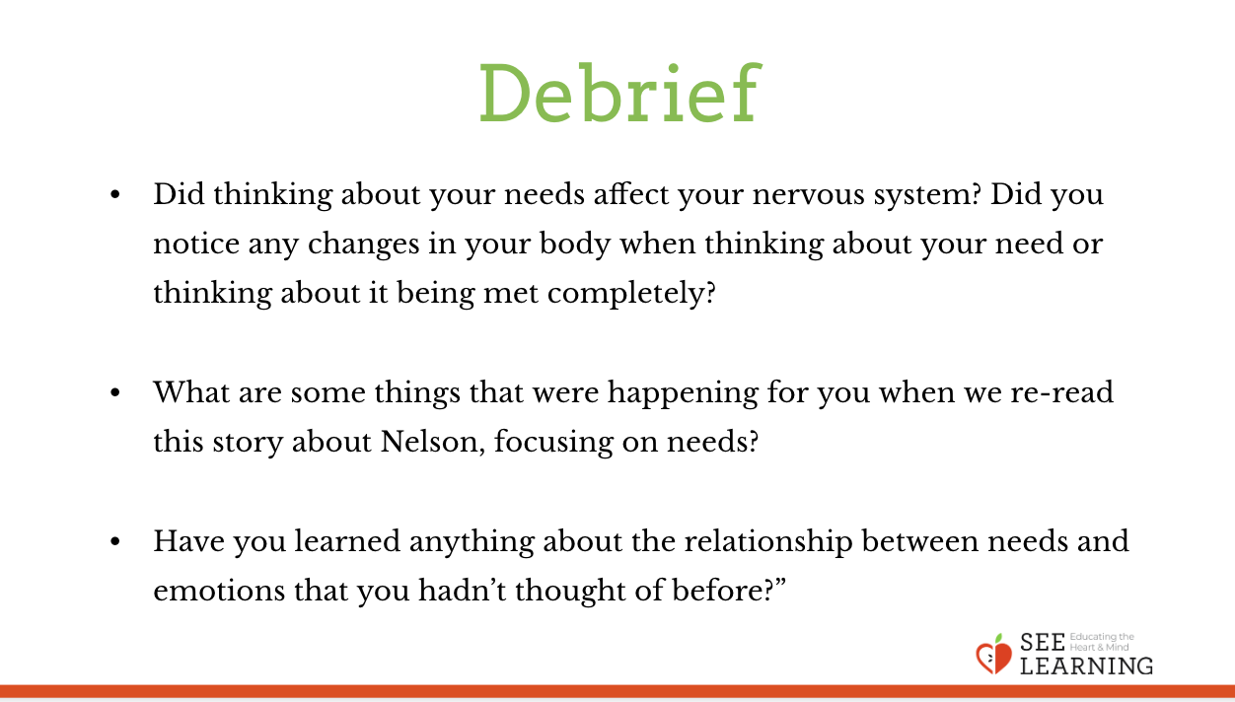 | Sample Script  - “Did thinking about your needs affect your nervous system? Did you notice any changes in your body when thinking about your need or thinking about it being met completely?  - What are some things that were happening for you when we re-read this story about Nelson, focusing on needs?  - Have you learned anything about the relationship between needs and emotions that you hadn’t thought of before?”

