Sparks of Emotions

Purpose:
The purpose of this learning experience is to introduce the concept of emotions, how they arise, and how they can escalate, through use of a story and activity. This leads to an exploration of how emotions differ from thoughts and sensations, and how all three (emotions, thoughts, and sensations) relate to each other.
Learning Objectives:  Students will:  - Learn how emotions can arise from events and can escalate.  - Learn how past experience can influence our emotions.  - Learn how emotional responses to events can vary from person to person. | Primary Core Component  Attention & Self-Awareness  
Length  30 Minutes | Materials Required  - Pictures of the spark and forest fire (these can be the same ones that you used earlier from Chapter 3)  - 2 pieces of rope or string, approximately 20 feet long each  - The provided story and questions

Check In (4 min)
Slide 2 : Check In   | Sample Script  - Let’s prepare for a short attention practice. How do we want our body to be?  - First we’ll take a comfortable and upright posture. Then we’ll keep our eyes on the ground or close them.  - Before we strengthen our attention, we’ll do some resourcing or grounding to calm our bodies. Choose one of your resources from your resource kit, or you can choose a new one, or you can imagine one.  - Now let’s just bring our resource to mind. And let’s see if we can just pay attention to our resource with our mind for a few moments quietly. Or if you’d rather do grounding, you can do that too. Whichever you choose, we’re going to rest quietly and pay attention for a few moments. [Pause.]  - What do you notice inside? If you feel pleasant or neutral, you can rest your mind on that.  - If you feel unpleasant, you can shift to a different resource, or you can ground. You can also change your posture but try not to disturb anyone else if you do that. Otherwise, just keep your attention resting with your resource. [Pause.]  - Now let’s become aware of our breathing. Let’s see if we can pay attention to the breath as it enters and leaves our body.  - If you find paying attention to the breath uncomfortable, then feel free to go back to your resource or grounding, or just take a small break, making sure not to disturb anyone else. [Pause for 15-30 seconds.]  - If you ever get distracted, you can just return your attention to the breath. You can also count your breath. [Pause for a longer time, such as 30-60 seconds or longer.]  - You can strengthen your attention by focusing on sensations or by focusing on the breath. It’s your choice - it’s always up to you.  - What did you notice?” [Share aloud.]

Presentation/Discussion (5 min)
Overview
This presentation/discussion prepares students for the insight activity that comes after it by reviewing the metaphor of the spark and the forest fire, and by introducing the idea that past experience can influence different people’s reaction to the same event.

Content to be Explored

- Experiences can trigger emotions.
- We can get better at noticing triggers / sparks and where they send us in our zones.
- What triggers our emotions can vary from person to person, because past experience and the state of our nervous system influences how we judge or evaluate a situation (called “appraisal”).

Materials

- Pictures of the spark and forest fire (these can be the same ones that you used earlier)

Instructions
- Remind students of the spark and forest fire example.
- Ask them what they recall about the metaphor and how it relates to emotions.
- Using the example of two children, one of whom was once bitten by a dog and is now afraid of dogs (or a similar example), explore how we evaluate situations (“appraisal”) differently based on our past experiences. This idea of appraisal will be developed further as the chapter goes on.

Teacher Tips

Feel free to adapt the story to your context; however, try to keep it short and simple.
Slide 3: Discussion: Sparks and Forest  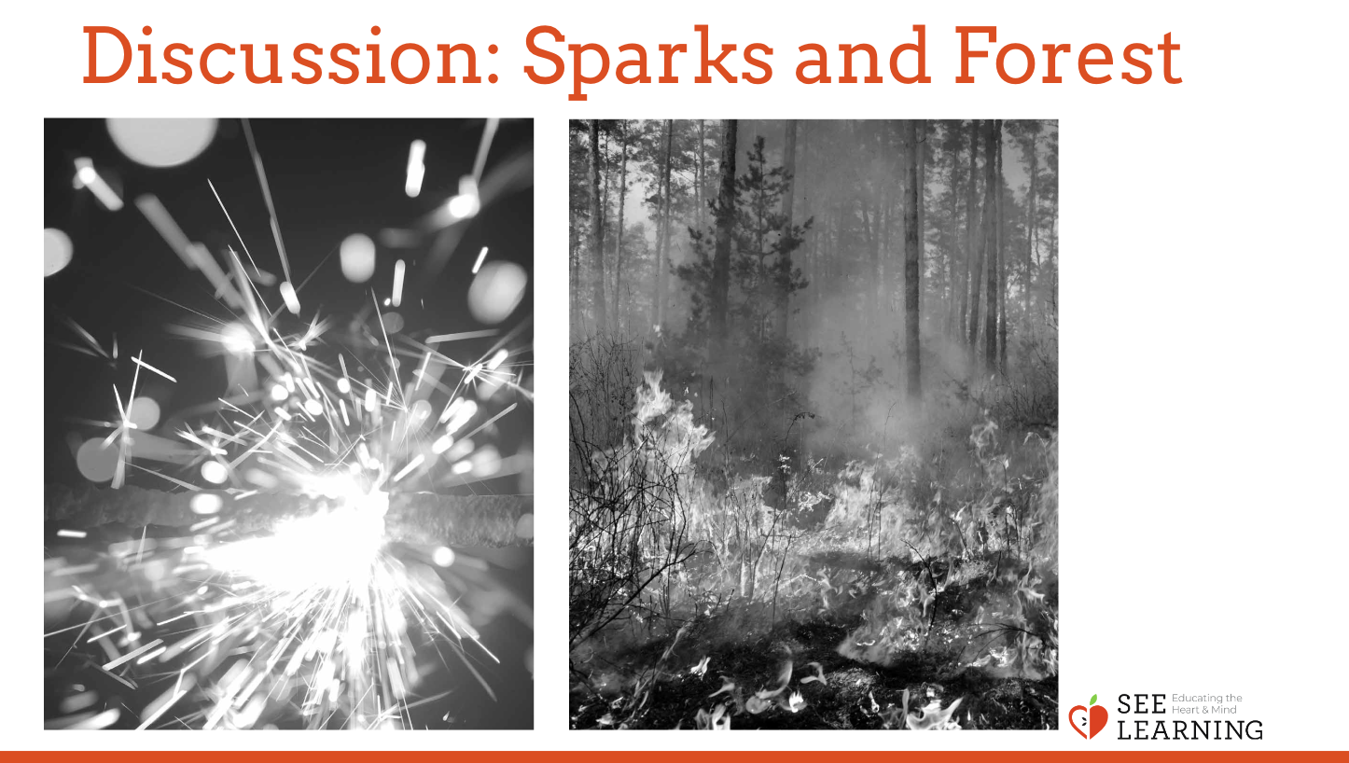  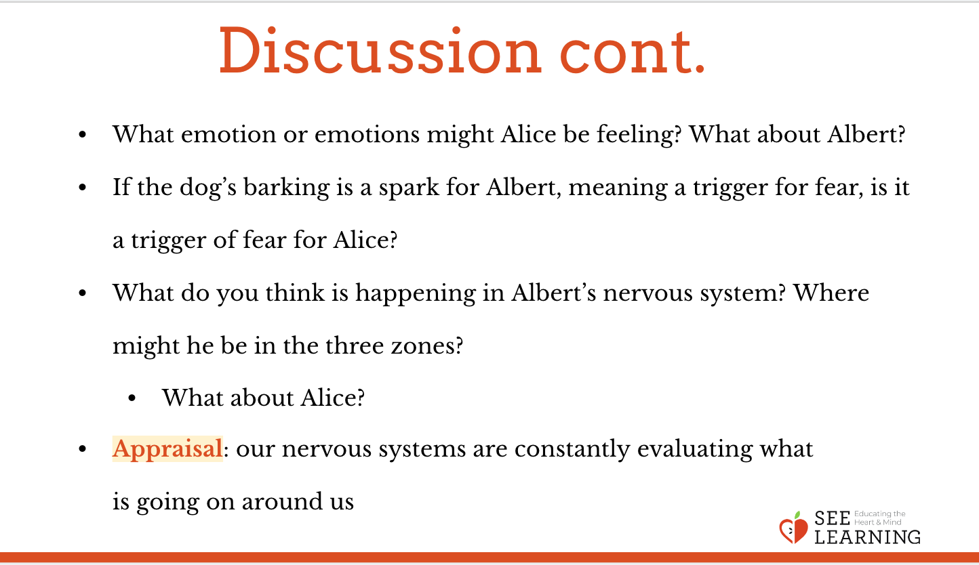 | Sample Script  • “Remember when we talked about sparks and forest fires as a metaphor for how emotions can arise? Who can share what they remember about the spark and the forest fire metaphor and how it relates to emotions? [Allow time for sharing.]  • So, now I’m going to tell you a story about two kids and I invite you to notice how they evaluate the same situation differently. We’ll discuss it after.  • Albert and Alice are two children who go to the same school. One day when they are on the playground, they hear a dog barking. Alice has a dog at home whom she loves to play with very much. So when she hears the barking, her heart starts beating faster, thinking there may be a dog nearby for her to play with. But Albert was once bitten by a dog. When he hears the barking his heart also starts beating faster and his body goes stiff, thinking there might be a dog nearby.  • What emotion or emotions might Alice be feeling? What about Albert?  • If the dog’s barking is a spark for Albert, meaning a trigger for fear, is it a trigger of fear for Alice?  • Some of their sensations are the same, like their hearts beating faster, but other sensations in their body might be different.  • What do you think is happening in Albert’s nervous system? Where might he be in the three zones?  • What about Alice?  • The bark is the same, but Alice and Albert were judging or evaluating it differently. Alice didn’t evaluate it as dangerous, but maybe Albert did. Our nervous systems are constantly evaluating what is going on around us. This is called “appraisal.”

Insight Activity: Nelson’s Difficult Day (14 min)
Overview

This activity involves reading a story about Nelson to the students and asking them to notice possible “sparks” or emotional triggers, where that might send Nelson in the three zones, and what Nelson might do to get back into his resilient zone.

Content/Insights to be Explored

• We may experience emotional triggers many times in a single day.
• Emotions can build up over time, resulting in us acting in ways we normally wouldn’t.
• If we notice emotional triggers, we can engage in practices that can help us stay in or return to our resilient zone.

Materials

- 2 pieces of rope or string, approximately 20 feet long each
- The provided story and questions

Instructions
- Create a representation of the three zones (high zone, resilient zone, and low zone) on the floor, using long lines of tape or string.
- Tell students that you will read a story that involves a character who has a difficult day and experiences small stresses that add up until he finally loses his temper. Ask students to snap their fingers or raise their hands when they notice a “spark” in Nelson’s day. The spark is anything that could be an emotional trigger or that could escalate into a forest fire.
- When they indicate a spark, invite the students to stand in the area of the floor in the three zones where they think Nelson would be. Then invite them to share, using one or more of the following questions:
- What was the spark?
- Why did you chose to stand where you are?
- What emotion might Nelson be feeling at this moment?
- What might happen if Nelson had more awareness?
- Has Nelson helped himself decrease the spark at the moment? If so, how?
- What might Nelson be able to do to help himself at this moment?
- For your assistance, asterisks are placed in places where students might notice a spark. If you are going through the story and no one is noticing a spark, you may wish to pause yourself at such places and ask the students whether they think this could be a spark, and where Nelson might be in the three zones.

Teacher Tips
- If you find the provided story inappropriate for your context, feel free to modify it slightly or choose a different story that exhibits a similar situation. You can also abbreviate it if necessary.
- If you prefer not to have the whole group moving within the zones, ask one person who snaps or raises their hand to move to the zone they think Nelson might be in. Then students can discuss if they agree or not and if necessary, another student could move to a different spot in the zones.
- Consider reading the story twice - the first time to simply individually and silently notice the sparks and then the second time have students snap their fingers or raise their hands when they notice a spark.
- Make sure to leave time for the reflective practice so that students can re-center themselves after this activity.

Story - Nelson’s Difficult Day

“Nelson woke up suddenly. It was late. Somehow he didn’t hear his alarm clock go off.

“Nelson! Get up! You’re going to be late for school!” his mother shouted.*

Her voice sounded so loud!

“Okay, okay, I’m coming,” he grumbled, but it was too soft for his mother to hear.

“Nelson!” His mother was inside his room now. Her voice sounded even louder. It sounded like a horn blasting in his ear. He felt his ears ringing. They hurt a little bit.

“I heard you!” Nelson said, grumpily.

“Then get out of bed,” she said.

Nelson stumbled out of bed and started to put on his clothes. He was feeling tired and a bit irritated and he knew it would be cold outside, so he made sure to get his favorite blue scarf. It was super soft. The instant he felt that scarf go around his neck, he started to feel a little bit better. He rubbed it and it felt so nice on his skin. When he put the scarf on, he always thought of his grandmother who had given it to him, and he saw her smiling face in his mind. Suddenly he felt a little bit happier.

“Come on!” called his mother. She took his backpack and put his lunch in it together with a little juice box that he really liked, and soon he was in the car on his way to school.

When Nelson got dropped off at school, he saw a group of boys who he didn’t like very much. They were a couple years older and often weren’t very nice to him. He tried to avoid them as he made his way into the school, but one of them called out at him. The instant he heard that boy’s familiar voice, he felt a chill go through his body, right down his spine and his legs seemed to go numb. One of the boys started walking towards him and got near enough to grab at him. Nelson quickly dodged him and hurried into the school building.

At last he was in the classroom, seated at his desk, right next to his friend Albert, who he felt glad to see. His heart was beating so fast and hard, but it felt a little bit better now that he was sitting down and next to his friend. He could barely hear the words of his teacher, Mr. Pink. They called him Mr. Pink because he always wore ties that were pink.

But then he saw Mr. Pink handing out a sheet of paper. Nelson’s eyes opened wide. What was this? A test?

“Do we have a test?” Nelson asked Albert.

Albert nodded. “Yeah, didn’t you study for it?”

“No, I completely forgot. I didn’t study at all!” Nelson wailed.

He was feeling even more frustrated now. When did Mr. Pink even mention the test? He felt angry with Mr. Pink and with himself for not having remembered it.

Then Mr. Pink put the test on his desk, and Nelson felt afraid because he knew he would probably fail the test. His stomach felt all tight and knotted. He reached for the scarf around his neck, since sometimes its softness made him feel better.

But the scarf wasn’t there! Nelson realized that the boy who came after him when he was dropped off at school must have taken it. When he realized that, he felt completely deflated and even more sad and angry. He couldn’t concentrate at all on the test.

At the end of the day, Nelson went outside to wait for his mother to pick him up from school.

“Please don’t let those boys be out here,” he thought to himself. “That’s the last thing I need.”

But sure enough, the boys that didn’t like Nelson were there.

“Where’s my mother?” Nelson wondered when he saw them.

“Hey Nelson!” one of the boys called out to him. They started walking towards him again.

Just then Nelson’s mother arrived. He quickly opened the door and jumped into the car.

“Where were you!” Nelson shouted at her. “You’re late!”

Nelson’s mother looked surprised. “Nelson! Why are you shouting?”

Nelson took his backpack and threw it on the floor of the car and stomped on it. “I hate this school!” he said.

“Nelson! Behave yourself!” said his mother.

Then Nelson looked down and saw that he had stomped on his lunchbox and the juice box he had saved, and now the juice was spilling out all over the car floor and onto his backpack. It was a complete mess. His anger turned to sadness and he started to cry.

“Nelson, honey, I’m sorry you’re upset,” said his mother. “We all have difficult days. We can talk about it if you want to. Let’s think about something fun we can do when we get home.”

[The End.]

Slide 4: Nelson’s Difficult Day  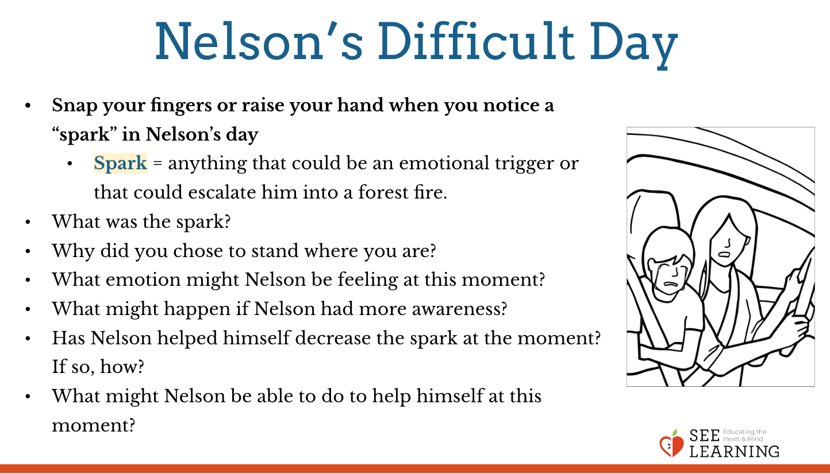 | Sample Script  - Today we’re going to read a story about a character named Nelson who faces small stresses until he loses his temper. As I read the story aloud, I invite you to listen closely and then to snap your fingers or raise your hand when you notice a “spark” that Nelson experiences.  - I’ll pause when I see or hear your fingers and then ask you to move to this space here where we have designated the high zone, resilient zone, and low zone. After you move, I’ll ask a couple volunteers a few questions. Then after we share, we’ll continue the story in the same way. What questions do you have before we begin?  - Let’s try it out. [Begin reading the story. When students indicate a spark moment, have them move into the zone they think Nelson’s in and then ask the following questions.]  - What was the spark?  - Why did you chose to stand where you are?  - What emotion might Nelson be feeling at this moment?  - What might happen if Nelson had more awareness?  - Has Nelson helped himself decrease the spark at the moment? If so, how?  - What might Nelson be able to do to help himself at this moment?  - Repeat the process above until you finish the story. Allow plenty of time for students to discuss their ideas; this is more important that reading every part of the story.”

Reflective Practice: Resourcing and Grounding (4 min)
Overview

Pointing out that we all have difficult days and small stresses can build up, lead your students in a resourcing, grounding, and attention training practice.

Slide 5: Nelson’s Difficult Day  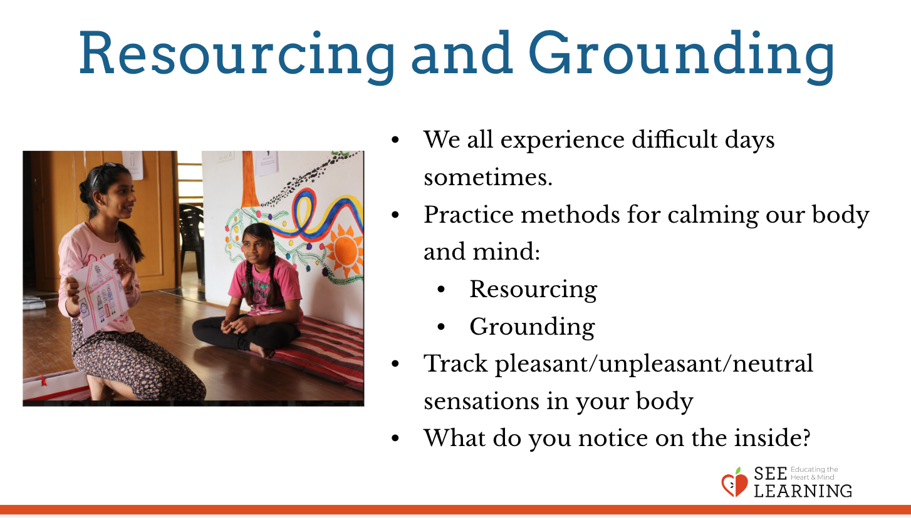 | Sample Script  - We all experience difficult days sometimes. Each little thing can add up until we feel overwhelmed or stressed out. Then we might do things that we wouldn’t ordinarily do, like lose our temper.  - That’s why we practice methods for calming our body and mind, like resourcing, grounding, and training our attention and awareness.  - That way, anytime there is a spark, we can notice it and maybe we can relax ourselves or help ourselves.  - Let’s do a resourcing practice in silence now.  - If someone did something kind for you recently, or if you were kind to someone else, you can feel free to use that as your resource.  - If you’d rather do grounding, you can find a comfortable way to sit or something comfortable to hold or touch.  - Let’s now take a few moments to think about our resource or pay attention to our grounding. [Pause.]  - Now let’s do tracking and pay attention to the sensations inside our bodies.  - If you find a pleasant or neutral sensation just pay attention to that and watch it. See if it changes or stays the same. [Pause.]  - If you haven’t found a pleasant or neutral sensation, see if you can shift to another part of your body to find a place that feels better. [Pause.]  - If you’d like, focus on your breath as you breathe normally. Count your breaths if you wish.  - If you find paying attention to the breath uncomfortable, then feel free to go back to your resource or grounding, or just take a small break, making sure not to disturb anyone else. [Pause for 15-30 seconds.]  - What did you notice on the inside?

Debrief (3 min)
Slide 6: Debrief  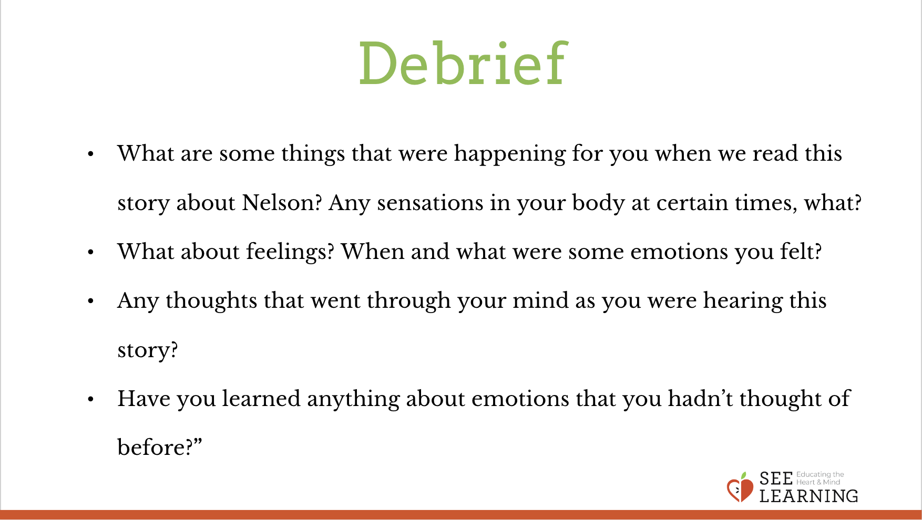Animated slide | Sample Script  - What are some things that were happening for you when we read this story about Nelson? Any sensations in your body at certain times, what?  - What about feelings? When and what were some emotions you felt?  - Any thoughts that went through your mind as you were hearing this story?  - Have you learned anything about emotions that you hadn’t thought of before?

