Emotion Families

Purpose: This learning experience enables students to explore how some emotions are related to others and how we can group them together in “emotion families.” By creating charts of “emotion families” around six common emotion terms used in SEE Learning (happiness, sadness, compassion, fear, anger, and jealousy), students will develop their emotion vocabulary further, while seeing how emotion terms can specify how emotions vary in specific ways, such as intensity.
Learning Objectives:  Students will be able to:  - Discuss the most common emotions and their variants.  - Develop a vocabulary of emotion terms.  - Explore the ways different emotion terms are related to each other. | Primary Core Component  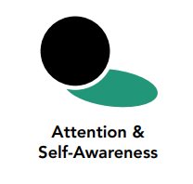
Length  35 minutes | Materials Required  - Whiteboard or chart paper and markers  - List of emotion words at end of this learning experience  - Large pieces of paper, enough for one per group  - Different colored markers or pens

Check In (4 min)
Slide 2: Check In   | Sample Script  - “Let’s prepare for a short attention practice. How do we want our body to be?  - First we’ll take a comfortable and upright posture. Then we’ll keep our eyes on the ground or close them.  - Before we strengthen our attention, we’ll do some resourcing or grounding to calm our bodies. Choose one of your resources from your resource kit, or you can choose a new one, or you can imagine one.  - Now let’s just bring our resource to mind. And let’s see if we can just pay attention to our resource with our mind for a few moments quietly. Or if you’d rather do grounding, you can do that too. Whichever you choose, we’re going to rest quietly and pay attention for a few moments. [Pause.]  - What do you notice inside? If you feel pleasant or neutral, you can rest your mind on that.  - If you feel unpleasant, you can shift to a different resource, or you can ground. You can also change your posture but try not to disturb anyone else if you do that. Otherwise, just keep your attention resting with your resource. [Pause.]  - Now let’s become aware of our breathing. Let’s see if we can pay attention to the breath as it enters and leaves our body.  - If you find paying attention to the breath uncomfortable, then feel free to go back to your resource or grounding, or just take a small break, making sure not to disturb anyone else. [Pause for 15-30 seconds.]  - If you ever get distracted, you can just return your attention to the breath. You can also count your breath. [Pause for a longer time, such as 30-60 seconds or longer.]  - You can strengthen your attention by focusing on sensations or by focusing on the breath. It’s your choice - it’s always up to you.  - What did you notice? [Share aloud.]”

PRESENTATION/DISCUSSION: What are Emotion Families? (4 min)
Overview
This discussion presents the idea of emotion families: emotions that are all related to each other or similar in some way.

Content to be Explored
Similar emotions can be grouped together, making them easier to distinguish from other emotions.

Materials
- Whiteboard or chart paper and markers;
- List of emotion words at end of this learning experience
- These emotions written out in a list on the whiteboard or chart paper:
  - Happiness
  - Fear
  - Sadness
  - Anger
  - Compassion
  - Jealousy

Instructions
- Let students know you will be talking more about emotions today. Show them the list of 6 emotion words included at the end of this learning experience, and ask someone to pick one for you to use as the example in your presentation/discussion. Ask for another word that is similar to that emotion word. As students list words, write them on the chart paper or the board. Ask students how the words’ meanings are similar to each other and how they are different. Discuss the relationship between the emotion words.
- Tell students that the groups of words are an emotion family. Discuss how they are different from another emotion word and its family. As a group brainstorm some ideas for a different emotion family.
- Tell them now they are going to do an activity in which they create emotion family posters.

Teacher Tips
none
Slide 3: What are Emotion Families?  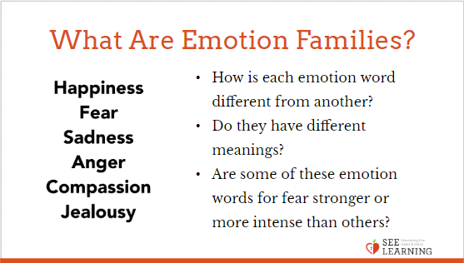 | Sample Script  - “Today we’re going to talk more about emotions.  - Some emotions are related to each other. We use different words for them, but they are similar.  - For example, we have many words for fear. If I’m afraid, there are a number of ways I could express my emotion. I could say, “I’m feeling a little bit timid right now.” That might mean I’m just a little bit afraid. Maybe I see a bee, and someone says, “That’s a bee. Are you scared?” I might say, “I’m not scared. I’m just a little bit anxious.” But maybe then I see a snake, and I say, “Oh, now I’m really scared. I’m terrified!”  - How is each emotion word different from another? Do they have different meanings? Are some of these emotion words for fear stronger or more intense than others?  - So we see that [afraid, fear, terrified, anxious, and timid] are all emotion words and they are all related, aren’t they?  - We could say they’re part of the same emotion family.  - They’re not really part of the emotion family of happiness, are they? If someone sees a snake and is feeling afraid, would we say they’re feeling happy at that moment? Probably not.  - What would be emotions that are part of the emotion family of happiness? Like imagine it was your birthday and you got some wonderful presents. Probably you’d be feeling the emotion of happiness. What other emotions might you be feeling? (Invite responses). So we could say those emotions are part of the emotion family of happiness.  - We’re going to do an activity in which we create emotion families.”

Insight Activity: Making Our Own Emotion Families (20 min)
Overview
In this insight activity, students will work to develop a vocabulary of emotions and explore how they relate to each other in “emotion families.”

Content to be Explored
- Similar emotions can be grouped together, making them easier to distinguish from other emotions.
- We can use many different terms for one type of emotion, each of which is slightly different

Materials
- Large pieces of paper enough for one per group
- Different colored markers or pens

Instructions
- Divide your class into groups of 3-4 students each. (If you have a small number of students you can have them do this individually, or if you have a large group of students you could make the groups larger or have more than one group doing the same emotion term). Make sure each group has a space to work on with enough room so that they can sit around a large piece of paper and draw on it.
- Give each group a large piece of paper and colored pens. Then assign each group a starting emotion word from the following list. If you have a larger group, it’s fine to have more than one group focused on each emotion word and it may be helpful to compare their two posters in the end.
  - Happiness
  - Fear
  - Sadness
  - Anger
  - Compassion
  - Jealousy
- Ask students to write their starting emotion word in the center of their piece of chart paper in large letters using blue or black colored pens (or you can already have written these words on the chart paper yourself).
- Explain that they will use these starting emotion words to create an “emotion family.” This means a group of emotions that are all related to each other, like members of a family.
- Ask them to add other emotions around the starting emotion word that they feel are related to it. What other emotions would be part of this emotion family?
- Don’t be too concerned at this point as to whether the words they put down are all emotions or not or whether the words are nouns or adjectives.
- If necessary or helpful, prompt them with questions like, “What is this emotion like?” “What would we call a little bit of this emotion or a spark of this emotion?” “What would we call a lot of this emotion?” What would we call a forest fire of this emotion?” “What other emotions might you feel if you’re feeling this emotion?”

- Also if necessary or helpful, you can suggest a few terms for them to consider adding to their emotion family, such as:
- Happiness: Joy, Excitement, Relieved, Peaceful, Excited, Satisfied, Feeling Good
- Sadness: Sorrow, Discouraged, Disappointed, Lonely, Helpless, Hopeless, Feeling Low, Grief
- Compassion: Love, Liking, Affection, Endearment, Friendship, Trust, Feeling Close, Feeling Connected
- Fear: Anxiety, Worry, Nervousness, Horror, Shock, Desperate, Panicked, Dread, Feeling Small
- Anger: Frustration, Annoyed, Bitter, Rage, Exasperated, Furious
- Jealousy: Envy, Resentment, Begrudging, Feeling Rivalry, Feeling Competitive
- As they add in related emotions, invite them to draw facial expressions, emojis, or other illustrations for each of the emotion terms on their chart paper.
- Once each group has had 3-5 minutes to work on their emotion family, rotate the groups by asking each group to get up and move in a clockwise fashion to the next emotion chart. Alternatively, you can ask each group to pass their chart on to the next group in a clockwise fashion. This way, each group should have a new emotion chart to work on.
- Once the groups have rotated, ask each group to examine what’s already on the poster - if you have time, give them one minute to look without adding anything, then ask them to look again for 5 seconds or so and notice something they did not see before - and then add any words they feel should belong to that emotion family. They can again add facial expressions, emojis, or other illustrations for any terms they add. Allow them a few minutes to add any emotion words they can. They may not be able to add many, so this can be short. Students may also add a checkmark next to words or illustrations already listed that resonate with them. (2 minutes)
- Next ask each group to add in some sensations someone might feel in the body if they were feeling a particular emotion in this emotion family. Ask them to write sensation words next to or around the emotion word they are describing. They can use a different colored pen (such as red) for the sensation words. Some sensation words may apply to more than one emotion in the emotion family. They can indicate this by drawing lines connecting the sensation to multiple emotion words if they like. Give them 3-5 minutes to add sensation words.
- Depending on time, you can continue to circulate and rotate the groups and emotion families, asking students to add to each family, or you can stop at this point. When you feel they are ready, stop for group sharing.
- Invite each group to share, one by one, asking:
  - “What was your starting emotion?
  - What other emotions are in that emotion family?
  - What sensations tend to happen when one feels those emotions?
  - What surprises you or interests you about what someone else wrote? Explain.
  - Would anyone like to add an emotion or a sensation to this emotion family? (If so, invite them to write it on the chart.)
  - Now let me ask you a new question: What thoughts might go through someone’s head if they were feeling these emotions?” (Write a few of the sample thoughts on the chart paper as the students share.)
- If you had groups double up on the emotion words, ask them to notice what’s similar and different about posters for the same emotion word.
- Save these emotion family charts, as they will be used later.

Teacher Tips
- You may want to have the questions above written out or projected for students to see as they are working.
- Alternative Instructions: You may choose to administer this activity by using stations where groups or individuals move to posters that contain a single emotion word. Groups or individuals can rotate after 3 minutes. When they end up back at the emotion word they began, then the whole group can share together.
Slide 4: Making Our Own Emotion Families  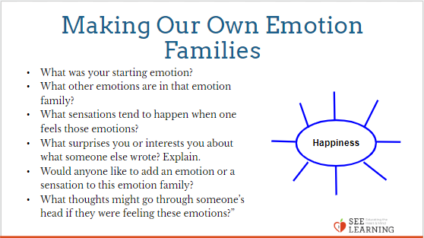 | Sample Script  - “Remember when we talked about emotion families? Who can remind us what an emotion family is?  - Today we are going to work in groups on specific emotions to make posters of those emotions’ families.  - I’ll assign your group an emotion word and someone in your group will write it in the middle of your poster. After that, everyone in the group will begin to brainstorm and write down other words that have similar meaning or are related to the emotion word. Go ahead and get started.”  - As they work, you can use these prompts to help spur more brainstorming:  - “What is this emotion like?  - What would we call a little bit of this emotion or a spark of this emotion be?  - What would we call a lot of this emotion?  - What would we call a forest fire of this emotion?  - What other emotions might you feel if you’re feeling this emotion?  - Feel free to draw facial expressions, emojis, or other illustrations of the emotion terms on your posters.  - Now we’re going to rotate to another emotion family and see if we can add to what the previous group made. Before you write anything on the poster though, you are going to pause to observe the poster for about 5 seconds and then try to add something new – a word, a drawing, whatever you think the poster needs to further explain the emotion. You may just add checkmarks next to words or drawings you agree with. [Instruct them to rotate as you previously decided, then give them 5 seconds to view the charts, and then about a minute to add to the chart.]  - Now, let’s pause and transition to thinking about sensations. See if you can add some sensations someone might feel if they were experiencing an emotion in this family. Write the sensation words next to the emotion word you are describing. Draw lines if the sensation fits with more than one emotion word.  - [Depending on your time, you may continue to rotate after this, or you can stop at this point and begin group sharing.]  - Let’s all come back together as a large group and have a brief discussion. Each group will share out about their emotion family. Which group would like to go first?  - What was your starting emotion?  - What other emotions in that emotion family?  - What sensations tend to happen when one feels those emotions?  - What surprises you or interests you about what someone else wrote? Explain.  - Would anyone like to add an emotion or a sensation to this emotion family? [If so, invite them to write it on the chart.]  - Now let me ask you a new question: What thoughts might go through someone’s head if they were feeling these emotions?  - Write a few of the sample thoughts on the chart paper as the students share. If you had groups double up on the emotion words, ask them to notice what’s similar and different about posters for the same emotion word. Save the charts they make, as they will be used later.

Debrief (3 min)
Slide 5: Debrief  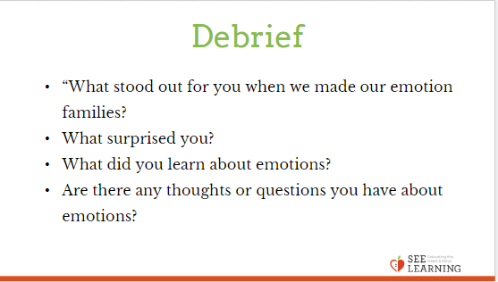 | Sample Script  - “What stood out for you when we made our emotion families?  - What surprised you?  - What did you learn about emotions?  - Are there any thoughts or questions you have about emotions?”

Optional Reflective Practice (30 min to several days)
Slide 6: Optional Reflective Practice  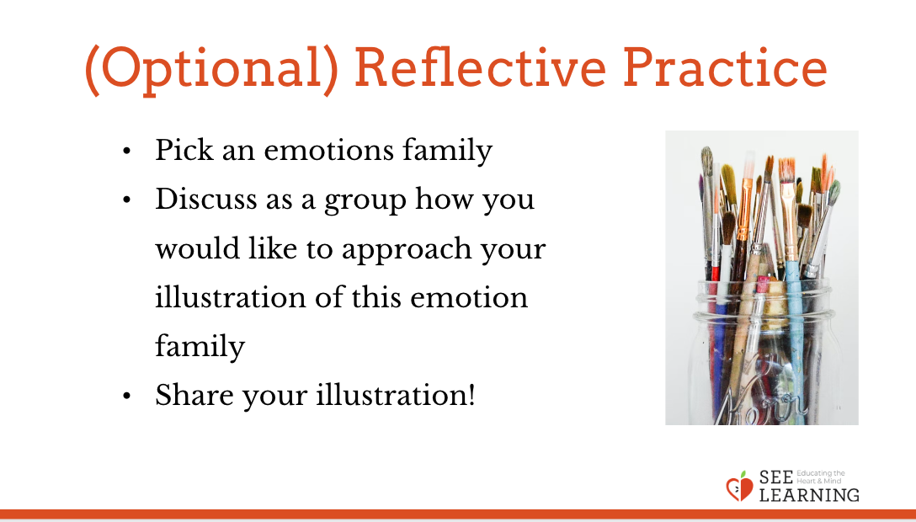 | Instructions  Allow students to pick an emotion families chart that they would like to illustrate. After each student has picked a chart, and thereby divided themselves into groups, have each group illustrate their chart, starting afresh on a large piece of chart paper or any other suitable surface. Have them begin by discussing among themselves the way they would like to approach their illustration. Then allow them to collaboratively draw their illustration that depicts that particular emotion family. If they like, they can put in the individual emotion terms in the illustration also. Alternatively, students could make collages (or a combo of both) if you are able to provide magazines and other materials that have pictures that may be cut up. This project could be done in a session or multiple sessions. When the projects are completed, have each group share their project and explain why they illustrated that emotion family the way they did.

Optional Insight Activity (8-10 min)
Slide 6: Optional Insight Activity  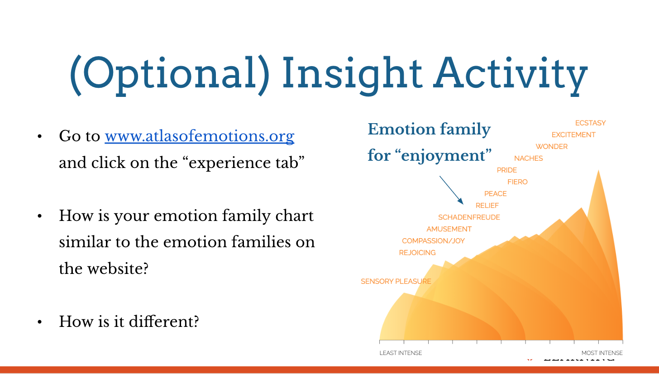 | Instructions  If you have internet access in your classroom, have your students compare the charts they created to the “emotion families” available on Paul and Eve Ekman’s website “Atlas of Emotions,” available at www.atlasofemotions.org. Note that this website is currently only available in English and Spanish.  Happiness  Fear  Sadness  Anger  Compassion  Jealousy

