Exploring Emotions

Purpose:
This learning experience allows students to explore the similarities and differences among the three categories of thoughts, sensations, and emotions. This leads to an exploration of what some of the basic characteristics of emotions might be. Since definitions of emotions vary, the purpose of this learning experience is to start students on the process of exploring emotions, not to come up with a definitive definition of emotions, thoughts, and sensations.
Learning Objectives:  Students will:  - Differentiate emotions from thoughts and sensations.  - List some of the basic characteristics of emotions.  - Discuss the most common emotions and their variants.  - Develop a vocabulary of emotion terms | Primary Core Component  Attention & Self-Awareness  
Length  35 Minutes | Materials Required  - The prompts provided at the end of this activity  - A bell or chime  - Chart paper or whiteboard  - Markers  - A printout of the sheet at the end of this learning experience that has at the top “Sensations - Emotions - Thoughts”

Check In (4 min)
Slide 2 : Check In   | Sample Script  - “Let’s prepare for a short attention practice. How do we want our body to be?  - First we’ll take a comfortable and upright posture. Then we’ll keep our eyes on the ground or close them.  - Before we strengthen our attention, we’ll do some resourcing or grounding to calm our bodies. Choose one of your resources from your resource kit, or you can choose a new one, or you can imagine one.  - Now let’s just bring our resource to mind. And let’s see if we can just pay attention to our resource with our mind for a few moments quietly. Or if you’d rather do grounding, you can do that too. Whichever you choose, we’re going to rest quietly and pay attention for a few moments. [Pause.]  - What do you notice inside? If you feel pleasant or neutral, you can rest your mind on that.  - If you feel unpleasant, you can shift to a different resource, or you can ground. You can also change your posture but try not to disturb anyone else if you do that. Otherwise, just keep your attention resting with your resource. [Pause.]  - Now let’s become aware of our breathing. Let’s see if we can pay attention to the breath as it enters and leaves our body.  - If you find paying attention to the breath uncomfortable, then feel free to go back to your resource or grounding, or just take a small break, making sure not to disturb anyone else. [Pause for 15-30 seconds.]  - If you ever get distracted, you can just return your attention to the breath. You can also count your breath. [Pause for a longer time, such as 30-60 seconds or longer.]  - You can strengthen your attention by focusing on sensations or by focusing on the breath. It’s your choice - it’s always up to you.  - What did you notice?” [Share aloud.]

Insight Activity: What are Emotions? (15 min)
Overview

- In this activity, students will gather into small groups of three to answer a series of prompts intended to get them thinking about the nature of emotions.
- You will then come back together as a class to create a word map for the word “emotion.”

Content to be Explored

We can learn to distinguish emotions from thoughts and sensations, and begin to determine the characteristics of emotions as a whole and of specific emotions.

Materials

- The prompts provided at the end of this activity
- A bell or chime
- Chart paper or whiteboard
- Markers

Instructions
- Show your students the circular graphic at the end of this learning experience that has the words “thoughts, emotions, sensations.” Ask them what they notice about it. Invite observations and questions.
- Explain that you are now going to be discussing ideas about emotions, and how they differ from thoughts and sensations.
- Tell them they are going to walk around and “mingle” with each other until they hear the chime and you say “group of 3 (or another number).” At that point, they will get into groups of that number and greet each other. Next, you will state one of the prompts below and students should spend 15 seconds thinking about the prompt & then take turns (about 20 seconds each) talking about what they think of the prompt. Repeat this process for as many of the prompts as you have time for.
- After each prompt, ask for a couple volunteers to share out something said in their group.
- Together, create a “word map” of the word “emotion,” by writing the word “emotion” in the center of a large piece of chart paper or the whiteboard.
- First ask your students, “What words would we use to explain emotions? What words come to mind when we think of emotions?” Write their suggestions on the word map around the word “emotion.” Then ask your students, “If you were trying to explain to someone what an emotion is, what would you tell them? Could we come up with a definition of emotion?”
- Write the preliminary definition of emotion that your class comes up with on a piece of chart paper and save both the definition and the word map for later use.

Prompts

- Emotions cloud your mind or cloud your judgment. How?
- Emotions cause us to behave in ways that we wouldn’t if we didn’t have that emotion. How?
- Emotions can be powerful or weak. Describe.
- Emotions and thoughts are different. How?
- Emotions and sensations are different. How?
- Some emotions are related to each other. Which ones?
- Emotions can help us. How?
- Emotions can cause problems for us. How?
- We can develop our awareness of our emotions. How might we do that?

Teacher Tips
- It may be helpful to project the prompts onto a screen or reveal them on the whiteboard as you go.
- If you are limited on time, try to complete the activity with the prompts that are in bold, saving the others for another time.
Slide 3: What are Emotions?  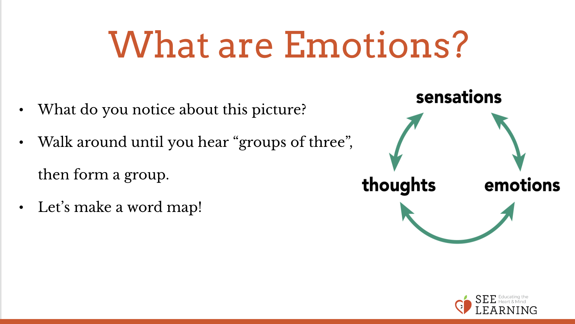 | Sample Script  - “Let’s examine this graphic. [Hold up the graphic.] What do you notice or wonder about this graphic? Invite students to share aloud.  - We are going to think about and explore some ideas about emotions, thoughts and sensations and how they are related to each other.  - For this activity, I’m going to have you stand up and mix yourselves up – you’ll walk around and “mingle” like you’re talking to different people at a party. When you hear my bell, listen for me to say “group of 3” or “group of 4” or another number. At that point, you will get into a group of that number and greet each other with a hello, a high five, or a pinky hug.  - After you’ve gotten into groups, you’ll hear me read a prompt. Then you’ll silently think about it for 10-20 seconds. I’ll ring the bell again, and then one at a time, each person in the group will share their thoughts about the prompt.  - You’ll hear the bell ring again when it’s time to put our focus back to the whole class discussion. Then we’ll repeat the process, but you will move into a new group with different people each time. What questions do you have for me before we begin?  - Let’s begin. [Each round might take about 2 minutes. After enough time has passed for each person in each group to share, ring the chime again.]  - Who can share something interesting that was said in their group chat? [Ask for 1-2 volunteers to share out something that was said by someone in their group.]  - After the first round, check in with the group to see how the process went and what changes may need to be made. Then repeat the process above for the remaining prompts.  - Now let’s all come back to our seats.  - Let’s make a word map of the word “emotion.” I’m going to write your thoughts down on this word map.  - What words would we use to explain what emotions are? What words come to mind when we think of emotions?  - If you were trying to explain to someone what an emotion is, what would you tell them?  - Let’s see if we can come up with a draft of a definition of the word “emotion” for our use in our work together. “Emotions are...” [Allow your students to explore how they might define emotions. The point here is to stimulate thinking about emotions, not to arrive at a perfect or even correct definition, since the rest of the learning experiences in this chapter will further develop and refine their understanding of emotions.]  - It can be quite hard to define the word “emotion.” We’re going to explore emotions much more in the coming weeks. We can learn what emotions are by coming up with lists of emotions and also by seeing the differences between emotions, sensations, and thoughts

Reflective Practice : Sensations, Emotions, and Thought (12 min)
Overview

In this reflective practice, students will work in groups to come up with words they agree fall into the categories of sensations, emotions, and thoughts. Each group will then look at their lists and discuss the similarities and differences between each category. Then the entire class will share.

Content/Insights to be Explored

We can differentiate between sensations, emotions and thoughts. These are useful categories for how we talk about our inner experiences.

Materials

• A printout of the sheet at the end of this learning experience: “Sensations - Emotions - Thoughts”

Instructions
- Have students do this exercise in groups of three or individually. Give each group (or individual student, if they are doing it individually) a printout of the “SensationsEmotions-Thoughts” handout.
- Instruct each group or individual to come up with a list of 5 words that they agree would fit under each column as examples of a sensation, emotion, or thought. They should only write words they agree should be there. If they don’t agree, they can put the word in the “Unsure” space below the column for later discussion.
- Once they have finished coming up with 5 words in each column, they can they try to come up with 10 words in each column by filling out an additional 5.
- Check on group progress. After most groups have put words in each of the three columns, or after you feel enough time has elapsed, ask them to move on to answering the questions at the bottom of the page.
- Give them a few minutes to discuss, look at their terms, and come up with short answers for each of these.
- Then invite each group or individual to share what they notice about what each category has in common with another and how they differ from each other. Then, focus in on emotions and ask students about the qualities particular to emotions. Write “General Qualities of Emotions” on a piece of chart paper or the whiteboard and document what students say. If they struggle prompt them with one of the items from the chart below.

Teacher Tips
- You may find it helpful to draw a Venn diagram as students share out the commonalities and differences among the qualities of the categories of sensation, thought, and emotion.
- Document what students say about the qualities to describe emotions and save this for later.
- As your students discover aspects of the table below (General Characteristics of Emotions), you may wish to use the language they come up with to create a similar table that will be in their own words.

Here are a some examples of general characteristics of emotions that your students may discover. Listen for them to hit upon some of these in this learning experience and the following LEs in this chapter. If and when they do, use this as an opportunity to explore that characteristic further.
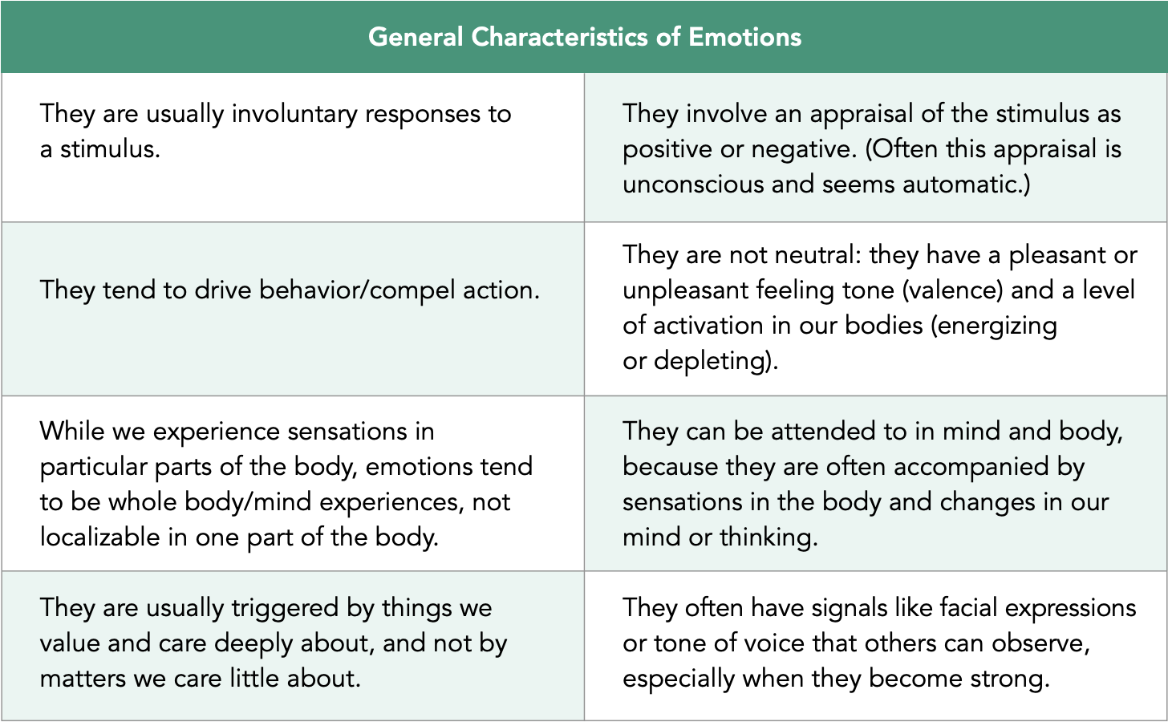
Slide 4: Sensations, Emotions, and Thoughts  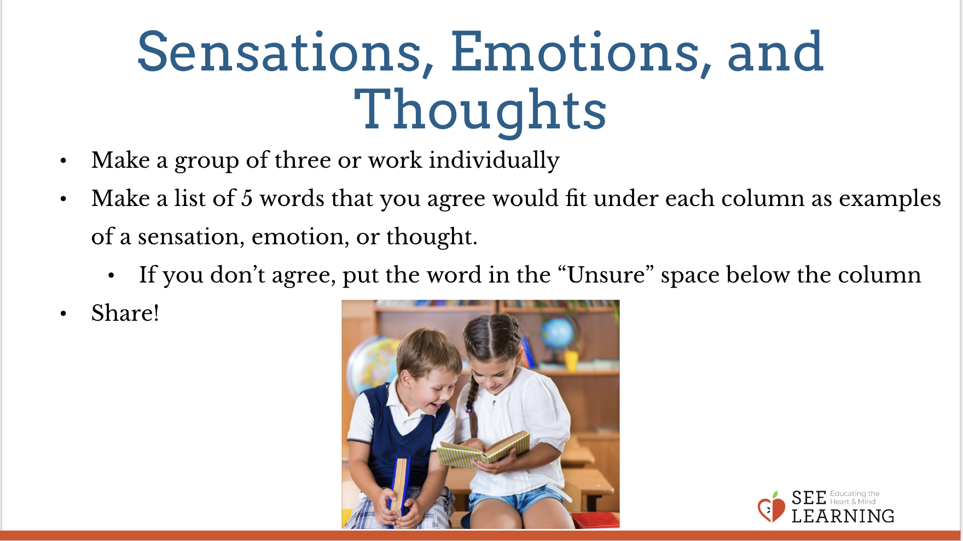 | Sample Script  - “We are going to do some work categorizing sensations, emotions, and thoughts in small groups.  - Each group will use this worksheet to come up with a list of 5 words that are examples of that thing. So you will come up with 5 sensations, 5 emotions, and 5 thoughts. Only put words that you all agree on fit in that column. If you come up with a word but can’t all agree on whether its a sensation, emotion, or thought, then that’s a good thing! Put those words in the space marked “Unsure” and we’ll talk about them later. What questions do you have before we proceed?  - After you have come up with 5 example words for each column, see if you can come up with 5 more for each for a total of 10 in each. [Allow them time to complete this activity.]  - Now let’s all move down to the questions at the bottom of the handout. Take a few minutes to discuss the questions there and share your ideas with your group.  - Together, come up with short answers for each question. It’s ok if your answers to these questions are different from other members of your group, but it’s important to talk with your group about your ideas before you write them down. [Allow them a few minutes to answer the questions on the sheet.]  - Now let’s come back together as a whole group. Let’s have a few people from different groups share out something they noticed about what each category has in common with another and/or what is different between categories.  - Let’s focus in on emotions and look at the definition we made for the word “emotion.”  - If we were going to describe what qualities emotions have, what might we say? [Continue this line of questioning for as much time as you have, until you get at least three qualities listed. If you need to prompt them using the chart provided, feel free to do so.]  - This is a great list to start with. We may decide we want to add more as we continue our work with emotions.”

Debrief (4 min)
Slide 5: Debrief  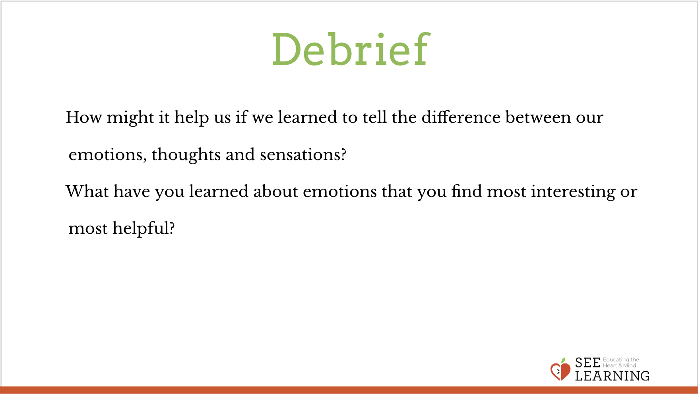Animated slide | Sample Script  - “How might it help us if we learned to tell the difference between our emotions, thoughts and sensations?  - What have you learned about emotions that you find most interesting or most helpful?”

