Self-Awareness

Purpose:
Students have already learned to direct their attention inwards to the body and sensations. In this learning experience they will explore directing attention inwardly to the mind (called “metacognition”), meaning thoughts, emotions, and feelings. They will explore how such attention can eventually help them to create a “gap” between stimulus and response, a great aid for stopping the spark before it becomes a forest fire.
Learning Objectives:  Students will be able to:  - Learn the practice of observing their own thoughts and feelings.  - Notice a gap between stimulus and response, facilitating impulse control. | Primary Core Component  Attention and Self-Awareness  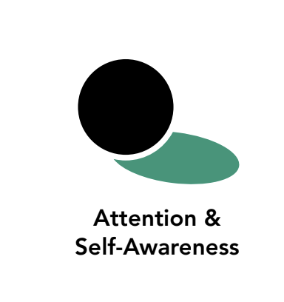
Length  25 Minutes | Materials Required  - The mind jar  - A print-out of the sky image at the end of this learning experience

Check In (5 min)
Slide 2 : Check In   | Sample Script  - "Let's prepare for a short attention practice on the breath. How do we want our body to be?  - First we'll take a comfortable and upright posture. Then we'll keep our eyes on the ground or close them.  - Before we strengthen our attention, we'll do some resourcing or grounding to calm our bodies. Choose one of your resources from your resource kit, or you can choose a new one, or you can imagine one.  - Now let's just bring our resource to mind. And let's see if we can just pay attention to our resource with our mind for a few moments quietly. Or if you'd rather do grounding, you can do that too. Whichever you choose, we're going to rest quietly and pay attention for a few moments. [Pause.]  - What do you notice inside? If you feel pleasant or neutral, you can rest your mind on that.  - If you feel unpleasant, you can shift to a different resource, or you can ground. You can also change your posture but try not to disturb anyone else if you do that. Otherwise, just keep your attention resting with your resource. [Pause.]  - Now let's become aware of our breathing. Let's see if we can pay attention to the breath as it enters and leaves our body.  - If you find paying attention to the breath uncomfortable, then feel free to go back  to your resource or grounding, or just take a small break, making sure not to disturb anyone else. [Pause for 15-30 seconds.]  - If you ever get distracted, you can just return your attention to the breath. You can also count your breath. [Pause for a longer time, such as 30-60 seconds or longer.]  - What did you notice?"

Presentation/Discussion: Can We Watch the Mind? (7 min)
Overview
Students will step in and out of a circle depending on whether the prompts the teacher reads apply to them. Then students will take a moment to notice who is on the inside and who is on the outside. This shows who shares that same trait or experience, and who doesn’t.

Content to be Explored
- We can place our attention on our mind itself.
- We can notice thoughts, feelings, sensations, memories and images as they come and go.
- We can pay attention to our thoughts and emotions in our mind.
- When we watch simply observe our thoughts, we get less caught up in them.
- Watching our thoughts helps us learn about what's going on inside us and helps us be less reactive.

Materials
- The mind jar
- Copies of the image of the sky with clouds and birds (at end of this learning experience)

Instructions
- Review what we can pay attention to inside and outside.
- Show students the mind jar again. Recollect together what you did together in building the mind jar.
- Ask students about how many thoughts they may have in one day. Try to count them
using an example. They might notice images, thoughts, feelings, sensations.
- Allow time for sharing.
- Let them know you are going to talk them through a reflective practice to try to watch their own thoughts.

Teacher Tips
- Remind students that we are "just noticing" like we did with the object in "I notice, I wonder."
- There are no right answers. A distraction is just something to notice.
Slide 3: Can We Watch the Mind?  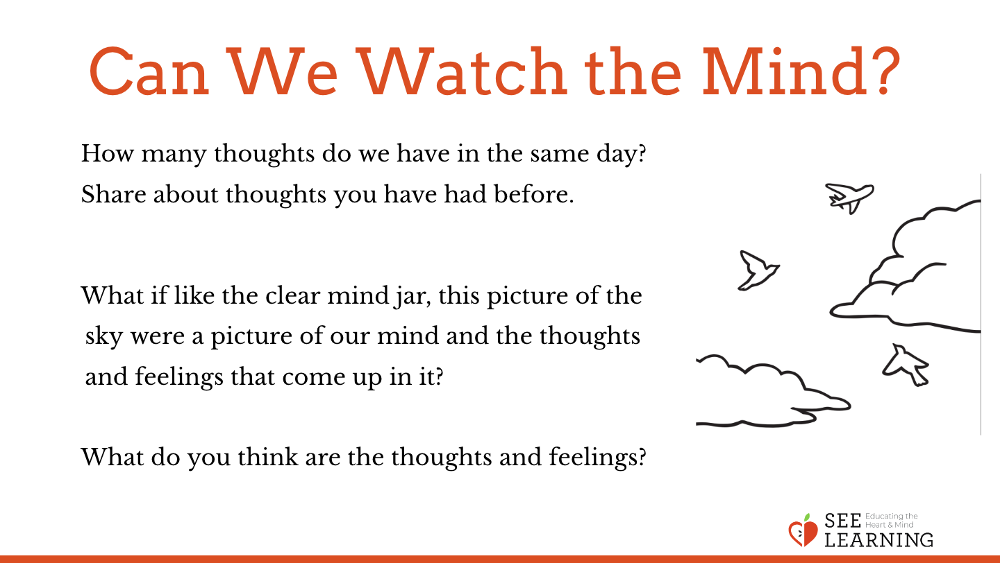 | Sample Script  - "We've been learning how to strengthen our attention.  - We've learned we can pay attention to things on the outside and things on the inside.  - What are things we could pay attention to on the inside? What goes on inside us?  - Where are our thoughts? When I have an idea or think of something, is that on the outside or inside?  - What about when I feel something? Like when I feel happy or tired? Or when I'm upset? Or when I'm happy? Where are those?  - Do you think we can pay attention to our thoughts and what's going on inside us?  - Remember when we made the mind jar and we read the story about Theresa? Lots of things were going on and we put them in the mind jar.  - What did we put in? Can you remember what those things stood for?  - Do we have thoughts there? What about feelings? What else do we have there?  - All these things like our thoughts and feelings come up in our minds. How many thoughts do you have each day? Do you think you could count them?  - Do you think it's possible to watch your thoughts?  - Usually when we have a thought we get all caught up in it. It carries us away. For example, I might think of ice cream. Let's talk a moment to do this right now. Let's close our eyes and think about ice cream. I will ring the chime when a minute is up.  - [Allow a minute to pass and ring the chime and ask:] What happened? [Then make this point.] Then suddenly I am thinking of what kind of ice cream I want, and where I' m going to get it, and how good it’s going to taste! Then I might be thinking about the ice cream I had at the beach, and then I might be thinking I wish I could go to the beach, and pretty soon I would be carried away.  - But what if I just watched that thought? What do you think would happen?  - Do our thoughts stay forever?  - And if I watched it, do you think a new thought would come eventually?  - Take a look at this picture. [Show picture of the sky with clouds.] What do you notice about this picture?  - What if like the clear mind jar, this picture of the sky were a picture of our mind and the thoughts and feelings that come up in it?  - What do you think are the thoughts and feelings? Maybe they are the clouds here. What are other things that appear in the sky? Maybe a rainbow, birds, or an airplane? Maybe even a storm or lightning bolt would appear sometimes!  - When all those things come up in the sky, what does the sky do? Does it change? Does it try to hold on to anything that appears? Does it try to push anything away?  - I wonder if we can watch our thoughts and feelings like this sky. Do you think we can watch thoughts come and go without holding on to them or pushing them away? We're going to try. We'll do an experiment together."

Reflective Practice: Observing the Mind (10 min)
Overview
This is a reflective practice similar to the focused attention on the breath, except that instead of a single object of focus, students will be just sitting quietly with eyes closed or downcast while simply noticing what arises in their mind, without getting involved with the contents of their thoughts and feelings. The practice here is just to watch and observe them with open curiosity and without getting too involved.
Unlike daydreaming, the purpose is to not get caught up in thoughts and get carried away by them, but instead watch them with an open curiosity and without judgment. Practicing this can increase one's ability to catch impulses before they turn into strong emotions and behavioral reactions.

Teacher Tips
- You will notice that this practice combines resourcing and grounding, attention on the breath, and then observing the mind. Each of these practices have been built up to
sequentially, so if your students are not able to do this full practice, go back and practice the shorter practices with them more.
- Once they can do this combined practice, you can consider making this your main practice, and repeat this practice many times with your students, ideally twice or more each week. You can then gradually lengthen the pauses until they are 30 seconds to a minute in length. Eventually you may be able to do 5-minute long practices. As your students eventually become able to do this, they will be engaging in very significant attention training, and their progress will be an encouraging sign to them that they are strengthening their muscle of attention.
Slide 4: Observing the Mind  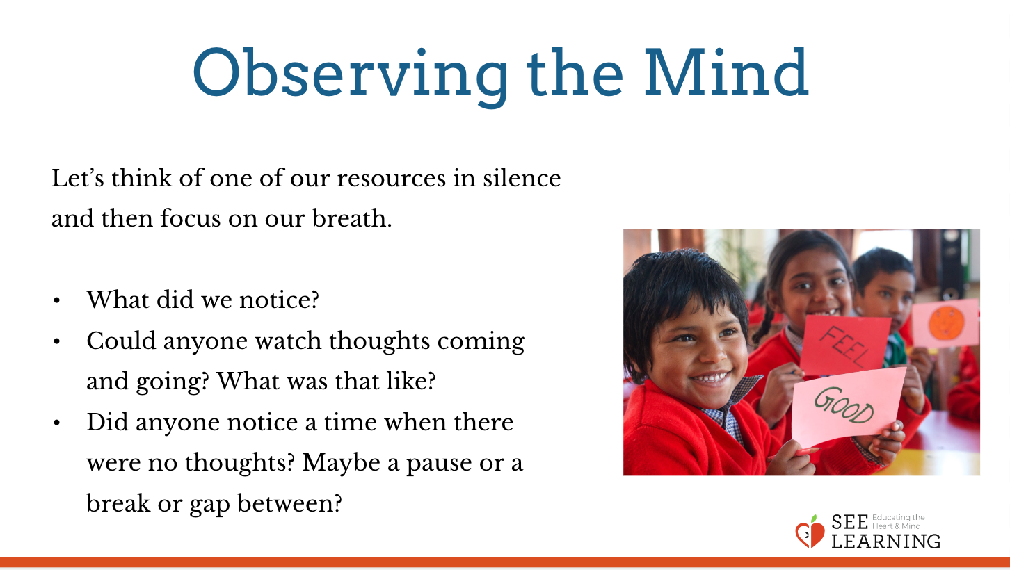 | Sample Script  - "Let's take a comfortable, alert posture.  - If we're too excited or too tired, or if we're not in our resilient zone, it will be hard to train our attention. Just like in our drawings where we drew our minds when they were too dull or too excited.  - So let's sit upright with our backs straight. And so we don't get distracted, let's lower our eyes to the ground or close them.  - So first we'll do a resourcing and grounding activity to help us be in our resilient zone.  - Let's think of one of our resources in silence. Or if you prefer, you can do some grounding where you are sitting. [Pause.]  - Let's focus on our breath now. We'll use that as our object of focus. Remember if you start to feel uncomfortable, you can go back to your resource or to grounding. [Pause for 30 seconds or longer if your students are comfortable doing so.]  - Now let's practice just watching our mind.  - We're going to release our breath. Instead of focusing on our breath, we're just going to watch to see whatever comes up in our mind.  - But instead of getting caught up in our thoughts, we're going to see if we can just watch them.  - Let's be silent and pay close attention and see if we can do that. [Pause for 15-30 seconds, or more if your students are comfortable doing so.]  - If we get distracted or caught up in our thoughts, let's just remember that we're watching our thoughts. We're seeing them come, stay, and g o. Let's try to do that just a little bit more. [Pause for 15-30 seconds or more.]  - Now let's open our eyes and share.  - What did you notice?  - Could anyone watch thoughts coming and going? What was that like?  - Did anyone notice a time when there were no thoughts? Maybe a pause or a break or gap between?"

Debrief (3 min)
Slide 5: Debrief  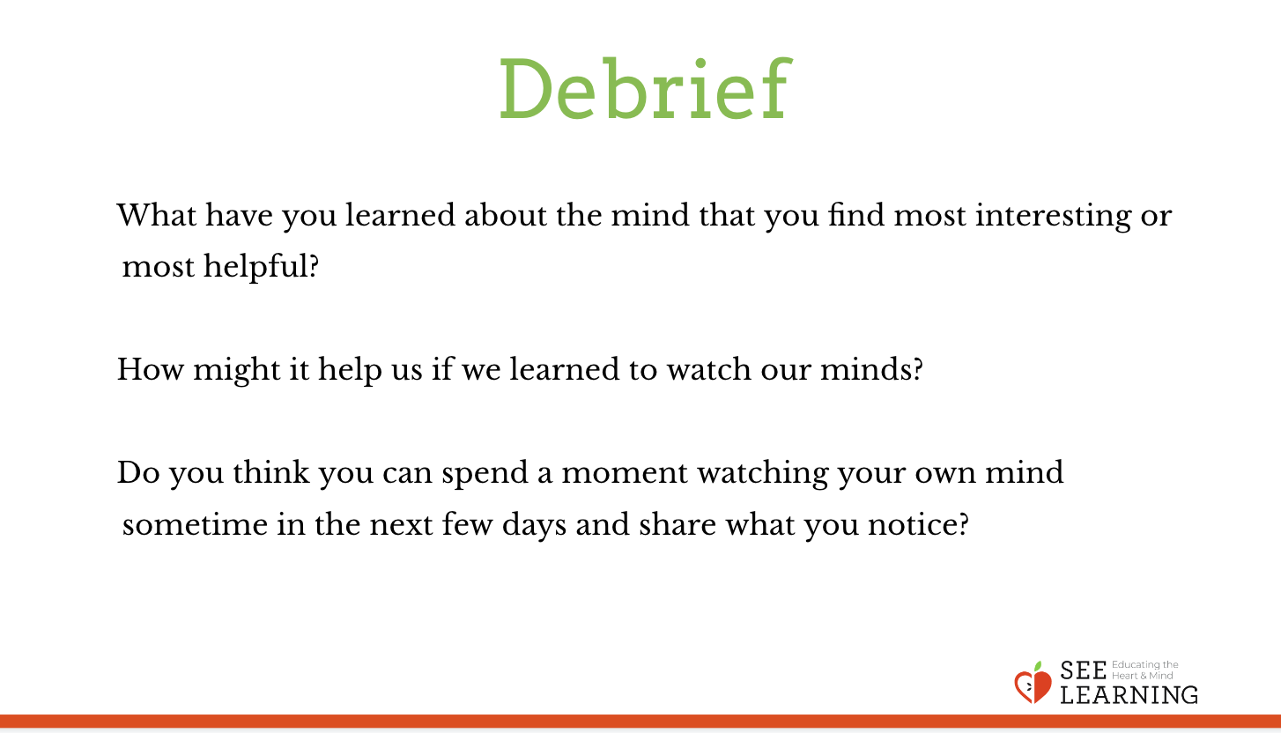  Animated slide | Sample Script  - "What have you learned about the mind that you find most interesting or most helpful?  - How might it help us if we learned to watch our minds?  - Do you think you could spend a moment watching your own mind sometime in the next few days and share what you notice?"

