Cultivating Attention on an Object

Purpose:
This learning experience introduces the idea of focused attention training, using the breath or some other neutral object (such as a neutral sensation) as the object of focus. This may be more challenging than previous activities, which involved paying attention to things that are more stimulating. True attention training, however, involves learning how to pay attention even when something is not that stimulating, because we already naturally pay attention to things that we find interesting. The example of training a puppy or elephant is first introduced to explain the basic components of focused attention training, followed by a reflective exercise involving focus on a single neutral object, such as the breath, and then a drawing exercise to reinforce learning.
Learning Objectives:  Students will be able to:  - Reinforce their understanding of mindfulness and awareness through metaphors as well as direct experience.  - Experience the process for cultivating focused attention on a single object.  - Draw their own images to illustrate attention training. | Primary Core Component  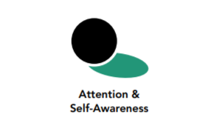
Length  35 minutes | Materials Required  - Drawing paper and pens, pencils, or markers for drawing  - Print-outs of the images at the end of this learning experience

Check-In (4 min)

Slide 2: Checking In   | Sample Script  - “What are some experiences we have had together that helped us to strengthen our attention muscle?  - Did anyone notice a time when a spark could have become a forest fire, but you noticed and stopped it in time? It could be something small.  - Let’s practice our attention a bit with a resource. To help us concentrate, we’re going to keep our eyes on the ground or close them.  - Choose one of your resources from your resource kit, or you can choose a new one, or you can imagine one.  - Now let’s just bring our resource to mind. And let’s see if we can just pay attention to our resource with our mind for a few moments quietly. Or if you’d rather do grounding, you can do that too. Whichever you choose, we’re going to rest quietly and pay attention for a few moments. [Pause.]  - What do you notice inside? If you feel pleasant or neutral, you can rest your mind on that.  - If you feel unpleasant, you can shift to a different resource, or you can ground. You can also change your posture but try not to disturb anyone else if you do that. Otherwise, just keep your attention resting with your resource. [Pause.]  - Whenever you notice that you got distracted and you forgot about your resource, you can bring your mind back to your resource. [Pause for a longer time, such as 15-30 seconds or longer.]  - What did you notice on the inside?”

Presentation/Discussion - Cultivating Focused Attention (8 min)
Overview
- The purpose of this presentation and discussion is to introduce the idea that we can learn to focus our attention on a single object and sustain that attention over time. The method we use is simply to hold a neutral object of focus (such as the breath) in mind and bring our mind back to it whenever we notice that our mind has wandered or has become sleepy (lethargic or dull).
- This presentation uses a metaphor of training a puppy to reinforce the concepts of mindfulness and awareness:
  - Mindfulness = being able to keep one’s mind on a chosen object without forgetting it
  - Awareness = noticing what is taking place in the mind (such as when it gets distracted or sleepy)
  - The puppy = the mind
  - The path = the object of focus (what we’re paying attention to)
  - The leash = mindfulness (what we use to keep our object of focus in mind)
  - The compassionate owner = awareness (what we use to notice if the mind has wandered or is sleepy)
- This not only can help to bring about greater calm and well-being in our bodies and minds, but it also builds our attention like a muscle. With increased attention, we can learn better, we can focus and pay attention better, we can redirect our attention easily when necessary, and we also have a tool for examining our own minds and mental processes, including thoughts and emotions.

Content to be Explored
- We can keep our attention on a single object for longer periods of time.
- Our mind may wander or it may get a bit sleepy.
- If we lose track of our object, we can simply return our attention to the object and hold it again gently in our mind.
- When we keep bringing our mind back and holding our object, our attention gets stronger over time.
- We can feel calmer when we practice sustaining our attention.
- We can learn more easily when we strengthen our attention.
- We can see our attention strengthen gradually through practice.
- We can learn to pay attention even to a neutral or seemingly uninteresting object.
- Our body posture can help us to pay attention.
- Attention involves using mindfulness and awareness to keep us on task.

Materials
- The picture of the puppy, provided at the end of this learning experience (Alternatively, a picture of training an elephant is also provided.)

Instructions
- Show your students the picture of the puppy, provided at the end of this learning experience. (Alternatively, a picture of training an elephant is also provided.)
- Explain that the picture of the puppy is a visual metaphor for attention training. In the picture of the puppy, the path is the object of focus and the puppy is being trained to stay on the path, just as we might train our attention to remain focused on an object or activity. The puppy is the mind, which is what we are training. The leash is mindfulness, since it keeps the puppy on the path. The kind owner is awareness, since it pays attention to what the puppy is doing. (In the picture of the elephant, the elephant is the mind; the stake in the ground is the object of focus; the rope is mindfulness; and the attentive trainer is awareness.)
- In this way you can use the picture(s) to explain the concepts and practices you have been using to help students cultivate stronger attention. Discussing the importance of compassion also helps, because attention training takes time and patience. This will also support the topic of self-compassion, which comes later in the SEE Learning curriculum.

Teacher Tips
- You have already introduced attention with the metaphor of the flashlight.
Slides 3 & 4: Cultivating Focused Attention  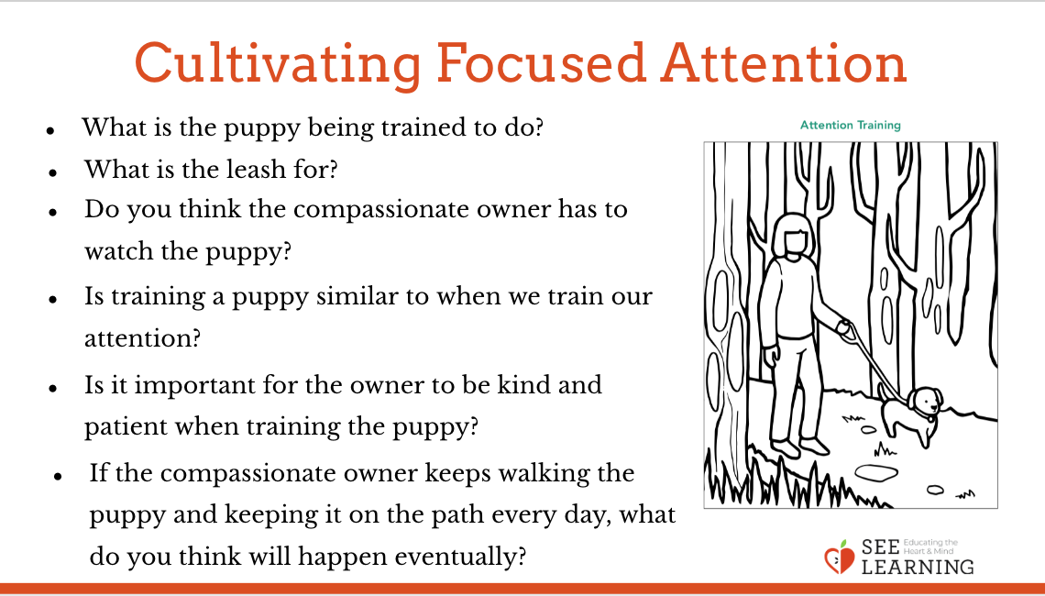  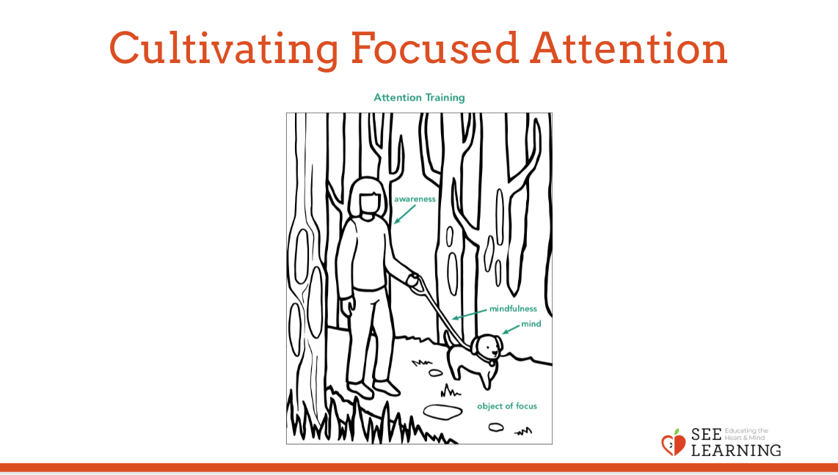 | Sample Script  - What do you think is happening here?  - How do you train a puppy? Do you see anything in this picture that’s being used to train the puppy?  - What is the puppy being trained to do? (Stay on the path. Walk along the path. Not run away.)  - What is the leash for? (Keeping the puppy on the path. Not letting it run away. Keeping it safe.)  - Do you think the compassionate owner has to watch the puppy? Why? (It might stray off the path. It could get into danger.)  - What should the owner do if the puppy wanders off the path?  - If the puppy is too excited, will it be hard to train? What if the puppy is very sleepy?  - Is training a puppy similar to when we train our attention? How might it be similar? (It takes time and practice. We keep our mind on one thing, like the trainer keeping the puppy on the path. We are training our mind.)  - If we’re trying to pay attention to something, like the puppy on the path, and our mind wanders off, what could we do? Could we bring our mind back like the kind owner brings the puppy back?  - Is it important for the owner to be kind and patient when training the puppy? Why? (It takes time. The puppy could get discouraged.)  - If the compassionate owner keeps walking the puppy and keeping it on the path every day, what do you think will happen eventually? (It will get used to it. It will get trained. It may be able to walk without a leash one day.)

Reflective Practice - Focused Attention on the Breath (8 min)
Overview

This reflective practices introduces the more formal practice of attention training on a single object, such as the breath. The key is to sustain attention and bring the mind back when it wanders (or keep attention crisp if one becomes sleepy). The simple method is bringing the mind back whenever it wanders.

Content to be Explored
- N/A

Materials
- None

Instructions
- Begin with a grounding or resourcing practice first to bring about greater calm in the body.
- Ask students to pick a part of the body where they can notice their breathing (nose, chest, belly).
- Ask students to pick some other neutral object if they prefer (a spot on the ground, a part of the body that feels neutral, a neutral sensation). The object should be neutral and not very stimulating.
- Remind them that when their attention wanders, they can bring it back to their object (the breath or other object of focus)
- Remind students that if they become uncomfortable focusing on one thing, they can always return to doing grounding or resourcing or can stop the practice entirely. (Use the script below to facilitate the practice.

Teacher Tips
- It is very important to remind students that they can always return to doing grounding or resourcing or can stop the practice entirely, especially those who experience dysregulation when trying to sit still or focus, for whom it may take more time before they can do practices like this with ease.
- This third chapter of SEE Learning provides a range of attention training practices, but this particular reflective practice of focusing attention on the breath can become a foundational practice for your class. You are encouraged to repeat this practice throughout the school year.
- Feel free to record yourself or a student guiding the practice so that you can play the recording back. Be aware that it may take many sessions until your students gain some familiarity with it.
Slide 5: Focused Attention on the Breath  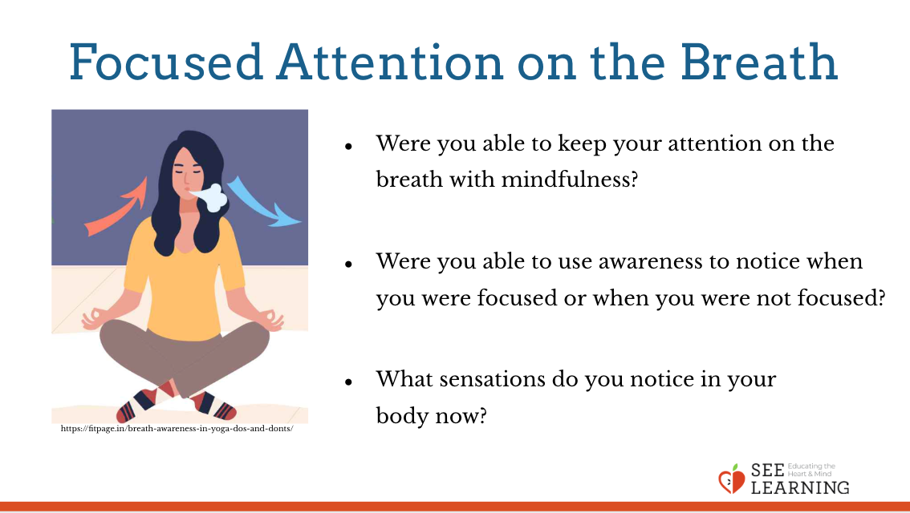 | Sample Script:  - Now let’s try to train our attention in the way we’d train a puppy.  - Let’s take a comfortable seat and we will use what we just learned.  - Just like the puppy, if we’re too excited or too sleepy, or if we’re not in our resilient zone, it will be hard to train our attention.  - So first we’ll do a resourcing and grounding activity to help us be in our resilient zone.  - Let’s think of one of our resources in silence. Or if you prefer, you can do some grounding where you are sitting. [Pause.]  - As we think of our resources, let’s notice any pleasant or neutral sensations in the body. [Pause.]  - If you find a pleasant or neutral sensation, just keep your focus on that. That can be your object of focus for now. [Pause.]  - Maybe now our bodies are feeling more relaxed. Let’s focus on our breath now. We’ll use that as our object of focus. If you don’t want to use your breath, you can choose a neutral sensation.  - It can help to close your eyes. If you don’t want to close them, then lower your eyes to the floor. Let’s be careful not to distract anyone else, because we’re all trying to pay attention.  - Bring your attention to your breath as it enters and leaves your body and just allow your attention to remain with the breath.  - You may notice the breath in your nose. If so, you can pay attention there.  - You may notice the breath in the rise and fall of your belly. If so, you can pay attention there.  - You may notice the breath somewhere else. Then you can pay attention there.  - Wherever you choose, we’ll just keep our attention there on the breath. [Pause.]  - Let’s just breathe in a very natural and relaxed way, and keep our attention with the breath.  - We should be relaxed when doing this, but if instead you feel uncomfortable, you can stop paying attention to the breath and instead go back to doing resourcing or grounding. Or if you need to, just stop and relax on your own quietly.  - Otherwise let’s keep our attention on the breath. [Pause.]  - If we get distracted or our mind wanders, we just bring our mind back to the breath, just like bringing the puppy back. And we see if we can hold the breath in our mind a little longer. [Longer pause.]  - Now we can open our eyes. What was that like? Who would like to share?  - Were you able to keep your attention on the breath with mindfulness?  - Were you able to use awareness to notice when you were focused or when you were not focused?  - What sensations do you notice in your body now?

Insight Activity - Drawing Attention Training (12 min)
Overview

In this activity you will ask students to make a drawing that shows one thing they have learned about attention. You may decide to allow them to choose freely or you may wish to specify more clearly what you’d like them to draw about. The drawings will help them to bring home their understanding and share with you and their classmates what they have come to understand about attention and how to strengthen it.

Content to be Explored
- N/A

Materials
- Blank paper for drawing
- Markers, crayons, or pens

Instructions
- Together, make a list of the things they have learned about attention.
- Have them each choose something from the list to draw. If some students struggle to find something to draw, you can ask them to draw an activity you did as a class (such as mindful walking or mindful eating). Or you can ask them to draw any activity they like to do, since any activity can be done with mindfulness and awareness.
- Allow several minutes for drawing and then allow students to share and explain their drawings. As they share, be sure to ask how attention plays a role in the drawing, asking about how mindfulness, heedfulness or awareness might be present in their drawings.

Teacher Tips
- You can also ask them to write a word on their drawing that explains what it is trying to depict (e.g. “mindfulness,” “a cloudy mind,” etc.) or the activity they are depicting (“mindful walking,” “playing games,” etc.).
- After your students have shared, you may wish to hang up their drawings around the classroom as reminders and reinforcement of what the class has learned about attention.
Slide 6: Drawing Attention Training  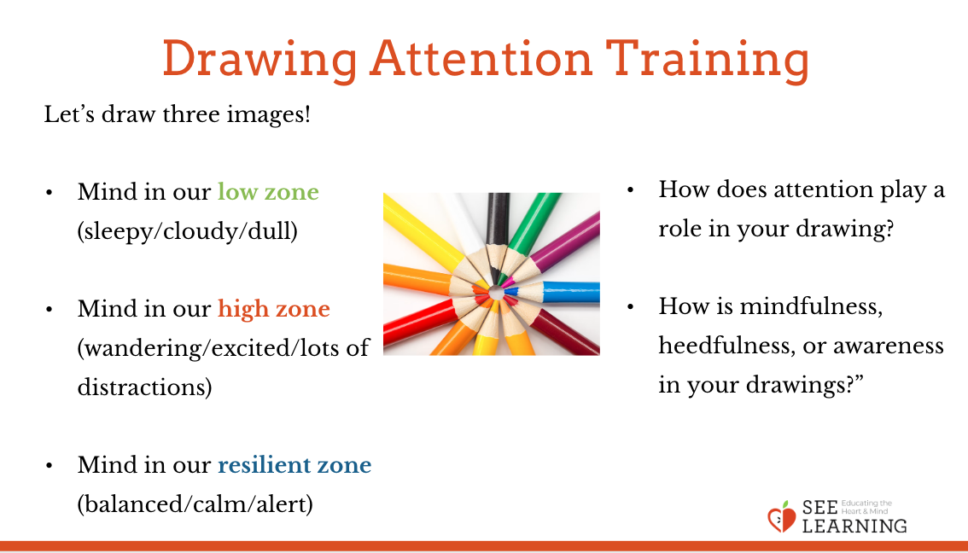 | Sample Script:  - We’ve learned a lot of things about attention and how to strengthen it.  - What if we wanted to share what we’ve learned with other students in the school or with our family?  - Let’s come up with a list of a few things we’ve learned and then we’ll draw pictures that we could use to share what we’ve learned with others.  - Who can name one thing we’ve learned about attention? (For example: It can be trained. It is like a flashlight. It is like training a puppy. It helps us learn and notice things. We can do it with any activity. It helps us have a clear and not cloudy mind like in the mind jar. It involves mindfulness, awareness and heedfulness, etc.) (You may wish to come up with a list that you write on the board or a piece of chart paper.)  - Who can name one way we strengthen our attention? (For example: By practicing. By exercising it. By bringing our mind back when it wanders. By not falling asleep. By having good posture. You may wish to make a separate list of these.)  - Who can describe our mind when we’re not able to pay attention? How might it be?  - Do you think we could make some drawings to share what we’ve learned?  - Let’s each making a drawing that shows one thing we’ve learned about attention.”  - You can also give them more direct guidance about what to draw while still allowing for their individual creativity, such as:  - Let’s each take a piece of paper and draw three images.  - First we’ll draw what it looks like when our mind is sleepy, cloudy or dull, or we are in our “low zone.” You can draw yourself or an animal or something else that shows that the mind doesn’t have much clarity.  - The second image will be when our mind is wandering because we’re stuck in our high zone. Maybe we’re too excited or uncomfortable. Here our mind is full of distractions. What does that look like?  - And the third image will be when our mind is balanced and we are in our resilient (or OK) zone. Here our mind is in a calm, alert state. It’s not too distracted and it’s not too dull and sleepy. This kind of mind can pay attention and learn anything.  - After students have had time to draw, invite students to share their work. Ask:  - “How does attention play a role in your drawing?  - How is mindfulness, heedfulness, or awareness in your drawings?”

Debrief (3 minutes)
Slide 7: Debrief  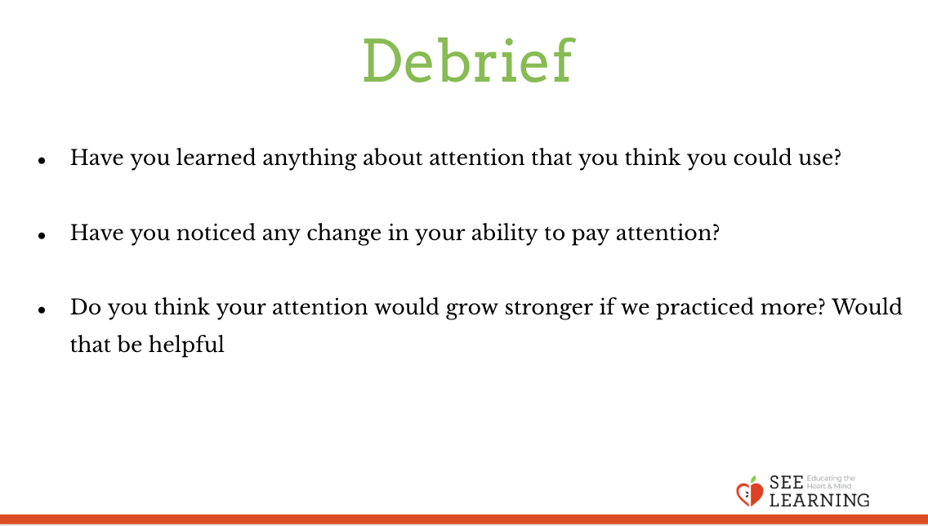 | Sample Script  - Have you learned anything about attention that you think you could use?  - Have you noticed any change in your ability to pay attention?  - Do you think your attention would grow stronger if we practiced more? Would that be helpful?

Expanding on the practice of focused attention on the breath

As you practice focused attention on the breath more with your students, you can also introduce the idea of mentally counting the breath. This involves counting “1” in one’s mind on the inbreath, and then “2” on the out-breath until one gets to 10. After that, one can start over at 1 again. This can be a vivid way of illustrating how quickly we can get distracted, whereupon we tend to lose count of where we were. Counting the breath is a very concrete way to help students reach the critical insight that attention can be strengthened through practice, because students can tangibly see for themselves that their ability to count without losing track of where they are increases over time.

As you continue the practice, you can also begin to show your students that body posture can help facilitate a calm, alert mind. In subsequent practices, you can encourage them to sit in a way that they find comfortable but alert.
- Did you know that the way we sit can affect our mind? If we sit like this [slumping], we can actually make our minds more dull and sleepy. If we stood up with our eyes wide open, how do you think our minds would be? Dull and sleepy or more easily distracted?
- So instead, next time when we do our attention training on the breath, we’re going to find a comfortable posture helps us be stable and clear, helps us be in that calm, alert state. I’m going to sit right now in that way. [Sit so that your spine is relatively upright and straight, and your feet are planted on the ground firmly.]
- I like to imagine sometimes that I am a mountain, sitting very stable and unable to be distracted.
- Sometimes to help me sit up straight, I imagine that I’m a puppet with a string pulling me gently from the top of my head straight up.
- And I like to keep my eyes on the ground, so I’m not distracted. Sometimes, I like to close my eyes entirely. You can do that too if it helps you to not get distracted.
- Shall we try sitting like that?

