Cultivating Attention in Activities: Part 2

Purpose:
The purpose of this learning experience is to show what the cultivation of attention looks like when applied to simple activities like listening, eating, or walking, which are mildly but not overly stimulating, before transitioning to even more neutral things like the breath and writing. It also introduces the idea of “the spark and the forest fire” as an analogy for how our feelings and impulses can get out of control and cause problems for us if we do not pay attention to them with heedfulness and address them in time. There are many activities included here, so feel free to split the learning experience into multiple sessions.
Learning Objectives:  Students will be able to:  - Notice that the training of attention can be involved in any activity we do.  - Practice mindful eating.  - Practice mindful walking, including how to lead the activity | Primary Core Component  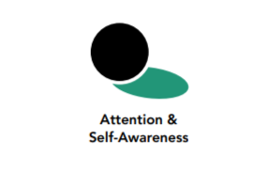
Length  40 minutes | Materials Required  - Provided scenario  - A picture of a spark and a forest fire (provided at the end of this chapter)  - A chime or bell  - Optional: small food or snack items such as grapes, raisins, grape tomatoes, or crackers with enough for two items per student; napkins; a clear open space where your students can walk in a circle together

Check-In (3 min)
Slide 2: Checking In   | Sample Script  - “We’ve been learning how to pay attention. What are some things you have learned about attention?  - Have you been noticing people paying attention or not paying attention? Would anyone like to share an example?  - Have you thought of any other things that attention helps us to do? Since yesterday, can you share one time you used your attention?  - Let’s take a moment to calm our bodies and minds so that we can pay attention for the activities we’re about to do. Take a comfortable posture, one that is relaxed but that will help you keep your attention here. Let’s lower or close our eyes.  - Let’s do grounding or resourcing. First, take a moment to think of one of your resources that you would like to use to help you today. Raise your left hand when you have thought of your resource. Let’s begin. If you’re doing grounding, notice the contact of your body with the floor or chair or some other contact.  - If you’re doing resourcing, bring your resource to mind.  - If you ever feel uncomfortable, you can shift to a pleasant or neutral sensation in your body and focus on that instead. [Pause 15-30 seconds or longer as your students are able.]  - What did you notice on the inside?”

Insight Activity - The Spark and the Forest Fire (8 min)
Overview

In this insight activity, students review the metaphor of the spark and the forest fire as representations of feelings and impulses through reading a scenario. Then they discuss some times when they practiced heedfulness themselves.

Content to be Explored
- Feelings and impulses can be like sparks that quickly grow to a forest fire if we don’t catch them in time.
- It is important to notice our sparks and address them before they become fires, and that can be helped through strengthening our attention and awareness muscles.
- When it’s still a spark, a fire is easy to put out and even a child can do it. Once it’s a forest fire, it lasts until it burns itself out.

Materials
- Scenario, provided below
- Pictures of spark and forest fire (provided at end of learning experience)

Instructions
- Ask students to help remind each other of the spark/forest fire metaphor. Show students a picture or video of a forest fire. (Script below if needed.) • Share the story provided below.
- Give students a few moments to reflect and think about the story. Then ask the group:
  - What happened in the story?
  - What was the spark for the main character?
  - What could happen next if he doesn’t catch the spark?
  - What might he do to catch his spark?
  - How can we benefit from catching our sparks?
  - How can we help others by catching our sparks?

Teacher Tips
- You can write the main character’s thoughts on the board with arrows connecting them to show how one leads to another.
- You can also share with your students the graphic novel Sparks! provided in the supplementary materials to SEE Learning or a similar story that illustrates the concept of the spark of a feeling becoming a forest fire or someone catching it before that happens.
Slides 3 & 4: The Spark and the Forest Fire  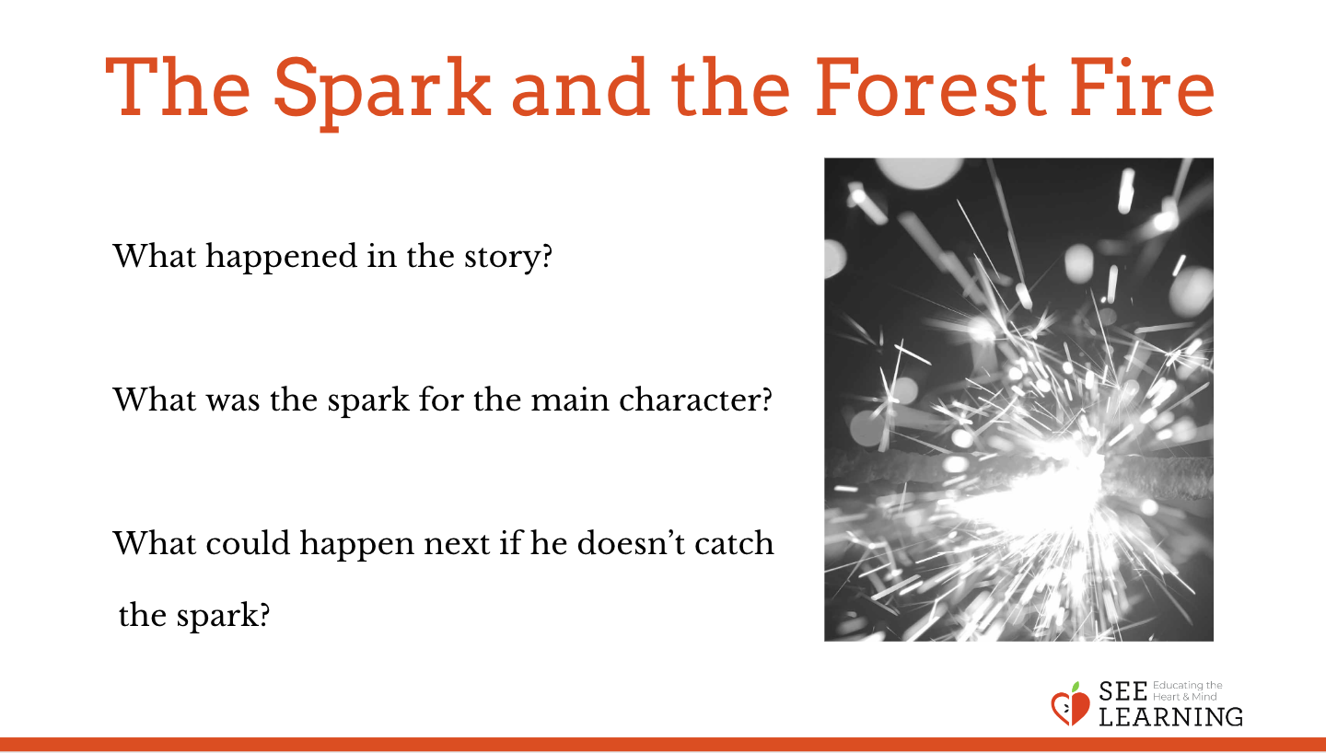  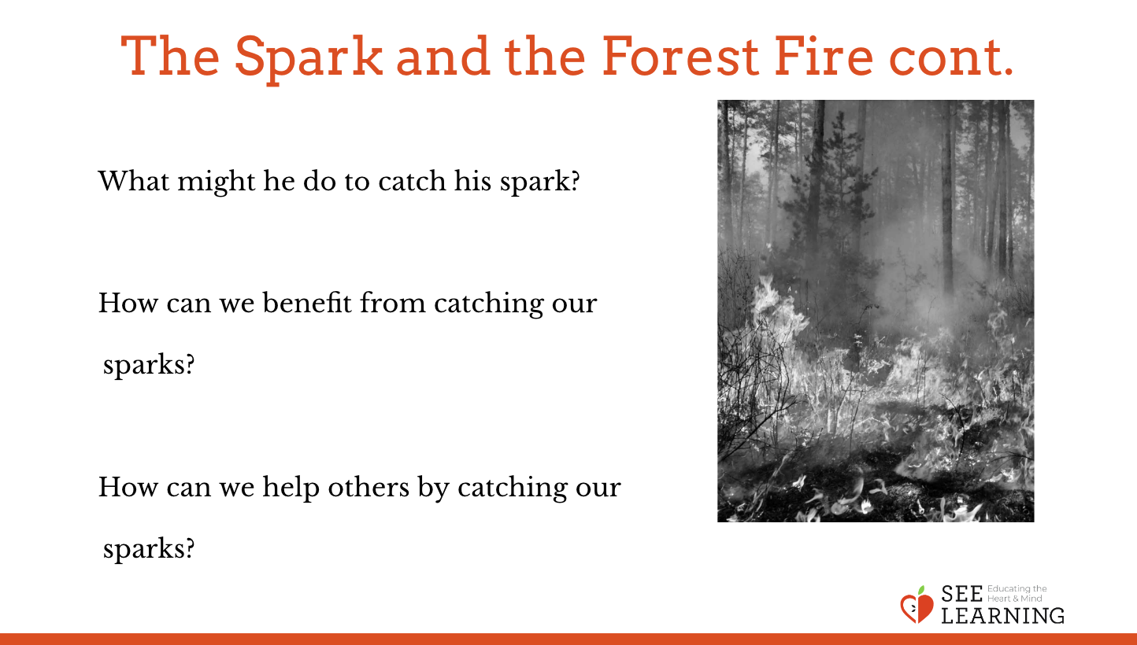 | Sample Script  - “Who knows what is happening here? (Show picture of forest fire.)  - Does anyone know how a forest fire gets started? How big is the fire when it first starts?  - How would you put out the spark or small flame when it’s just getting started? Who could do that?  - What about when it’s really big like this? How would you put it out? Is it harder to put out when it’s a big forest fire like that?  - We’ve been talking about things on the inside, like our thoughts and feelings. How might our feelings be like a spark that turns into a forest fire?  - What happens when someone has a feeling and then it starts to get bigger and bigger, and suddenly they’re feeling really angry or really unhappy?  - What could they have done if they caught that feeling when it was just a spark?  - How could we be careful or heedful of those sparks before they become forest fires?  - Let’s read a short scenario together and talk a little more about this metaphor.  - [After reading the scenario, ask:]  - What happened in the story?  - What was the spark for the main character? What could happen next if he doesn’t catch the spark?  - What might he do to catch his spark?  - Can you think of a time when you caught a spark before it became a forest fire? What did you do to help yourself?  - How can we benefit from catching our sparks?  - How can we help others by catching our sparks?”  Sample Scenarios  “Louis got his math test back. He saw that he missed 3 problems and failed the test. He thought “I did terribly on this test, I’m terrible at math.” Then he thought,”I am never going to be good at math, which means I’m not a good student and then I’m not going to get into college and get a good job and have a successful and happy life...” ”

Reflective Practice - Mindful Listening*(12 min)
Overview

In this practice students try mindful listening. This also serves as a grounding practice after discussing heedfulness and students’ own examples, which could be activating for some.

Content to be Explored
- We can pay attention to any activity.
- We notice more when we pay close attention.
- Attention can make things more vivid and interesting.
- Despite looking the same at first, each thing is unique and different in some way.
- Paying close attention can calm our body and mind.
Slide 5: Mindful Listening  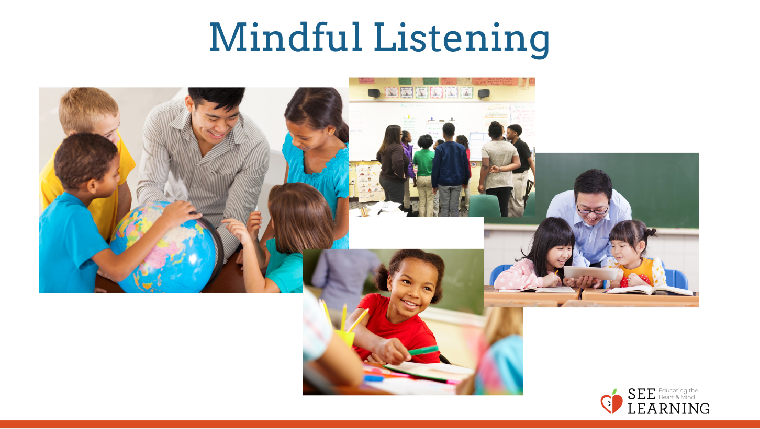 | Sample Script  - “Find a comfortable place in the room. It may be more comfortable for you to close your eyes, but if not, you are also welcome to focus your eyes on the floor. Now, let’s take two breaths to settle in.  - We are first going to focus on things that are far away from us. Open up your ears as big as you can. Can you find the farthest away sound? It is not important to identify the sound, just notice it.  - Now we are going to find the sounds happening inside the building.  - Let’s bring it in even closer - notice the sounds happening inside the room.  - Finally, bring your hearing in as close as possible, what sounds do you hear inside your own body?  - Open your eyes, and come back: How do you feel? What zone do you feel in right now?  - What sensations do you notice in your body? Has your breathing changed?  - What other activities could we do together mindfully?“

Reflective Practice - Mindful Writing* (12 min)
Overview

In this practice, students try mindful writing.

Content to be Explored
- We can pay attention to any activity.
- We notice more when we pay close attention.
- Attention can make things more vivid and interesting.
- Despite looking the same at first, each thing is unique and different in some way.
- Paying close attention can calm our body and mind.

Materials
- SEE Learning journals
- Writing utensils for each student

Instructions
- Distribute SEE Learning journals to students and make sure everyone has a writing utensil.
- Invite students to participate in mindful writing.
- Facilitate mindful writing, using the alphabet as the subject.
- Discuss the experience.

Slide 6 & 7: Mindful Writing  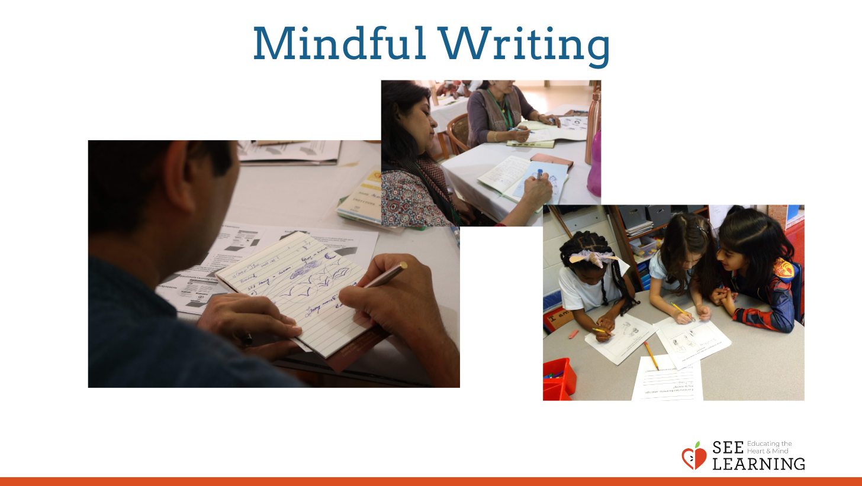  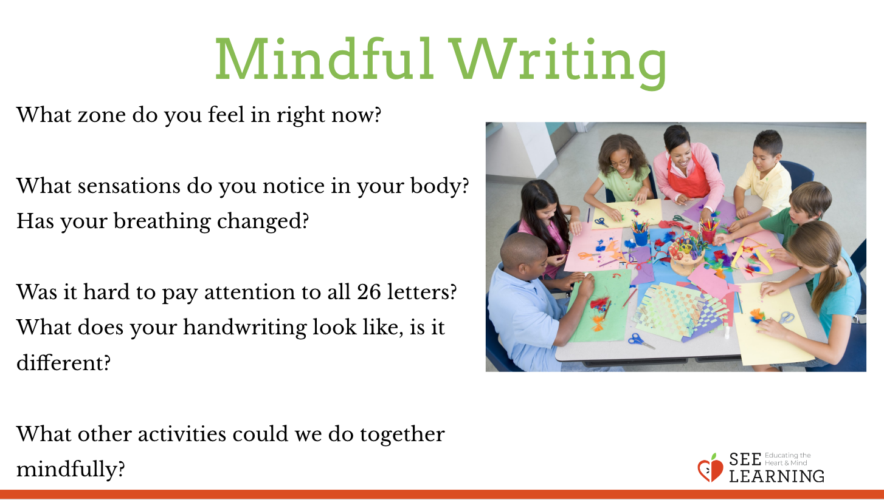 | Sample Script  - “Now we are going to mindful with something that is a little more challenging to pay attention to: handwriting.  - Notice how you are sitting: are you in a comfortable posture for a short writing practice?  - Let’s take one breath to settle into a comfortable posture for mindful writing.  - Slowly pick up the pencil. Notice how you are holding it, where do you feel the pencil in your hand, against your fingers? Can you notice anything else with any other of your senses?  - Slowly put the pencil to paper, but don’t move from there. [Pause.]  - In a moment, you are going to write the lowercase alphabet. But not yet.  - As you write, notice how the pencil feels as it presses down against the paper; notice the movement of your hand remember to keep breathing, if your attention wanders, notice it wandering and then bring it back.  - When you finish, slowly put your pencil down, then take three breaths.  - Debrief: What zone do you feel in right now?  - What sensations do you notice in your body? Has your breathing changed?  - Was it hard to pay attention to all 26 letters? What does your handwriting look like, is it different?  - What other activities could we do together mindfully?”

Debrief
There is no debrief listed here because each Reflective Practice contains discussion questions specific to each practice.

Optional Reflective Practice - Mindful Eating* (12 min)
Overview

In this activity, your students will engage in a mindful eating exercise, which involves examining and then very slowly eating a piece of food with full attention.

Materials Required
- Small food or snack items such as grapes, raisins, grape tomatoes, or crackers with enough for two items per student
- Napkins

Instructions
- Put food items on a plate that can be passed. Let students know that they will be eating the item eventually.
- Tell students to take one item and a napkin and pass it on. Be sure not to eat it yet.
- Remind students of “I Notice, I Wonder.” Tell them this activity is similar. Let them know they are going to pay close attention with all their senses to the food item. This will be a slow process. [Use the script below if needed.]
- After you conclude (such as when the timer or chime goes off), have the students remain in a circle standing and debrief with the questions below.

Teaching Tips
- Be mindful of student allergies or other special circumstances with your group.
Slide 8: Mindful Eating  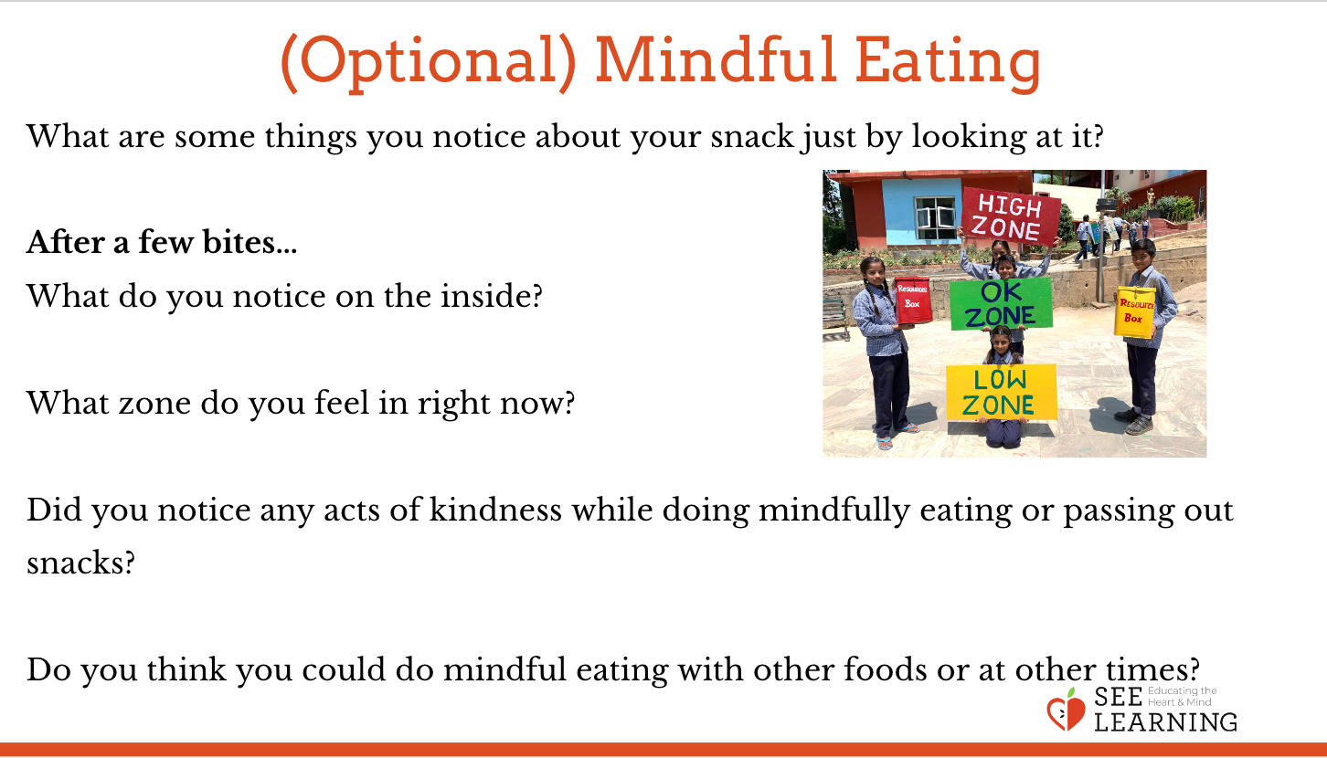 | Sample Script  - “We’re going to do a mindful eating activity now. That means we’re going to eat by paying attention very closely. Let’s see what that means.  - I have some snacks here and some napkins. I’m going to take one snack and one napkin pass it on. Each of you can take one and then pass it on to the next person until we all have one. Don’t eat yours just yet - just put it on the napkin.  - Earlier we did an activity called “I Notice, I Wonder.” We all looked at an [the object you used for that activity] together. We paid close attention to it and noticed all sorts of things.  - We’re going to do something similar with this snack. Let’s pay close attention to it with all our senses and see what we notice. We can look at it, smell it, feel it in our hands or against our lips, even listen to it. And soon we’re going to taste it, but not just yet. Then we’ll share at the end of the activity  - What are some things you notice about your snack just by looking at it? (for example, its color, how it reflects the light, its surface) Now, Look again...what is another detail that you did not notice before? Now, pick it up – anything more you notice? Now smell it. Anyone notice a smell? Do you notice anything happening in your mouth while you’re looking at it? When you think about eating it, do you notice any thoughts? Your mind might be telling you “oh boy, I can’t wait!” or “Yuck, I don’t want to eat that!” or you might feel a little curious, or just neutral.  - Now we’re going to eat it, but we’re going to do it mindfully. That means we’ll pay close attention. We’re not going to eat it all at once.  - Take your snack and put it in your mouth but don’t bite on it yet. Just feel what it’s like inside your mouth.  - Now let’s take a first bite - just one bite. Pay close attention and see what you notice.  - Now let’s take a few more bites, but very slowly. You don’t need to speak just yet: what are you noticing? Is the taste staying the same or changing? Can you notice any thoughts?  - Let’s take a moment to slowly eat our snack mindfully, keeping our attention focused on our eating. At the same time we’re using awareness to see what we notice. Let’s do this in silence and raise your hand when you are finished eating. [Wait until most of your students have finished eating, then ring the chime.]  - Now let’s share what we noticed. What did you notice?  - Next ask:  - What do you notice on the inside? [Ask specifically about sensations and where they are in the body, reinforcing learning from Chapter 2]  - What zone do you feel in right now?  - Did any of you notice any acts of kindness when we were doing mindful eating or passing out the snacks?  - We each received the snack from someone else, and they received it from someone else, didn’t they? How many acts of kindness can you count from receiving your snack?  - Do you think you could do mindful eating with other foods or at other times? If you like you can even do mindful eating at home or at lunchtime in school.  - What other activities could we do together mindfully?” [Invite sharing.]  If you have time, repeat the activity with the same snack or with a different snack. Then conclude by pointing out that we can eat anything with mindfulness and attention.

Optional Reflective Practice - Mindful Walking*(12 min)
Overview

- This activity involves having students walk slowly in a line, one in front of the other, while paying attention to the simple act of walking and the sensations of one’s feet on the ground.
- Mindful walking is different from mindful eating in that the activity itself can be less stimulating and even boring. It’s important to cultivate attention using neutral or “boring” things, because we naturally pay attention to fun and stimulating things, whereas it is the things that we find less stimulating that we have difficulty paying close attention to.

Materials Required
- A clear open space where your class can walk in a circle together.

Instructions
- Clear an open space where your class can walk in a circle. Make sure there are no obstacles that students can trip on or bump into.
- Get your students into a circle. Set the distance between students (two to three feet between each student).
- Have students turn to face the same direction. Decide on a number of rounds (two to three) you will mindfully walk, or set a timer (3-5 min).
- Lead the slow walk yourself the first time, then have a student lead.
- Set the pace (one step per in-breath and outbreath may work well).
- Ask students to lower their gaze so they only see the feet of the student in front of them.
- After you conclude (such as when the timer or chime goes off), have the students remain in a circle standing

Teaching Tips

- You may need to use an outdoor space, hall, or gym.
- As an alternative to leading the activity yourself, you may start with a few students and then allow students to join the line or circle as they feel ready. In this case, you would join last, first making sure that each student understands what to do and feels comfortable engaging in the mindful walking.
- You are recommended to do this activity more than once. As your students gain familiarity, you can start and conclude the activity in mindful silence also. For example, you can each rise from your seats slowly and with full attention one by one as you join the line, and when the mindful walking concludes, you can slowly take your seats, again in silence, one by one, until the last person is seated. You can also start having students volunteer to be the “leader”—the person who starts and ends the activity and sets the pace.
Slide 9: Mindful Walking  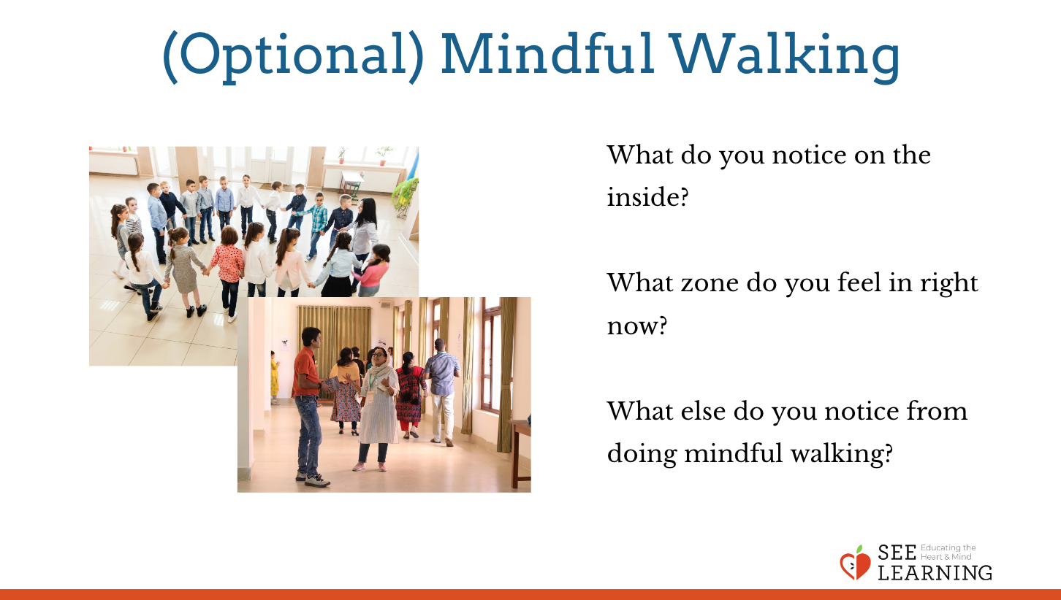 | Sample Script  - “Now we’re going to be mindful with something that’s a little harder to pay attention to.  - We walk all the time, so it’s hard to pay attention to it. It’s easier to pay attention when something is new or exciting or fun, isn’t it?  - Let’s all get in a circle and hold our arms out to make sure we have enough space in between us. Now take 2 large steps back.  - We’re going to walk in a circle. I will lead you in a slow walk. I might pace my walking by taking one step with my in-breath and one step with my out-breath. You can do this if you like. It’s not required.  - You’ll wait until the person in front of you moves away from you to begin. Once we are all mindfully walking, we will go for a couple rounds.  - Keep your eyes down on the feet of the person in front of you. See if you can keep the same distance as you walk—not too close to them and not too far away  - Now I’m going to start and we’re going to do the whole thing in silence, without talking.  - When your walking is completed, ask:  - What do you notice on the inside? [Ask specifically about sensations and where they are in the body, reinforcing learning from Chapter 2]  - What zone do you feel in right now?  - What else do you notice from doing mindful walking?  - What other activities could we do together mindfully?

