Cultivating Attention in Activities: Part 1

Purpose:
This learning experience introduces three concepts : (1) “awareness” of what is going on in our mind, our bodies, and around us; (2) “heedfulness” of things that could be dangerous or harmful; and (3) “mindfulness” of what we are trying to do or accomplish without distraction and without forgetting what we are doing. These aspects of attention not only allow us to maintain our focus and learn better, they also help us catch emotional impulses before they create problems for ourselves and others: that is, catching the spark before it becomes a forest fire.
Learning Objectives:  Students will be able to:  - Further explore the term “attention” and the benefits of strengthening attention.  - Learn we can pay attention to things on the inside (our body and mind).  - Be introduced to the terms “mindfulness” “awareness,” and “heedfulness.”  - Learn to catch impulses before they cause us problems, like catching a spark before it becomes a forest fire. | Primary Core Component  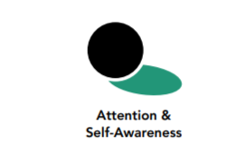
Length  40 minutes | Materials Required  - Chart paper and markers  - A piece of chart paper or a whiteboard with the word “attention” written in the center and the words “mindfulness,” “awareness” and “heedfulness” written around it  - Heedfulness scenarios printed-out (provided at and of learning experience)  - For optional insight activity: 4 oz cups (small cups work best because there is limited space for holding)  - A water source and towel for spills

Check-In (3 min)
Slide 2: Checking In   | Sample Script  - “We’ve been learning how to pay attention and how to strengthen our attention like a muscle. Can anyone think of a time recently when you had to pay close attention? What was that like?  - Maybe you can think of a time when you had to pay attention, but it was hard because there were a lot of distractions, but you still paid attention. Who has a moment that they can share?  - Remember when we used the flashlight? How was that like what we had to do when we wanted to pay attention but there were things that got in the way?  - What are some of the things attention helps us to do?  - Let’s take a moment to calm our bodies and minds so that we can be ready to pay attention Take a comfortable posture, one that is relaxed but that will help you keep your attention here.  - Now let’s do grounding or resourcing. If you’re doing grounding, notice the how your body is touching the floor or chair or some other place. Then notice pleasant or neutral sensations and keep your attention there for a few moments.  - If you’re doing resourcing, bring your resource to mind and see if you can keep your attention on your resource for a few moments.  - If you ever feel uncomfortable, you can shift to a pleasant or neutral sensation in your body and focus on that instead. [Pause 15-30 seconds or longer as your students are able.]  - What did you notice this time?”

Presentation/Discussion - What is Attention and What is it For? (8 min)
Overview
- This discussion is for exploring what attention is, what we can pay attention to, and what the benefits of attention are.
- You will create a further word map for the word “attention,” this time to explore: (1) the various things we can pay attention to, (2) what we pay attention with (our senses, our body, and our mind), and (3) what the benefits of attention are.
- The students have already been paying attention to things on the inside through the practice of “tracking” their sensations. Here you can expand it to include paying attention to things on the inside that include the mind and aren’t limited to sensations. Some examples are: a piece of music stuck in one’s head; daydreaming; getting lost in a particular thought or memory; picturing something imaginary in one’s mind, such as when resourcing; worrying about something then realizing it’s going to be okay; and so on.

Content to be Explored
- Just as we can pay attention to outside things with our senses, we can pay attention to what’s going on inside us (sensations, thoughts, feelings, etc).
- Attention supports learning and can be strengthened.
- We can learn to catch impulses before they cause us problems.

Materials
- Markers
- A piece of chart paper or a whiteboard with the word “attention” written in the center (Later you will add the words “mindfulness,” “awareness,” and “heedfulness” written around it.)

Instructions
- Co-create a word map by writing the word “attention” in the middle and then writing out other words that students suggest around it, connected with lines or arrows.
- Divide the large group into small groups of 3-4.
- Assign each group one or more of the following questions:
  - Co-create a word map by writing the word “attention” in the middle and then writing out other words that students suggest around it, connected with lines or arrows.
    - Divide the large group into small groups of 3-4.
    - Assign each group one or more of the following questions:
      - Why is important to pay attention, what would it be like if we couldn’t/didn’t, what could happen?”
  - Tell each group to make a thought map of their answer(s).
  - Facilitate sharing of each group to a shared thought map for the whole class.
- Alternatively, complete this activity as a whole group.
  - Ask students what things on the outside we can pay attention to. Write those suggestions in a list entitled Outside.
  - Ask students what we use to pay attention to those things on the outside. Write these senses near the Outside list.
  - Ask students what things on the inside we can pay attention to. Write those suggestions in a list entitled Inside.
  - Ask students what we use to pay attention to those things on the inside. Write these suggestions (mind, body, attention) near the Inside list.
  - Ask students why it is important to pay attention to these things, on the inside and the outside. Write the benefits they suggest.
  - Ask students to consider what it might be like if we couldn’t pay attention at all. Discuss.
  - Remind and reinforce that everyone can pay attention and we can all strengthen our attention like a muscle with practice

Teacher Tips
- Save the thought maps or take photos of them for later reference.
Slide 3: What is Attention and What is it For?  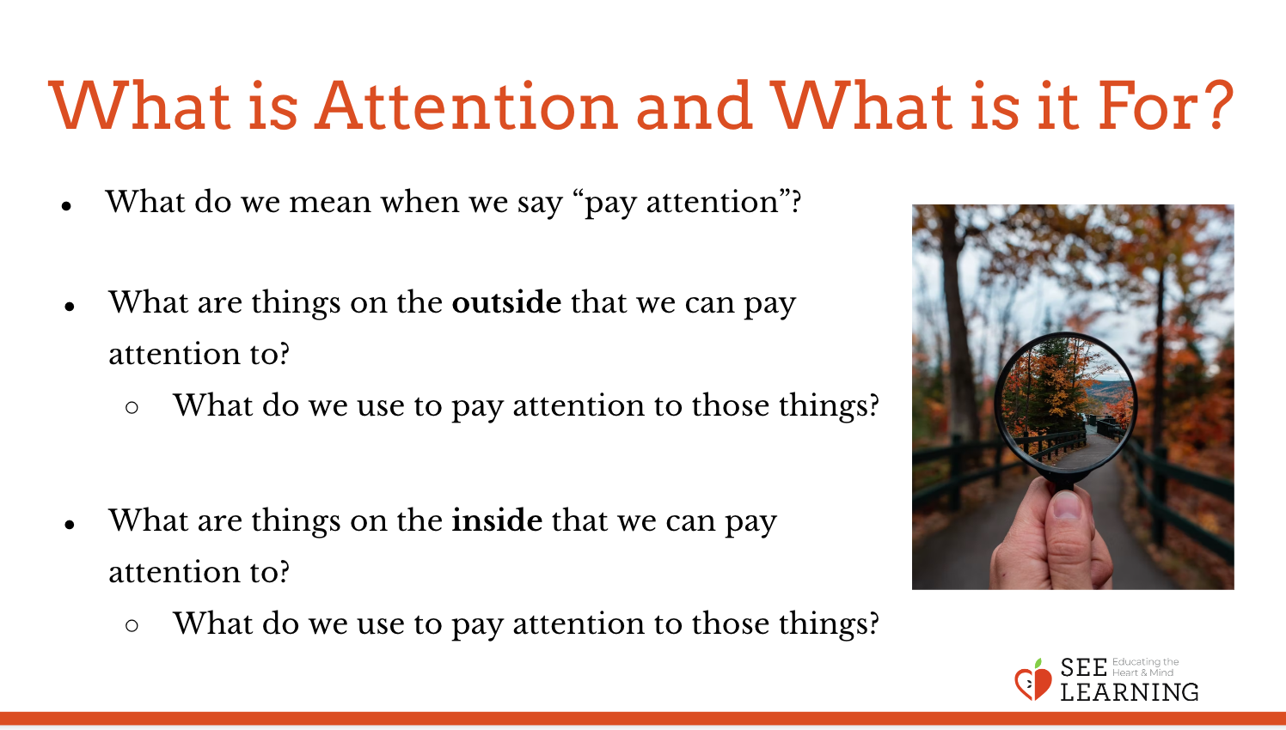 | Sample Script  - “What do we mean when we say “pay attention”? (Write down students responses around the word attention.)  - Can we pay attention to things on the outside and on the inside?  - What are things on the outside that we can pay attention to? Things outside of us. (For example, the room, the sound of a fire truck, other people. Write these on a list under the word “Outside”.)  - What do we use to pay attention to those things? (Our senses, our eyes, ears, etc. Write these near the same list)  - What are things on the inside we can pay attention to? (Sensations, being hungry, thoughts, emotions, feelings, worries, memories, our activities. Write these on a list under the word “Inside”.) • What do we use to pay attention to these things on the inside? (Our body, our mind, our attention.)  - What do we use to pay attention to these things on the inside? (Our body, our mind, our attention.)  - Why is it important to pay attention to these things? (If you like, list benefits on another piece of chart paper.)  - What would it be like if we couldn’t pay attention at all? What might happen?  - Fortunately, everyone can pay attention and we can all strengthen our attention like a muscle with practice.”

Insight Activity - The Story of Ben (10 min)
Overview

In this activity you’ll review a story that gives an example of paying attention to one’s activities, and then discuss it with your students to gradually introduce the concepts of “mindfulness,” “awareness,” and “heedfulness.” You’ll also help them make a list of examples of things we might need to be heedful of.

Content to be Explored
- We can learn to catch impulses before they cause us problems.
- Awareness and attention can be strengthened with practice.
- There are things that it’s helpful to be heedful of.

Materials
- One of the stories (provided below)
- Chart paper or whiteboard
- Markers

Instructions
- Students who had SEE Learning in previous years may already know the Story of Ben. Remind students of the story or re-read the story to your class. .
- Review the ideas of “heedfulness” and “awareness.”
- Have kids brainstorm times during which they were or were not heedful. This brainstorm can be whole group or individual.
- Brainstorm a general list of what things it’s good to be heedful of or careful about.
- Select two or three ideas from that list and write about why it’s helpful to be heedful of those things.
- Invite students to share with the whole group if they wish.

Teacher Tips
- The story can be fun to act out by yourself or with your students. For example, you can stretch out one hand and then catching hold of it with your other hand at the appropriate time. Feel free to alter details or replace the story with one that you feel may be more suitable for your students, as long as it exemplifies paying attention to the mind and catching a habitual tendency before it becomes problematic.
- Help students start brainstorming with a funny one, such as: Ms. Austin was walking in her backyard, thinking about a lot of things other than where she was going, and she forgot to look out for dog poop (or a dirty puddle) and stepped in it!
Slide 4: The Story of Ben  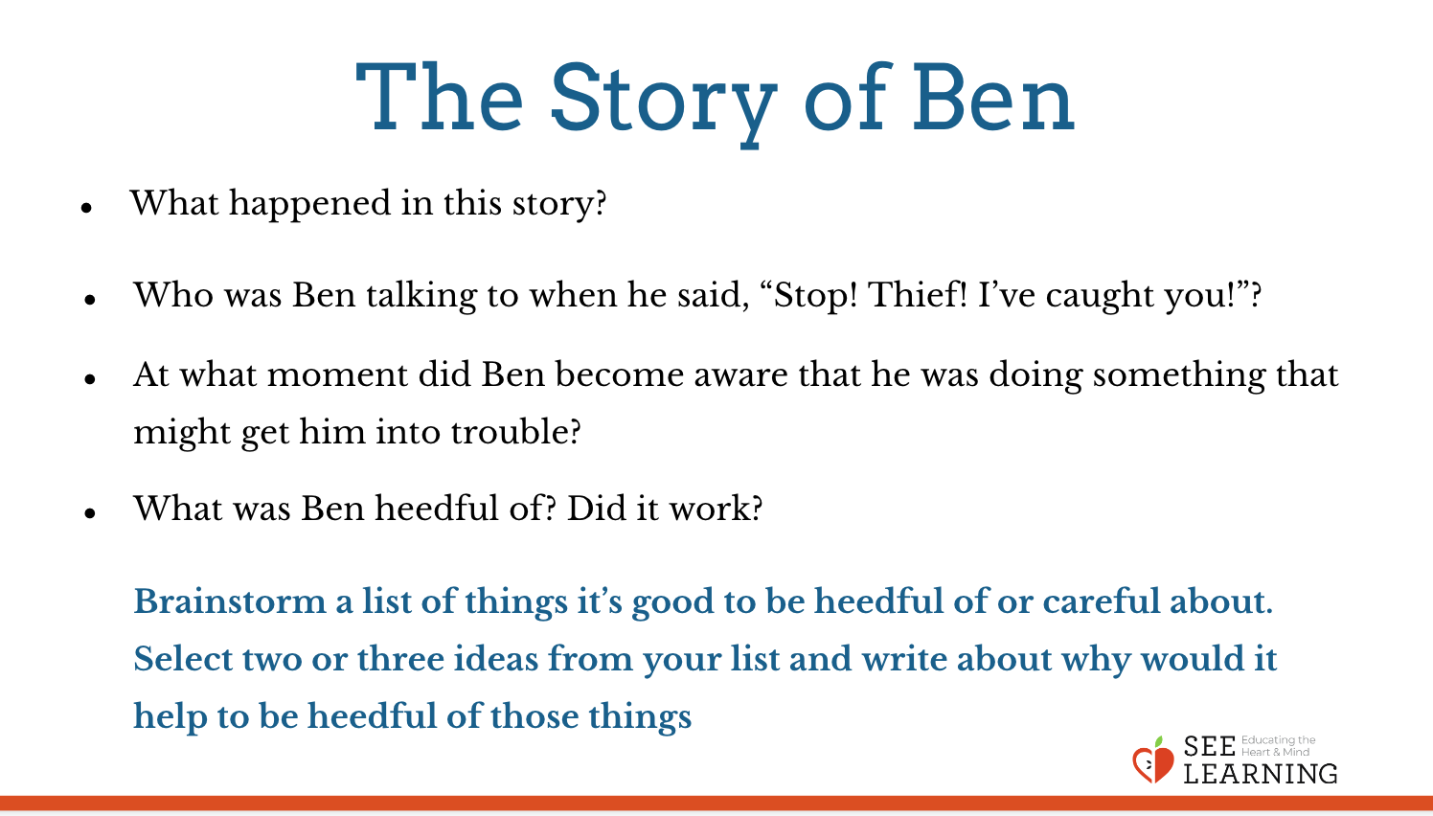 | The Story of Ben  “Once there was a fellow called Ben. When he was younger, Ben had a bad habit of just taking things that didn’t belong to him. Some people even called him a thief. But when he grew a bit older he stopped doing that. He decided that he shouldn’t steal from people, because if he did, they would be hurt and it would be hard to be friends with them. One day while out walking, Ben was invited in by some friends for a meal. While sitting at the table, he noticed the food in front of him, and while his friends were away, he quickly reached out to take some of the food with one hand to put into his pockets. Suddenly he caught himself, and his other hand quickly grabbed hold of the arm that was about to steal the food. “Stop! Thief! I’ve caught you!” he shouted loudly. His hosts rushed in, surprised. “What’s going on? Where’s the thief?” they asked. “It’s Ben!” he shouted, holding his own arm tightly. “Ben is the thief!””  Alternative story: The Boy and the Acorns  “A boy in school was playing and throwing acorns. He was throwing them away from other children, over the playground fence, when a car came by. He hit the car with the acorn. The driver got out and was upset. “Why did you throw something at my car?” she asked. The boy was in tears. He said, “My hand just threw it before my mind knew it was a bad idea.” The driver nodded and she said, “Don’t worry. I used to do things like that too. With practice, you can learn to catch yourself before you do something that could be dangerous. It’s called heedfulness.””  Sample script for use with The Story of Ben  - “What happened in this story?  - Who was Ben talking to when he said, “Stop! Thief! I’ve caught you!”?  - Why were the other people surprised when they walked in and heard Ben say that?  - What did Ben do without thinking about it?  - At what moment did Ben become aware that he was doing something that might get him into trouble? We could say that at that moment he had awareness – he realized what he was going to do.  - We can have awareness of things on the outside by seeing them or hearing them. Can we also have awareness of things on the inside? Can we have awareness of what we’re doing?  - Ben knew that stealing was dangerous. When you know something could be dangerous, you have “heedfulness.” It means to be very careful.  - What are things we need to be careful around or heedful of if we are in the kitchen?  - What was Ben heedful of? Did it work?  - If Ben hadn’t practiced being heedful, what do you think would have happened? What would have happened if he just stole the food without catching himself in time?  - Let’s take some time for individual writing [or in small groups].  - Brainstorm a list of things it’s good to be heedful of or careful about.  - Select two or three ideas from your list and write about why would it help to be heedful of those things. We’ll take some time to share if you like after writing.”  - [Provide time for students to share.]

Insight Activity - Using Heedfulness and Awareness for Different Outcomes (14 min)
Overview

Students will look at familiar scenarios and determine where the main character could have used heedfulness or awareness to have a different outcome.

Content to be Explored
- We can learn to catch impulses before they cause us problems.
- Awareness and attention can be strengthened with practice.
- There are things that it’s helpful to be heedful of.

Materials
- Print-outs of the “Heedfulness Scenarios,” provided at the end of this learning experience
- Chart paper or white board
- Markers

Instructions
- Divide your students into groups of 3 or 4 and give each group a scenario.
- Ask each group to read the scenario together.
- Ask each group to discuss the following questions about their assigned scenario:
- What happens in the scenario?
- At which points could the character have practiced heedfulness?
- What could the character have done instead of what they actually did?
- Next, each group will plan to act out the scenario with heedfulness for the rest of the class. (Allow them about 4 or more minutes for this). Students can “play” the characters in the scenario, but they can also “play” sensations, emotions, or thoughts experienced.
- Bring the class back together and invite each group to act out their skit, while others observe.
- Only if you feel the acting may have been unclear, read the scenario aloud for the class so that it’s clear what happened.
- Ask the students who were watching to explain where they saw the character or characters practicing heedfulness.
- Move on to the next group, asking them to act out their scenario and repeat.

Teacher Tips
- Kids can do this in partnerships or small groups. Each group can get a copy of all scenarios or just one scenario.
- Remember to alter the names of the characters in the scenarios if they are the same as any of your students.
- Write the questions on the board or a piece of chart paper.
- Blank scenario cards are provided if you want to create your own, or you can allow your students to create their own custom scenarios
Slide 5 & 6: Using Heedfulness and Awareness for Different Outcomes  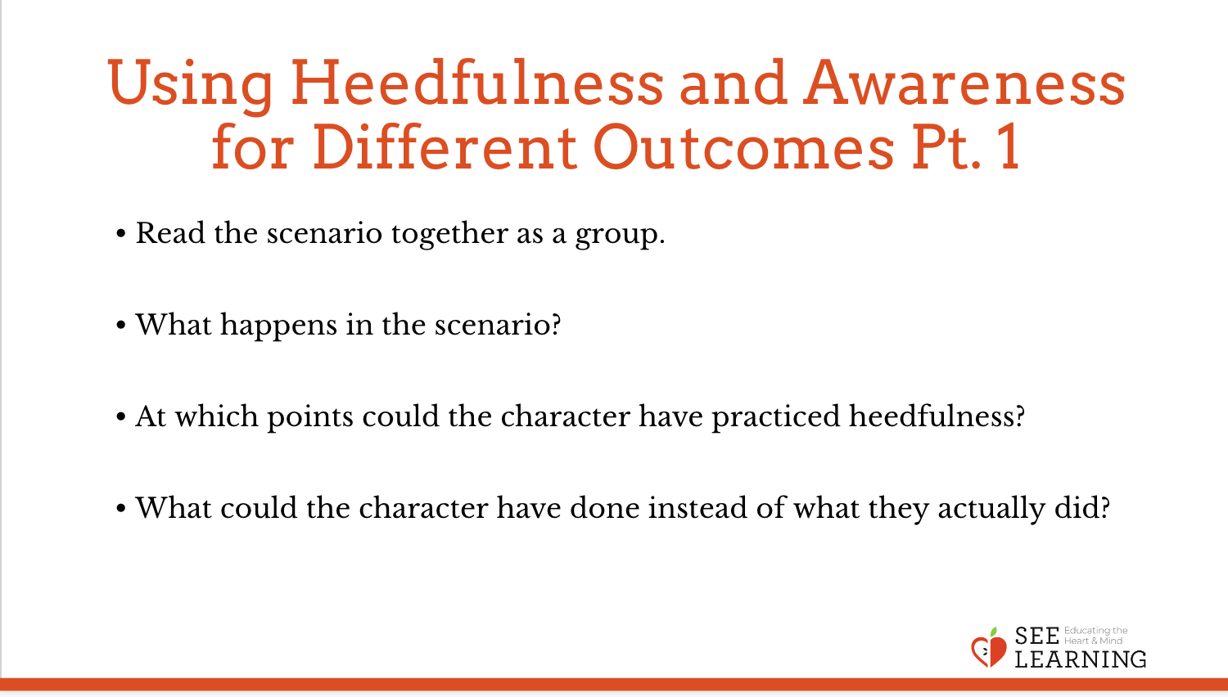  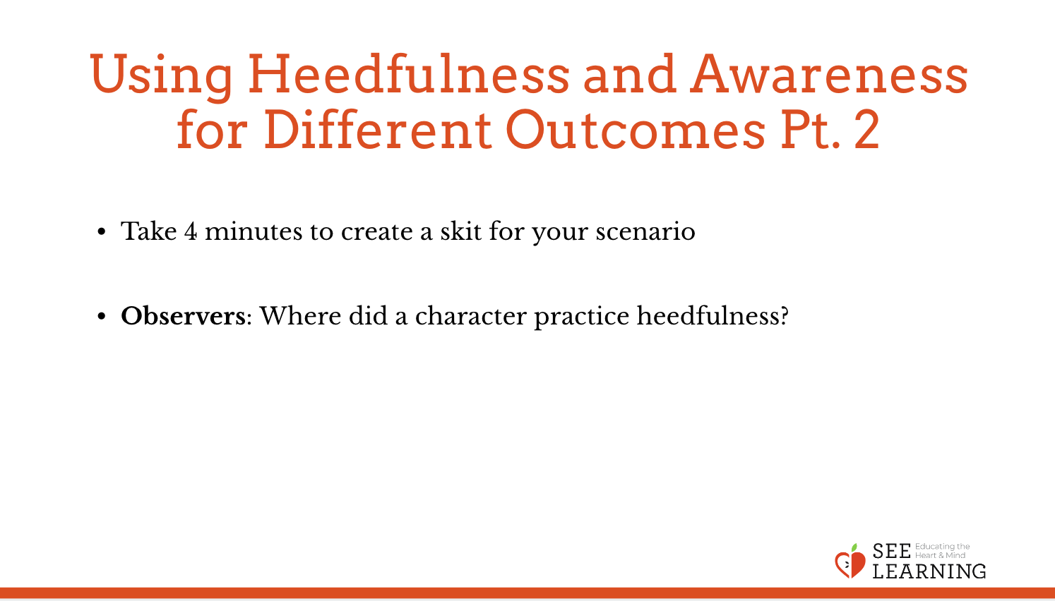 | Heedfulness Scenarios  (These are also provided as handout cards that you can print out.)  - Rosa is playing soccer on the playground. Her team has not scored in some time, while the other team has. A lot of her friends are on the other team and keep smiling and getting excited when they score. The other team scores again and one of her friends jumps up and down and says “Yes, we are so good!” right next to Rosa. Rosa pushes her friend to the ground.  - Martin loves being helpful. He is often the first to offer to help anyone, even if he is in the middle of something else. One day during writing, he noticed a friend could not reach a material she needed. “I’ll help you,” Martin called from across the room. He raced over, grabbed a chair, and quickly stood on the chair to grab the material. In his haste, he did not realize the chair was not stable, and he fell to the ground, hurting his wrist.  - Oskar had the best weekend. He and his best friend had a sleepover, he played basketball, and he ate at his favorite restaurant. During Monday morning at school, everyone gets to share about their weekend and he couldn’t wait. It was another classmate’s turn, and she was sharing about her sleepover. Oskar immediately interrupted his classmate by blurting out, “I had a sleepover too and I played basketball, and I ate at my favorite restaurant!”  - Jadon and his class were doing a project that required them to build a sturdy but tall structure out of toothpicks and marshmallows. When everyone was done, the class walked around to each structure to look at how different they were and let each other explain their structures. In his excitement to have the best spot to see, Jadon tripped over another child and knocked a structure over.  - Emerson was really hungry and was helping her mom make pasta. While her mom was not looking, Emerson used a spoon and grabbed a noodle out of the boiling pasta water. She quickly put it in her mouth, realizing too late how hot it was.  - Tenzin really wanted to make sure he got a seat next to his friends in the cafeteria, so that they could talk about and look at the comic book that he had brought, which was under his arm. His tray was piled high with food, and he decided to also balance his drink on top of it so he wouldn’t have to go back to get it. On his way to the table where his friends were, he dropped his tray.

Reflective Practice - Setting the Mind with a Resource* (5 min)
Overview

This reflective practice is the same as that in the previous learning experience. You are encouraged to do this practice on a regular basis with your students to strengthen the muscle of attention.
Slide 7: Settling the Mind with a Resrouce  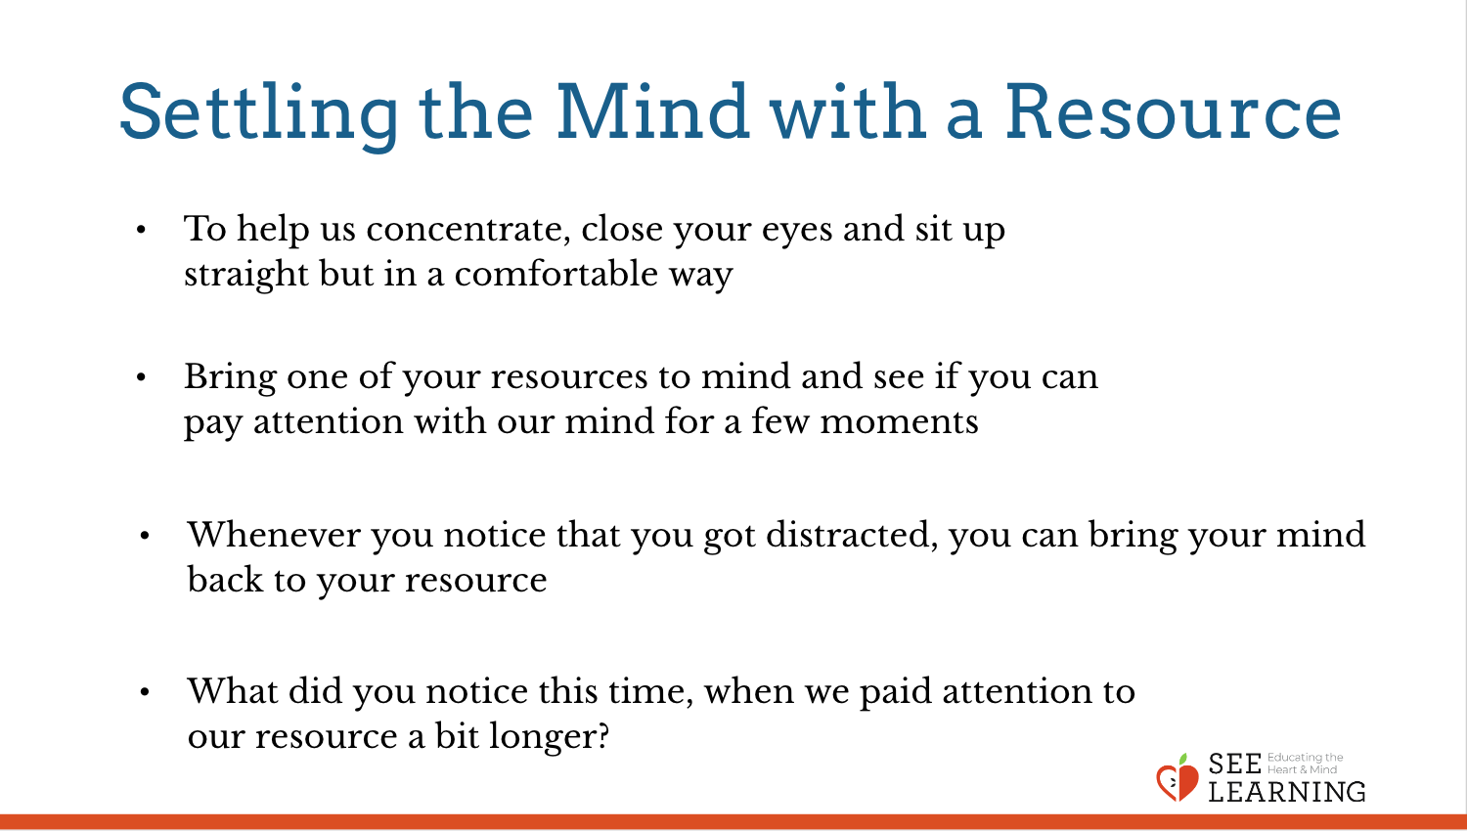 | Sample Script  - “Let’s practice training our attention just a little bit. We’re going to do it with a resource, just like we’ve been doing, except this time we’re going to hold our attention a bit longer.  - To help us concentrate, we’re going to keep our eyes on the ground or close them.  - I’ll talk you through the practice and we can share out after.  - Choose one of your resources from your resource kit, or you can choose a new one, or you can imagine one. Raise your hand when you have thought of the resource you want to focus on.  - Now let’s just bring our resource to mind. And let’s see if we can just pay attention to our resource with our mind for a few moments quietly. [Pause.]  - If you feel a neutral or pleasant sensation in the body, you can pay attention to that. Or if you’d rather do grounding, you can do that too. Whichever you choose, we’re going to rest quietly and pay attention for a few moments. [Pause.]  - If you feel unpleasant, you can shift to a different resource, or you can ground. You can also change your posture but try not to disturb anyone else if you do that. Otherwise, just keep your attention resting with your resource. [Pause.]  - Whenever you notice that you got distracted and you forgot about your resource, you can bring your mind back to your resource. [Pause for a longer time, such as 15-30 seconds or longer.]  - Let’s finish now. You can open your eyes.”

Debrief (3 minutes)
Slide 8: Debrief  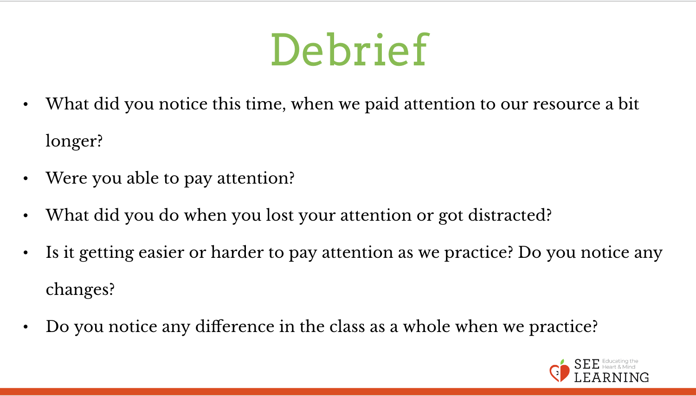 | Sample Script  - “What did you notice this time, when we paid attention to our resource a bit longer?  - Were you able to pay attention?  - What did you do when you lost your attention or got distracted?  - Is it getting easier or harder to pay attention as we practice? Do you notice any changes?  - Do you notice any difference in the class as a whole when we practice?”  Allow students to share out or pass

Optional Insight Activity - Pass the Cup (10 min)
Overview

In this activity, students will pass around a cup filled almost to the brim with water in order to learn about attention. Begin by filling a cup almost to the brim or as full as you imagine your students can handle. The students should pass it hand to hand around the circle. You can pause them in the task to notice what sensations they feel in their bodies as the cup comes closer or it’s their turn (tracking), then notice the sensations in their bodies as they watch others when their turn is over. As some students might get nervous while doing this, make sure to remind them that it’s only water, and though you’re going to try hard not to spill it, no harm will be done if it spills a little. This activity allows students to feel where heedfulness happens in their bodies and helps them monitor their attention.
Slide 9: Pass the Cup  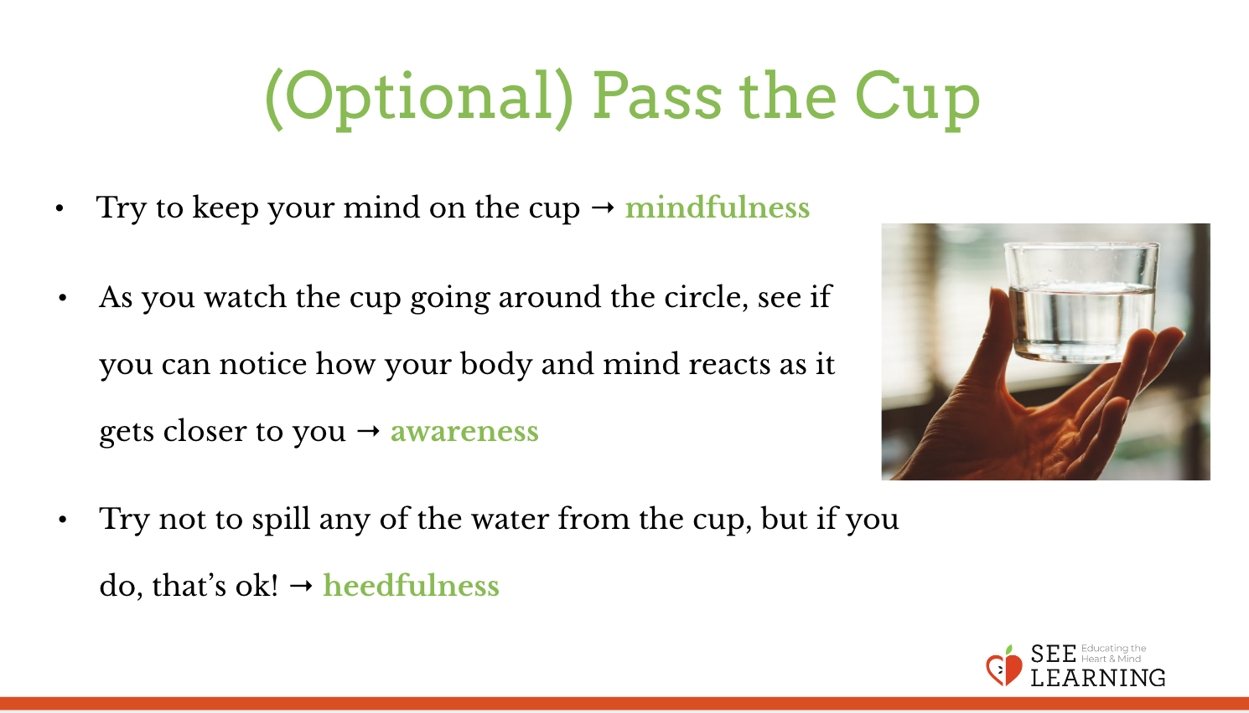 | Sample Script  - “Now we’re going to use our attention the best we can with a little game.  - Let’s all get into a circle.”  Pour the water very slowly into a 4oz paper cup.  - “Did anyone notice that they started paying closer attention as I poured the water? Did you notice what you were thinking?  - We’re going to pass this cup around the circle and try not to spill any of the water.  - There are a couple of important things to remember:  - Try to keep your mind on the cup. When we do something and pay close attention to it, keeping our mind right on it, we call that mindfulness. It’s not a race. Go as slowly as you need to.  - As you watch the cup going around the circle, see if you can notice how your body and mind reacts as it gets closer to you. Noticing what’s going on inside us is awareness: we are paying attention to things on the inside.  - By being careful not to spill, we’re practicing heedfulness. But if it does spill, it’s only water, so don’t be disturbed if a little gets spilled.  - Okay, let’s begin!”  Start passing the cup slowly around the room. After 3 or 4 students have passed the cup, remind students to check-in with their bodies:  - “Notice what you feel on the inside as you watch the cup move around the circle.  - If there are any thoughts or feelings in your mind, notice those too. This is practicing awareness.”  When the passing is complete, give everyone a moment at to reflect on their experience. Ask them to consider how they felt while watching as well as passing. Here are some sample questions you can use to facilitate a discussion about the activity:  - “Before we share, take a moment to yourself, and think about how it felt for you during the passing the cup game. What did you notice on the inside?  - Who would like to share what they noticed on the inside. (Good! So you had awareness.)  - Who could feel sensations in their body when other people were passing the cup? What did you feel and where? (Good! So you had awareness of that too.)  - Did you notice any moments when you lost your attention, when your attention went to something else? What distracted you?  - How were you able to practice mindfulness by keeping your attention on the cup? What helped you pay attention?  - Who was practicing heedfulness by trying not to spill the cup? Raise your hand.  - Were you able to bring your mind back to the cup if you lost your attention?  - What are some other times when you pay close attention like this?  - This game is really good practice for other things that need our attention. Can you think of some?”  Your students may want to try again. As an option, you can try with two cups going in opposite directions at the same time.

Optional Insight Activity - Mirroring (10 min)
Overview

- This activity involves two people mirroring each other’s arm movements, first with one playing the role of leader and the other following and mimicking and then switching roles. It is helpful if you’ve practiced this yourself in advance. You can also practice with a student first so that the two of you can demonstrate for the entire class.
- The exercise often leads to momentary experiences of close attunement, which demonstrates an aspect of focused attention: namely that our mind and body become “merged” in the activity and we lose track of other things around us. Some students may experience a state of “flow” and often it is possible to lose track of who is leading, and who following.

Leading the Activity
If you like, demonstrate with a student and yourself first. Then divide the class into pairs, with an A and B. Pairs stand, facing each other holding their hands up as if they were only an inch from a mirror.
- “Let’s begin by feeling the energy between your hands. We’re going to do this activity in silence so that we can pay attention and use our mindfulness fully. We will talk together about the experience afterwards.
- Partner A can now begin to move one hand very slowly. Partner B is going to use mindfulness to follow and mirror the movement as exactly as you can. Partner B, you’re going to match everything about A’s hand as if you were an exact mirror.
- Now Partner A can move the other hand very slowly, and Partner B, you follow the movement, paying close attention with mindfulness.
- Now try moving both hands away and back, up and down. Move freely but slowly.
- Now let’s use our awareness to notice what’s happening in our mind and body right now.”

Give them a few minutes to do the mirroring, then let them switch roles with the student who was mirroring becoming the leader. If there is time, you can ask them to try changing their body shape slightly, for example balancing on one foot, shifting their weight, or turning a little to the side so that they are not facing each other straight on. If any partnership has become particularly comfortable working together, it can be fun to ask them to choose secretly who is the leader and who the mirror. Then let the class try to guess.

After playing the game, prompt your students with questions like the ones for the Pass the Cup activity, such as:

- “Remember we said our attention is like a flashlight. What were we shining the flashlight on just now?
- What was happening in your body and mind? What were you aware of?
- What are some other times when you pay close attention like this?
- This game is really good practice for other things that need our attention. Can you think of some?”

Slide 10: Mirroring  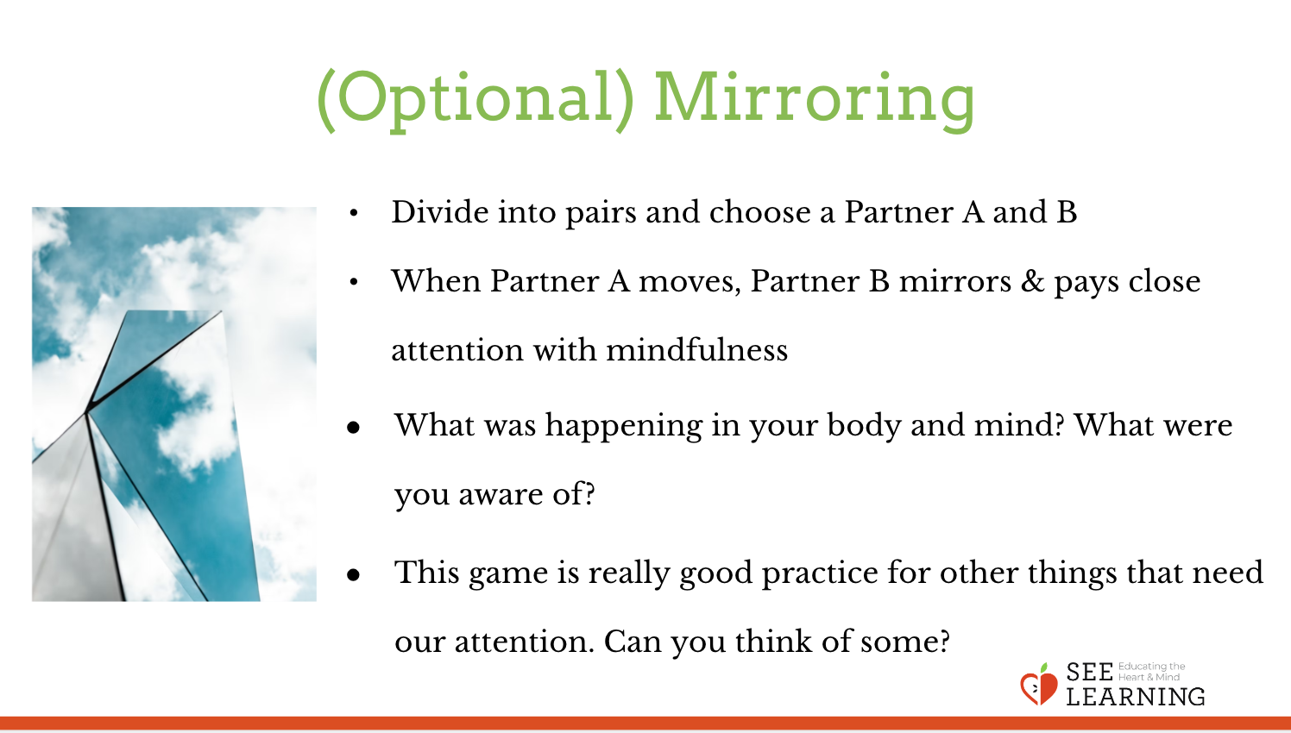 | Sample Script  N/A

