Exploring Attention

Purpose:
This learning experience introduces the concept of attention by using the visual metaphor of a flashlight. After discussing attention and its benefits, students play a game called “I Notice, I Wonder,” whereby they pass around a novel object while sharing what they notice about it, and then things they wonder about it. This activity highlights how close attention reveals details and can make even a simple object interesting and also that we can each experience the same object in different ways. The learning experience concludes with a reflective practice for strengthening attention using a resource.
Learning Objectives:  Students will be able to:  - Explore the various things we mean by “attention” and its importance in learning.  - Learn key vocabulary related to attention.  - Explore the strengthening of attention as a skill.  - Learn that while we often perceive things differently, even when looking at the same thing. | Primary Core Component  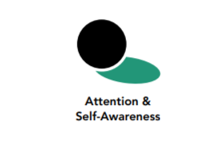
Length  35 minutes | Materials Required  - The mind jar (for the check-in)  - A flashlight or other light source  - One or two small objects of curiosity, preferably ones that students are unlikely to have encountered before (such as a seashell, textile, wooden mask, honeycomb, bone, piece of rare fruit, etc.)  - A bag (optional)

A Note On Vocabulary

During these activities and over the course of subsequent learning experiences, it can be helpful to gradually introduce some of the following key terms about attention, which also prepare the students for a fuller “map of the mind” to come.

- attention: directing the senses or mind to one thing
- to notice: to be aware of something; to see something (not just with the eyes, but with any of the senses or the mind), especially something new
- to observe: to watch closely with the senses or mind so that we can notice things about it
- to experience: to sense or feel something directly
- to concentrate: to devote all of one’s attention to one thing
- focus: attention on a single thing or activity; a center of attention; like concentration
- to judge (or make a judgment): to form an opinion or decide if something is one way or another (such as good or bad)

Check-In (3 min)
Slide 2: Checking In   | Sample Script  - “Let’s begin by thinking about one of our resources.  - You can choose a resource from your resource kit, or think of a new one, or even imagine one.  - As you think of your resource, notice what happens in your body. [Pause.]  - Now let’s try settling with the mind jar again. I’m going to shake the mind jar gently and we can allow our minds to settle as we watch it settle. We’ll just sit quietly and keep our attention on the mind jar, watching it.  - Remember that you can do grounding or return to your resource if it makes you feel more comfortable. Just be careful not to disturb anyone else as they settle.  - What did you notice as we settled with the mind jar?”

Insight Activity - Attention with a Flashlight (7 min)
Overview

In this insight activity, students will explore the concept of attention by using a flashlight as a visual metaphor for attention.

Content to be Explored
- We can direct the flashlight of our attention to different things.
- What we “shine the light on” can seem more interesting, more important or more detailed.
- Our attention is like a muscle. It gets stronger as we use it.
- We can direct our attention and this helps us notice and learn new things.
- If we don’t pay attention, we may miss important things
- We can pay attention with our senses and our mind. We can strengthen our attention like a muscle.
- When just observing and not judging, each of us may have different experiences, all of which are valid.

Materials

A flashlight or other light source

Instructions
- Dim the lights.
- Ask students to describe an object or part of the room seen in darkness, then again when a flashlight shines on it.
- Discuss how differently the room looks when we shine a light on it, how much more we can see and how the flashlight is like our attention

Teacher Tips
- It’s not necessary to make the room completely dark.
- As an alternative to the darkened room and the flashlight, use a bag with an unfamiliar object inside it and have students reach in and describe what they sense with their hands.
Slide 3: Attention with a Flaslight  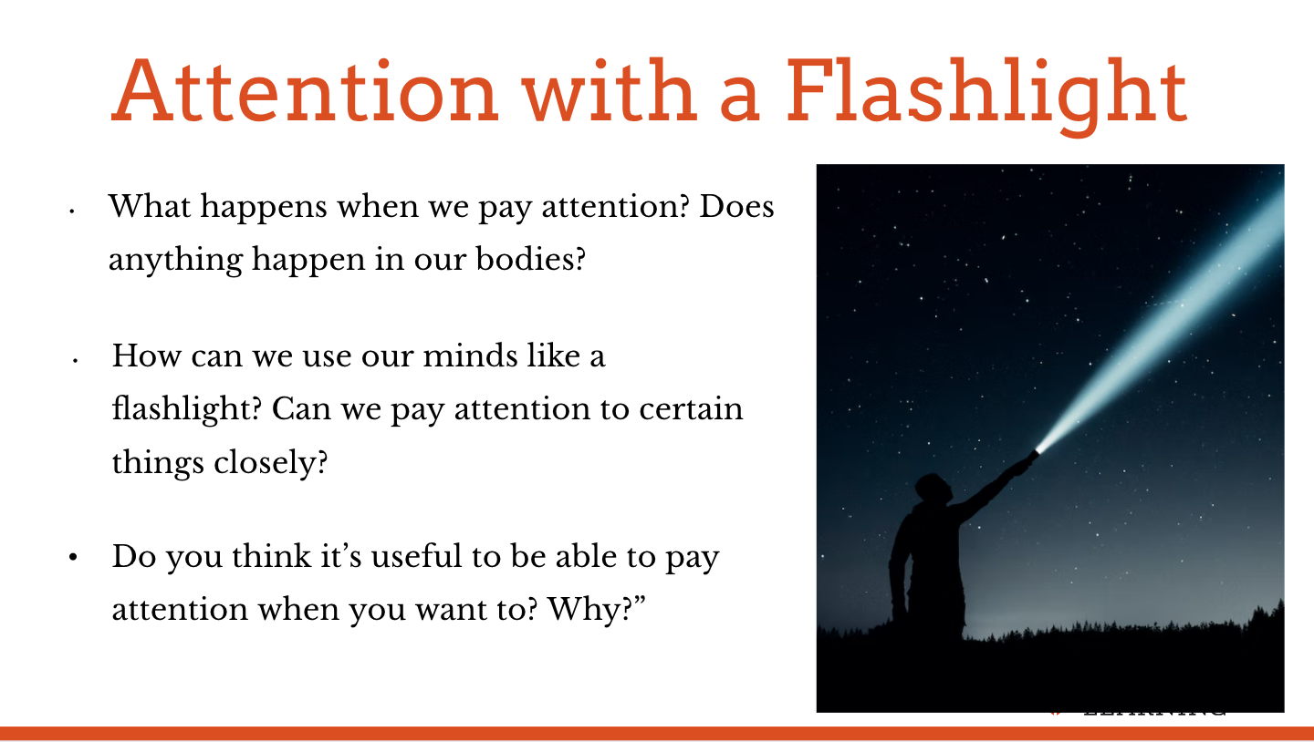 | Sample Script  - “Today we’re going to do some activities that will help us pay attention better.  - You already know a lot about paying attention. You’ve been doing it all your life. What does it mean to pay attention?  - How do we do that?  - What happens when we pay attention? Does anything happen in our bodies?  - Can anyone give an example of a time when you paid attention and noticed something important?  - What about a time when you didn’t pay attention and missed something important?  - So attention helps us notice things, and some of those things might be very important. Attention can be so helpful. Let’s try something. I’m going to dim the lights a bit.”  With the lights dimmed (but not too dark) first ask the students to describe something in a dark area. Then shine a flashlight (or some other light source) on that area and ask them to describe what they notice that they couldn’t see before.  - “What does the flashlight help us do?  - How about when I shine the light on something in particular, are the other objects in the dark still there, even though we can’t see them?  - Right, they’re there, but we can’t see them as clearly.  - How can we use our minds like a flashlight? Can we pay attention to certain things closely or point our attention at them?  - Can we keep our attention on something, like holding a flashlight steady?  - Do we sometimes get distracted and lose attention? Let’s see.  - [Draw a circle on the whiteboard and tell students to pay close attention to it. Then, stand off to the side and make distracting motions and sounds.]  - What was that like for you? What did you do with your attention?  - Do you think it’s useful to be able to pay attention when you want to? Why?  If helpful, do a visual mapping of the word “attention” by writing it in the center of a piece of chart paper and inviting students to suggest other words related to attention. Feel free to do this with the other key terms if they came up in the conversation  - “Did you know we can strengthen our attention like a muscle if we practice ? In that way, it’s even better than a flashlight.  - Since attention is so useful, we’re going to practice paying attention so we can get better at it. But we’ll do it in some fun activities.”

Insight Activity - Notice, Wonder (7 min)
Overview

In this insight activity, students further explore the concept of attention and practice nonjudgmental noticing and wondering. This activity can be repeated many times.

Content to be Explored
- When we pay close attention to something we keep noticing new things about it.
- Everyone has their own perspective. We notice different things about the same object.
- When we look closely and just observe before making a judgment, there are no “right” answers, just different experiences.

Materials
- One or two small objects of curiosity, preferably ones that students are unlikely to have encountered before (such as a seashell, textile, wooden mask, honeycomb, bone, piece of rare fruit, etc.)
- A bag (optional)

Instructions
- Have ready an interesting object (possibilities - a pine cone or seed pod, a tool, a little known fruit or vegetable, a sea shell, perhaps something that connects to a class story or area of study).
- Explain that each student will have a chance to study the object carefully and say something they notice or wonder. The challenge is that they cannot repeat something someone else has already said. If this feels too hard, students can do this in smaller groups first and work up to whole class.
- Pass the object (hand-sized or smaller) from student to student
- Encourage each child to begin with “I notice...” or “I wonder...”
- Alternatively, pass the object around in a bag and have each student reach in to feel it.

Teacher Tips
- Continue to support students by reminding them that because we are just observing and sharing our experiences, there is no right or wrong answer. If a student wants to repeat something that has already been said, like “It’s brown,” invite them to elaborate, such as “It’s brown like chocolate” or “It’s very light brown” or “It’s as big as…” You may need to remind students also to keep paying attention to each other and the object, seeing if they can notice more and more of its features.
Slide 4: I Notice, I Wonder  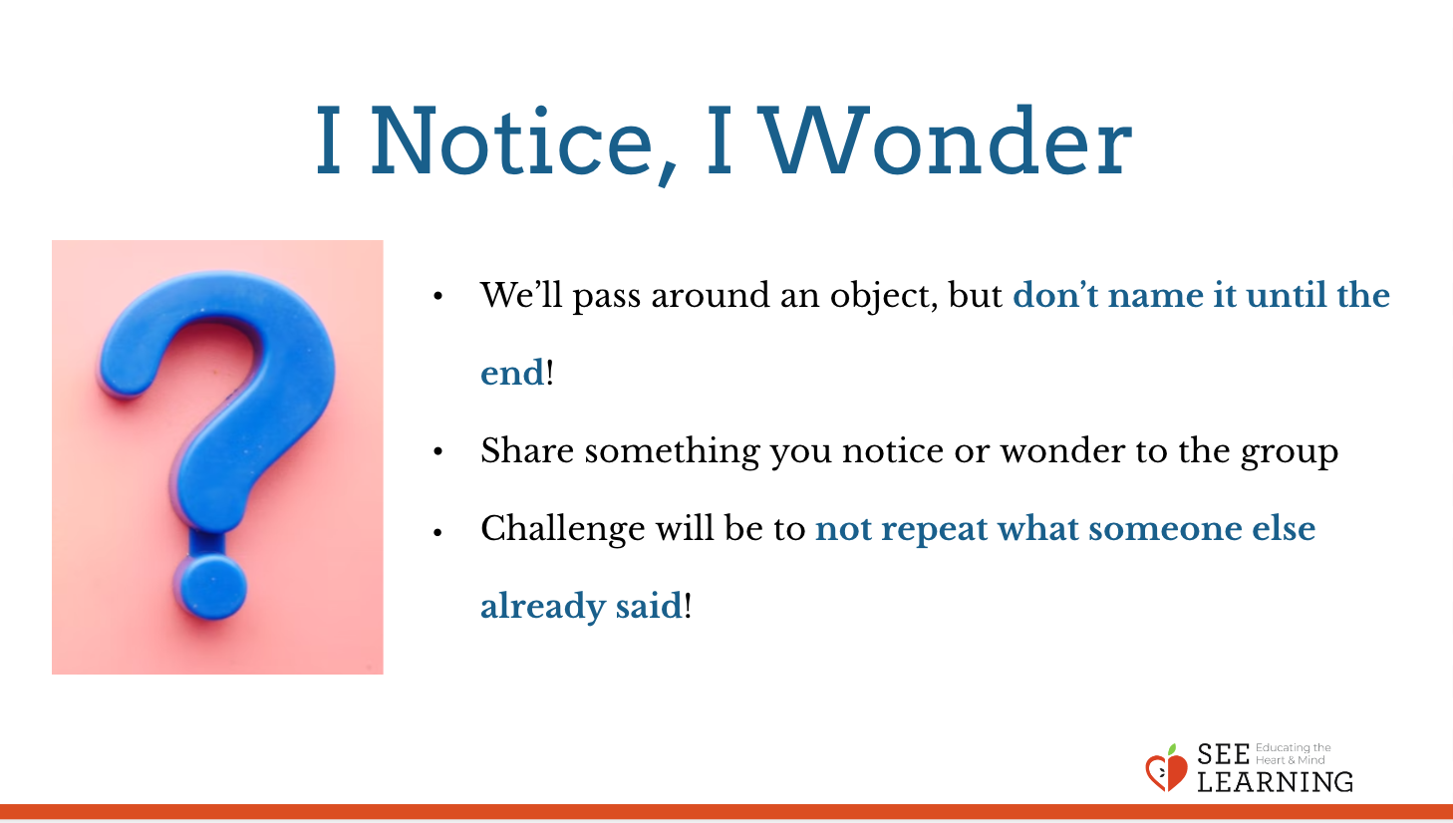 | Sample Script  - “Let’s all get into a circle for an activity on attention. It’s called “I Notice, I Wonder.”  - I have an object here that I will pass around. If you know what it is, don’t tell anyone what it is, and instead try to pretend you are seeing it for the first time.  - As the object goes around the circle, we’ll each look at it carefully. We can smell, touch, and listen to it too.  - So we’re going to pay close attention to it for a moment and observe it.  - Then offer one thing you notice or wonder to the group. We’ll pay attention to each other and to the object.  - It’s ok to say, “It reminds me of… It’s about as big as a…. The color is like…. I wonder where it came from...I wonder what it’s used for…”  - We aren’t going to name the object. We’re not going to say what it is until after we are finished with the activity. The challenge will be to not repeat someone else’s has already said.  - We don’t have to make a judgment about the object either. That means we don’t need to say if we like it or don’t like it.  - If you are stuck, you can say “pass”, and we can come back to you if you choose. And, there’s no right or wrong answer. Just notice something about this object and share that.  - Before you pass the object, model for students by starting yourself: Let’s try it. I’ll start. (Look at the object closely for a moment.) I notice the object is … (insert descriptor).  - [Send the object around the circle. When the object has been around once, do a second round in which students can state a “notice” or a “wonder.” Model a “wonder” this time.]  - Remember, there are no right or wrong answers, just your own experience. Listen carefully to what other people wonder.”  - [Send the object around the circle.]

Slide 5: Discussion  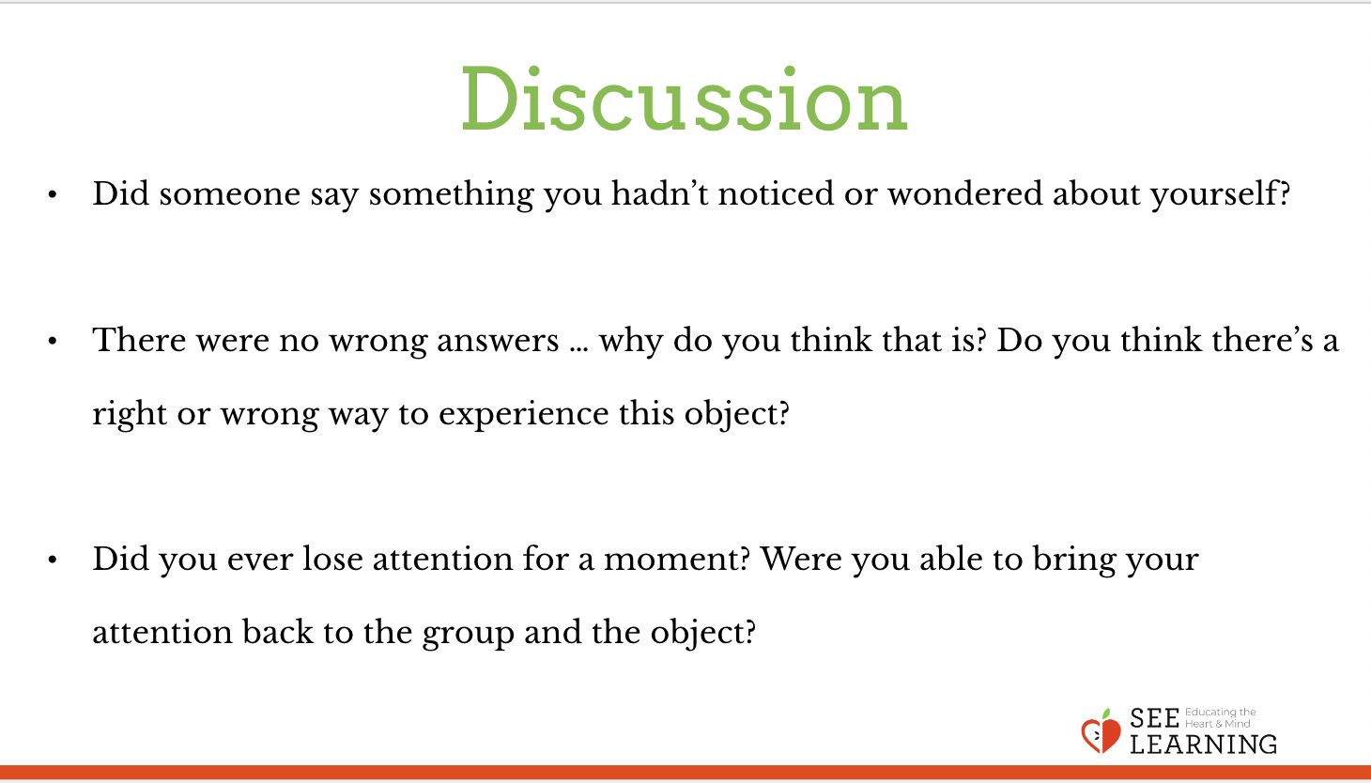 | Sample Script  - “Did anyone hear someone else say something that you were thinking too?  - Did someone say something you hadn’t noticed or wondered about yourself?  - Who can add one more thing they notice? Or wonder? Could we keep on noticing and wondering about more and more things?  - I noticed there were no wrong answers. Why do you think that is? (We’re describing our own experiences, not opinions or judgments.) Do you think there’s a right or wrong way to experience this object?  - Did anyone get distracted? Did you ever lose attention for a moment? Were you able to bring your attention back to the group and the object?  - Write or share as a whole group what this felt like:  - Where did you feel sensations in your bodies?  - What were these sensations?  - Why might this activity be helpful when thinking about attention or why did we do it?”

Insight Activity - Individual Practice with Writing* (10 min)
Overview

In this independent writing activity, students practice attention training by finding interesting things about a particular object. This helps reinforce the idea that our ability to stay focused on something is also related to our ability to find interest in that thing.

Content to be Explored
- When we pay close attention to something we keep noticing new details about it.
- Our attention is like a muscle. It gets stronger as we use it.
- We can direct our attention and this helps us notice and learn new things.

Materials
- An object for each child (or enough to share)
- SEE Journals
- Writing utensils

Instructions
- Give each student one object or organize groups to share.
- Tell them to select an interesting thing about the object that they notice or wonder about and to write about that quality. If there is enough time, they can select other interesting things and write about those.
- After 2-3 minutes of writing, ask students to discuss the experience as a whole group:
- What was that like for you?
- Did you notice your attention wandering? How did you notice it? How did you bring it back?

Teacher Tips
- This activity could be done on a different day from the other insight activities.
- Remind students that if they notice their attention wandering, notice it, then bring it back without judgment.
- The amount of writing time can be varied based on age and number of times done.
- To scaffold for learning differences, you may want to provide specific questions for students to answer rather than the open-ended prompt above.
Slide 6: Individual Practice with Writing  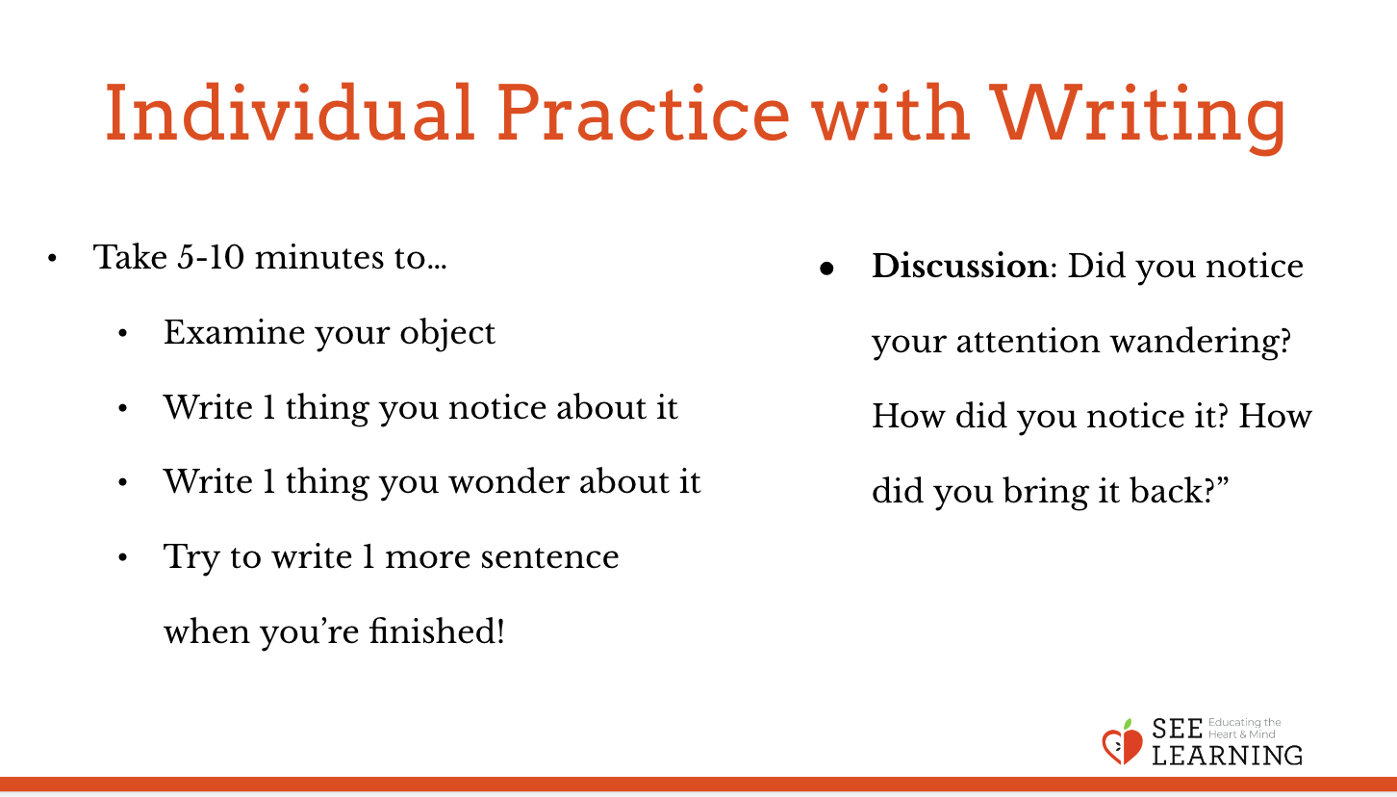 | Sample Script  - “Who can remind us what we did with the flashlight? How did we connect the flashlight to our attention?  - And what about when we passed around [the object], what did we talk about during that activity?  - So what we’re going to do now is similar to those activities. We are going to do some individual writing that helps us practice focusing our attention.  - I’m going to give you an object and then ask you to examine it and write for [5-10] minutes about one thing that you notice about the object. Then write about one thing that you wonder about the object. When you think you are finished writing, try to write one more sentence.  - If you feel your attention wandering, just notice that, and bring it back without judgment.  - When we’re finished writing individually, we’ll discuss the experience as a group.  - [Distribute SEE Learning Journals and objects for students.]  - Please begin writing now.  - [After the writing time is over, facilitate the group discussion.]  - Ok, let’s stop writing and discuss what that was like for you.  - Did you notice your attention wandering? How did you notice it? How did you bring it back?”

Reflective Practice - Setting the Mind with a Resource* (5 min)
Overview

In this reflective practice, students will choose one of their resources from their resource kits and will use it as an object of focus for a brief attention practice. This is identical to resourcing, except that here you are using the resource or the sensations that arise as an object to sustain attention on.

Instructions
- Use the script below to facilitate this reflective practice.

Teacher Tips
- As before, make sure you give students the option of shifting their attention to another resource, to grounding, or to a pleasant or neutral sensation in their bodies should they ever feel uncomfortable from trying to focus their attention. Allow them to move slightly and adjust their posture also, as long as they are careful not to distract or disturb other students.
- As before, where the script says “Pause,” you can pause for as short as 8-12 seconds, or as long as you feel is comfortable for your students.

Slide 7: Settling the Mind with a Resource  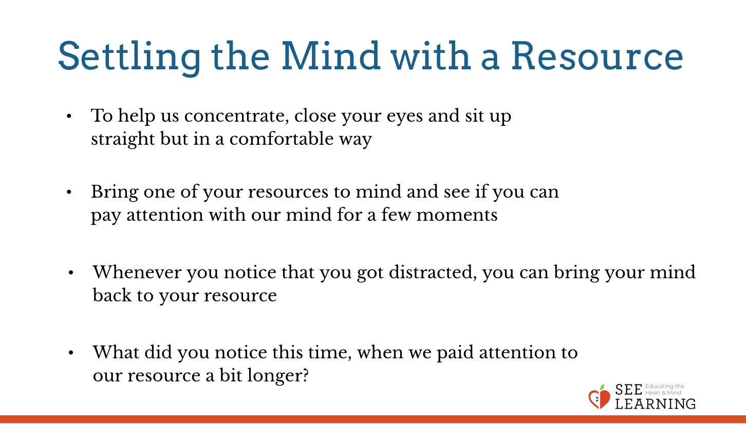 | Sample Script  - “Let’s practice strengthening our attention just a little bit. We’re going to do it with a resource, just like we’ve been doing, except this time we’re going to hold our attention a bit longer.  - To help us concentrate, we’re going to keep our eyes on the ground or close them and we’re going to sit up straight but in a comfortable way.  - I’ll talk you through the practice and we can share out after.  - Choose one of your resources from your resource kit, or you can choose a new one, or you can imagine one.  - Now let’s bring our resource to mind. And let’s see if we can just pay attention to our resource with our mind for a few moments quietly. [Pause.]  - If you feel a neutral or pleasant sensation in the body, you can pay attention to that. Or if you’d rather do grounding, you can do that too. Whichever you choose, we’re going to rest quietly and pay attention for a few moments. [Pause.]  - If you feel unpleasant, you can shift to a different resource, or you can ground. You can also change your posture but try not to disturb anyone else if you do that. Otherwise, just keep your attention resting with your resource. [Pause.]  - Whenever you notice that you got distracted and you forgot about your resource, you can bring your mind back to your resource. [Pause for a longer time, such as 15-30 seconds or longer.]  - Let’s finish now. You can open your eyes.  - What did you notice this time, when we paid attention to our resource a bit longer?  - Were you able to pay attention?  - What did you do when you lost your attention or got distracted?”

Debrief (3 minutes)
Slide 8: Discussion  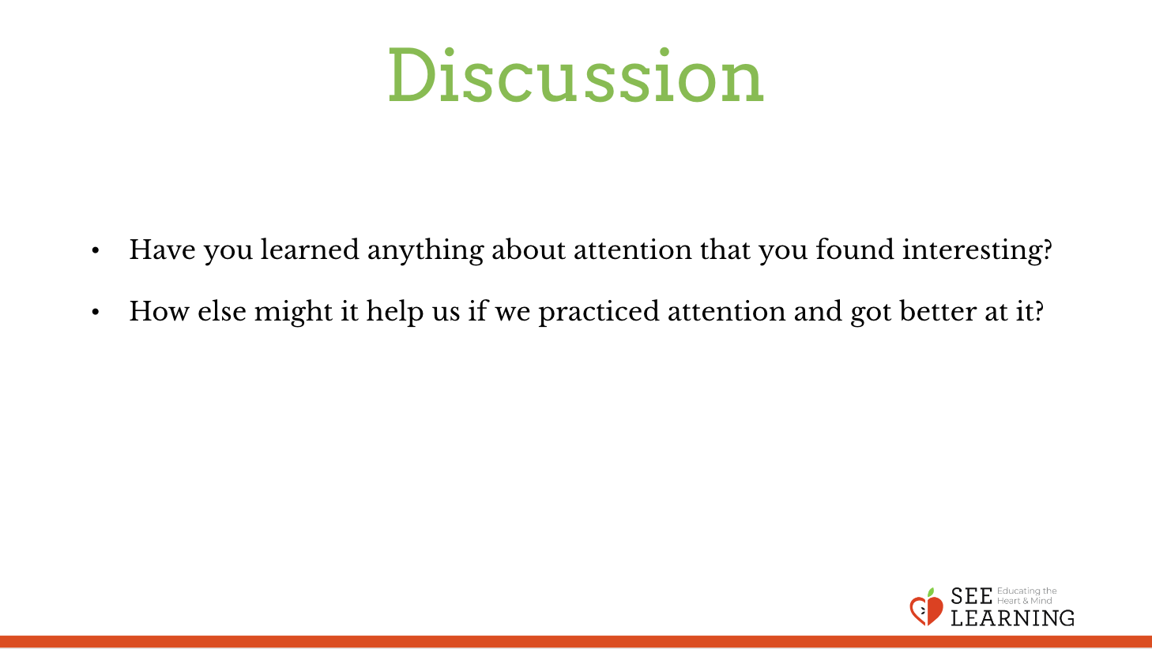 | Sample Script  - “Have you learned anything about attention that you found interesting?  - How else might it help us if we practiced attention and got better at it?”

