Exploring the Mind
Purpose:
This learning experience uses a story and a “mind jar” to explore what goes on in our minds. In SEE Learning, “mind” is a broad category that involves our first-person experience of the world, including feelings, emotions, thoughts, memories, hopes and fears, our imagination, and so on. The mind is also what we use to pay attention to - or to be mindful of - things. Students also create two illustrated mind jars of their own in groups to show what might be in their minds when they are feeling stirred up and anxious, as opposed to when they are feeling calmer and more relaxed.
Learning Objectives:  Students will be able to:  - Explore what we mean by “mind” and the ways we can categorize mental experience.  - Learn that our mind can be relatively clear or cloudy, making it easier or harder to discern what is happening in our minds.  - Learn that we can calm and stabilize the mind by allowing it to relax and settle.  - Explore the similarities we share with regard to our minds and mental experiences. | Primary Core Component  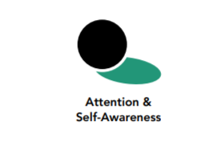
Length  - 25 minutes | Materials Required  - Water in a large, clear glass (pint) jar with lid  - Small containers with sand, pebbles, small glass stones, or glitter if available (or other materials with some that sink and some that float)  - Spoon to stir with  - A small stool or table to put the jar on at eye level so the class can watch it

Check In (3 min)
Slide 2: Checking In   | Sample Script  - “Let’s start with some resourcing. If you like you can take out a resource from your resource kit or you can just imagine your resource.  - If someone did something kind for your recently, or if you were compassionate to someone else, you can feel free to use that as your resource.  - If you’d rather do grounding, you can find a comfortable way to sit or something comfortable to hold or touch.  - Let’s now take a few moments to think about our resource or pay attention to our grounding. [Pause.]  - Now let’s do tracking and pay attention to the sensations inside our bodies.  - If you find a pleasant or neutral sensation just pay attention to that and watch it. See if it changes or stays the same. [Pause.]  - If you haven’t found a pleasant or neutral sensation, see if you can shift to another part of your body to find a place that feels better. [Pause.]  - What did you notice?”

Insight Activity - The Mind Jar (12 min)
Overview

In this insight activity, your class will explore what we mean by “mind” through a story and the use of a “mind jar.” A mind jar is a large transparent jar of water to which you can add sand, pebbles, and other things that can float in the water and make it cloudy, but eventually settle down if left undisturbed, leaving the water clear. The mind jar serves as a visual metaphor for how our minds become clearer when we let them settle.

Content to be Explored
- There are many things that go on in our minds, including thoughts, emotions, memories, feelings, hopes, fears, and more.
- When agitated, our minds can become cloudy, making it hard for us to see what is going on inside us or around us. Even pleasant sensations/thoughts/emotions can cause our minds to become cloudy instead of calm.
- We can cultivate greater clarity of mind by not agitating it and instead developing focus and attention.
- When our mind is calm, things in our mind become more clear. We feel calmer; we learn more easily; we make better decisions; and our body feels more settled.
- We can stir our mind up (agitation, confusion, rumination) or let it settle.

Materials
- Water in a large, clear glass (pint) jar with lid
- Small containers with sand, pebbles, small glass stones, or glitter if available (or other materials with some that sink and some that float)
- A spoon to stir with
- A small stool or table to put the jar on at eye level so the class can watch it

Instructions
- Review the zones that were introduced in Chapter 2: the resilient zone, the high zone, and the low zone
- Place a large plastic or glass jar with water on a table or in a place where it is clearly visible. Invite your students to join you sitting in a circle or in a way that everyone can see the jar.
- Show the students how clear the water is and how easy it is to see through.
- “What do you notice about the water now?”
- “I’m going to tell you a story about a girl called Theresa. For this story, we will be using this jar to show what is happening in Theresa’s mind. Can you see clearly through it? We’re going to use sand, pebbles, and glitter. Sand will be for neutral things, pebbles for challenging things, and glitter for nice things.”
- Tell a “Clear-Muddy Mind” story (a sample story is provided below). Add the materials into the jar yourself, or invite your students to add them, at appropriate times (here marked by letters in the story).
  - S = Sand
  - P = Pebbles
  - G = Glitter
Or substitute other appropriate substances for neutral, challenging, and nice things. As the story goes on and your students start to understand the process, you can ask them what substance to add after each sentence.

Teacher Tips
- This activity uses the mind jar in conjunction with a story (you can make one up or use the story provided below).
- It is highly recommended that you test out your mind jar before doing this activity with your class.
- You can vary the substances you put inside.
- When left on its own, ideally the substances in the mind jar will sink within a minute or two, resulting in the cloudy liquid becoming clear.
- You can use a snow globe, but you lose the opportunity for class participation and the chance to show different mental activities (thoughts, feelings).
- After you finish, keep the mind jar set up, as you will use it again in upcoming learning experiences.
Slide 3: The Mind Jar  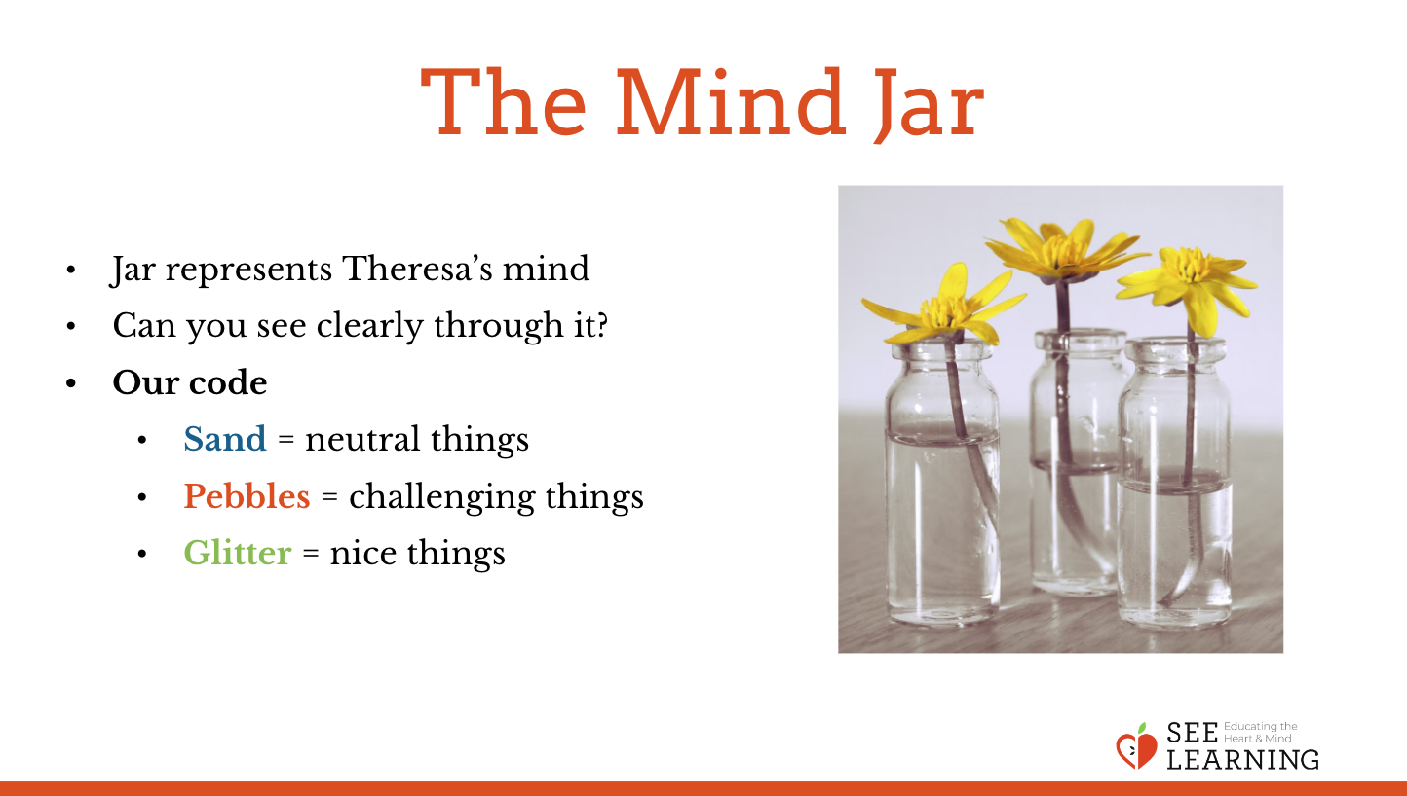 | Sample Clear-Muddy Mind Story  - “Here’s Theresa’s mind when she first opens her eyes.  - Theresa wakes up. (S)  - She likes to hear the quiet sound of the rain. It makes her feel cozy in bed. (G)  - Then she remembers: rain means they won’t be playing outdoors today. She was really excited to go to the first day of practice after school with her friend Nelson. Now she feels disappointed.(P)  - When she gets up, her sister is in the bathroom. (P)  - And she can’t find her favorite T-shirt! (P)  - But she does manage to find her very favorite jeans . (G)  - She gets dressed and goes to the kitchen. (S)  - Her dad asks her if her homework is done. (S)  - Oh, no! She remembers he didn’t finish it. She was too busy playing. She feels worried.(P)  - Her younger sister says happily “I did mine!” That just makes Theresa a bit annoyed but she doesn’t show it. (P)  - She takes out her pencil, pours milk in her cereal, and starts a math problem. (S)  - Now her dad is reminding her sister to feed the dog. (S)  - Theresa tries to pay attention to her math homework, but it’s hard with all the noise around the house and the dog barking while it’s being fed. (P)  - When Theresa has done 3 math problems and eaten half of her cereal, her father says it’s almost time to go. (P and swirl jar)  - “Wait! I’m not done!” Theresa says. (P)  - Her sister says, “You should have finished it last night!” (P and swirl jar)  - That makes her a bit more angry. She wants to say something back to her sister, but she stops herself. (G)  - Her sister jumps up and down happily and says. “I finished all my homework! I always finish mine!” (P)  - That makes Theresa really upset. She can’t hold it in anymore, so she says, “Be quiet!” angrily to her sister. Her sister looks shocked and starts to cry. (P)  - “Theresa! That’s no way to talk to your sister,” her father says. He starts to comfort Theresa’s sister. Theresa feels miserable. (P)  - Theresa’s dad looks at her homework and says, “It’s time to go and fortunately you’re almost done. You can finish it in the car. Come on.” (G)  - Theresa finishes her homework just in time while riding in the car. Also her dad doesn’t seem angry any more. She feels so relieved. (G)  - “Be kind to your sister,” her dad tells her as he drops her off at school, “she’s just a small kid.” Theresa nods and says, “Yes, dad, I will.” (G)”
Debrief (2 min)
Slide 4: Debrief  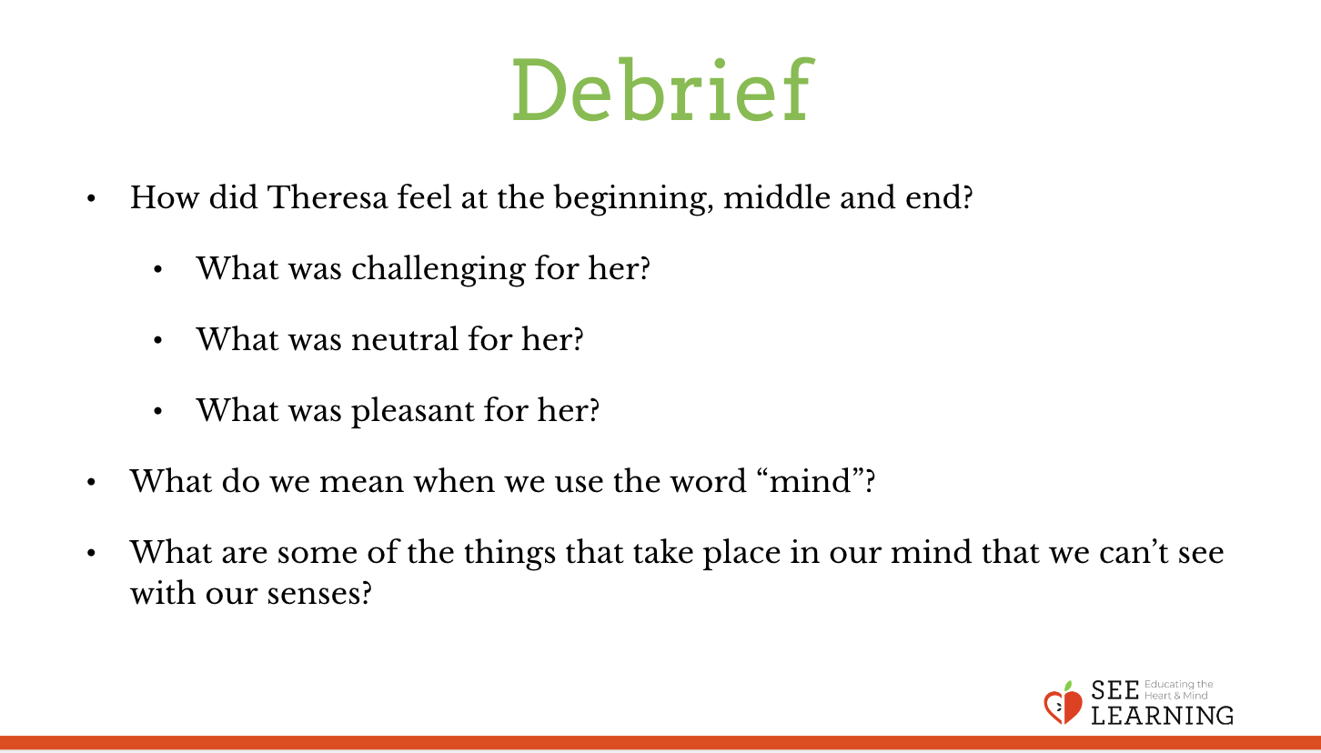 | Sample Script  - “What happened in the story?  - How did Theresa feel at the beginning, middle and end?  - What was challenging for her?  - What was neutral for her?  - What was pleasant for her?  - What do we mean when we use the word “mind”?  - What are some of the things that take place in our mind that we can’t see with our senses?”

Reflective Practice - Settling the Mind* (4 min)
Overview

In this practice, students will practice keeping their attention on the mind jar for a short while as it settles. However, they also have the option of shifting their attention to their bodies – particularly to neutral or pleasant sensations – and keeping their attention on those sensations. Either way, the students will be cultivating attention.

Teacher Tips

It’s recommended that you start with very brief attention training exercises like this— even as short as a minute or two—and gradually build to longer sessions over weeks and months. Where the script says “Pause,” you can pause for as short as 8-12 seconds, or as long as you feel is comfortable for your students. It is also recommended that you allow students to shift to resourcing, grounding, or a Help Now! strategy as needed. This is because if students feel dysregulation in their bodies, asking them to still their bodies and focus their concentration on a particular thing can sometimes increase discomfort.

Slide 5: Settling the Mind  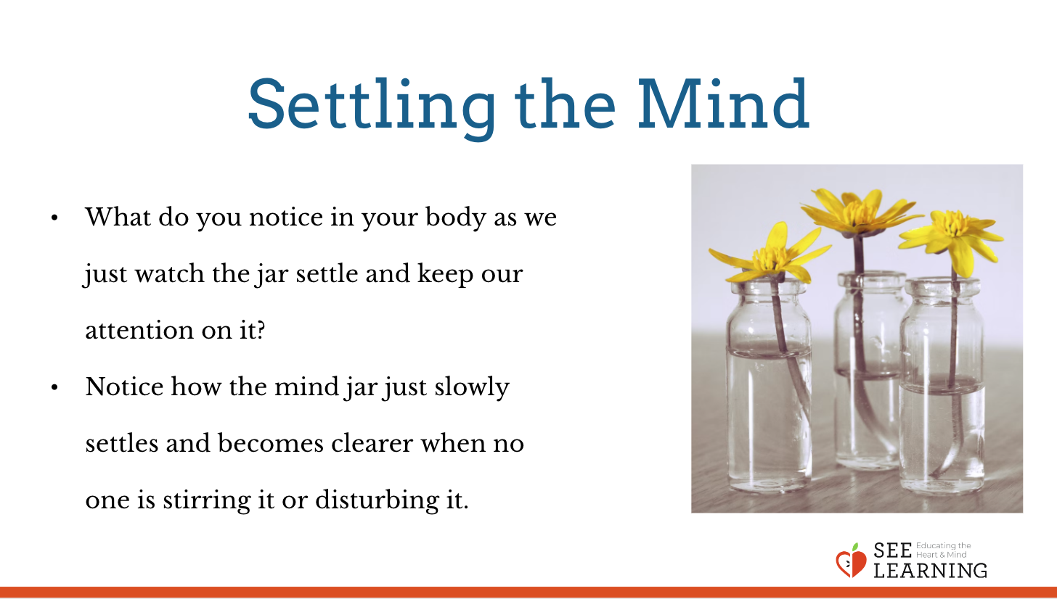 | Sample Script  - “I’m going to talk you through this reflective practice and then we can share out at the end. Remember that you can always adjust your position to a better one, and you can always think about a resource or do grounding if you ever feel uncomfortable  - The mind jar settles if we leave it alone and allow it to return to its natural state.  - I’m going to shake this jar and then we’ll just watch as it settles.  - When we watch (or listen) to something closely we call that “paying attention.” If we keep watching for a longer time, that’s called “keeping our attention” on whatever it is we’re watching. See if you can keep your attention on the jar as it settles.  - Let’s watch the jar quietly now. [Pause.]  - What do you notice in your body as we just watch it and keep our attention on it?  - If you find a neutral or pleasant sensation in your body, then you can shift your attention to that if you like.
Debrief (4 min)
Slide 6: Debrief  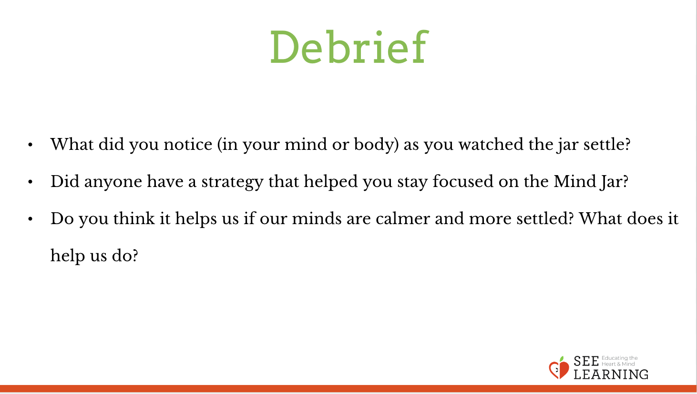 | Sample Script  - “What did you notice – in your mind or in your body - as you watched the jar settle?  - Who had a strategy or a way that helped you stay focused on the Mind Jar? Could you share it with the group?  - Do you think it helps us if our minds are calmer and more settled? What does it help us do?”

