How Compassion and Safety Affect the Body
Purpose:
The purpose of this final learning experience in Chapter 2 is to return to the foundational concepts of kindness, happiness, and safety explored in Chapter 1 and tie in what has been learned in Chapter 2. Now that the students have a greater understanding of their bodies, how to calm them, and the resilient zone, they can connect this with what they learned about happiness, compassion, and the value of class agreements. Stress and a sense of threat can knock us out of our resilient zone, making us feel uncomfortable and actually releasing chemicals in our bodies and dysregulating our nervous system in ways that are unhealthy and can even cause long-term damage. Since students now have first-person experience exploring how we can get bumped out of our resilient zones, and how uncomfortable that can feel, and also know that we can help each other return to our resilient zones/OK zones through compassion, they can understand the importance of compassion and their class agreements on a deeper level. They are helping each other to be happy and healthy, and are even helping each others’ bodies to be happy and healthy.
Learning Objectives:  Students will be able to:  - Synthesize the class agreements with their understanding of how the body experiences kindness, safety, and happiness.  - • Recognize the relationship between nervous system dysregulation and physical health. | Primary Core Component  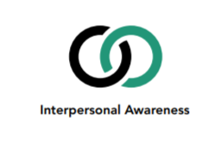
Length  - 30 minutes | Materials Required  - The chart of class agreements and the chart of helping actions that were created in Chapter 1  - The resilient zone chart  - Graphic of the autonomic nervous system (if possible - there is one in the chapter introduction for your use)

Check In (4 min)
Slide 2: Checking In  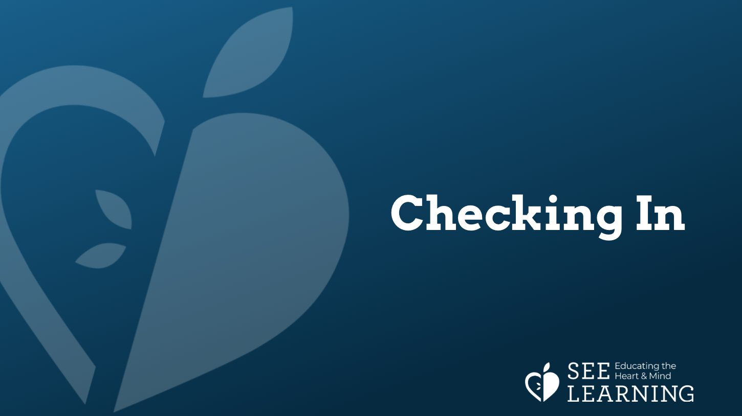 | Sample Script  - “Let’s take out our resource kits and see if there’s something in there we’d like to use. Or if you’d rather do grounding, you can find a comfortable way to sit, stand or lean.  - If you’re resourcing, then pick one of your personal resources and hold it in your hands or place it in front of you. Let your eyes rest on it, or close your eyes and feel it carefully with your hands.  - If you’re grounding, just bring your attention to your body  - Let’s now take a few moments to do tracking and pay attention to the sensations inside our bodies. [Pause.]  - If you find a pleasant or neutral sensation just pay attention to that and watch it. See if it changes or stays the same.  - If you haven’t found a pleasant or neutral sensation, see if you can shift to another part of your body to find a place that feels better. [Pause.]  - What did you notice?”

Presentation/Discussion (8+ min)
Overview
The point of this discussion is to help your students understand that what they have been experiencing in the body has implications for health and happiness overall.

Content to be Explored
- Experiencing a lack of compassion can make us feel stressed and unsafe and knock us out of our resilient zone. Experiencing kindness can help us feel safe.
- Having less stress is healthy for our bodies.
- By being kind and respecting others, we can help others feel safer, happier, and more healthy.

Materials
- Resilient zone chart
- Graphic of the autonomic nervous system (if possible - there is one in the chapter introduction for your use)
Instructions
- Begin by reviewing sensations and the information we receive from them.
- Show students the resiliency zone chart again. Review what happens to our bodies when we are in or out of the resilient zone. Discuss how the body might feel when in the high zone and the low zone. Discuss ways of helping one’s body return to the resilient zone.
- Use the resource kits for resourcing after talking about the zones.
- If possible, show a picture of the human body showing the autonomic nervous system (ANS) and/or the organs inside the body.
- Explain the ANS and how it reacts to danger and stress.
- Discuss how we can affect others and their zones and how we can help others get back into the resilient zone.

Teacher Tips
- Our nervous systems are designed to keep us alive, and as such respond to perceived threats or the need to mobilize with activation of the sympathetic nervous system. This stress response releases chemicals in our bodies and increases inflammation as the body prepares for potential danger. This is not a problem in the short term, but chronic inflammation and stress gradually weakens our bodies and makes us susceptible to a whole range of physical and mental illnesses.
- This means that when we feel safer, calmer, and/or happier, our bodies are physically healthier and can do things like learn, grow, develop, rest, digest, regenerate, and heal. When we are feeling unsafe and unhappy, our bodies shut down the systems that allow us to do those things, instead preparing us for danger. When we understand this, we can realize that how we treat each other matters deeply. Being mean to someone is likely to cause them to feel stress and a lack of safety, making their bodies less healthy and contributing to illness. Being kind to someone helps them feel safe, making their bodies more healthy. Since we want health and happiness for ourselves, we want others to treat us with kindness and we want to feel safe around them. It makes sense therefore to show to others what we want for ourselves: kindness and compassion.
Slide 3 & 4: Discussion  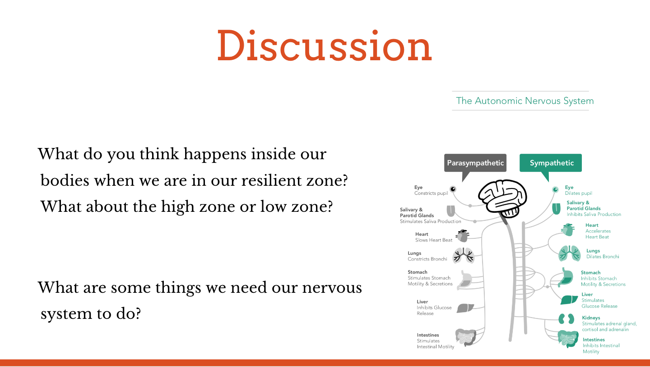  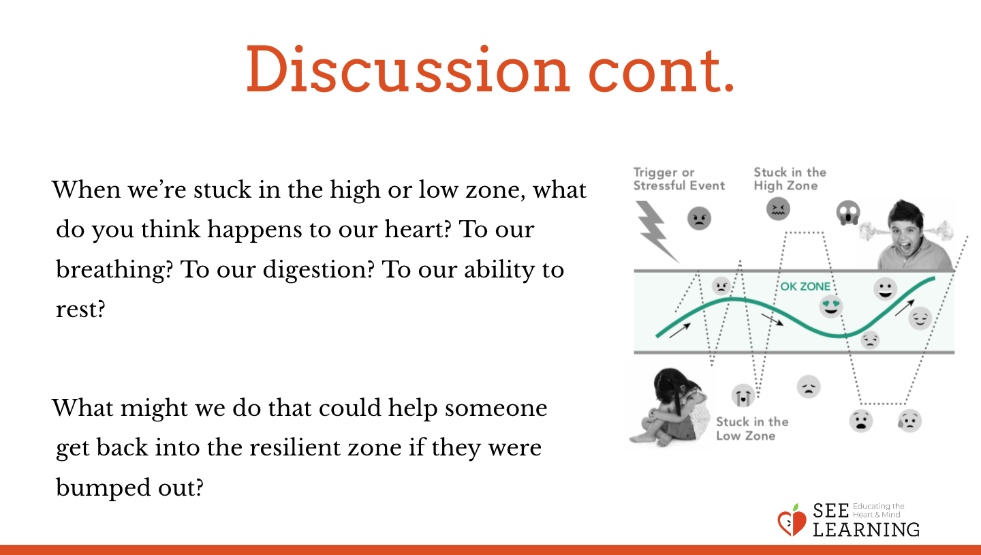 | Sample Script  - “We’ve been exploring the sensations in our body. When we pay attention to them, we learn if we’re feeling good, happy and safe, or if we’re feeling a bit nervous, unsafe, or unhappy.  - We’ve also learned what we can do to make ourselves feel happier, calmer, and safer in our bodies. What are some of the things we’ve learned to do for that? [Allow for just enough sharing that students are connecting with the last lessons.]  - Show the resilient zone chart. When we are in the resilient zone/OK zone, can someone show me what that may feel like in your body? Why?  - What do you think happens inside our bodies when we are in our resilient zone/OK zone? Do you think it’s healthy for our bodies to be in our resilient zone/ok zone? Why or why not?  - What do you think happens inside our bodies when we get stuck in the high zone a lot? Do you think it’s healthy for our bodies to be stuck in the high zone? Why or why not?  - What about the low zone? Why?  - Let’s take a moment to look at something in our resource kit, think of a resource, or ground. Be aware of what happens inside.  - • [If possible, show a picture of the human body showing the autonomic nervous system and/ or the organs inside the body.] Scientists have discovered that when we are feeling unsafe or when we are stuck in our high or low zones for a long time, it is not healthy for our bodies.  - We get stressed, and our nervous systems release a lot of chemicals in our bodies that could make us sick if we’re not careful.  - What are some things we need our nervous system to do? It’s the part of the body inside that controls our inner organs, like our stomach, our heart, our lungs. It helps us digest things when we eat. It helps us sleep and rest. It even helps us grow our body to be bigger and stronger. It has to keep our heart beating and our lungs breathing and our blood flowing.  - • It’s the nervous system that does all these things. When we’re in the resilient zone/OK zone, then it can do all these things just fine. It also protects us properly against germs, diseases, and illness.  - But when we’re stuck in the high zone or low zone, our nervous system has a hard time doing these things. Instead, it gets ready for danger and it stops doing things we need to be doing to be healthy  - That’s okay if there’s a real danger, and we need to run fast or do something quickly. But if there’s no real danger, then it doesn’t need to be ready like that.  - When we’re stuck in the high or low zone, what do you think happens to our heart? To our breathing? To our ability to digest food? To our ability to rest?  - If we can’t digest our food properly, or if we can’t rest properly, or if we can’t grow properly, then that’s a problem, isn’t it?  - If we are not in danger and our nervous system does not need to take action to keep us safer, in which zone would we want to be?  - Would we want to make someone else feel unsafe and bump somebody into their high zone or low zone? What might we do that could bump someone into the high zone or low zone? [Allow sharing.]  - What might we do that could help someone stay in the resilient zone/OK zone or get back into the resilient zone/OK zone if they were bumped out?” [Allow sharing.]

Reflective Practice - Acting Out the Class Agreements with Tracking (13+ min)
Overview
In this practice, students will work together to create little skits. If you have the ability to do so, you can video record these skits and tell your class that you’ll be making a short movie.

Content to be Explored
- Experiencing a lack of kindness can make us feel stressed and unsafe and knock us out of our resilient zone. Experiencing kindness can help us feel safe.
- Having less stress is healthy for our bodies.
- By being compassionate and respecting others, we can help others feel safer, happier and more healthy.

Materials
- The chart of class agreements
- The chart of helping actions that were created in Chapter 1

Instructions
- Using the class agreements and the helping actions they created in Chapter One, explain that they will create stories based on these agreements being followed or broken and then will act these stories out (and make a movie, if you have the ability to do so). When creating stories, be sure to use made-up names for characters that are not the actual names of students in your class. As before, it may work to have one student pretend to be in need and have one or two other students see that need and engage in helping actions.
- After a story has been created, ask for volunteers to act it out. Explain that when you say “Go!” they will start the story and everyone else will be quiet and watch. When you say “Slow!” they will slow down their actions and take a moment to notice sensations in their body (tracking). You might also first ask the observing students what they think the characters in the story might be sensing in their bodies, and which zone they might be in. When you say “Go!” again, the acting students will continue the story. When you say “The End!” they can stop acting out the story.
- After the scenario has been acted out, which may only take a minute, allow both those who volunteered, and then those who observed, to share what they saw and felt. Then ask the observers what helping actions they might have done had they been in the story.
- When this debrief is completed, have your students create another story if there is time

Teacher Tips
- You can repeat this reflective practice several times, each time emphasizing different class agreements or activities. You can also draw from actual scenarios that have happened in class, seeing how they relate to the class agreements and walking students through the scenario while having them pay attention to their sensations and prompting them to suggest what skills or actions could be helpful.
Slide 5: Acting out the Class Agreements with Tracking  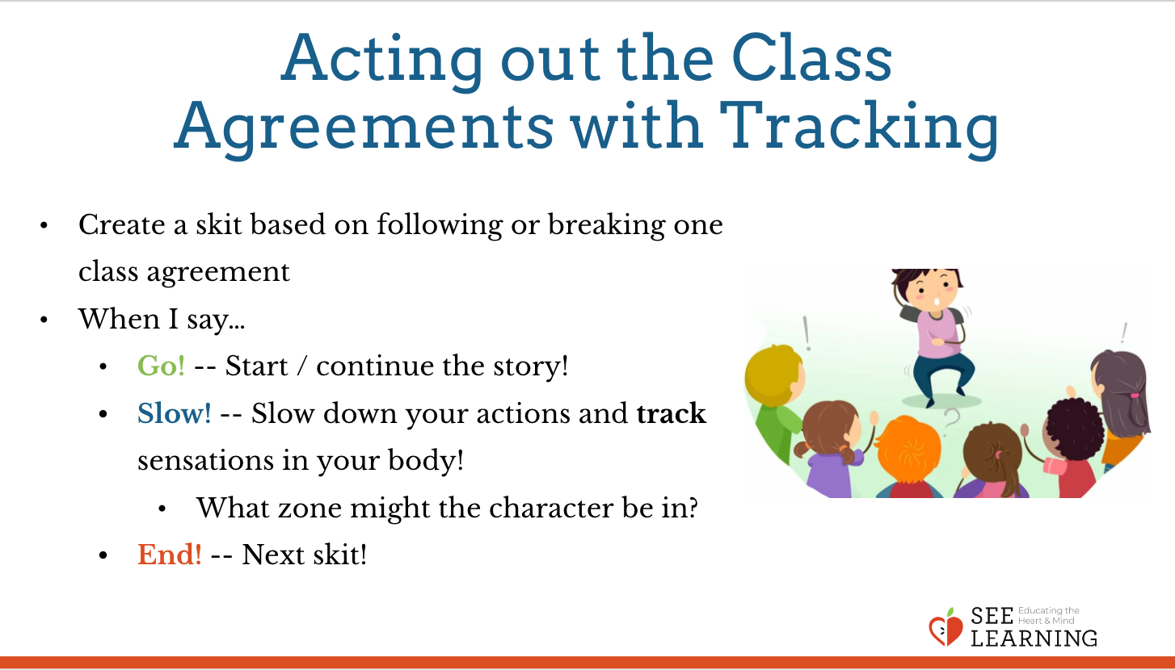 | Sample Script  None

Debrief (5 min)
Slide 6: Debrief  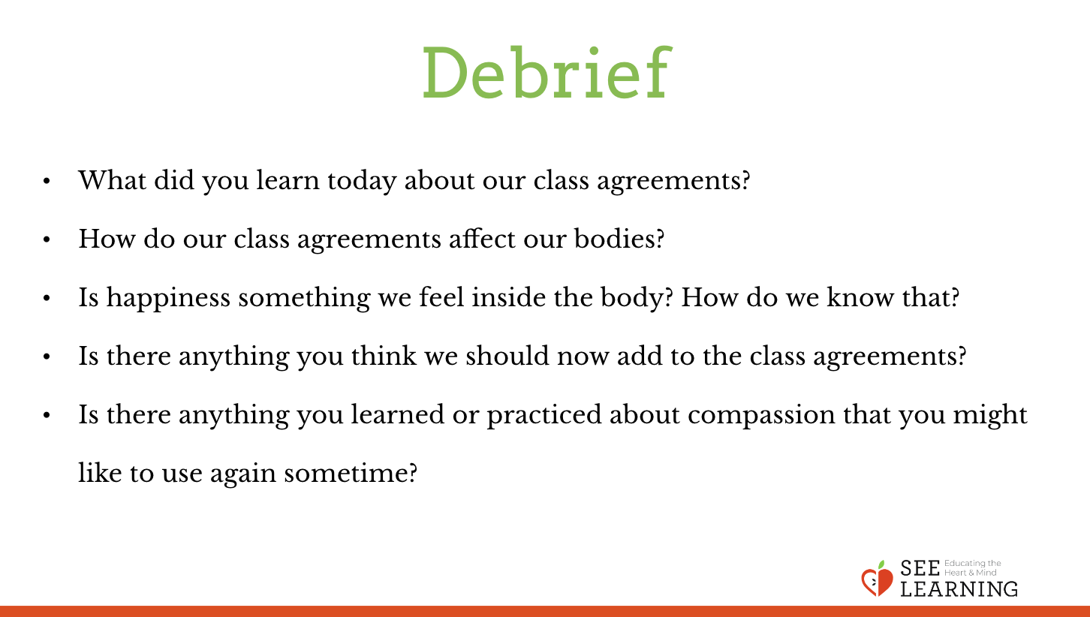 | Sample Script  - “What did you learn today about our class agreements?  - How do our class agreements affect our bodies?  - Is happiness something we feel inside the body? How do we know that? What about compassion?  - Is there anything you think we should add to the class agreements after what we did today?  - Is there anything you learned or practiced about compassion that you might like to use again sometime?”

Slide 7: Writing Extension  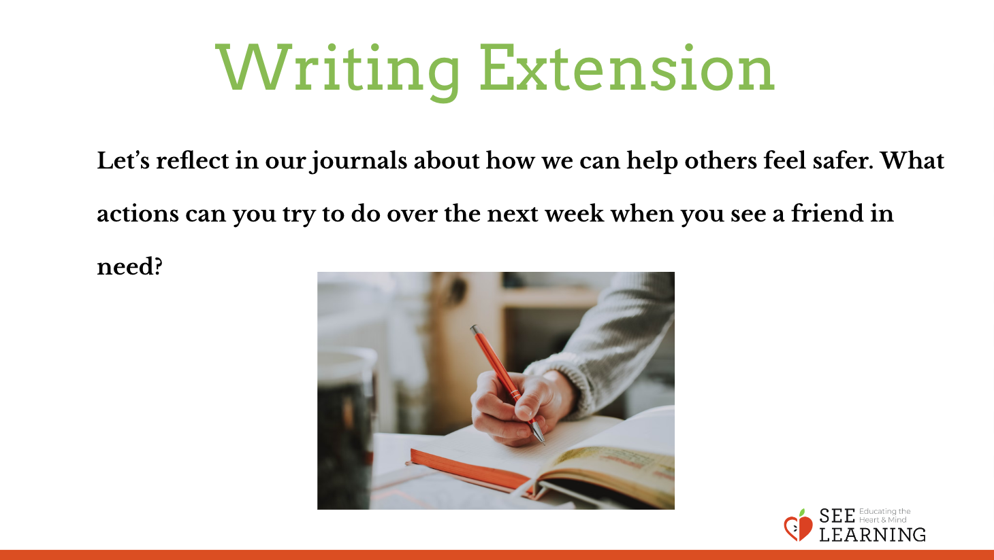 | Sample Script  - We have learned that compassion can make us feel happy and safe. It is important that we receive compassion on an everyday basis and that we are being kind to others. When we are kind to others, it can help them feel safer. This makes it a bit easier for them to move into or stay in their resilient zones. Let’s reflect in our journals about how we can help others feel safer. What actions can you try to do over the next week when you see a friend in need?

