Exploring the Resilient Zone through Scenarios
Purpose:
The purpose of this learning experience is to build off of Learning Experience 5, “The Resilient Zone,” by allowing students to move on a map of the three zones on the ground according to how they feel the characters in specific scenarios might be feeling. This helps them to further embody their understanding of resiliency and the nervous system, while still maintaining an indirect approach, in that you are not asking them what it is like when they themselves are stuck in their high or low zones, but rather you are exploring this through characters in a scenario.
Learning Objectives:  Students will be able to:  - Understand our three zones.  - Develop the skill of recognizing which zone they are in at any given moment through tracking.  - Develop the skill of returning to the resilient zone using resourcing and grounding. | Primary Core Component  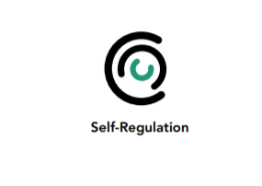
Length  - 30 minutes | Materials Required  - The charts of the resilient zone and nervous system to put up for students to see  - Sample scenarios (provided)  - Colored tape to place on the floor to create the three zones

Check In (5 min)
Slide 2: Checking In   | Sample Script  - “Take a moment to give your attention to the sensations inside your body. You might want to check how much energy you have, whether you are feeling heavier or lighter, warmer or cooler, relaxed and soft, or tight and jumpy. I invite you to notice what’s going on.  - • Last time we talked about grounding - using our body and senses to help us calm down and feel better. Can you remember something you tried that felt pleasant or neutral to you? (Take enough responses to feel that most strategies have been represented.) Is anyone having trouble remembering these? (If so, you might want to make a list to post in the classroom.)  - Is there one form of grounding you would like to try right now? (Allow some time for individual choice and exploration, or you may want to choose one experience for the whole group to try.)  - How do you feel now? Can you tell whether that exercise was helpful to you? Do you notice any differences in your body?”

Insight Activity - Exploring the Three Zones through Scenarios* (20 min)
Overview
In this activity, you will provide different scenarios and the students will stand along a line or diagram on the ground that shows the three zones, indicating where they think the character would be in their bodies based on that scenario. They will share what it’s like to be in those zones. Then they will suggest to each other what the character could do to return to their resilient zone. Those stuck in a high or low zone will then do the practices suggested, and can move if they find themselves returning to the resilient zone. This is an activity you may wish to repeat multiple times.

Content to be Explored
- Stressors can knock us out of our resilient zone. All people experience being stuck in the high zone or stuck in the low zone.
- When we are stuck in one of those two zones, we tend not to make the best decisions and we don’t feel good.
- There are specific practices we can do to return to the resilient zone.
- Once in the resilient zone, we experience more well-being, our bodies are healthier, we are kinder to ourselves and others, and we make better decisions.
Materials
- The chart(s) of the resilient zone and nervous system to put up for students to see
- Sample scenarios (provided)
- Colored tape to place on the floor to create the three zones.
Instructions
- Draw a visual representation on the ground of the three zones, which will be your “zone map.” An easy way to do this is to use colored tape and simply draw two parallel lines, thereby creating the three zones. The resilient zone will be the space between the two lines, the high zone will be above the top line, and the low zone will be below the bottom line. If you like you can also put signs on the ground that say “High,” Resilient” (or “Well-Being”), and “Low.”
- • If you feel it would be helpful, because your students don’t quite have a firm grasp on the word “resilient,” you can also write the word “resilient” on the board or on chart paper and ask students to name other words that are like resilient, creating a word map.
- Next ask for 2-4 volunteers who will stand on the zone map based on a scenario you read. Explain that everyone else will be an observer. You will then read out a scenario from the samples below (or make up your own) and ask these volunteers to stand where they think the character(s) in the story would be. Tell them that the three zones are a continuum: for example, they can be in the resilient zone but towards the high end of it (for example, if they are energetic or excited, but not stressed out), just into the high zone (slightly stressed), or very far high in the high zone (highly stressed out).
- • After they’ve found their positions, ask the volunteers to share why they are standing where they are standing (they do not all have to agree or stand in the same place), and ask them to share what they might be sensing in their bodies.
- Then ask the rest of the class (the observers) for suggestions as to what the character(s) could do to feel better. They should suggest some of the skills (Help Now! skills, resourcing or grounding, or other activities. Ask the volunteers (and observers if you like) if they would like to practice what has been suggested. Those who wish to can then do the skill. Then ask them how the character would now be feeling, and if they’d like to move to a place that better describes where the character would be now.
- Repeat with a new scenario and new volunteers.

Teacher Tips
- Note that this activity is a soft way of exploring the zones and the practices due to the fact that you are using scenarios rather than asking students directly where they are in their bodies. Because our nervous systems are constantly reacting to circumstances, however, it is very likely that you will in fact have students who may be stuck in a high zone or low zone. Our nervous systems also react to thoughts and imagination as if they were real. Therefore, the practice combines imagination with reality, and it is good for you as the teacher to be aware of this and see that activation of the nervous system is going to happen, and that the practices the students use can help them regulate their bodies in the moment.
- Gradually, practicing these skills can expand your students’ resilient zones, making it harder for them to be bumped out into the high or low zones by stressors and making it easier for them to return to their resilient zone if they are bumped out.
- Once students understand the process, using scenarios that have actually happened in your class or between students can very effective: this helps develop the important skills of empathy, perspective-taking, and conflict transformation that are more fully explored later in SEE Learning.
Slide 3: Exploring the Three Zones Through Scenarios  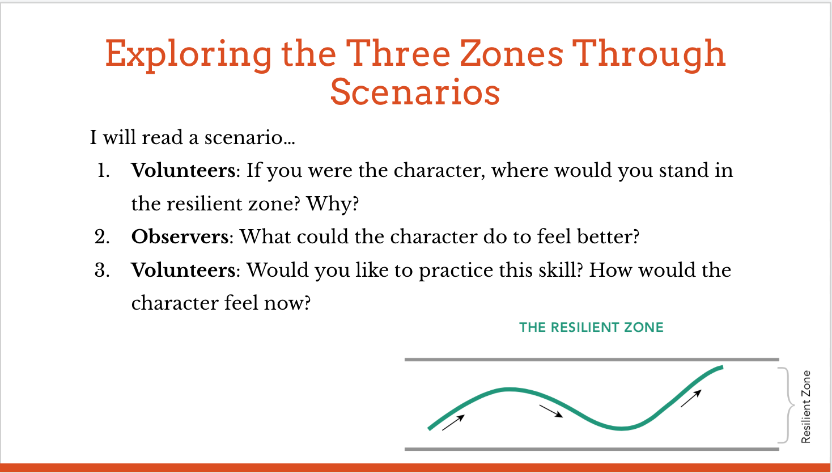 | Sample Scenarios  These scenarios are offered only as examples. Please feel free to change the names of the characters to be appropriate for your class or to choose situations more appropriate for your class. You may wish to choose names that are not names that your students have. While you can allow students to be wherever they feel they should be and explain why, some suggestions of typical responses are provided in brackets.  - Stanley is a student your age, and he has to perform in front of the whole school. [He might be stressed out, and stuck in the high zone or low zone if he is scared of public speaking. He may be excited but in the resilient zone because he likes public speaking.]  - Keiko is in bed at home. She can’t sleep because tomorrow is her birthday and she knows she’s going to be getting some wonderful presents. [She might be excited but not stressed, and therefore probably not stuck in the high zone.]  - Jasmine goes to sit with her friends at lunch, but none of them saved her a seat. Instead, they all spread out at the table so there isn’t room for her. She’s left holding her tray with nowhere to sit. [Probably stuck in the low zone, or in the lower part of the resilient zone. Alternatively, she could get angry and be stuck in the high zone or in the higher part of her resilient zone.]  - Cameron shows up for school and is asked by his teacher for his homework. But he didn’t do any of it.  - Steven is at home one evening. He hears his older brother fighting with his mother and both of them are shouting.  - Claire is at home with her parents on the weekend. They say, “We’re going out and you are going to watch your two brothers.” This is the first time she will babysit at night with no adults in the house.  - Aliyah is out at the mall with her parents, but they’ve allowed her to shop on her own for an hour. When she shows up at their meeting place, her parents aren’t there. Fifteen minutes pass, and they don’t answer her texts. [You can also ask where her parents may be since they are running late.]  - Kiara comes to school to find that her class has thrown her a surprise birthday party!  - Tyler and Santiago are at a haunted house. “Let’s go in! It will be fun!” says Tyler. “I don’t want to go,” says Santiago. “No, let’s go!” says Tyler and he pulls Santiago inside. [Have some students show where they think Tyler would be and some Santiago.]  You may wish to repeat this activity a few times. Use these examples to come up with your own scenarios, developing ones that will be closer to situations your students might encounter. Work with students to come up with scenarios, perhaps similar to those that have occurred in your class.

Debrief (5 min)
Slide 4: Debrief  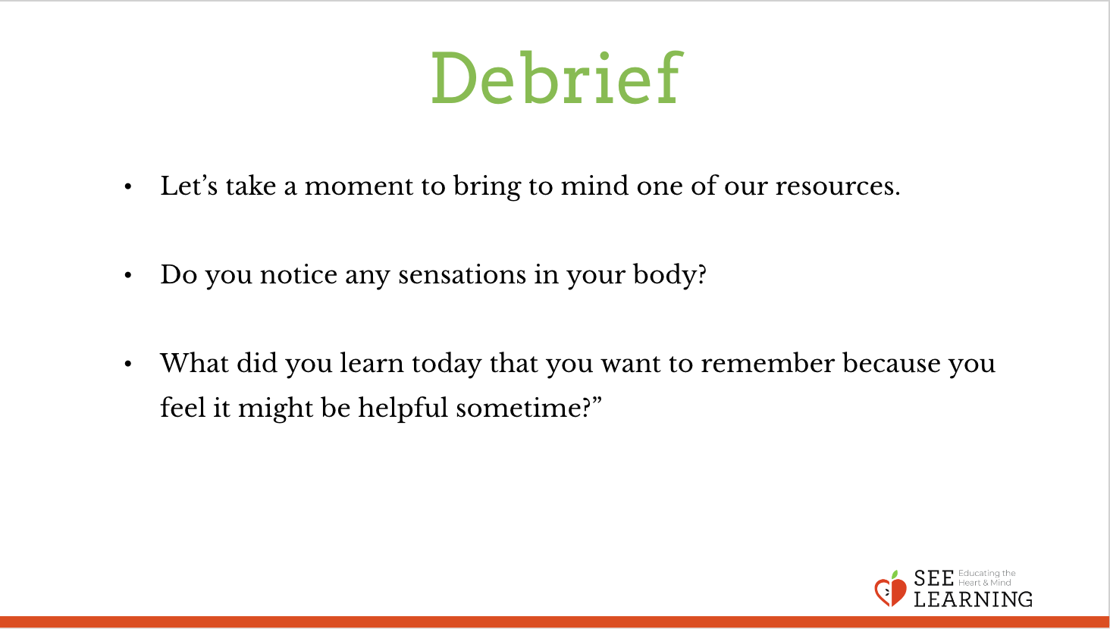 | Sample Script  - “Let’s take a moment to bring to mind one of our resources. You can take one out of your treasure chest if you like and touch it or hold it.  - Let’s pay attention to our resource for a moment and notice any sensations that arise in the body.  - If you notice a pleasant or neutral sensation, let’s stay with that for a few moments. If you notice an unpleasant sensation, let’s find a place that feels better in the body and then rest there.  - What do you notice?  - What did you learn today that you want to remember because you feel it might be helpful sometime?”

