Grounding

Purpose:
The purpose of this learning experience is to explore the skill of grounding as a way of returning to and staying within the resilient zone/OK zone. Grounding refers to attending to the physical contact of one’s body with an object. Grounding is always practiced with tracking (attending to sensations in the body), as these two together build body literacy. As there are many ways to do grounding, and each student will likely find methods that work best for him or her, it is recommended that you repeat some of the activities in this learning experience a few times.

Learning Objectives:  Students will be able to:  - Increase awareness of how our bodies feel when we move them in certain ways.  - Gain proficiency in the practice of grounding through various postures.  - Gain proficiency in the practice of grounding through holding an object. | Primary Core Component  Self-Regulation  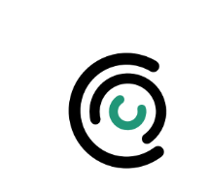
Length  30 Minutes | Materials Required  - Students’ resource kits  - A grab bag of objects for students to hold such as stuffed animals/soft toys, articles of clothing, pendants, watches, toys. (If you prefer, or if it is difficult to arrange these items, you can ask students beforehand to bring something that they feel they might enjoy using for this activity.)

Check-In (4 min)
Slide 2: Check-In   | Sample Script  - “Let’s take out our resource kits and see if there’s something in there we’d like to use.  - Pick one of your personal resources and hold it in your hands or place it in front of you.  - Let your eyes rest on it, or close your eyes and feel it carefully with your hands.  - Let’s take a few moments to really give our attention to our objects. [Pause.] As you do that, try to notice the sensations inside your body. You might feel warmer or cooler, lighter or heavier, perhaps tingling, maybe you notice your breathing, just be curious. If you don’t notice any sensations, that’s okay and just notice that you’re not feeling any sensations at the moment. You can still just sit and enjoy your object.”

Insight Activity 1: Grounding with One’s Stance* (12 min)
Overview

In this activity students will practice the skill of grounding by trying out different stances and seeing which ones bring about the greatest sense of well-being in their bodies.

Content to be Explored

• Our nervous system responds to the physical contact of our bodies with objects and surfaces.
• Attention to pleasant or neutral sensations in the body when grounding can lead to relaxation.
• We each have specific grounding techniques that will work best for us.
• Practicing grounding can make it easier and more effective over time.

Materials
None

Instructions
- You may need to prepare the space first to allow for students to push down on a desk as well as push and lean against a wall.
- Use the script below to guide your students through grounding with one’s stance and tracking for the first time.
- Explain that you will be learning a skill called “grounding” which is to help the body feel better, safer, more secure, and more stable. (In that sense it is quite like resourcing, but instead of thinking of a resource, it involves moving your body until it is most comfortable.)
- Lead your students through different postures (standing, sitting, pushing down on their desk, leaning against the wall, pushing against the wall), pausing briefly during each posture to allow them to track their sensations, and then allowing them to share what sensations (if any) they notice.
- Conclude by allowing them to practice the stance or posture that they like best, and note that they can use stances and postures like this when they need to calm down or help their bodies feel better.

Teacher Tips
- Because our nervous systems constantly monitor the posture of our bodies and the contact of our bodies with objects (including what is supporting us, such as the floor, beds, or chairs), simply changing our stance can help the nervous system regulate itself better. Tracking sensations allows a deepening of the experience and the building of body literacy.
- If you like you can add other postures as well, even including lying down or sitting with one’s back against the wall. Arm positions can also be used, such as folding one’s arms. Remember to encourage them to use tracking to notice the sensations in their bodies, as this will help them see which postures are most helpful.
Slide 3: Grounding with one’s stance  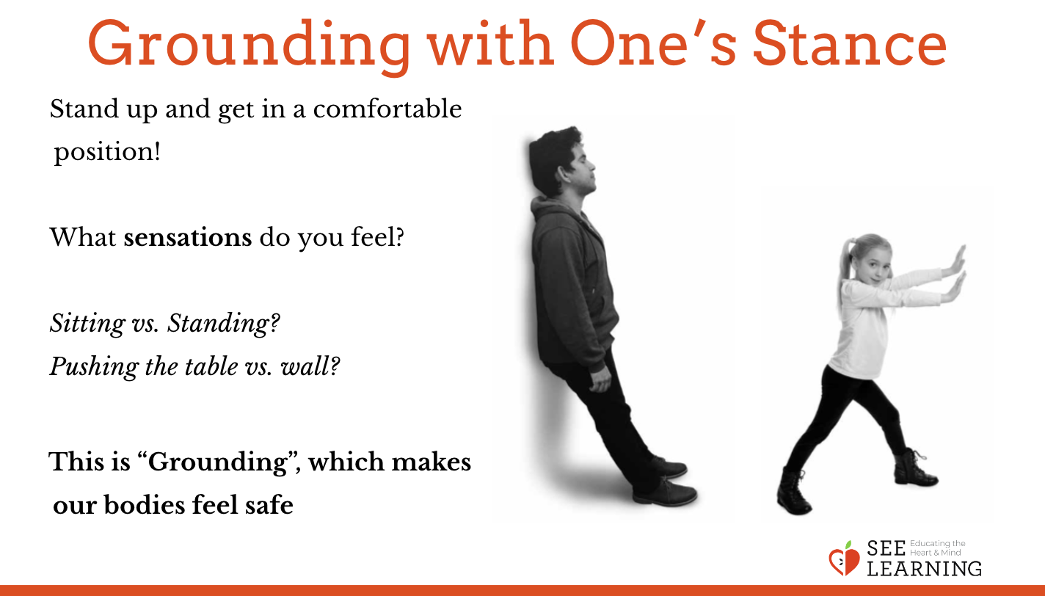 | Sample Script  - “We can use the sense of touch to practice a skill called “grounding.”  - We are going to try a little experiment and see if we feel differently depending on what our body is doing. Remember, our nervous systems are all different, so something that feels pleasant for you might feel unpleasant for others. Since we’re all sitting now, let’s notice the sensations in our bodies that come from sitting. Feel free to change your way of sitting to one that is most comfortable for you. Now let’s track our sensations by paying attention to them. [Pause.]  - Now let’s all stand. Stand in the way that is most comfortable for you.  - Let’s track what sensations we notice in our body now that we’re standing. Let’s see what we’re feeling on the inside. [Pause.]  - Who would like to share? [Allow for student comments on what they are sensing.]  - Raise your hand if you feel better standing. Raise your hand if you felt better sitting.  - That’s interesting, isn’t it? Tracking helps us know which feels better for us. It is different for each of us.  - What we’re doing is called “grounding.”  - We use grounding to help our bodies feel more safe, strong, secure, or happy.  - That’s because our nervous system always pays attention to the position of our bodies and what we’re touching. It senses what position we are in and it responds to that. It can feel better or not so good depending on how we’re standing or what we’re touching.  - Now that we are paying attention to sensations, we can see if the way we hold our body changes those sensations.  - Sometimes by changing the way we are standing or sitting can help us feel better.  - Let’s try something different. Let’s push down on the table with our hands. It doesn’t have to be too hard. And let’s track what sensations we feel on the inside. [Pause.] (If students are sitting in a circle away from tables, they can place their hands on the bench or floor and push hard to lift themselves up off their seat, feeling the contact and also the pressure in their arms.)  - What sensations do you notice on the inside? [Allow students to share.]  - Let’s try a different thing. Let’s push against the wall with our hands. While we’re doing that, let’s do tracking. Let’s notice what sensations are in our body when we push like this and where in our body we feel those sensations. [Pause.]  - What sensations are you noticing? [Allow students to share.] Are they pleasant, unpleasant, or neutral?  - Let’s try leaning against the walls with our backs. And let’s track while we do this, paying attention to our sensations on the inside. [Pause.]  - What sensations are you noticing now? [Allow students to share.] Are they pleasant, unpleasant, or neutral?  - Raise your hand if you felt better pushing against the wall. Raise your hand if you feel better leaning against the wall. Raise your hand if you felt better pushing down on the table or seat.  - Now let’s each do what we prefer. If you want to sit, do that. Or you can stand, you can push down on the table, you can lean against the wall, or you can push against the wall. Let’s all do the one we like best.  - Now let’s pay attention to the sensations inside our body by tracking. You might like to close your eyes to help you feel the sensations.  - What do you notice? Do we all like the same things?  - Did you find one that made you feel better?  - When we do this, we learn what feels best for us. We can use this practice of grounding to help our body be calmer if it isn’t feeling calm.”

Insight Activity 2: Grounding with an Object* (10 min)
Overview

In this activity you will allow your students to choose an object they like from a selection that you provide (or ask them to bring objects of their own) and they will practice holding a few of the objects and noticing what sensations arise in their bodies when they do this.

Content to be Explored

•Our nervous system responds to the physical contact of our bodies with objects and surfaces.
• Attention to pleasant or neutral sensations in the body when grounding can lead to relaxation.
• We each have specific grounding techniques that will work best for us.
• Practicing grounding can make it easier and more effective over time.

Materials
A grab bag of objects for students to hold such as stuffed animals/soft toys, articles of clothing, pendants, watches, toys. (If you prefer, or if it is difficult to arrange these items, you can ask students beforehand to bring something that they feel they might enjoy using for this activity).

Instructions

Use the provided script to guide students through grounding with an object and tracking for the first time.

Teacher Tips
- Grounding is the physical contact of our body with an object. This can include the ground, a chair, or the wall, as in the previous activity. But it can also involve holding an object. When we enjoy the sensations that arise from holding an object, attention to those sensations can also help us relax.
- You may wish to have a variety of soft objects or objects with nice textures as well as some hard objects like wooden objects or stones. Students can also use their resource stone from the previous Learning Experience. If you will not have enough objects for them, you can ask them to bring in something from home prior to doing this activity.
Slide 4: Grounding with an Object  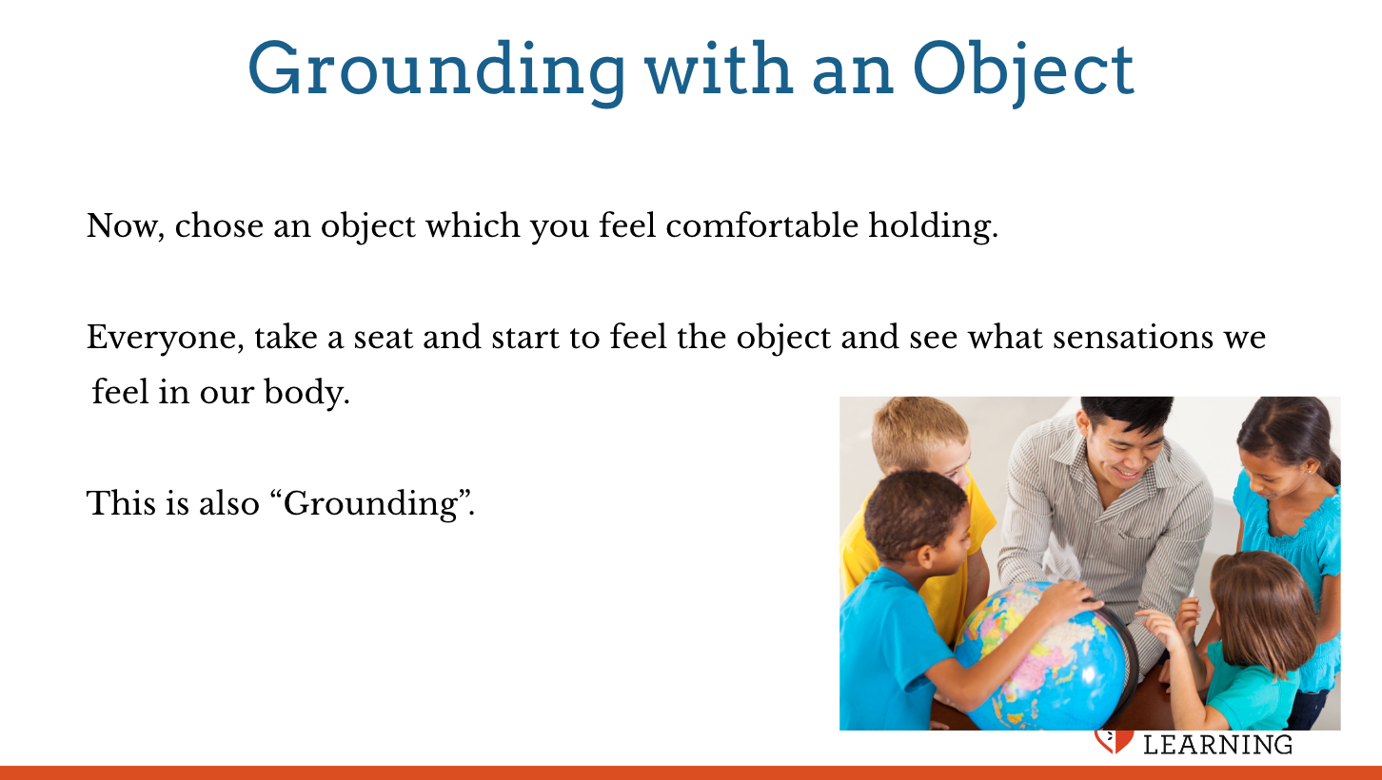 | Sample Script  - “We can do grounding by holding or touching things also.  - Here are some things we can use to practice grounding. You can each choose something you think you might enjoy holding.  - Let’s sit and hold our object. You can feel it with your hands or place it on your lap.  - Notice how it feels.  - Can anyone describe their object using sensation words? What does it feel like?  - Now let’s do tracking. We’re going to pay attention to the sensations in our body as we hold our object.  - Let’s be silent for a moment and notice any sensations in our body as we hold our object. [Pause.]  - What did you notice? Where did you notice it in the body?  - Let’s be silent again and do some more tracking. [Pause.]  - What did you notice this time?  - Would anyone like to change their object? [Repeat once allowing students to pick a different object if they didn’t particularly like their first one.]  - This is also grounding.”  - After you do this a few times, you may find that some students like particular objects especially and can use them for grounding. If this is the case, you may wish to leave some of these objects in the classroom to allow students to use them for grounding when they feel the need to as it suits your classroom.

Optional Insight Activity 1: Grounding with a Part of the Body* (10 min)
Overview

This activity is an extension of further ways students can use grounding, in this case by becoming aware of their feet and hands while lightly pressing down on a table, leaning against the wall, sitting, or standing. As in other grounding activities, what is important is to combine grounding with tracking (awareness of sensations in the body).
Slide 5: Grounding with a part of the body  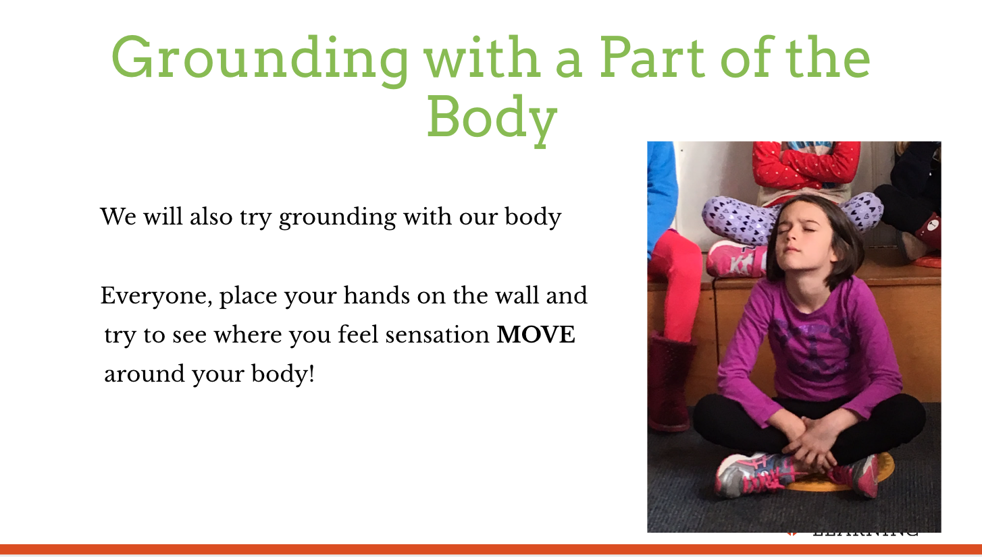 | Sample Script  - “We can do grounding by becoming aware of a part of our body in relationship to a surface.  - Let’s try placing our hand(s) against a table, a wall or the floor.  - Let’s try paying attention to our feet and how they are positioned on the ground.  - Now let’s do tracking. We are going to pay attention to the sensations in our body.  - Let’s be silent for a moment and notice any sensations in our body. [Pause.]  - What did you notice? Where do you notice it in the body?  - Let’s be silent again and do some more tracking. [Pause.]  - What did you notice this time?  - Did you like paying attention to your hands, your feet, or both?  - This is also grounding.”

Debrief (4 min)
Slide 6: Debrief  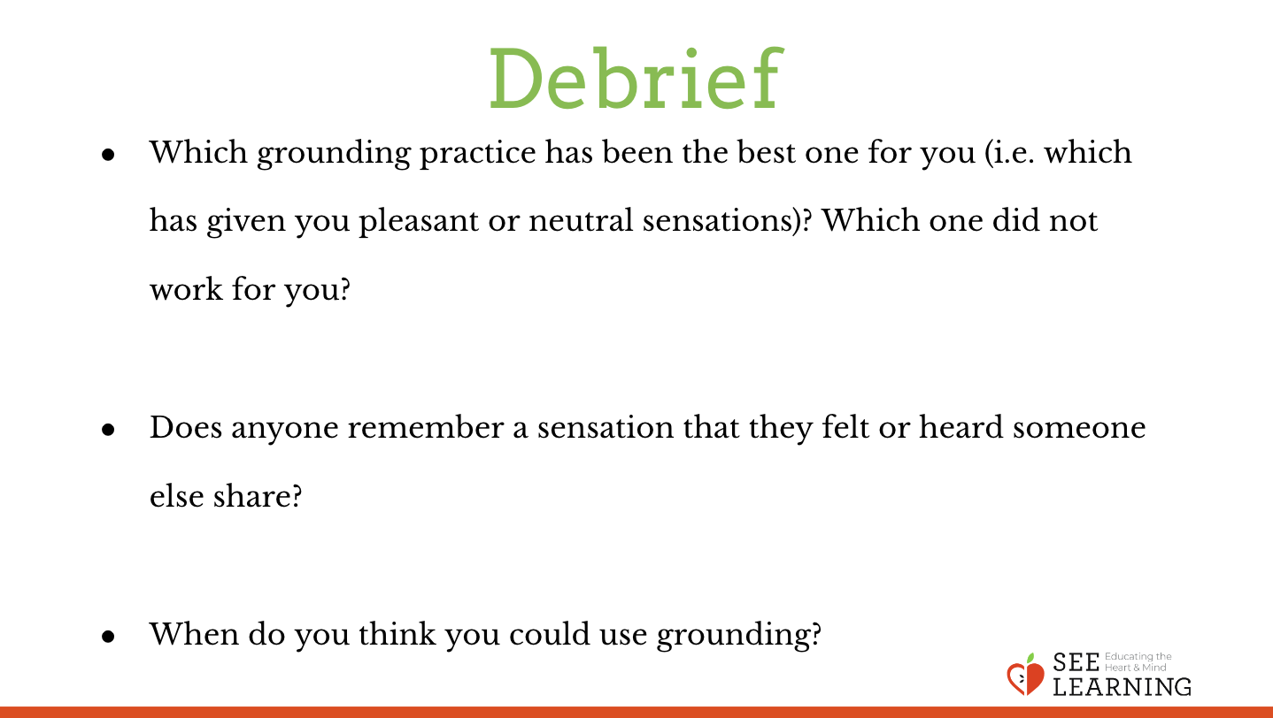  Animated slide | Sample Script  - “We have spent some time together trying out different ways of grounding ourselves and noticing sensations within our bodies. Which has been the best one for you (i.e. which has given you pleasant or neutral sensations)? Which one did not work for you?  - Does anyone remember a sensation that they felt or heard someone else share?  - When do you think you could use grounding?”

