Creating a Resource Kit

Purpose:
This learning experience builds on the last activity by helping students create a “resource kit” (or tool kit or treasure chest, as elementary students may call it) of personal resources. Personal resources are internal, external, or imagined things that serve to bring about sensations of greater well-being in the body. They are unique to each person. Thinking about a personal resource tends to bring sensations of well-being to the body. It is good to have more than one resource, because a particular resource might not work all the time. For example, some resources might serve to energize us when we are feeling down, while others might calm us when we’re feeling hyperactive. It is important to practice resourcing along with tracking, since it is the tracking skill that builds body literacy
Learning Objectives:  Students will be able to:  - Create a resource kit of personal resources that they can use to calm themselves when stressed. • Discover how to use their personal resources to relax and calm the body.  - Develop greater skill in identifying and tracking sensations in the body. | Primary Core Component  Self-Regulation  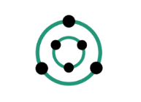
Length  30 Minutes (40 with optional activity) | Materials Required  - The compassion drawings from Chapter 1  - Colored or white blank 4”x 6” cards (or paper cut to a similar size) and colored pens or markers for each student  - Small box, pouch, or a large colored envelope to serve as the “resource kit” for each student to store their drawings of personal resources in  - A box of small colored rocks, stones, crystals, or other similar objects (optional)  - Art supplies for decorating the resource kit (optional)

Check-In (4 min)
Slide 2: Check-In  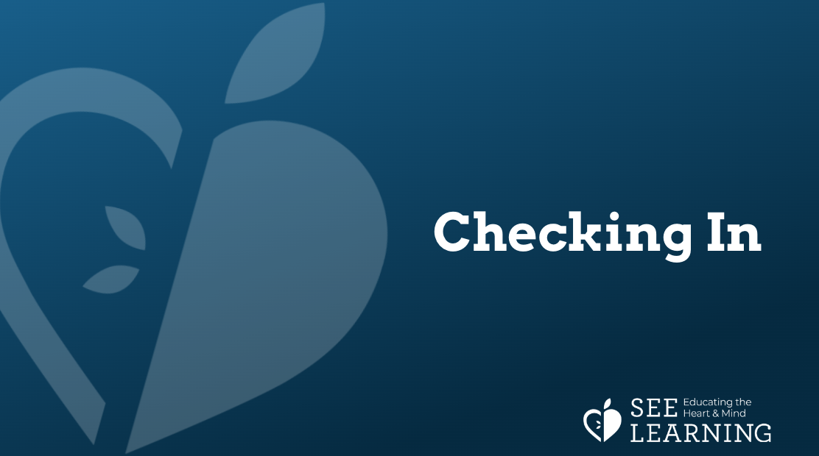 | Sample Script  - Distribute the compassion drawings from the previous learning experience to each student.  - “Let’s take a moment to get comfortable as we take out the compassion drawings we did a few days ago.  - Look around the room, and see what catches your attention that is pleasant or neutral, it could be an object, a color, a favorite friend, or something else.  - Bring your attention to a place on the inside that feels pleasant or neutral.  - Now let’s think of our moment of compassion or the drawing of a resource. (Pause.) Take a look at your drawing and see if you can remember what the act of compassion or resource was that you drew, where you were, or who you were with.  - When you think about this moment of kindness or resource, what do you notice happening the inside your body? (If students share pleasant or neutral sensations, allow them to sit with their attention on those sensations. If they share unpleasant sensations, encourage them to shift and stay, or to choose one of the Help Now! activities.  - As we do this, we’re learning about our bodies and how to calm them and make them feel okay.”

Insight Activity 1: Creating a Resource Kit of Personal Resources* (16 min)
Overview

In this activity students will come to understand what a personal resource is: something specific to them that makes them feel good or better when they think of it. They create a set of personal resources for themselves, drawing each one on a piece of paper and then labeling it. The pieces of paper can be small so that they can be folded and placed in a box (or colored envelope) which will serve as a resource kit of the student’s personal resources. If you or your students prefer, you can call the resource kit something else, like a “pouch of resources,” “tool box” or “tool kit.” (Similarly, you can provide pouches instead of boxes.) As the year goes on, they can add to their resource kit of personal resources and they can pull resources from it when they need to.

Content/Insights to be Explored

• We can develop and use a variety of resources to help the body feel calmer and safer.
• Our nervous systems respond when we think of things we like and enjoy or things that make us feel safer.
• Some resources may work better at certain times than others.
• Resourcing can become easier with practice.

Materials
Colored or white blank 4”x 6” cards (or paper cut to a similar size) and colored pens or markers for each student; small box, pouch, or a large colored envelope to serve as the “resource kit” for each student to store their drawings of personal resources in; a box of small colored rocks, stones, crystals, or other similar objects (optional); art supplies for decorating the treasure chest (optional)

Instructions
- Tell students you are going to make a resource kit and explain to students what resources are.
- Ask questions to get students to share some of their resources.
- Provide ample time for students to draw their resources and then share them. Sharing can be done in pairs or as a whole group or both.

Teacher Tips
- What’s important in this learning experience is students identifying what serves as a personal resource for them, that is, recognizing the value of something in their life as a resource that makes them feel good or better. Although we all have things in our lives (people, places, activities, memories, hopes, etc) that make us feel better, we sometimes take them for granted or don’t recognize them as having this special value.
- You may wish to repeat this activity to create more resources. Also, you can set aside time for your students to decorate and personalize their resource kit, thereby making it individualized. In this way, their resource kit itself may come to serve as a resource for them. You can also use the following supplemental insight activity (“resource stone”) to add to the resource kit.
- Note: Personal resources can be quite simple; they do not have to be something incredibly wonderful. Personal resources are also unique to the individual; what works for one person will often not work for someone else. To keep the range as broad as possible at first, use a variety of words to describe what a personal resource can be rather than a single word like “happiness,” “safety,” “joy,” etc. That will make it easier for your students to find something that works for them.
Slide 3: Creating a Resource Kit  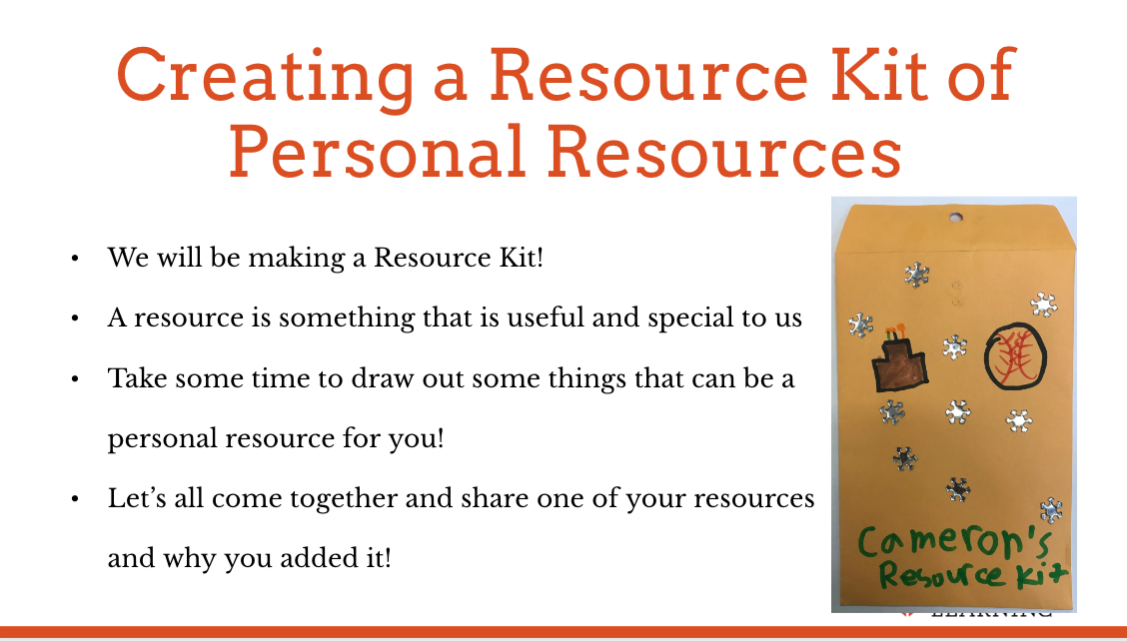 | Sample Script  - “Today we’re going to create a resource kit. It’s like a tool kit.  - What’s a tool kit for? What kind of things do you find in a tool kit?  - In this kit we’re going to put reminders of things that make us feel good, things that make us feel safe, or things we like.  - We call these things personal resources. A resource means something that is useful. It’s personal because our resource is something special to us. It doesn’t have to be special to other people.  - Personal resources are things that make us feel good or happy or safe.  - They can be things we like to do. They can be things we find relaxing or fun. They can be people we like. They can even be things about ourselves - things we’re proud of or happy about.  - Is there someone you like who makes you feel safer and happier when you think of them?  - Is there a place you like that makes you feel better when you go there or think about it?  - Is there something you really like to do that is fun?  - These are all personal resources. It can be anything that makes you feel good or makes you feel better when you’re not feeling good.  - It can even be something that you imagine that makes you feel good or happy when you think of it.  - Let’s take a moment to think of a personal resource for ourselves, it might be two or three.  - Now let’s take a moment to draw our resource or resources.  - Let’s write down the name of our resource on the drawing so we can remember what we drew later.  - [Allow students ample time to draw.]  - Now we’ve created a few personal resources. Each one is like a treasure. It’s valuable. Like treasure, we can save it for later and we can use it when we want to.  - We can keep our resources in our resource kits. Let’s write our names on our treasure chests.  - Let’s share what we made with each other. Who would like to share one of your resources and why it is a resource for you?”

Reflective Practice 1: Practicing Resourcing and Tracking* (7 min)
Overview

In this reflective practice, students will choose one of their personal resources and sit with it for a moment, seeing if they can notice sensations in the body and identify them as pleasant, unpleasant, or neutral (in-between).

Teacher Tips
- Note that if students share unpleasant sensations, remind them that they can shift to a place in their body that feels better or even just neutral. This skill is called “shift and stay.” Also, remember that you are helping them to learn what a sensation is, so if they say things like “It feels good” or “It feels bad,” ask them things like, “What does good feel like? Can you describe the sensation?” You can use the sensation word list that you created with them in the previous learning experience.
- Resourcing is a skill that will take time to develop. It is suggested that you repeat this activity a few times until students gain some direct experience with pleasant sensations in the body while thinking of their personal resource. After such critical insight is born, further practice will then lead to an embodied understanding of the way their own nervous system experiences and expresses stress and well-being.
Slide 4: Practicing Resourcing and Tracking  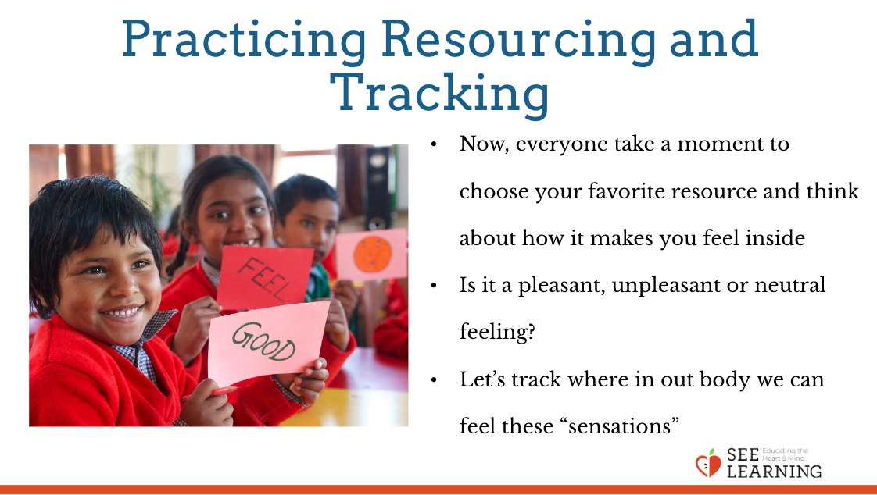 | Sample Script  - “Now we’re going to notice sensations in our bodies. (Review what a sensation is with examples if necessary).  - Let’s take a moment and choose one of your favorite resources.  - Make yourself comfortable and place the drawing of your resource in front of you.  - If you feel that you are distracted, move to a place where you are less distracted.  - Let’s take a moment and be still and just look at our resource and think about it.  - What does it feel like on the inside when we look at and think about our resource?  - Do you notice any pleasant sensations? If you don’t, that’s okay.  - If you notice unpleasant sensations, then just shift and find another part of your body that feels better. Stay with the place that feels better.  - Once we’ve found a pleasant sensation, or just an in-between sensation, then we can stay there and just feel that sensation. [Pause.]  - It’s like we’re reading our body and its sensations. We call this tracking. Tracking means to follow something closely. When we notice the sensations in the body and pay attention to them, we are tracking.  - Would anyone like to share a sensation that they notice in their body?  - What does it feel like when you just pay attention to that sensation?”

Debrief (3 min)
Slide 5: Debrief  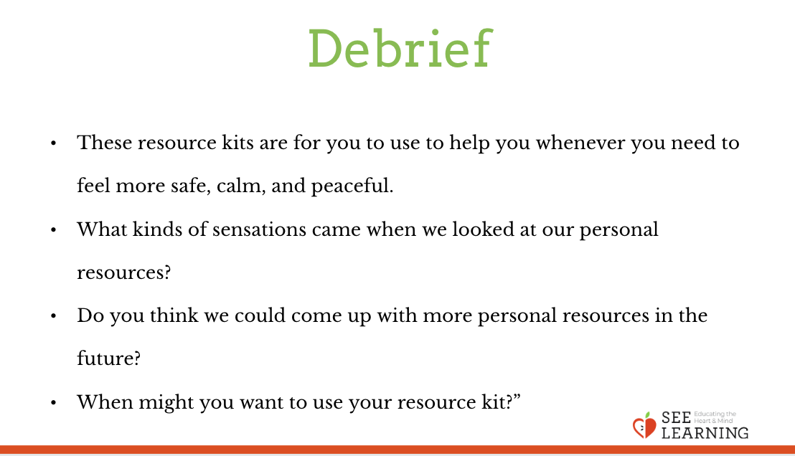  Animated slide | Sample Script  - “These resource kits are for you to use to help you whenever you need to feel more safe, calm, and peaceful.  - Whenever you feel you need some help feeling calmer, you can take a few moments and touch your stone quietly, and remember something you’re thankful for. Or look at your pictures of your resources.  - What kinds of sensations came when we looked at our personal resources?  - Do you think we could come up with more personal resources in the future?  - When might you want to use your resource kit?”

Optional Insight Activity 1: Resource Stone (10 min)
Overview

This is an optional supplemental insight activity that can go along with the resource kit activity. You may not have time to do both activities in one lesson, so you can always do this later. In this activity, you invite the students to form a circle and choose a small stone, crystal, or other object from a bag or box. They then think of something they are thankful for, and the stone or object comes to represent that thing. They then add the object to their resource kit.

Materials
• A small stone, crystal, or other small item for each students
• Students’ treasure chests

Instructions
- Invite the students to join you in a circle.
- Give each student a small crystal, stone, or other small item or invite them to choose one they like from a box or bag. They should choose.
- Lead them through the resourcing practice, scripted below.
Slide 6: Resource Stone  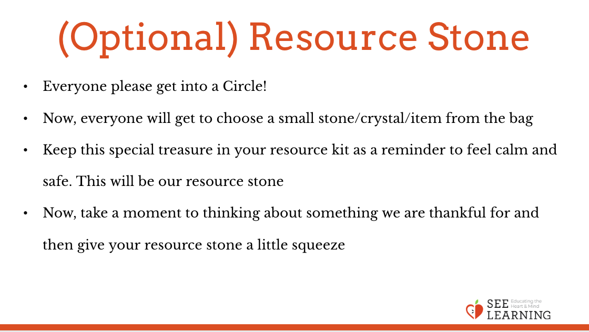 | Sample Script  - “This is a special treasure for your resource kit.  - It is a stone (or crystal) that can help remind you how to feel calm, safe, and peaceful. We’ll call it a resource stone, since we will use it to remind us of a resource.  - But, before it can do that, we have to practice something new.  - Take a moment and think of something that you are thankful for.  - It can be one of your personal resources or something new.  - We can feel thankful for little things, like a someone giving you a smile, or big things like special people in our lives.  - Let’s all take a moment and think about something we feel thankful for: a place, a person, an object, or something else.  - It could be an adult in your life, a pet, a favorite park. Whatever it is, take a moment to picture it in your mind.  - As you think about this special thing, give your stone a gentle squeeze. You can rub it with your fingers too.  - Notice what sensations you feel on the inside as you hold your stone and think of what you’re thankful for.  - Now, we’ll go around the circle and share what we’re thankful for.  - I’ll start: “I’m thankful for… (the trees that I see outside, my walk home, my good friends, my cat).”  - Go around the circle until everyone has shared. It’s ok to pass.  - “Notice how you feel on the inside now that we’ve all expressed thanks for something special to us.  - Does anyone notice any sensations on the inside? What do you notice?  - Now you can return to your desks (tables) and place your special stone inside your resource kit. • We can write a note and put it in our resource kit also, so that we remember what it is we were thankful for.”

