Resourcing

Purpose:
The purpose of this learning experience is to help students explore the use of a personal resource (in this case, the kindness drawings created in Chapter 1) to bring about greater well-being in the body. Personal resources are internal, external, or imagined things that serve to bring about sensations of greater well-being in the body. They are unique to each person. Thinking about a personal resource tends to bring sensations of well-being to the body.
When we notice these sensations (tracking) and then focus upon pleasant or neutral sensations, the body tends to relax and return to its resilient zone (which students will learn about later). Both resourcing and tracking are skills that develop over time and lead to what can be called body literacy, since we are learning about our own bodies and how they respond to stress and well-being
Learning Objectives:  Students will be able to:  - Discover how to use a personal resource to relax and calm the body.  - Develop greater skill in identifying and tracking sensations in the body | Primary Core Component  Self-Regulation  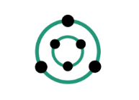
Length  30 Minutes | Materials Required  - The drawings of kindness that students created in Chapter 1. If you do not have those drawings, you can have them create new ones, but this will take additional time.

Check-In (5 min)
Slide 2: Check-In   | Sample Script  - “Let’s practice some of the Help Now! activities that we learned. (You may wish to have pictures of the Help Now! activities up to allow students to pick one of them.)  - Let’s listen and see if we can hear three things inside this room.  - Now let’s listen and see if we can hear three things outside this room.  - What do we notice on the inside as we do that? Do you notice a pleasant or neutral sensation? Remember, neutral means inbetween.  - Look around the room, and see what catches your attention that is pleasant or neutral, it could be an object, a color, a favorite friend, or something else.  - Now let’s check-in with our bodies. What do you notice on the inside? Can you find a pleasant or neutral sensation in your body?  - Is there anyone that can’t find a pleasant or neutral sensation? If so, raise your hand. (If some students raise their hands, help them shift to a place in their body that feels better.)  - Once you’ve found a pleasant or neutral sensation, let’s just pay attention to that place quietly for a moment. See if the sensation changes or if it stays the same.”

Insight Activity 1: Using the Compassion Drawing as a Personal Resource (20min)
Overview

In this activity, students share their drawing and then notice sensations in their body, paying particular attention to pleasant and neutral sensations.

Content to be Explored

• Sensations can be pleasant, unpleasant, or neutral; the same sensation (such as warmth) could be any of these three
• When we focus on pleasant or neutral sensations, our bodies tend to relax.
• We can use resources and attention to sensations to relax our bodies.

Materials
The drawings of compassion that students created in Chapter 1.

Instructions
- Follow the script below to facilitate resourcing for the first time.

Teacher Tips
- Bringing to mind something that evokes greater well-being, safety, or security is called “resourcing.” The object that one brings to mind is called a personal resource. Noticing the sensations that arise is called “tracking” the sensations or “reading” them (you can use whichever term you prefer). When a pleasant or neutral sensation is found through tracking, we can keep our attention on that sensation for several moments and observe the sensation, seeing if it stays the same or changes. This tends to deepen the sensation and lead to greater relaxation in the body.
- Although we all have nervous systems, there can be great variety in terms of what functions as a personal resource for us and what sensations arise in us related to wellbeing or stress. If tracking leads us to noticing unpleasant sensations, we can try to find a place in the body that feels better, and focus on that instead. This is called “shift and stay.” When we do find a pleasant or neutral sensation in the body through tracking, we can keep our attention on it for a few moments. As noted, this silent attention tends to deepen the experience and signals to the body that we are safe, and the body typically responds with relaxation.
- It’s possible that during resourcing, the students will share sensations that are coming from things other than the kindness drawing. For example, the student may feel nervous speaking up and may describe sensations related to that. If that happens, you can redirect the student back to the compassion drawing and see if that evokes any pleasant or neutral sensations. If the student does report a pleasant sensation, then ask them to pause for a moment and just notice that sensation. It is this pausing and staying aware of the pleasant or neutral sensation that allows the body to relax and deepen into an experience of safety. If the student reports unpleasant sensations, ask if there is somewhere else in the body that feels better, then allow them to pause and notice that place that feels better.
- Note: A single sensation (like warmth, for example) can be pleasant, unpleasant, or neutral. Coolness similarly can be pleasant, unpleasant, or neutral. So it is helpful to ask the students specifically whether the sensation is pleasant, unpleasant, or neutral so that they begin to learn the skill of tracking in this way. Also note that the nervous system responds to stimuli very quickly. So if you wait too long when the student is sharing their kindness drawing, their attention will have moved on to something else, and they will no longer be experiencing sensations related to recalling a moment of compassion. The timing of this will become more apparent to you with practice
Slide 3: Using Your Compassion Drawing as a Personal Resource  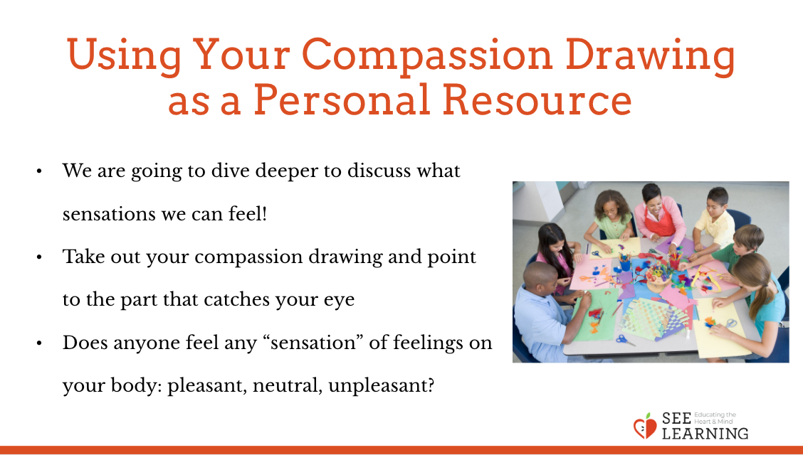 | Sample Script  - “Remember how we said we all like compassion?  - We’re going to explore how looking at or thinking about something we like can lead to sensations in the body.  - Does anyone remember what we call the part of our body that senses things and sends information to our brain? That’s right—the nervous system. We’re going to learn more about that now.  - Sensations can be pleasant, unpleasant, or they can be neither. If they are not pleasant and not unpleasant, we say they are “neutral” or “in between.”  - What sensations do you think could be pleasant or unpleasant or in-between?  - How about warmth? What’s it like when it’s pleasant? Unpleasant? In-between?  - Or coolness?  - Or having lots of energy and movement inside our bodies? What’s it like when we have that and it’s pleasant? Have you ever felt that but it was unpleasant? Could it be in-between and neutral?  - Now let’s take out our compassion drawing that we made.  - Take a moment to look at your compassion drawing. Remember what it was about.  - If you like, see what catches your eye on your drawing, and touch the part that catches your eye.  - Are the sensations pleasant, unpleasant, or neutral? Is there a difference between looking and touching your kindness drawing?  - Who would like to share their compassion drawing with the rest of us?  - It’s important that when one of us shares, everyone else is going to listen and watch quietly.”  - Allow one child at a time to share. After the child has shared, ask them immediately (waiting too long will allow the sensations to pass):  - “What do you notice on the inside right now as you remember that moment of compassion?  - Are there any sensations you notice in your body?  - Is that sensation you just told me about pleasant, unpleasant, or in between?  - What other sensations do you notice in your body as you remember the moment of kindness?  - Would anyone like to share?”  - As an option, you can allow them to share other things that make them feel happy, safe, or good, besides their compassion drawing.  - “If you’d rather choose something else to think of instead of your compassion drawing, you can think of a person, place, an animal, a thing, or memory that makes you feel good and share that.”  - Allow a few students to share and go through the same process with each one. It’s possible that as one student shares and experiences pleasant sensations, there may be noticeable changes in their body associated with relaxation. Other students may notice this. If they do, allow them to share what physical changes they noticed.  - Once you have modeled this process two or more times, you can have the children form pairs and share with each other

Debrief (5 min)
Slide 4: Debrief  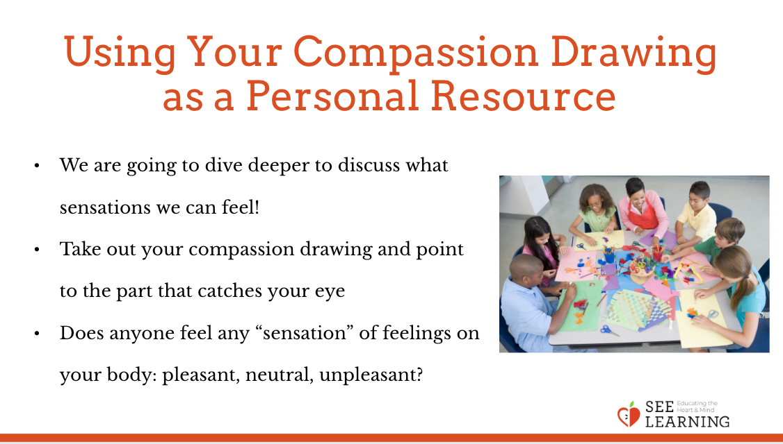  Animated slide | Sample Script  - “What did we discover about personal resources and sensations?  - What kinds of sensations came when we looked at our personal resources?  - Where in our bodies did we feel those sensations?  - Do you think we could come up with more personal resources in the future?  - If you ever feel unpleasant, do you think you could use one of your personal resources to help your body feel better?”

Extension Activity (5 min)
Slide 5: Extension Activity  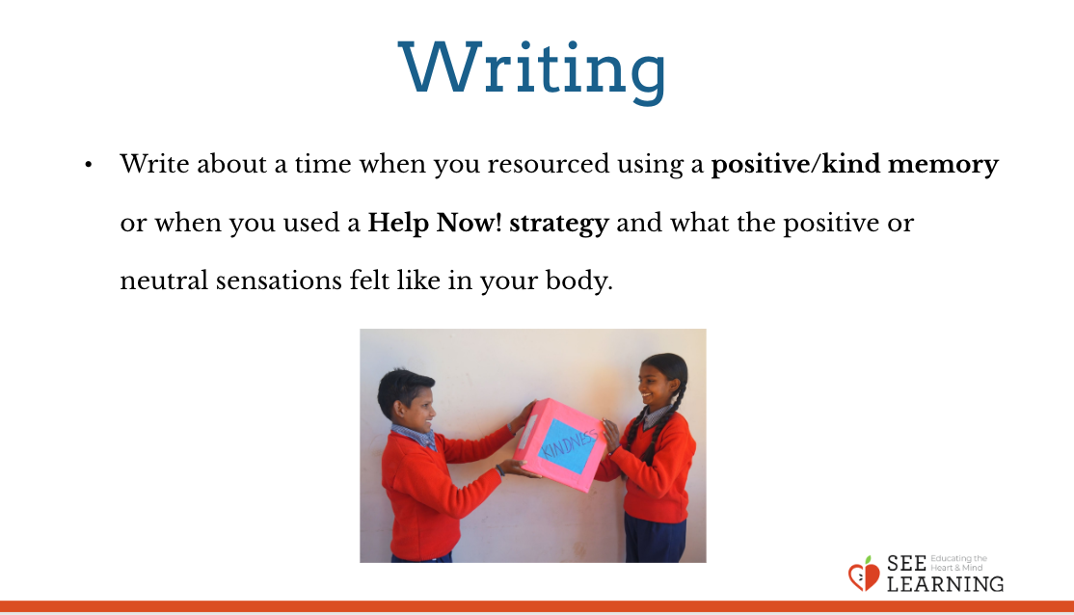 | Writing  - Write about a time when you resourced using a positive/kind memory or when you used a Help Now! strategy and what the positive or neutral sensations felt like in your body.

