The Resilient Zone

Purpose:
The purpose of this learning experience is to introduce students to the concept of the resilient zone, which you can also call the “OK zone” or “zone of well-being,” by using a puppet and charts to facilitate understanding. The resilient zone refers to when our mind and body are in a state of well-being. When we are in our resilient zone we can handle the stresses that happen during the day and react with the best part of ourselves. Stress can bump us out of our resilient zone into our high or low zone. When we are stuck in the high zone we may feel anxious, agitated, nervous, angry, stressed out, and so on. Our body is dysregulated, making it hard for us to concentrate, learn new information, or make good decisions. When we are stuck in the low zone, we may feel tired, lacking in energy, unexcited about things we normally like, unmotivated, and deflated and it’s just as difficult for us to learn new things, solve problems, or make our best choices.

Learning Objectives:  Students will be able to:  - Understand our three zones.  - Develop the skill of recognizing which zone they are in at any given moment through tracking.  - Develop the skill of returning to the resilient zone using resourcing and grounding. | Primary Core Component  Self-Regulation  
Length  30 minutes | Materials Required  - A board or chart paper for drawing the three zones  - Enough copies of the provided stories to distribute to pairs or trios if you wish to do the insight activity in small groups  - For optional insight activity: another story to diagram

Check In (4 min)

Slide 2: Check In   | Sample Script  - “Take a moment to give your attention to the sensations inside your body. You might want to check how much energy you have, whether you are feeling heavier or lighter, warmer or cooler, relaxed and soft, or tight and jumpy. I invite you to notice what’s going on.  - Last time we talked about grounding - using our body and senses to help us calm down and feel better. Can you remember something you tried that felt pleasant or neutral to you? (Take enough responses to feel that most strategies have been represented.) Is anyone having trouble remembering these? (If so, you might want to make a list to post in the classroom.)  - Is there one form of grounding you would like to try right now? (Allow some time for individual choice and exploration, or you may want to choose one experience for the whole group to try.)  - How do you feel now? Can you tell whether that exercise was helpful to you? Do you notice any differences in your body?”

Presentation/Discussion: The Resilient Zone (10 min)
Overview
In this presentation, you will discuss the concept of the resilient zone, the high zone,
and the low zone, using a story and charts to facilitate understanding and set up for the next activity, which goes through the day of a child (“Nelson”) and how that child experiences the
day in his body and nervous system.

Content to be Explored
- Stressors can knock us out of our resilient zone. All people experience being stuck in the high zone or stuck in the low zone.
- When we are stuck in one of those two zones, we tend not to make the best decisions and we don’t feel good.
- There are specific practices we can do to return to the resilient zone.
- Once in the resilient zone, we experience more well-being, our bodies are healthier, we are kinder to ourselves and others, and we make better decisions.

Materials
A board or chart paper for drawing the three zones

Instructions
- Explain that you are going to read a story together about a character named Nelson and that you are going to talk about Nelson’s day and ask them to think about what Nelson might be feeling as he goes about his day. In order to do this, explain that you will be using a chart that shows different zones or different ways Nelson could be feeling in his body.
- Show a chart of the resilient zone or draw one on the board or a piece of chart paper. Your drawing should have two horizontal lines and a wavy line between them inside it going up and down.
- Explain that this drawing shows how our bodies, and specifically our nervous systems, go throughout the day: sometimes getting more excited or even upset, sometimes feeling more tired or low in energy.
- Explain that the middle zone is the “resilient zone” (or “OK zone” or “zone of well-being” or another name your class can come up with.) This is where we’ll put Nelson when he’s feeling OK. He could be experiencing a range of emotions and feelings in this zone, but his body is still healthy and he can make good decisions. He can be OK sad or OK mad and still be in his resilient zone/OK zone.
- You can explain that “resilient” means the ability to deal with and handle difficulties; the ability to bounce back; inner strength, fortitude or toughness.
- Draw the lightning bolt symbol (or some other symbol) to represent the stressor or trigger. Explain that sometimes things happen that upset Nelson or make him feel less safe. If we come across something like this in the story, we can use a lightning bolt to indicate that something might be stressing Nelson. This might even knock Nelson out of his resilient zone. If that happens, he could get stuck in the high or low zone.
- Now add two pictures that represent a child being stuck in the high zone or low zone, such as the ones provided in the graphic. (You may print out the accompanying graphic and use that instead.)
- Ask your students what they think the boy in the high zone is feeling – really angry, upset, nervous, anxious? If Nelson gets stuck in the high zone, what might he sense on the inside?
- You may need to provide examples first. Write down the words they give you, using a different color (such as red) for sensation words. Then repeat this with the low zone. What do they think the girl in the low zone is feeling-sad, tired, alone? If Nelson were to get stuck in the low zone, what might he sense on the inside? Write down the words they give you, using a different color for sensation words.
- Then tell the story of Nelson included in the sample script below, pausing to check (a) what the students think Nelson might be sensing in his body; (b) where he might be on the resilient zone chart; (c) what he could do to get back to the resilient zone or stay there.
- Conclude the discussion by reminding the students that we have already learned a lot of skills that we can use to return to our resilient zone.
- Invite them to resource and/or ground as you end the discussion.

Teacher Tips
- Don’t be concerned if your students do not reach these critical insights right away, as they are reinforced in the following two learning experiences also.
- A note on safety: When teaching about the three zones, it is safest to use a proxy at first (such as a story, a puppet, pictures, or emojis) to represent being stuck in the high or low zones and to ask students about what they think that proxy is feeling or sensing. This is a way of teaching the three zones indirectly at first. It is not recommended to ask students direct questions such as, “What do you feel like when you’re stuck in your high zone?” or “What is it like for us to be stuck in the high zone?” or “Do you remember a time when you were stuck in your high zone?” Doing so could inadvertently cause a student to experience a traumatic flashback or to describe the worst thing that ever happened to them. Similarly, it is best to avoid creating scenarios to teach this material that involve students directly simulating being stuck in their high zone or low zone, rather than through a proxy or a role play.
- You may find the script below particularly helpful as you try this learning experience for the first time.

Slides 3 & 4: The Resilient Zone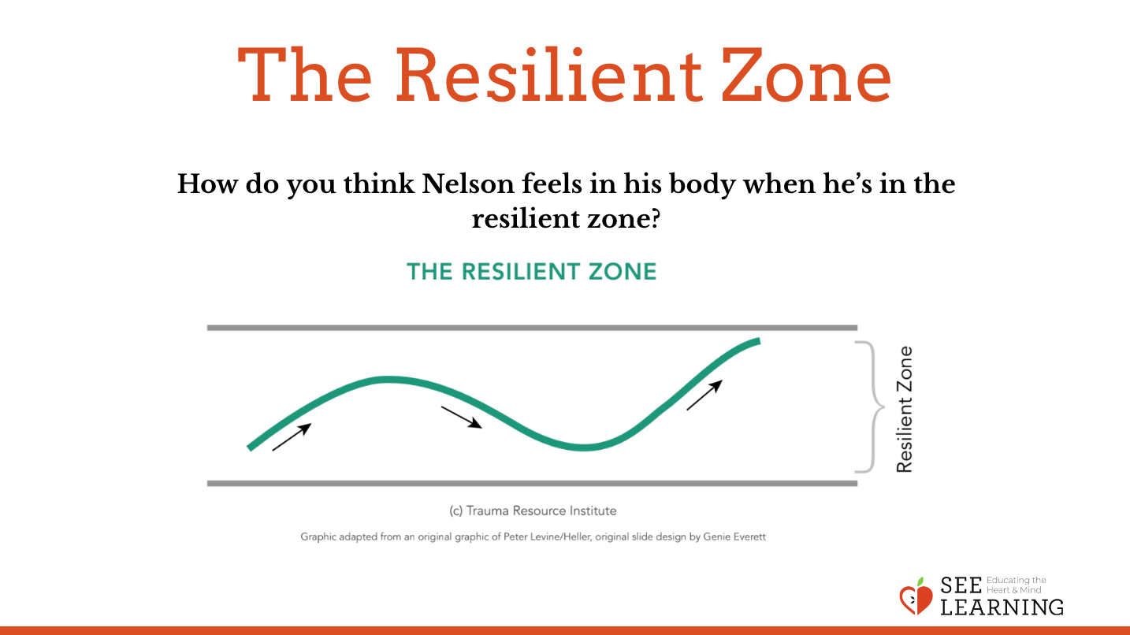  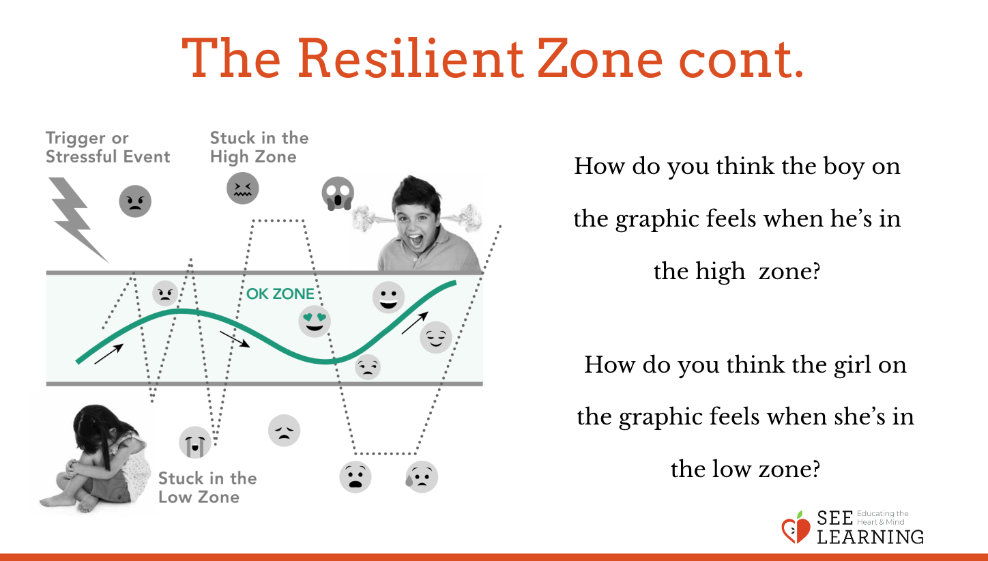 | Sample Script  - “We’ve been learning about our bodies and in particular our nervous system.  - What have we learned that our nervous system does?  - We’ve been paying attention to our sensations. And we’ve learned how to calm ourselves using resourcing, grounding, and Help Now! strategies.  - We’re going to read a story together about a character named Nelson.  - Nelson is the same age as most of you. He also goes to a school like you, and we’re going to work to understand the nervous system better by thinking about what Nelson goes through in a day.  - To do that we’re going to use a picture that is helpful for understanding our nervous system. This picture shows us what Nelson’s nervous system is doing as he goes about his day.  - This middle part is called our resilient zone [or OK zone or zone of well-being.] That’s because in the middle here, Nelson’s body is feeling resilient.  - Has anyone heard the word “resilient”? Who can take a guess at what the meaning is? [Allow students to share.]  - Resilient means we are strong on the inside, we are in control, and we can handle any difficulties. Even if difficult things happen, since we are resilient, we can bounce back and be in control again.  - When we’re in our resilient zone, we might have some difficulties, but we can deal with them because we have inner strength. We are not super stressed-out or super troubled because we have learned how to get our bodies and minds into a better place that helps us feel better.  - How do you think Nelson feels in his body when he’s here in this zone?  - Through the day we might go up and down [draw a wavy line in the resilient zone]. The line going up means we might get excited and have lots of energy, or the line going down means we might get sleepy or be a bit low in energy. But we can still do that in our resilient zone.  - But then something scary happens or something we don’t like [draw or point to the lightning bolt]. And it knocks us out of our resilient zone. And we might get stuck in our high zone.  - How do you think this boy [on the graphic] feels when he gets stuck in his high zone? [Allow responses.]  - Yes, many of you noted what it feels like to be stuck in the high zone - he doesn’t like it. He feels anxious and scared. He also might feel angry and upset! He feels out of control, like he doesn’t know what he’s going to do. He feels a lot of stress in the high zone. And sometimes feeling a lot of stress can make him go to the low zone as well.  - How do you think that girl who is stuck in the low zone is feeling? [Allow responses.]  - Yes, many of you noted what it feels like in the low zone - she might feel low in energy and sad. She just doesn’t feel like doing things. She doesn’t feel like playing the games she usually likes; she’s just not interested. She may just want to be alone. She may feel lonely, even if other people are around. She thinks it feels bad to be stuck in the low zone and she feels better when she can get back to the resilient zone.”

Insight Activity: Nelson’s Day (12 min)
Overview
In this insight activity, students go through Nelson’s day, which is a typical day in the life of a child roughly the same age your students. As you tell the story of Nelson’s day, you will let the students guide the process by asking them where Nelson is on the resilient zone chart.

Content to be Explored
- Stressors can knock us out of our resilient zone. All people experience being stuck in the high zone or stuck in the low zone.
- When we are stuck in one of those two zones, we tend not to make the best decisions and we don’t feel good.
- There are specific practices we can do to return to the resilient zone
- Once in the resilient zone, we experience more well-being, our bodies are healthier, we are kinder to ourselves and others, and we make better decisions.

Materials
- The sample story (below)
- Marker
- Whiteboard or chart paper

Instructions
- An asterisk is placed at each point in the story where you can pause and ask your students to guide you as to what Nelson might be feeling and where he is on the resilient zone chart. Ask, “What sensations do you think Nelson is feeling right now in his body?” After they’ve shared that, ask, “Where is Nelson in his three zones?” Ask them to be specific—if he’s in the resilient zone, is he in the middle or the upper part of it or the lower part of it? Or has he been bumped out of his resilient zone? If so, he is stuck on high, and if so how high? As they give you the answers, you will be drawing a wavy line from left to right that chronicles Nelson’s day and where he is on the chart based on what they say.
- At some points the students may feel something stressful has happened that knocks Nelson out of his resilient zone. At those times you can ask, “Should we put a lightning bolt here? Should it be a big lightning bolt or a small one?” If your students think these bump Nelson out of his resilient zone, you will draw the line accordingly to show that.
- Also when you see an asterisk in the story and pause, you can ask your students to recommend things Nelson could do to calm himself or make himself feel better. As Nelson does those things, they may decide that he returns to his resilient zone. Note that you do not need to adhere rigidly to every time an asterisk appears in the story. These are just suggested moments when you can pause and check-in. Most likely, your interaction with the students will be more fluid than this and you may wish to pause more or less frequently depending on how they are participating in the activity.
- At the end, you will ask them to look at the whole picture and share what they notice. Lastly, explore the idea that if Nelson thinks about his day, and knows when stressful things tend to happen, might he be able to prepare in advance for those things so that they have less of a chance of bumping him out of his resilient zone?
- End with an opportunity for them to practice resourcing and grounding themselves.

Teacher Tips
- A sample story is provided for you, but before doing this activity you should feel free to change it to fit the typical experiences your own students might have so that they can best relate to what Nelson is going through. (Note that once you go through this exercise once with your students, they should be able to do a similar exercise with any story that you read to them or tell them: that is, they will be able to tell you what the character(s) is feeling in his or her body and where they might be in their resilient zone (or out of it).)
- As an alternative, you can demark the resilient zone on the floor with rope or tape and have students move from zone to zone as they hear Nelson’s story and you land on an asterisk.

Slide 5: Nelson’s Day  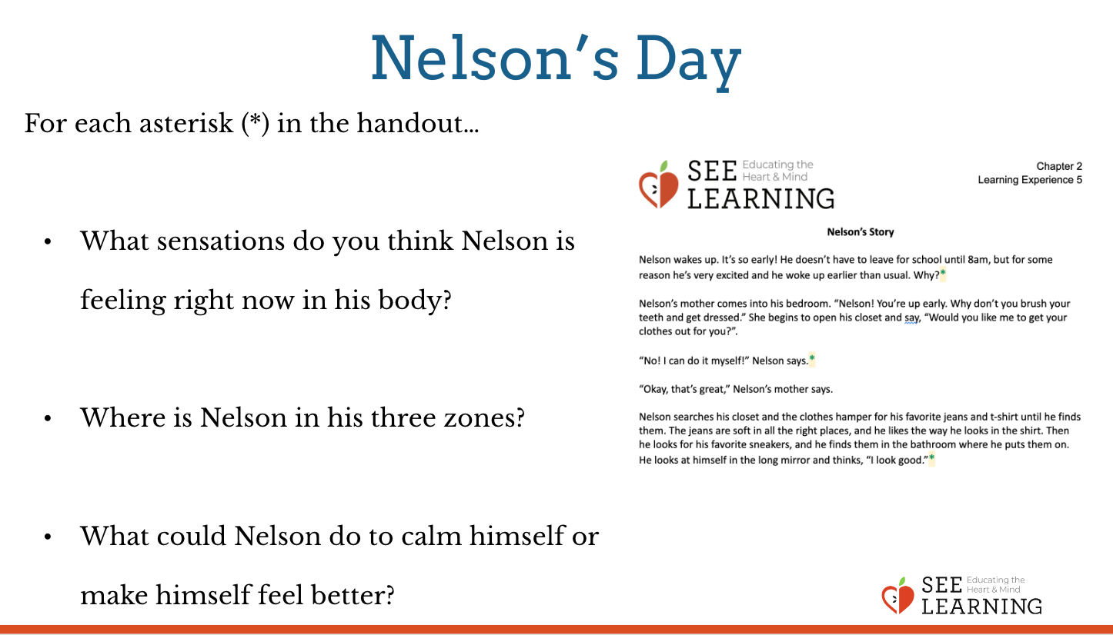 | Sample Script  - “Nelson wakes up. It’s so early! He doesn’t have to leave for school until 8am, but for some reason he’s very excited and he woke up earlier than usual. Why?*  - Nelson’s mother comes into his bedroom. Nelson! You’re up early. Why don’t you brush your teeth and get dressed.” She begins to open his closet and say, “Would you like me to get your clothes out for you?”.  - “No! I can do it myself!” Nelson says.*  - “Okay, that’s great,” Nelson’s mother says. Nelson searches his closet and the clothes hamper for his favorite jeans and t-shirt until he finds them. The jeans are soft in all the right places, and he likes the way he looks in the shirt. Then he looks for his favorite sneakers, and he finds them in the bathroom where he puts them on. He looks at himself in the long mirror and thinks, “I look good.”*  - Nelson brushes his teeth and goes downstairs. His mother is preparing breakfast for him. It’s eggs and roast potatoes, his favorite. “Yay!” he says as he settles down to eat.*  - “Nelson, you’re going to be late,” says his mother. “Hurry up and finish your food. Do you have your book bag?”  - “No, it’s upstairs,” Nelson says as he’s eating.  - “Go and get it,” says his mother. “And don’t forget to put your homework assignment in it.”  - “But I’m still eating!” says Nelson. He is enjoying his food so much.  - “You have to go and get it now or you’ll be late,” says his mother. “Go now.”*  - Nelson has to take a bus to school. He almost misses the bus! But he gets out just in time to catch it. When he finally gets on the bus and sits down next to his friend Arya, he says, “Phew! I just made it!”*  - Nelson arrives at school and goes to his classroom. The teacher comes in and has all the students sit in a circle.  - “Now it’s time for us to show our assignments,” the teacher says. “Remember I gave you some homework to do?”  - Nelson suddenly remembers that the teacher gave them some homework to do, but he didn’t do it.  - “Oh no,” he thinks. “How did I forget about that again?”  - “Let’s go in a circle,” the teacher says. One by one, each student shows their homework. Nelson knows it’s going to be his turn soon.  - “Now it’s your turn, Nelson,” says the teacher and points at him.*  - “I didn’t do it,” said Nelson. “I’m sorry.”  - “Don’t worry,” says the teacher and smiles at him kindly. “You can bring it tomorrow.”*  - Nelson sees that a few other students also didn’t do their homework, and the teacher tells them that they too can bring theirs tomorrow.*  - At lunchtime, Nelson is so happy because it’s his favorite food: pizza!*  - Nelson goes outside to play for recess after lunch, when they always have a little time to play before coming back to class. He sees some other kids playing kickball. “I love kickball!” Nelson thinks.  - But when he goes over to play with them, they don’t let him play. “You can’t play with us!” they shout. “You’re no good!”  - Nelson is surprised and sad. He goes off by himself and stands at the edge of the playground. Suddenly he doesn’t feel like playing with anyone any more. His whole body suddenly feels very heavy.*  - Then Nelson’s friend Theresa comes over to him.  - “Hey, Nelson,” she says, “we’re playing kickball too. Won’t you come and play with us? We’d love to have you on our team!”  - “Really?” says Nelson. “Okay!”*  - He runs over and plays kickball with Theresa and the other students until recess is over.  - At the end of the school day Nelson goes home. He does his homework, has dinner with his family, and then crawls into bed. He’s so tired and his legs hurt a bit from playing so much kickball, but the soft pillows feel so good under his head.*  - The End”

Debrief (4 min)

Slide 6: Debrief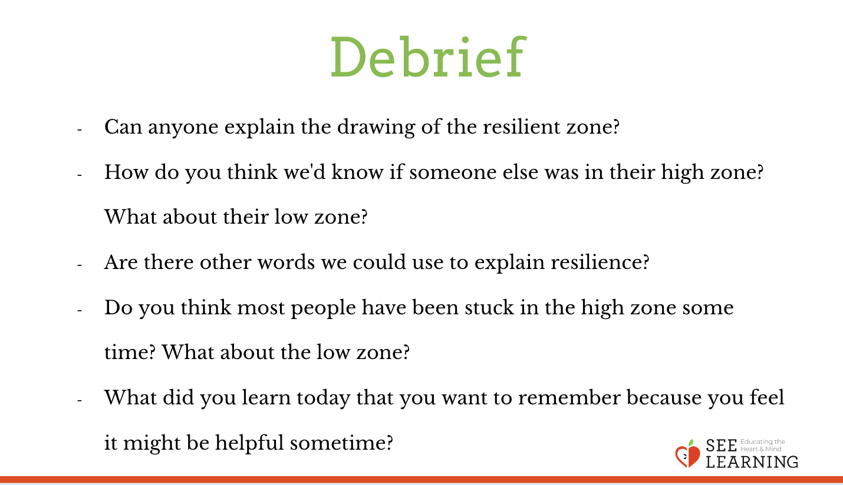 | Sample Script  - “Who would like to explain a part of what the drawing of the resilient zone means?  - How do you think we’d know if someone else was in their high zone?  - What about their low zone?  - What do you think are other words we could use to explain to someone what resilient means?  - Do you think most people have been stuck in the high zone some time? What about the low zone?  - What did you learn today that you want to remember because you feel it might be helpful sometime?”

Optional Insight Activity: Practicing Naming Sensations and Zones with Stories* (15 min)
Overview
This activity offers a way for small groups of students to practice noticing and naming sensations and zones through the use of stories. Select a story for your class to read - it can be almost any story or you could write it yourself. It could just be part of a story, enough to give them something to diagram.

Slide 7: Practicing Naming Sensations and Zones with Stories  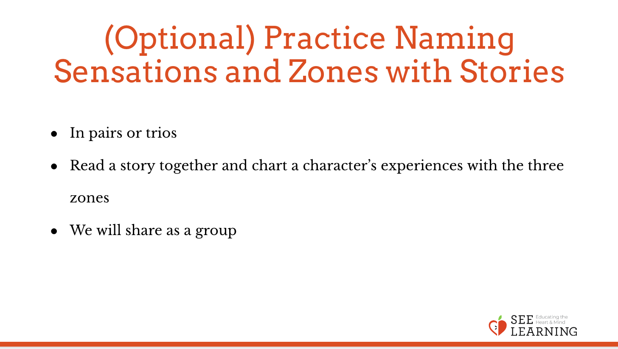 | Sample Script  - “In pairs or trios, your group is going to read a story together and chart a character’s experiences with the three zones.  - Together, your group will create a chart like the one we made together in a large group.  - When you are finished, we will share out as a whole group.”

