Recognizing Compassion and Exploring Interdependence

Purpose: The focus of this learning experience to practice recognizing compassion and exploring interdependence. Although students will already have some notions of what compassion looks like by looking deeper at everyday activities and seeing the various ways compassion is involved, their appreciation for compassion can grow further. Similarly, thought students may have some idea of the concept of interdependence, the simple activity of mapping an accomplishment and all the things that the particular accomplishment depended on can help them see interdependence refers to the fact that every object and event comes into being from a variety of causes, in the sense that it depends on other things. Exploring interdependence can be a powerful tool for recognizing how we depend on others and others depend on us; it can underscore the importance of reciprocity; and it can serve as a foundation for gratitude and a feeling of connectedness to others. It also supports systems thinking, since interdependence is a feature of all systems.

In SEE Learning, capacites like our ability to recognize compassion and interdependence are approached as skills that, while innate, can also be strengthened and enhanced through repeated practice, practicing the skill of recognizing compassion and interdependence can lead to a deeper appreciation for how essential they are to our everyday like, our happiness, and even our very survival.
Learning Objectives:  Students will:  - Recognize acts of compassion in their day.  - Recognize interdependence as a feature of our shared reality.  - Recognize how the objects and events that we need come from the acts of countless others. | Primary Core Component  Interpersonal Awareness  
Length  35 minutes | Materials Required  - Whiteboard or chart paper  - Markers  - SEE Learning journal  - Writing utensils

Check In (5 min)
Teacher Tips
- Use your discretion in guiding this, as you know your own class. Encourage them to think of any moment–no matter how small. Let your students know that it’s okay if they can’t think of a time, because they can imagine one. Encourage curiosity: the feeling that we’re all just exploring and wondering about this together.
- It’s possible you may wish to do the check-in during a morning meeting time, and then save the other parts of the learning experience for later in the day. That way, children will already be oriented towards thinking about compassion when you come to the activities.
Slide 2: Check In   | Sample Script  - “Can anyone remember what we defined compassion as? We created a way of explaining it to others. Who remembers what we said?  - Let’s look at our explanation of what compassion is now. I wrote it up on this piece of paper.  - Have any of you felt compassion today? Yes? What was it like? If you can’t think of a moment of compassion from today, you can imagine one if you like.  - Let’s take a moment to sit for a few seconds and remember what compassion feels like. If you are comfortable with it, close your eyes and really try to picture that moment when someone was kind to you and when you felt kindly towards someone else. Or if you are using your imagination, just imagine that moment. [Pause.]  - Thank you. Can some of you share some of the acts of compassion you thought of?”

Insight Activity: Recognizing Compassion* (5 min)
Overview
In this activity you will invite students to share moments of compassion that they observed or participated in during the day, guiding them to reflect on how it made them and others feel, and challenging them to recognize as many forms of compassion as they can.

Content/Insight to be Explored
- We see countless acts of compassion around us every day, but we may recognize very few of them if we do not look deeply.

Materials
- Whiteboard or chart paper
- Markers
Instructions
You can begin by asking them how many acts of compassion you can think the class will come up with from just things that happened to them today and write the numbers they propose on the board. Then, at the end of the activity, ask them if they think their original guesses were correct, too low, or too high.
Teaching Tips
As in every insight activity, students may have other critical insights as you go along–if so, record them or note them on the board so that you can return to them later. This is a quick exercise that can be done many times throughout the year that reinforced that compassion is all around.
Slide 3: Recognizing Compassion*  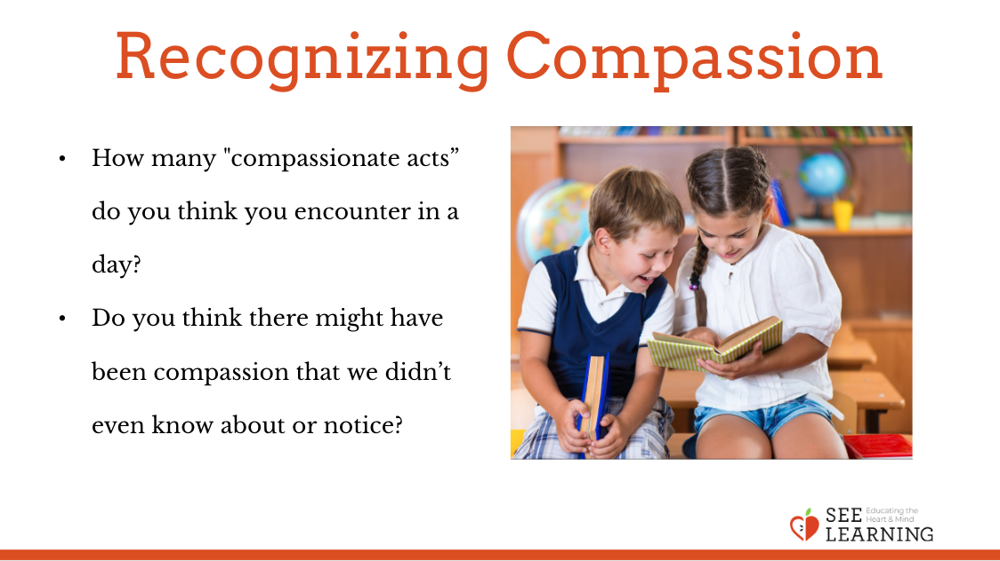 | Sample Script  - “So, I have a question for you. If you think about our day together in school, how many “compassionate acts” do you think you could count? 10? 20? [Let them make guesses and write the numbers on the board or chart paper.]  - I’m going to write those numbers down on the board here so we can check them again later.  - Now, let’s see how many acts of compassion we can come up with. Who can think of something that happened today that was an example of compassion? Did anyone show you compassion today? Or did you do anything that was compassionate for someone else?  - [Allow for student sharing. If you like you can write a single word or phrase that captures what was shared on the board so that a list begins to grow. After the student was shared, you can ask follow up questions, such as: Why was that compassionate? How did it make you feel? How do you think it made the other person feel?]  - [You can ask these follow-up questions to other students as well, not just the student who shared, so that they can think about the various ways the action was kind and how it might have made others feel.]  - Now let’s try to look more deeply. I wonder if we can find even more acts of compassion?  - Do you think there might have been compassion that we didn’t even know about or notice?  - We found a lot of acts of compassion when we looked deeply, didn’t we? How does it feel to know that we are surrounded by so many acts of compassion?  - Now, let’s see. How many did we find? Did we find more than we thought we would? (You can compare with the numbers the students suggested earlier and that you wrote on the board.)  - It seems we can find a lot of acts of compassion if we look for them. But if we don’t look, we might not see them.”

Reflective Practice: Recognizing Interdependence (20 min)
Overview
In this activity students will form groups and draw a web of interdependence starting with a single accomplishment, event, or object.

Content/Insight to be Explored
- Objects and events exist in a web of interdependence; they depend on countless other objects and events.
- We are connected to and depend on countless other people in a variety of ways, even if they are strangers to us.

Materials
- A large sheet of paper for each group to draw on
- Markers

Instructions
- If necessary for your group, model the activity to demonstrate what you want them to do in small groups. (The script below includes modeling at two different points in the activity.)
- Divide the class into groups of 4 to 5 students each.
- Ask each group to identify an important accomplishment or event that they share in common or have all participated with in some way. Provide 1-2 minutes for this.
- If they cannot think of an event or accomplishment that they all have in common, ask them to identify an object made by humans that they all need.
- Ask them to draw this accomplishment, event, or object in the middle of their sheet of paper. This will be their subject.
- Ask them to create a first circle by adding anything their subject depends on or needs to exist. They can draw a line connecting these things to their subject. For example, if they chose “learning to ride a bike”, they might add a teacher, a friend, a bike, a flat surface, etc. Ask them to see if they can think of at least 10 people or things their subject depends on.
- Ask them to now add and draw what the items in that first circle themselves depend on. Again have them draw lines connecting the new items as they are added.
- Have them continue the process freely, selecting any item on the page and identifying things or people it depends on. Monitor each group to provide guidance as necessary. You can prompt them to think further by asking questions like, “This item here. Does it exist all by itself or does it need other people or things for it to exist?”
- When each group has had sufficient time to fill out most of the paper, stop the groups and ask them to estimate how many people in total are needed for their subject. Give them a minute to calculate this and ask them to write it on their sheet of paper.
- Invite each group to share. They should explain their subject; show the various aspects of the interdependence web they created; and then share their estimate of how many people were involved.
Teacher Tips
As in every insight activity, students may have other critical insights as you go along–if so, record them or note them on the board so that you can return to them later.
Slides 4 & 5: Recognizing Interdependence  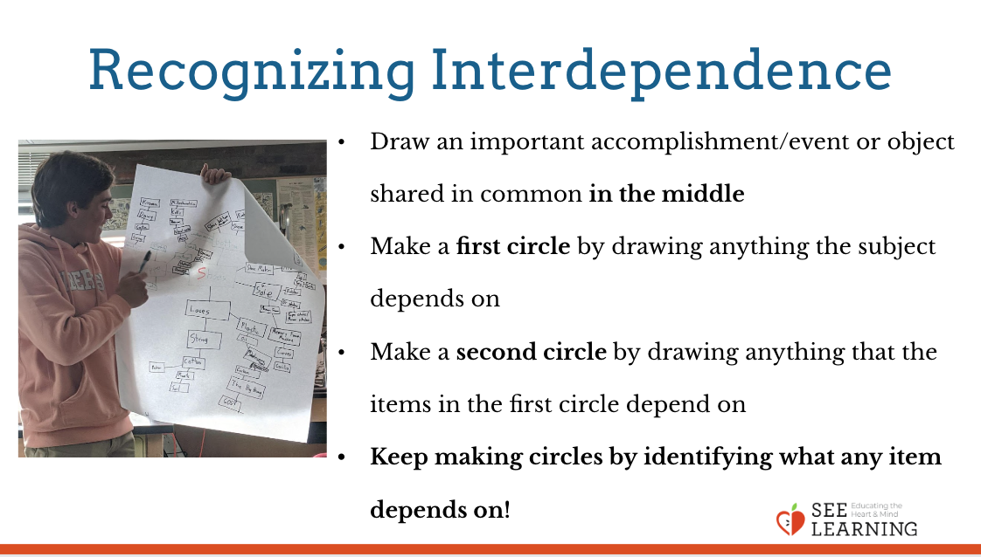  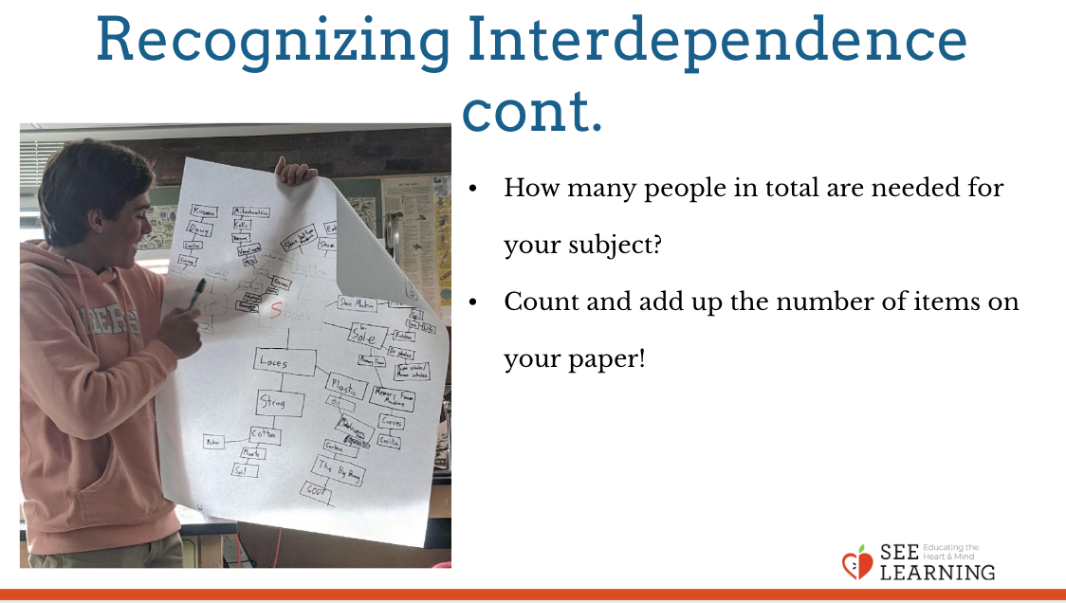 | Sample Script  - “We have done much investigation about compassion in our lives, and one insight that we might have seen is that compassion rarely involves just you–usually kind acts that occur in our lives involve at least one other person. We call this interdependence: we constantly depend on others. Interdependence is not limited to kind acts, but everyday things that we use or experience that we’ve had.  - Today, we are going to investigate this idea or interdependence more deeply. In a small group, you and your peers will come up with an important accomplishment or event that you have in common: Examples for you might include going on a trip; learning to ride a bike; learning to play a game; and so on. When your group has decided one, draw or write it in the middle of your piece of paper that you have. This will be your subject.  - [Divide the class into small groups of 4-5 students. And have them complete the activity up through instructions you have given so far.]  - Now, think about people and things that your subject depends on. Each time you think of something, write it down, circle it, and draw a line connecting it to the subject. First, let me show you how I did this. For my accomplishment, in my imaginary group of a few other adults, we chose “learning to drive a car” as our accomplishment that we all have in common. I’ll write/draw that in the center of the paper.  - Next, we discussed who and what that accomplishment depended on for each of us to achieve. I put down “my dad” because he had me drive his car in a parking lot to get some practice. Another person in my group said “the tires” because without the tires, I couldn't have driven the car.  - Try and come up with 10 things that your subject depends on and write/draw them on your group’s paper.  - Draw a circle around each thing you wrote that your subject depends on. Now, we are going to take this even further. We are going to look at each item we have already written down and think, what does that item depend on? For my example I will focus on “the tires”. The tires on the car would not exist if someone in a factory somewhere did not make them, so I will write “factory worker” out next to “the tires”.  - Go ahead and add branches to each circle, writing or drawing what each thing depends on. Create appropriate branches as best you can. See how many connections you can make.” [When this is finished, invite groups to share. If time does not allow this, the sharing part can be at a different time.]

Reflective Practice: Recognizing Interdependence in One’s Life (5 min)
Materials
- SEE Learning journals
- Writing utensils

Instructions
- Have your students take out their SEE Learning journal for some private journaling in silence. Explain that they do not have to share what they write if they don’t want to.
- Ask them to choose something important in their life: an event, accomplishment, person, or object. This will serve as their subject. They will journal for 5 minutes about what their subject depends on. They can draw it out as an interdependence web, or they can simply write.
Teacher Tips
As in every insight activity, students may have other critical insights as you go along–if so, record them or note them on the board so that you can return to them later.
Slide 5: Recognizing Interdependence in One’s Life  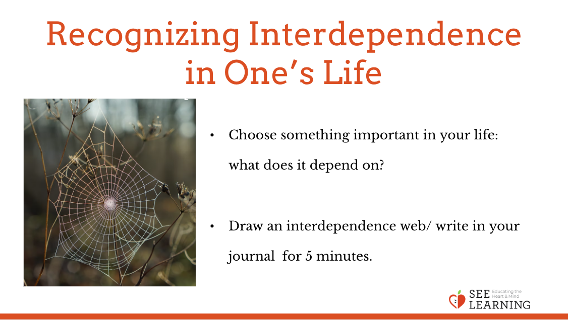 | Sample Script:  N/A

Debrief (5 min)
Slide 6: Debrief  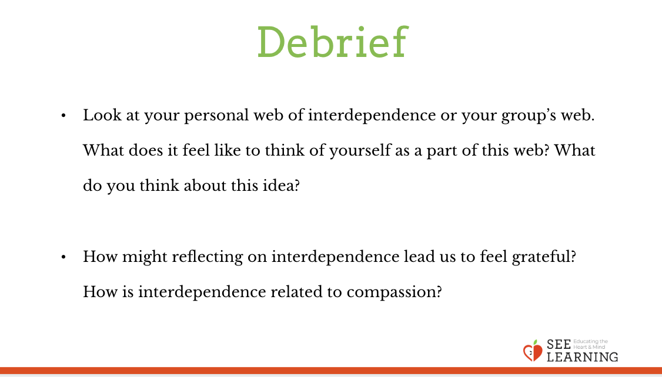 | Sample Script  - “Look at your personal web of interdependence or your group’s web. What does it feel like to think of yourself as a part of this web? What do you think about this idea?  - How might reflecting on interdependence lead us to feel grateful? How is interdependence related to compassion?”

