Exploring Happiness

Purpose:
The focus of this learning experience is to explore how we all want happiness and well-being, and how this is a basic orientation in our life and is something that we share in common with all human beings and even animals. Understanding that we all want happiness is fundamental to understanding our need for compassion, since as social beings we depend on others for our happiness, and appreciate it when they show consideration for our wellbeing and happiness.
However, it is not always evident to us that our wish for happiness and to avoid unhappiness underlies our motivations, emotions, and actions, and that this is the same for others as well. It takes insight to see that even when people do things that appear to be leading to pain and distress, their underlying motivation is often relief, happiness, and well-being. This understanding in turn creates powerful support for the future topics of self-compassion, empathy, and compassion for others.
*The asterisk by a practice denotes that it can be repeated multiple times (with or without modifications)
Learning Objectives:  Students will be able to:  - Investigate whether they want happiness and don’t want distress.  - Explore how universal the wish for happiness and to avoid distress is.  - Explore how this basic orientation underlies human activities, motivations, and emotions. | Primary Core Component  Interpersonal Awareness  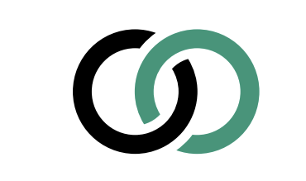
Length  30 Minutes | Materials Required  - Enough space for students to move around an imagined continuum line  - A sign that reads “Yes” and one that reads “No” that can be placed on either end of a line  - Printouts of the “Happiness” sheet–one for each student

Check-In (3 min)
Slide 2: Check-In   | Sample Script  - “Who can remind us what we did last time in our SEE Learning session?  - (Last time we learned about what we have in common when it comes to compassion and happiness. We did the “step in, step out” activity and we also drew a moment when we experienced compassion.)

Insight Activity 1: Stand by Your Experience* (15 min)
Overview

In this activity, students will be given prompts that will encourage them to think about their wish for happiness, how universal it is, and the role it plays in their motivations and actions. They will be able to agree or disagree with the prompts and then explain why they feel the way they do with others and with the class.

Content to be Explored

Our wish for happiness and to avoid unnecessary hardship plays a significant role in our lives and in the lives of others, and it underlies our actions, motivations, hopes, and fears.

Materials
- Enough space for students to move around an imagined continuum line
- A sign that reads “Yes” and one that reads “No” that can be placed on either end of a line (the line can be imaginary or can be created with colored tape on the ground)
- The prompts noted below

Instructions
- Place the Yes and No signs at opposite ends of a continuum. Allow students to stand wherever they like to begin.
- Let students know that they will be sharing their thoughts with each other and that while this activity is leading them in the direction of making official class agreements together, in the meantime, we need to be respectful of each other’s voices and be kind to each other in our interactions. Ask for a consensus vote on the matter.
- Read the first prompt below.
- Give students 10 seconds to think about it and ask them to think of an example before they move to stand by their answer. Tell them to stand anywhere on the continuum that fits with their experience
- Once students are in place, ask them to turn and talk to one or two others who are near them and share where they are standing and why. (If a student is standing alone, the teacher should be her partner.)
- Invite 3-4 students from one end of the spectrum to the other to share out in order with the class. Encourage others to maintain an open mind.
- Invite students to move if they have changed their minds. Invite those who move to share what changed for them.
- Continue with the remaining prompts. Make sure all voices have been heard at least once if possible, and be careful of dominating voices.

Teacher Tips
- This activity may lead to rich discussions that take time, and if you find you are having a rich discussion during the insight activity, consider extending the activity, eliminating the reflective practice, and ending the session with the debrief. Then come back to the activity the next time you meet, do the remaining prompts, and finish off the second time with the reflective practice.
Slide 3: Stand By Your Experience  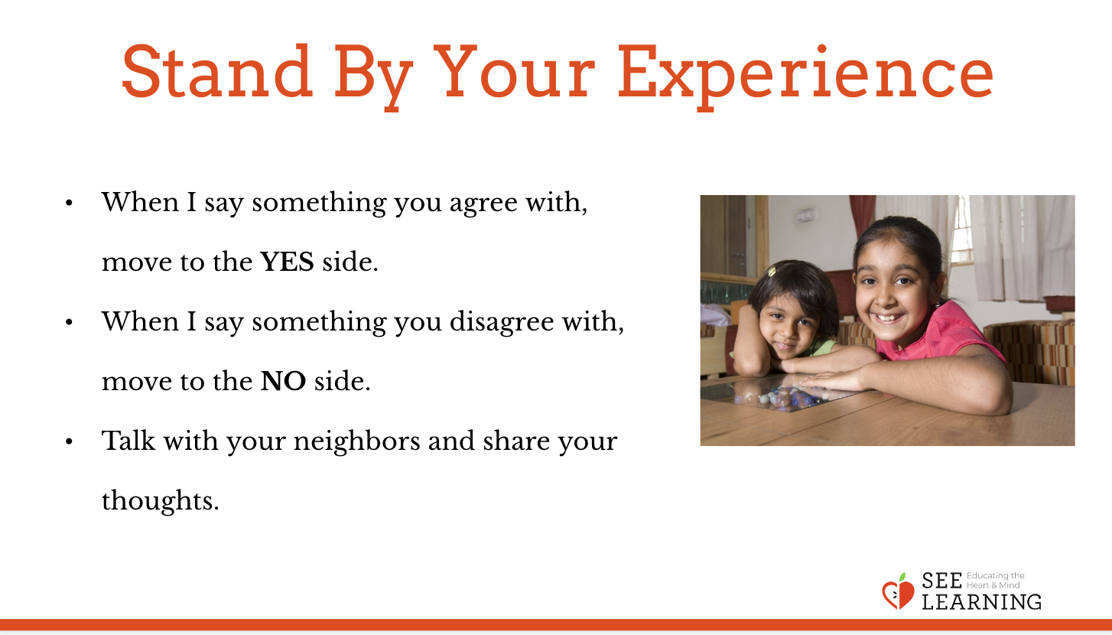 | Sample Script  - “For this activity, we will be sharing our experiences with each other. Though we don’t have formal class agreements with each other yet, this activity is going to help us make them together. Can we agree to be open-minded, kind, and to listen to each other’s voices during this activity? (Ask for thumbs up to agree, thumbs down to disagree, and a thumb in the middle if you’re not sure.) If you have a consensus, proceed. If not, ask those who disagree or aren’t sure what other agreements they need to feel safe during this activity.  - I’m going to read you a statement about happiness. I want you to take 10 seconds to think about the statement, your experience with the statement, and an example you might talk about once you move.  - Read the statement and wait 10 seconds.  - Now move to stand on the continuum where your experience is reflected. If you agree completely, stand by Yes. If you disagree completely, stand by No. If you’re undecided or if you’re somewhere between those two, then stand along the line in the middle or closer to Yes or closer to No  - Turn and talk to the people close to you on the line. Why are you standing there? What experiences have you had that make you think or feel the way you do?  - Let’s come back together as a whole group - who would like to share? Let’s go from one end of the spectrum to the other. We have time for about 3-4 people. As you are listening to your peers share, think about if your answer is changed. I will give you a chance to move if you would like to.  - Please move now if your answer has changed. How and why did your answer change? If it did not, speak about why you think that is.  - Repeat the above with the remaining prompts below.  - Debrief in a brief discussion: how did this activity change or reinforce your initial ideas about happiness?”  Happiness Statement Prompts  - Everyone wants happiness.  - I know exactly what I need to make me happy.  - If I got what I think I need to make me happy,  I would be happy forever.  - I can think of a time when something I thought  would make me happy did not actually make  me happy in the end.

Reflective Practice 1: Our Aspirations and Our Wish for Happiness (8 minutes)
Overview
In this reflective practice, students will work to connect to a basic orientation toward happiness with those things they find most important and meaningful in their lives.

Content to be Explored
Our wish for happiness and to avoid unnecessary hardship plays a significant role in our lives and in the lives of others, and it underlies our actions, motivations, hopes, and fears.

Materials
Printouts of the “Happiness” sheet found at the end of this learning experience – one for each student

Instructions
- Use the script below to lead the reflective practice.
- After students have shared, you can ask what they thought or felt when they saw other students sharing.

Teacher Tips
- The point is not to try to convince students that each item they write down is connected to their underlying wish to be happy and avoid distress and unhappiness, but to invite a discussion and critical reflection about it.
Slide 4: Drawing Kindness  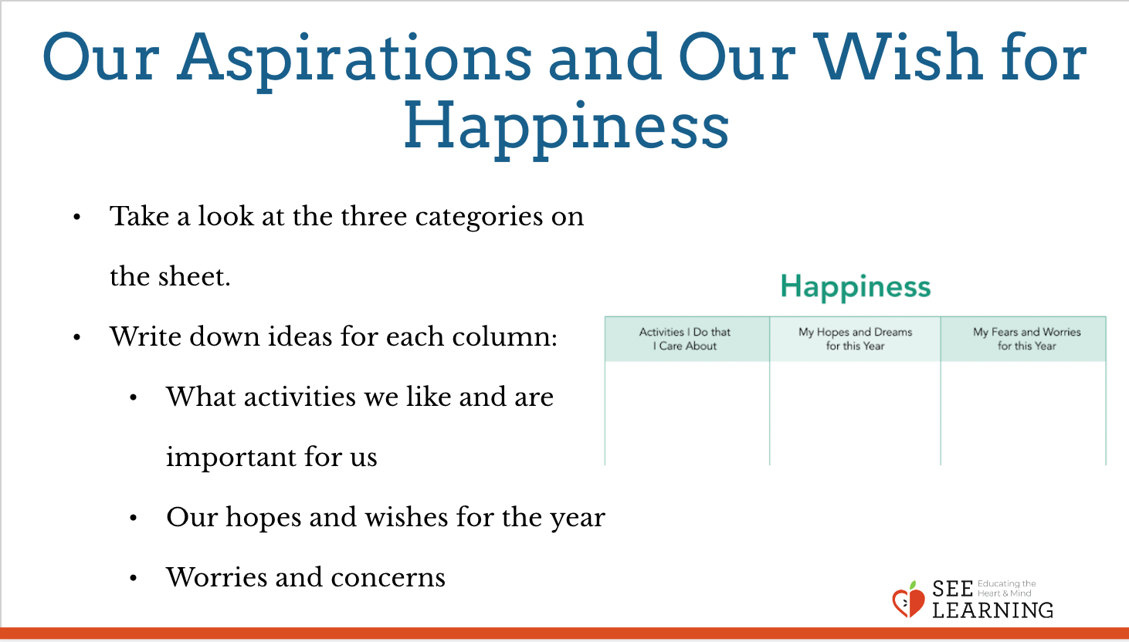 | Sample Script  - “It seems we all want happiness and don’t want distress, pain, and difficulties.  - Can we connect this to our own personal lives and what we want and don’t want in our lives?  - Sometimes we may not understand why we are doing what we’re doing, but if we connect it to our basic wish for happiness, it can make more sense. We see that the things we feel are most important to us are actually connected to our wish for happiness and well-being  - (Provide a handout with activities, hopes/ dreams, and worries/concerns.)  - On this sheet we have three categories. We’re going to take a moment to silently think about what activities we like to do and think are important for us, like playing sports, being with friends, doing well in school, and so on.  - Then we’re going to think about our hopes and wishes for this year. What do we want to accomplish? If we could achieve certain things by the end of this year, what would we want that to be?  - The last column is for worries and concerns. If you think about this coming year, do you have any specific worries or concerns?  - As you think and write, you should know that this is for yourself and no one else needs to see this unless you want to show it to someone.  - Let’s begin now and let’s do this in silence so that we can concentrate and reflect.  - (Give 3-4 minutes for this. You may wish to tell them when they have 30 seconds remaining that you will be wrapping up in 30 seconds.)  - Now let’s look at what we wrote and see if each of the items we wrote down is related to our wish for happiness and to avoid distress, unpleasantness, and unhappiness.  - If you see something that reflects this underlying wish, then you can circle it. If you see something that doesn’t seem connected to your wish for happiness, or you’re not sure, then you can put a question mark next to it.  - (Give one minute for this or more if necessary.)  - Would anyone be willing to share one thing that they circled, tell us what it is, and explain how it connects to their wish for happiness?  - Would anyone be willing to share one thing that they put a question mark next to?”  - After students have shared, you can ask what they thought or felt when they saw other students sharing.

Debrief (3 min)
Slide 5: Debrief  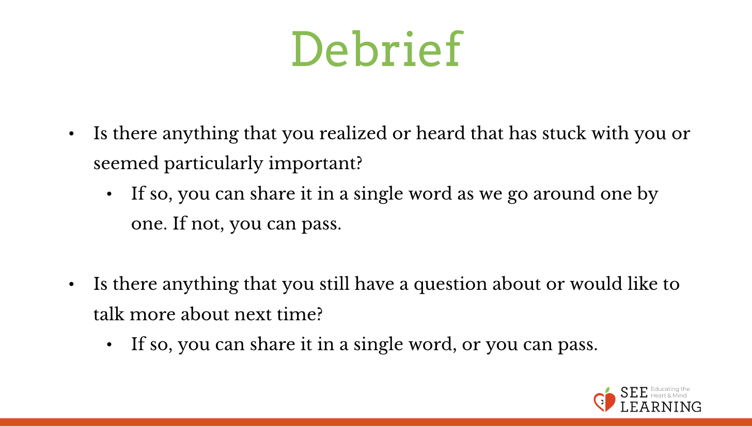 | Sample Script  - “Let’s take a moment to think about what we discussed today. Is there anything that you realized or heard that has stuck with you or seemed particularly important? If so, you can share it in a single word as we go around one by one. If not, you can pass  - Is there anything that you still have a question about or would like to talk more about next time? If so, you can share it in a single word, or you can pass.”

