Class Agreements

Purpose:
The focus of this learning experience is to further explore the idea of kindness, compassion, and consideration and how we all benefit from them by creating a mutually agreed-on list of class agreements that will support a safe, productive learning environment. The creation of agreements by students helps them explore compassion in a direct way that shows the clear implications of our need for compassion within the context of a shared space with others. It also increases their own investment in what is seen as constructive and non-constructive behavior in the classroom, since they can see how the items in the list directly impact themselves and others. It also orients students towards attending to the reality of others’ presence and their feelings and needs.
*The asterisk by a practice denotes that it can be repeated multiple times (with or without modifications).
Learning Objectives:  Students will:  - Explore several practical implications of our need for compassion for how we act with each other  - Identify agreements that can help create a compassionate, caring classroom S | Primary Core Component  Interpersonal Awareness  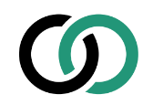
Length  45 minutes, split into 2 days if possible (30 minutes on day 1; 15 minutes on day 2) | Materials Required  - A piece of plain chart paper that can be hung on the wall with the header “In our classroom we agree to…”  - A board or a second piece of chart paper for scratch ideas  - Markers

Check In (3 min)
Slide 2 : Check In  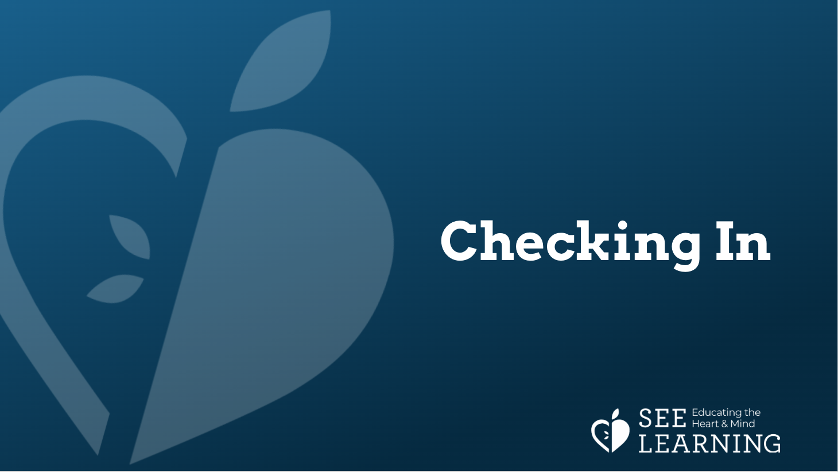 | Sample Script  - “Who can remind us what we did last time in our SEE Learning session?  - (Last time we talked about whether we all want happiness, whether we share this with all people, and how this orientation towards happiness underlies all our actions, hopes, and concerns.)  - Does anybody remember some of the things we talked about and shared?  - Do you think the world would be different if we showed each other more compassion, kindness, and consideration? How?  - What about our school experience? How might it be different if we showed each other more compassion?  - To do that we have to think a bit about how exactly we would do it. In this session of SEE Learning, we’re going to think about how we want to be with each other as a class to support each other’s happiness and our collective happiness.”

Insight Activity 1: Creating Classroom Agreements (24 min)
Overview

Students will consider what would contribute to happiness, kindness, and compassion in the classroom and make a list of class agreements.

Content to be Explored

- We all want compassion and happiness.
- There are specific actions we can take to support each others’ happiness.

Materials
- Chart paper or whiteboard
- Markers

Instructions
- Ask students what we can agree on to do with each others so we have a fun, safe, caring, and happy class.
- Take lots of suggestions and start a list on a board or the piece of scratch chart paper where all the students can see it. If needed, you can prompt the students with possible ideas, such as:
  - Kindness
  - Having fun
  - Not bullying
  - Helping each other
  - Sharing/taking turns
  - Showing respect for each other
  - Listening to each other
  - Not being mean
  - Not shouting
  - Asking for help
  - Paying attention
  - Saying sorry

Teacher Tips
- You can allow any student to answer the follow-up questions, not just the one who made the initial suggestion.
Slide 3: Creating Classroom Agreements  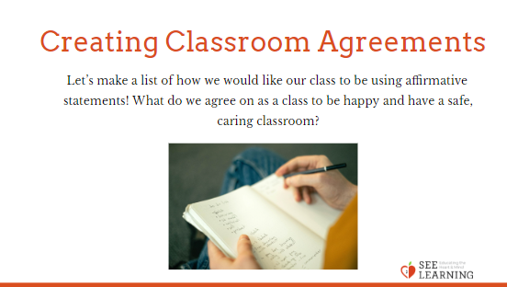 | Sample Script  - “Let’s try to make a list of how we would like our class to be.  - We all want to be happy, so that’s something we all have in common.  - And we saw that one thing that makes us happier is when people are kind to us.  - So kindness might be one thing we would put on the list. What do you think?  - What else might we put on the list that we will agree to do as a class so that we can be happy and have a safe, caring classroom?  - When a student suggests something, use it as an opportunity to have all students delve deeper by prompting them with one or two questions like:  - What does that mean?  - What does that look like?  - What would happen if we all did that?  - What would happen if we didn’t do that?  - [Continue this process as time allows.]

Insight Activity 2: Creating Classroom Agreements, part 2 (15 min) (another day, if possible)*
Overview
Students will continue to consider what would contribute to happiness and kindness in the classroom and make a list of class agreements.

Content to be Explored
- We all want compassion and happiness.
- There are specific actions we can take to support each others’ happiness.

Materials
- Chart paper or whiteboard
- Markers
- The list made in previous activity

Instructions
- Together, group the agreements and write them on the piece of chart paper that has the heading “In our classroom we agree to…”
  - For this, it’s important to put them into action statements that are in the affirmative, like “Be kind” or “Be helpful” or “Ask for help when we need it.”
- Read the agreements aloud together.
- It is helpful for kids to sign the agreements chart and hang it in the classroom.
- Remind students that you are making the agreements so we feel happier and safe here in our classroom.

Teacher Tips
- If possible, complete this insight activity the day after the first one. Students often need time to let the ideas about their agreements settle and marinate; sometimes they even come up with more the next time you sit down together.
- If you are able to complete this activity a day after the first one, use the provided check-in below to get started.
Slide 4: Creating Classroom Agreements  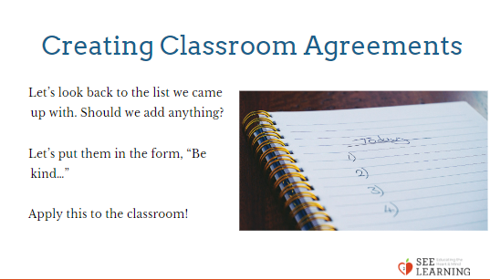 | Sample Script  - [Check-in if you are completing on a different day: “Last time we met, we came up with a big list of things we needed to feel safe and happy in our classroom space. Today we are going to look back at the list. If you realize there was something you wanted to add, let me know.]  - Maybe we can put some of these together if they are similar, so that we can have a few main agreements that we can remember.  - On this sheet it says, “In our classroom we agree to…” So we can put our agreements after tha from the list we just created.  - I wonder if these do together?  - And we can put them in this form, “Be kind…”  - [Continue this process as time allows.]  - Now we have some agreements we can make with each other.  - Let’s take a look at them and read them out loud together.  - We’re going to try to do this for ourselves so we feel happier and safe here in our classroom.  - Let’s keep thinking about this list until we meet again, when we might have more to add.”

Debrief (3 min)
Slide 5: Debrief  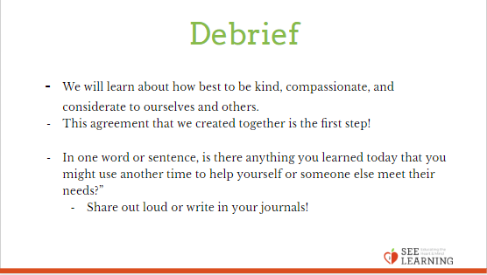 | Sample Script  - “This year we are going to learn about how best to be kind, compassionate, and considerate to ourselves and others. We’ll be learning ways to do this, and this agreement that we created together is our first step!  - In one word or sentence, is there anything you learned today that you might use another time to help yourself or someone else meet their needs?” (Ask students to share out, or write in their journals.)

Extra Practice
- Over the next week or two, have students write in their journals related to the class agreements. For example, if one agreement is “create a physically safe place for ourselves and others” a journal prompt could be: what does this look like, what would it look like if we didn’t do this, why is this important.
- Another idea is to do an idea map/graffiti wall of the agreement. In small groups, students get one agreement and brainstorm words, short phrases, and pictures that come to their mind when they think of this agreement.

