Compassion as an Inner Quality

Purpose: The focus of this learning experience is to go further into the idea of kindness and compassion by exploring whether it is just outer actions or also something inside one’s heart and mind. We easily associate kindness with external activities, like giving someone food or money, saying sweet words to someone, or helping someone when they fall. But if the intention behind those actions and words is to take advantage of the other person, then we do not see that as real or genuine kindness; nor do we see it as genuine help. For students to understand how to cultivate compassion as a disposition, which lies at the heart of SEE Learning, they will be aided by understanding that compassion goes deeper than just external actions but also refers to a state of mind and heart: one’s intentions to bring help and happiness to another person.
*The asterisk by a practice denotes that it can be repeated multiple times (with or without modifications).

Learning Objectives:  Students will:  - Explore compassion in the context of outer actions and inner intentions and motivations.  - Recognize the distinction between real (inner, genuine) kindness and apparent kindness.  - Develop their own definition of compassion.  - Provide examples of actions that might seem unkind, but are really kind, and vice versa. | Primary Core Component  Compassion for Others  
Length  35 minutes | Materials Required  - Chart paper with “compassion” written in the middle of each, enough for 1 piece per small group  - Markers  - Students’ SEE Learning journals; writing utensils  - The scenarios provided below  - The kindness drawings made in learning experience 2

Check In (3 min)
Slide 2: Check-In   | Sample Script  - “Last time we talked about how we could create a kind, caring classroom and we created some classroom agreements. Does anybody remember some of the things we talked about and put on our list? [Allow time for sharing.]  - Today we are going to think about how we can practice compassion.”

Insight Activity: Scenarios (15 min)
Overview
In this activity, you will read one or more scenarios to the students that show how we all naturally prefer kindness, consideration, and compassion, because they make us feel safe and secure, but that we also want genuine kindness, not just apparent kindness. Our preference for kindness is something so basic that we even share it with birds and mammals, who prefer those who protect and feed them over those who threaten them. Scenarios are provided for you here to generate discussion around our preference for kindness and compassion, and how genuine kindness and compassion refer to inner qualities. If someone pretends to be compassionate, but really intends to take advantage of someone, then we do not see that as genuine compassion. If students come to understand that compassion as an inner quality, not just apparently kind actions, then they will realize that to cultivate compassion, we need to cultivate that inner quality, not just act outwardly in a particular way or adhere to certain behaviors. The questions after the scenarios are intended to elicit these critical insights:
- We naturally prefer kindness and compassion and want to move towards them and away from meanness
- Kindness and compassion make us feel safer and more secure
- Compassion is an inner quality
- Pretend kindness (outward without a good intention) is not genuine compassion
Feel free to modify details from the scenario to suit your class and school. If you have time, it can be even more effective if you have some students act out the scenarios. The scenarios are provided as scripts at the end of the learning experience.

Content to be Explored
- Scenario 1: The Rich Woman and the Charity
A representative from a charity goes to a wealthy person to ask for a donation to assist people who are homeless.
“I know you’ve been very generous to charities in the past,” the representative said. “Please would you give us a donation? It would make a big difference to a lot of people who are in need.”
“How will I be recognized if I make a donation?” the woman asked. “It’s important that people know that I made the donation, not someone else.”
“The homeless people you help will all be so grateful, and they will all be told that it was you who helped them,” said the representative.
“But I want other people to know too, not just the homeless people,” she said. “Will it be in the news?”
“Oh yes,” the representative said. “And if your donation is large enough, you will be specially honored at our annual party celebration with a trophy.”
The woman smiled. “In that case, I agree.”
- Scenario 2: The Basketball Captain and the Recruit
The captain of the basketball team sees potential in a new student and really wants them to join the team, thinking it will help the team win the championship that year. The new student doesn't particularly want to join, though, and tells the captain this. The captain gets the members of the team to be really nice to the new student, giving her presents, saying all sorts of nice things to her.
- Scenario 3: The Two Brothers and the Kitten
Two brothers were playing in a park one day, and when they saw a beautiful little kitten, the older brother thought, “Oh, what a pretty kitten!” and he wanted to capture it for himself, so he threw a stick at it and started to chase it. The kitten got scared and tried to run away, but since it couldn’t run very well yet, it had trouble escaping him.
The younger brother said, “Stop! Don’t hurt the kitten! It’s only a baby!” and he went to go and help the kitten and protect it. When he reached the kitten, he petted it and offered it some food. But the older brother got angry and kept trying to get at the kitten and catch it. Then their mother came by and said, “What’s going on?”
“The kitten is mine,” said the older brother, who wanted to capture it. “I saw it first! Make him give it to me!”
“No, don’t give it to him,” said the younger brother. “He tried to hurt it.”
“I don’t know what happened because I wasn't here to see it,” said the mother. “Maybe we should let the kitten decide.”
The older brother who had tried to hurt and capture the kitten tried to call her sweetly. “Please come to me, little kitten! I will take good care of you!”
The mother placed the kitten between the two boys to see who it would go to, and she said to it, “Who do you choose?”
Teacher Tips
There are a few sample questions you can use to have a discussion and encourage the students to explore the scenario and its various dimensions. Feel free to add your own questions and respond to the flow of the discussion. Allow them to share openly and remember that there are no right and wrong answers, but also keep in mind the critical insights (listed above) that you are orienting them towards. These insights have to come naturally, and it’s all right if not all the students reach all the insights at once, since they will be returned to continuously in future learning experiences.
Slide 3: Scenarios  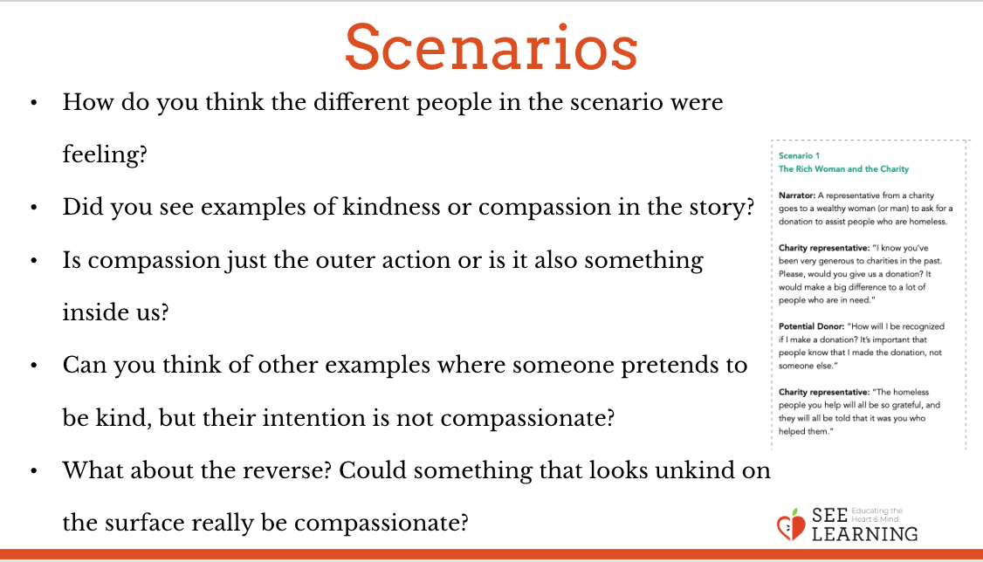 | Sample Script: Discussion of Scenarios  - “How do you think the different people in the scenario were feeling? (Go through the different characters in the scenario.) If they could talk to us, what would they be saying?  - When do you think might happen next in the scenario?  - Did you see examples of kindness or compassion in the story? Why or why not?  - Is compassion just the other action, like sweet words or making a donation, or is it also something inside us? An inner quality? What would we call it–an emotion, a motivation, a thought, an intention? Some or all of these? (Note that you are prompting thinking but not seeking a single “right” answer at this point, so welcome all thoughts.)  - Can you think of other examples where someone pretends to be kind, but their intentions are not compassionate? (Someone helping or donating to charity just to look good, etc.)  - What about the reverse? Could something that looks unkind on the surface really be compassionate? Can you think of an example? (A parent saying “No” to their child to protect them; someone scaring away animals who are moving towards danger; someone taking away a dangerous object from a little child even through the child wants it; etc..)”

Making and Reflecting on a Definition of Compassion (15 min)
Overview
In the reflective practice, students will make a word map of the word “compassion.” This will be used to develop a simple definition of compassion (one or two sentences) for use in the classroom. The students will take moments for silent reflection during the making of this definition and after making it to allow this wider understanding of compassion to deepen in them.
Content/Insights to be Explored
- We all prefer compassion and want to move towards compassion and away from meanness.
- Compassion makes us feel safer and more secure.
- Compassion is an inner quality.
- Pretending kindness (outward actions without a good intention) is not genuine compassion.
Materials
- Chart paper with “compassion” written in the middle of each (1 piece per small group)
- Markers
- Students’ SEE Learning journals
- Writing utensils
- The kindness drawings made in learning experience 2
Instructions
- Ask students to silently think about the scenarios and the discussion.
- Ask them to think about the word compassion and what it means to them. Next, divide them into small groups.
- Pass out chart paper with “compassion” written in the middle - one per group. In small groups, students will come up with ideas and words that explain compassion. Tell them to write their ideas around the chart paper.
- After 5-7 minutes, regroup all together. Have a big piece of chart paper with “compassion” written in the middle.
- Ask students to share some of their ideas and add them to the post. New ideas may come up as they share.
- When you feel like enough has been shared (this can be done on a different day), ask students to move to sit on their own and take out their SEE Learning journal. Ask them to write one sentence that defines compassion.
- Students can share their sentences at the end of this activity or at a later point.
Teacher Tips
- Note: Many of the reflective practices in SEE Learning involve moments of silent reflection for students to think, ponder, and internalize their insights. How long these moments should be will depend on the classroom environment and your students. They can be as short as 15 seconds or cna be as long as a few minutes. You will be the best judge of the appropriate amount of time. You may find that with practice, the student will get more comfortable and familiar with these moments, and that you can prolong them for longer periods of time.
- You may consider asking the students to do this small group portion of the activity in silence as a challenge - maybe for just a few minutes or half the time allotted.
- You may want to display their definitions of kindness in some way in your room as reference points–for example, students could make sentence strips of their definitions and they could be placed on the walls.
Slide 4: Making and Reflecting on a Definition of Compassion  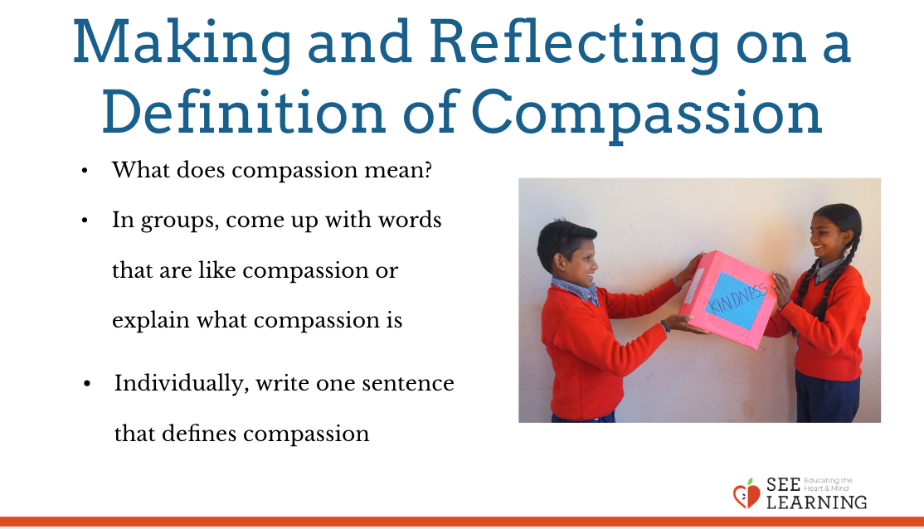 | Sample Script  - “I wonder if we could come up with one sentence to explain what compassion is so that if someone asked us “What does compassion mean?” we can tell them.  - Let’s take a quiet moment to think about the story and our discussion about it.  - I’m going to divide you into small groups. Your group is going to get a piece of paper with the word kindness in the middle. You and your group will come up with words that are like compassion that we can use to explain what compassion is. You may look at your kindness drawings to help you.  - [Allow students to work in small groups for 5-7 minutes.]  - Let’s hear from each group. What shall we add to our classroom agreements?  - We have lots of group ideas up here. Now, as a last step is to come up with a definition of compassion. You are going to go back to your spot, with your SEE journal and write one sentence that defines kindness. You can even start the sentence with “compassion means…””.  - [Allow students to work in small groups for 3-5 minutes. If time allows, ask students to share their sentences.]

Debrief (2 min)
Slide 5: Debrief  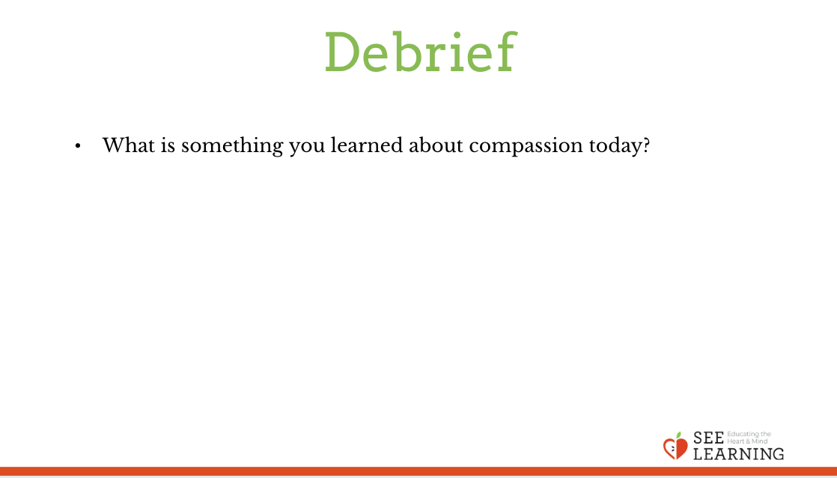 | Sample Script  - “What is something you learned about compassion today?”

