Life Together

Purpose:
Students will explore how actions take place within a broader system and can affect that system, beginning with examples form the Cupcake Story in the previous learning experience. They create an interdependence drawing that maps the effects of such actions within a system. They then look at a simple action that they themselves can take, how it could lead to a feedback loop, and what other people it could affect.
Learning Objectives:  Students will be able to:  - Recognize how feedback loops have effects beyond the loop that impact entire systems.  - Explore how their own actions can lead to feedback loops with others and can affect others in a system. | Primary Core Component  Recognizing Common Humanity  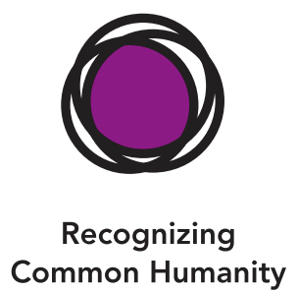
Length  25 minutes | Materials Required  - A large piece of chart paper or board to make an interdependence web  - Paper and drawing utensils for each student  - The class agreements made in Chapter 1  - The example of a positive feedback loop  - Seeing the School as a System class drawing from Learning Experience 2  - Optional: Systems Checklist Poster

Check-In | 3 minutes
Slide 2: Check In   | Sample Script  - “Let's do a short attention practice. How do we want our body to be?  - First we'll take a comfortable and upright posture. I'll be keeping my eyes open, but you can close them or look at the ground.  - Now choose one of your resources from your resource kit, or you can think of a new resource if you like: something that makes you feel better, safer, happier.  - Let's bring our resource to mind and focus on it for a few moments quietly. You can also do grounding if you prefer. [Pause.]  - What do you notice inside? If you feel pleasant or neutral, you can rest your mind on that. If you feel unpleasant, you can shift to a place in your body that feels better. [Pause.]  - Now let's become aware of our breathing . Let's see if we can pay attention to the breath as it enters and leaves our body.  - If you find paying attention to the breath uncomfortable, then feel free to go back to your resource or grounding . [Pause for 15-30 seconds.]  - If you ever get distracted, you can just return your attention to the breath. You can also count your breath. [Pause for a longer time, such as 30-60 seconds or longer.]  - Now let's end the practice and open our eyes. What did you notice? 11 [Share aloud .]

Insight Activity: The Effects of Our Actions in a System (12 minutes)
Overview

Students will take the Cupcake Story example and create an interdependence drawing that maps the effects of the actions on the broader class and school.

Content to be Explored

- We can map and draw the way actions impact others in a system.
- Feedback loops don't just affect the people inside them, but can affect others in a system, or even an entire system.

Materials

- "Seeing the School as a System" class drawing from Learning Experience 2
- The Cupcake Story, Part 1 (provided)
- Markers
- Optional: Systems Checklist Poster

Instructions

- Hang up the drawing made during Learning Experience 2's insight activity, "Seeing the School as a System ."
- Tell students you are going to review what we learned about systems thinking . Ask them what they remember. After a few students share, ask them, "How is our school a system?"
- Review the questions from the Systems Checklist in Learning Experience 2.
- Explain that now you're going to think together about the Cupcake Story and do some systems thinking.
- Write "Feel," "Need," and "Do," as three columns on the board.
- Re-read the Cupcake Story, Part 1. Ask how Kofi and Alice's actions might make the other students in the class feel. What might those students need? What might they do? What about their teacher-what might she feel, need, or do? Write their responses on the board in the appropriate column.
- Do an interdependence drawing that illustrates how others are affected by Alice and Kofi's actions . Either draw it yourself with prompts from your students, or ask your students to help you in making the drawing. Start with Alice and Kofi in the middle, then other students and the teacher, and then others beyond the classroom. An interdependence drawing uses lines to show the connections between people and events.
- Repeat these three questions for other people who might be involved (How might it make them feel? What might they do? What might they need?), starting with other students in the classroom , then Kofi and Alice's teacher; the parents or caregivers of the students; and other students and teachers in the school. (For example, their teacher might keep the children in at recess time to problem solve about this incident. How would this make them feel? Their friends feel? How would it impact the rest of their morning, if they weren't able to play and get fresh air and exercise because of this?)
- After you have created the interdependence drawing, ask the class to look at the entire drawing and share what they notice.
- Conclude with the following questions:
- " What needs are the same for these people? What feelings are the same for them?
- Where are pf aces people could intervene to help with this conflict?"

Teacher Tips
- For your convenience, the Systems Checklist and Cupcake Story, Part 1, are given below.
- Systems Checklist
  - " Does it have parts and what are they?
  - Are the parts connected to each other? How?
  - If we change one part, how does it affect other parts?
  - Are the parts connected to other things on the outside? How?"
Slide 3: “The Effects of Our Actions in a System”  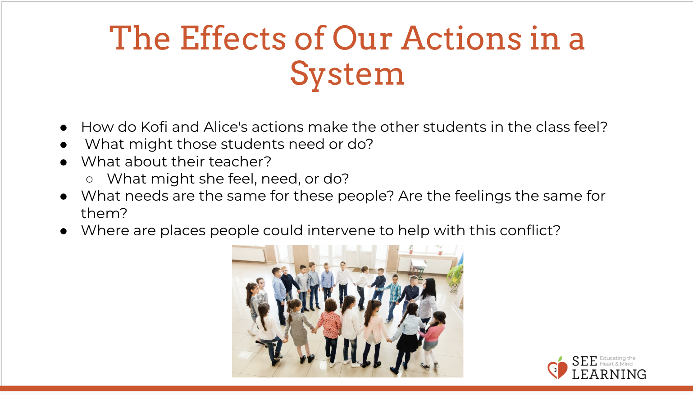 | Sample Script  - The Cupcake Story, Part 1  - "Alice is excited that today is finally their snack day! Alice and her mom made special cupcakes to share with the class. All of the kids are looking forward to tasting them. The teacher asks Alice to hand out the cupcakes. But as Alice is handing out the cupcakes, she remembers an argument she had with Kofi, one of her classmates, and on purpose [Pause.), deliberately skips Kofi when handing out the cupcakes! This surprises Kofi and hurts Kofi's feelings. Kofi says, "I don't like you," to Alice. Alice makes a face at Kofi and says, "You're mean!" Some of the other students in the class notice this and quietly laugh ."

Reflective Practice (13 minutes)
Overview

Students will draw themselves taking a helping action related to a class agreement as a feedback loop, and then how it affects others beyond the immediate feedback loop.

Content to be Explored

- Feedback loops don't just affect the people inside them, but can affect others in a system, or even an entire system.
- Our decisions and choices affect many others in our system(s), and we can reflect on and map this.

Materials

- Paper for drawing
- Markers or crayons for each student
- The class agreements made in Chapter 1
- The example of a positive feedback loop

Instructions
- Take a look at the class agreements made with your students in Chapter 1. (Refer also back to the list of Helping Actions made for the class agreements in Chapter 1, Learning Experience 3.)
- Remind the students that they made these agreements to show what kind of a classroom they wanted to have. Remind them that the classroom is a system with many parts, and we each are a part of that system. Read the agreements aloud together.
- Ask each student to pick a class agreement they like and name some helping actions related to that agreement.
- After a few people have given suggestions, show students the positive feedback loop again to remind them of what it looks like and explain that each student will now draw themselves doing one of the helping actions and a positive feedback loop. You can also remind them of the feedback loop created by Theresa and Nelson in the Cupcake Story, Part 2. In a positive feedback loop, warm feelings and helpful actions repeat between two people.
- Ask students first to draw themselves in the middle of the paper doing a helping action for the class agreement they have chosen.
- After a few minutes, ask them to draw another person who is helped or affected by this. Ask them to draw how that person feels, and what helpful or kind thing that person might do in return.
- Lastly, ask them to draw anyone else they can think of who might be affected by these kind actions.
- Invite students to share their drawings

Teacher Tips
- If appropriate to your students, you can have groups of students each perform a skit that shows people following one of the Class Agreement in a positive feedback loop.
Slide 4: “Reflective Practice”  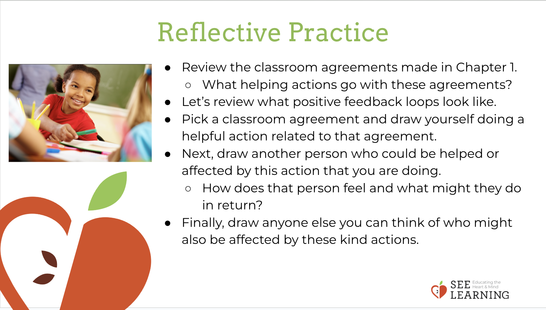 | Sample Script  - "We can think about how we're part of a system here, as our class, and how the choices we make sometimes help things go smoother, be more enjoyable, and help all of us learn, and sometimes our choices do the opposite, even when we didn't mean that to happen.  - Here is the poster of our class agreements that we all made together. They remind us what kind of system we all want to be in together. Let's read them out loud together. (Read each agreement, pausing between for a moment of private think time.)  - Let's imagine some ways our system in this room can be affected by whether or not we keep these Agreements well with each other. Which helping actions go with the first agreement? [Continue discussion going through a few of the agreements.]  - Thank you for sharing your ideas. Now, let's look at the positive feedback loop. In a few moments, you're going to draw one of your own. What do you remember about the positive feedback loop about Theresa and Nelson in the Cupcake Story, Part 2? [Allow time for sharing and remembering.]  - Yes, it sounds like you remember that in a positive feedback loop, warm feelings and helpful actions repeat back and forth between two people.  - Now, you're going to work independently. Here is a sheet of paper for you. First, select a class agreement you like and please draw yourself in the center of the paper doing a helpful action related to that agreement. [Provide a few minutes for drawing.]  - Next, please draw another person who could be helped or affected by this action that you are doing. If you can, draw how that person feels and what that person might do in return. [Provide a few minutes for drawing.]  - Finally, draw anyone else you can think of who might also be affected by these kind actions." [Provide a few minutes for drawing.]
Debrief (3 minutes)
Slide 5: Debrief  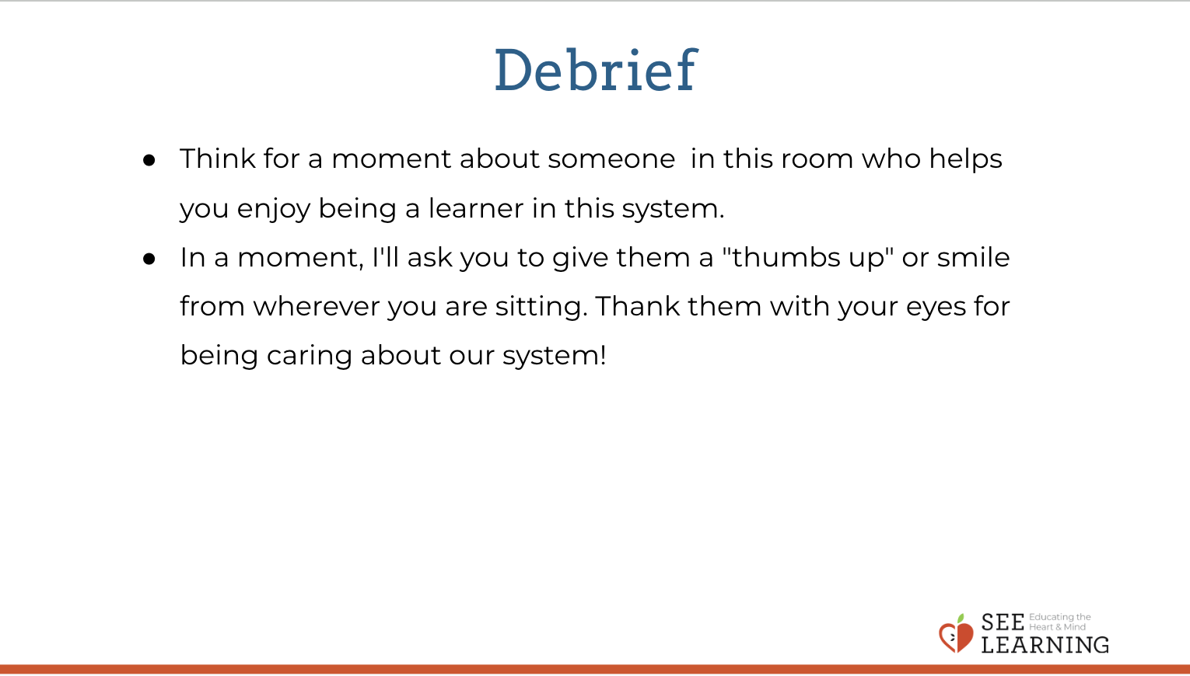 | Sample Script  - " Everything we do has an effect; everything we say matters. The more thoughtful we can be in our actions and words, the better our impact on our systems can be! Think for a moment about someone in this room who helps you enjoy being a learner in this system. [Pause.]  - In a moment, I'll ask you to give them a "thumbs up" or smile from wherever you are sitting. Thank them with your eyes for being caring about our system!  - Ready, GO!"

