Feedback Loops

Purpose:
In this learning experience, students learn what a feedback loop is through a story. A feedback loop is a circular process that keeps getting stronger and building on itself unless some internal or external change breaks the cycle. Students explore positive feedback loops (such as kind actions back and forth between two people growing and building up a stronger relationship over time), as well as negative ones (such as meanness between two people that escalates).
Learning Objectives:  Students will be able to:  - Recognize feedback loops, both positive and negative.  - Explore how kindness and meanness can lead to positive and negative feedback loops. | Primary Core Component  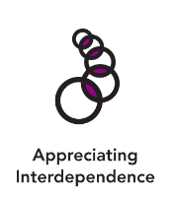  Appreciating Interdependence
Length  30 minutes | Materials Required  - The Cupcake Story, Parts 1 and 2 (provided)  - Markers  - Whiteboard/chart paper  - Paper  - Markers or crayons for drawing

Check-In | 3 minutes
Slide 2: Check In   | Sample Script  - " Let's do a short attention practice. How do we want our body to be?  - First we'll take a comfortable and upright posture. I'll be keeping my eyes open, but you can close them or look at the ground.  - Now choose one of your resources from your resource kit, or you can think of a new resource if you like: something that makes you feel better, safer, happier.  - Let's bring our resource to mind and focus on it for a few moments quietly. You can also do grounding if you prefer. [Pause.]  - What do you notice inside? If you feel pleasant or neutral, you can rest your mind on that. If you feel unpleasant, you can shift to a place in your body that feels better. [Pause.]  - Now let's become aware of our breathing . Let's see if we can pay attention to the breath as it enters and leaves our body.  - If you find paying attention to the breath uncomfortable, then feel free to go back to your resource or grounding . [Pause for 15-30 seconds.]  - If you ever get distracted, you can just return your attention to the breath. You can also count your breath. [Pause for a longer time, such as 30-60 seconds or longer.]  - Now let's end the practice and open our eyes. What did you notice ?" [Share aloud.]

Insight Activity: Feedback Loops (17 minutes)
Overview

In this learning experience, students learn what a feedback loop is through a story of two children who act unkindly towards each other. This is then contrasted with two children who act kindly towards each other.

Content to be Explored

- A feedback loop is when something goes round and round like a circle and keeps building up until something stops it or changes its course.
- Feedback loops can be positive or negative.
- Kindness and meanness can lead to positive and negative feedback loop s.

Materials

- The Cupcake Story, Parts 1 and 2 (provided)
- Markers
- Whiteboard/chart paper

Instructions

- Remind students of the example of the spark and the forest fire, used in Chapter 3.
- Explain that you're going to read a story that shows how this can happen between two people, when a problem gets bigger and bigger if no one stops it.
- Read students the story The Cupcake Story, Part 1 (The Negative Feedback Loop):
  - " Alice is excited that today is finally her snack day! Alice and her mom made special cupcakes to share with the class . All of the kids are looking forward to tasting the m . The teacher asks Alice to hand out the cupcakes. But as Alice is handing out the cupcakes, she remembers an argument she had with Kofi, one of her classmates, and on purpose [P a use .], deliberately skips Kofi when handing out the cupcakes! This surprises Kofi and hurts Kofi's feelings . Kofi says, "I don't like you," to Alice . Alice makes a face at Kofi and says, "You're mean!" Some of the other students in the class notice this and quietly laugh. "
- Explain that you're going to use a drawing to understand what happened in the story. This is a drawing of a feedback loop.
- Draw a diagram of a feedback loop like the one provided at the end of this learning experience.
- Ask the students to help fill in the feelings and actions of Alice and Kofi the loop goes around. Use the provided questions. Write their responses on the diagram.

Teacher Tips
- It is ideal for this insight activity to be done whole and in one day; however, if you need to break it up, you can do the comparison of the two feedback loops on another day.
Slide 3: “Feedback Loops”  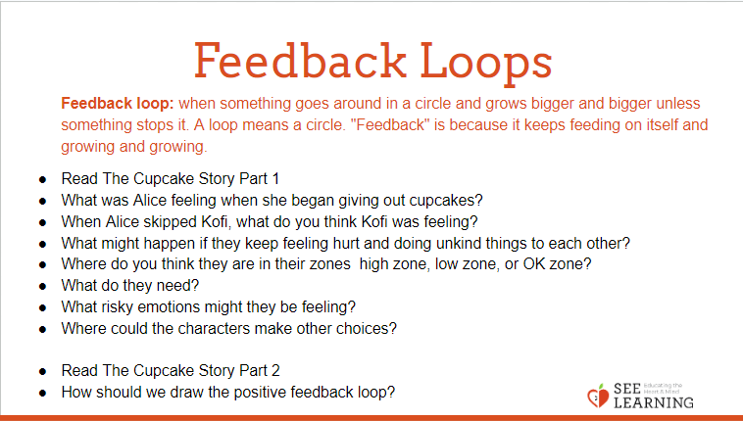 | Sample Script  - Negative Feedback Loop Questions  - " What was Alice feeling when she began giving out cupcakes?  - When Alice skipped Kofi, what do you think Kofi was feeling?  - What happened next? [Prompt students to suggest a few more back and forth actions between Alice and Kofi.]  - What might happen if they keep feeling hurt and doing unkind things to each other?  - Where do you think they are in their zones ­ high zone, low zone, or OK zone?  - What do they need?  - What risky emotions might they be feeling?

- Explain that what they have created is called a feedback loop.
  - " A feedback loop is when something goes around in a circle and grows bigger and bigger unless something stops it. A loop means a circle. "Feedback" is because it keeps feeding on itself and growing and growing ."
- Explain that this diagram is called a negative feedback loop because it is making things worse :
  - Unkind action -> Hurt Feelings ->
  - Unkind action -> Hurt Feelings
- Ask students: What happened? What would help break this negative feedback loop so that things wouldn't keep getting worse? Could Alice or Albert make a choice?
- Next, read students The Cupcake Story, Part 2 (The Positive Feedback Loop)
  - " Meanwhile , at the other side of the classroom, something else was happening. Theresa knew that her friend Nelson loved cupcakes very much. So when Theresa got her cupcake from Alice, Theresa decided to give it to Nelson .
  - "Thank you so much," Nelson said . "Next time when we get a snack that you like especially, I'll give mine to you."
  - "That's very kind of you, Nelson," said Theresa. "You're my friend, Nelson."
  - "Thanks, Theresa," said Nelson. "You're my friend too. " "
- Use the same format as above to draw a positive feedback loop on a separate piece of chart paper or on the board next to the negative feedback loop. Follow the same method as above, asking the provided questions. Write their responses on the diagram.

- Positive Feedback Loop Questions
  - " What do you think Theresa might have been feeling when she gave Nelson her cupcake?
  - How do you think that made Nelson feel?
  - What did Nelson do?
  - How do you think that made Theresa feel?"
- Ask students: how might the story and the positive feedback loop might continue?
- Explain that this is a positive feedback loop:
  - Kind Words -> Warm Feelings ->
  - Kind Words -> Warm Feelings
- Finally, place the two feedback loops side by side so that your students can see both. Tell them that we now know what a negative feedback loop is and what a positive feedback loop is.
- Use the provided compare/contrast questions below to help students compare and contrast the two loops and then focus on changing the negative feedback loop.

- Compare/Contrast the Loops and Change the Negative Feedback Loop Questions
- Ask students to compare the drawings of the two feedback loops :
  - " What's different about these feedback loops? What's the same?"
- Focus on the negative feedback loop.
- When Alice skipped giving Kofi a cupcake, what could Kofi have done instead of saying "I don't like you"?
- Which Help Now! strategy Kofi could use in that moment?
- What else could Kofi have done to change or stop the feedback loop?
- What about Alice? What could she have done to change or stop the feedback loop?
- When the students suggest a kind or helpful action, write down the new action . Then ask:
  - If Kofi/Alice did that, how might that have made them feel?
  - What might they have done next, instead of doing an unkind action?
- Explain how the positive feedback loop is one that we have the choice to create. At some point, someone in the loop has to make a choice to stop things or change things, so that the loop doesn't go on forever. If no one makes that choice, things could keep getting worse.
- Explain how the positive feedback loop is one that we have the choice to create.

Reflective Practice: Changing a Negative Feedback Loop into a Positive One (7 minutes)
Overview

In this reflective practice, students imagine the perspective of Alice or Kofi and come up with a way to change their negative feedback loop into a positive one and then draw it.

Content to be Explored

- A feedback loop is when something goes round and round like a circle and keeps building up until something stops it or changes its course.
- Feedback loops can be positive or negative.
- Kindness and meanness can lead to positive and negative feedback loops.

Materials

- Paper
- Markers or crayons for drawing

Instructions
- Use the provided script to facilitate this reflective practice.
- Collect student drawings at the end of the practice to check for understanding.
Teacher Tips

None

Slide 4: “Changing a Negative Feedback Loop into Positive One”  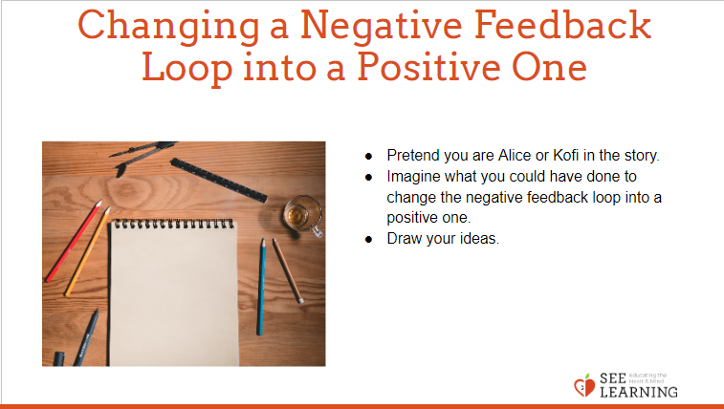 | Sample Script  - " Now we are going to do an individual reflective practice.  - I invite you to select either Alice or Kofi and pretend that you were one of them in the story.  - Imagine what you could have done to change the negative feedback loop into a positive one and draw the action. [Provide 4 minutes for drawing.]  - Let's share some of our ideas. Who would like to start us off?  - [For each student who shares the action they drew:] How might that action lead to a positive feedback loop?"
Debrief (3 minutes)
Slide 5: Debrief  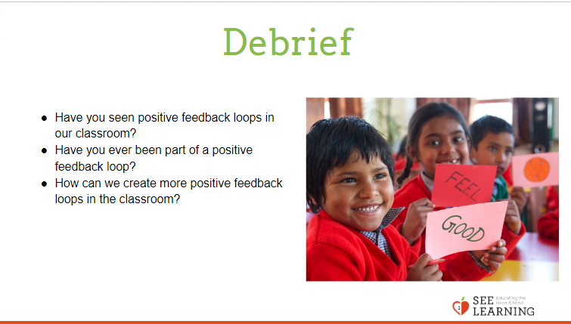 | Sample Script  - " Have you seen positive feedback loops in our classroom?  - Have you ever been part of a positive feedback loop?  - How can we create more positive feedback loops in the classroom?"

