Exploring Systems Thinking

Purpose:
In this learning experience, students are introduced to basic principles of systems thinking through a simple checklist, and they use it to identify various systems. They then analyze the school as a system and explore the various people in the school and how the school depends on them.
Learning Objectives:  Students will be able to:  - Learn how to engage in systems thinking by considering the questions in the systems checklist.  - Explore the ways in which their own school is a system through naming the people involved in it and what they do.  - Draw their school as a system. | Primary Core Component  Appreciating Interdependence  
Length  30 minutes | Materials Required  - Chart paper  - Markers  - Copy of the "Systems Thinking Checklist" at the end of this learning experience

Check-In | 3 minutes
Slide 2: Check In   | Sample Script  - " Let's do a short attention practice. How do we want our body to be?  - First we'll take a comfortable and upright posture. I'll be keeping my eyes open, but you can close them or look at the ground.  - Now choose one of your resources from your resource kit, or you can think of a new resource if you like: something that makes you feel better, safer, happier.  - Let's bring our resource to mind and focus on it for a few moments quietly. You can also do grounding if you prefer. [Pause.]  - What do you notice inside? If you feel pleasant or neutral, you can rest your mind on that. If you feel unpleasant, you can shift to a place in your body that feels better. [Pause.]  - Now let's become aware of our breathing . Let's see if we can pay attention to the breath as it enters and leaves our body.  - If you find paying attention to the breath uncomfortable, then feel free to go back to your resource or grounding . [Pause for 15-30 seconds.]  - If you ever get distracted, you can just return your attention to the breath. You can also count your breath. [Pause for a longer time, such as 30-60 seconds or longer.] Now let's end the practice and open our eyes. What did you notice ?" [Share aloud .]

Discussion: What is Systems Thinking? (9 minutes)
Overview

In this presentation, students are introduced to basic principles of systems thinking through a simple checklist.

Content to be Explored

- A system is something that has parts, and its parts are connected to each other.
- When we look for the ways that things are connected, we are doing systems thinking.
- Systems are everywhere!

Materials

- Whiteboard or chart paper
- Markers
- Copy of the Systems Thinking Checklist at the end of this learning experience

Instructions

- Tell students you will be talking about systems thinking today. Give them the definition of a system.
- A system is something that has parts.
- And its parts are connected to each other. If we change one part, we affect the whole system.
- Provide a visual example of a system. You can stacking up some cards in a house of cards, or stack up some blocks or books. Ask:
  - " What will happen if I remove one of these cards (or blocks) at the bottom? What effect will it have on the whole system ?"
- Explain what systems thinking is:
  - " When we look at something and its parts, and then think about how the parts are connected, we are doing systems thinking. Systems thinking means to look at something as a system, and noticing how the parts affect one another."
- Introduce your students to the Systems Checklist, which helps us to explore things as systems. Use the checklist with them to explore a few more examples of systems, such as the human body, a bicycle, a car, a group of friends, a family, etc.

- Systems Checklist:
  - " Does it have parts and what are they?
  - Are the parts connected to each other? How?
  - If we change one part, does it change other parts? How?
  - Are the parts connected to other things on the outside? How?"

- Allow students to suggest additional things that they could explore as systems. Run each suggestion through the Systems Checklist.
- Conclude the discussion by reminding students that systems thinking means looking for connections.

Teacher Tips
- Almost everything has parts and can be thought of as a kind of system . Since the point is not to correctly identify what is and what is not a system, but rather to teach a certain way of looking at things as systems, be encouraging even when students suggest things that may not immediately appear to be systems.
Slide 3: What is Systems Thinking?  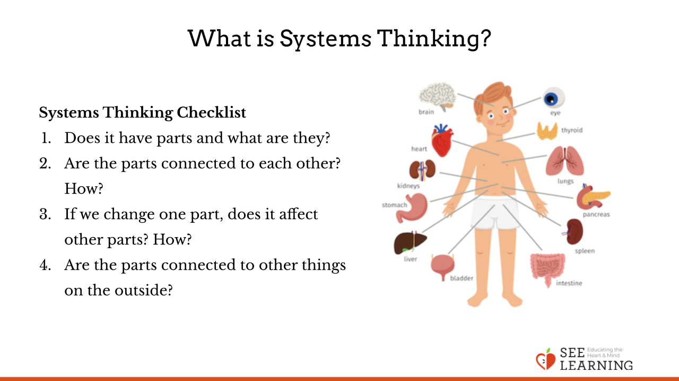 | Sample Script  - " Today we're going to learn about an interesting way of thinking. It's called systems thinking.  - A system is something that has parts. And its parts are connected to each other. When we look at something and its parts, and then think about how the parts are connected, we are doing systems thinking .  - Let's think together. Is your body a system? We can use the checklist to see.  Systems Checklist:  - " Does it have parts and what are they?  - Are the parts connected to each other? How?  - If we change one part, does it change other parts?  - Are the parts connected to other things on the outside? How?"  - Let's think of other thing s. What else might be a system? [Take examples from the class. Spend time going through at least one more example, using the checklist to see if the example is a system. If time permits, use the checklist for more examples.) Many things are systems.  - Remember, systems thinking means looking for connections. Once we start looking for connections, we find that systems are everywhere!"

Insight Activity: Seeing the School as a System (15 minutes)
Overview

Students will look at their school as a system and all the people involved in maintaining and running it. They will also recognize the ways the school needs each these people, and some of the things these people share in common.

Content to be Explored

- We can look at our school as a system
- The school depends on many types of people, who share common human experiences and feelings.

Materials

- Whiteboard or chart paper
- Markers

Instructions
- Remind students of the drawing they did together back in Chapter 1 where they explored interdependence and how we are connected to and dependent on other things. Tell them the class is going to do another drawing today with the school as the focus.
- Draw a representation of the school in the center of a large piece of chart paper.
- Discuss with them whether the school is a system by using the systems checklist.
- Explain that you will now explore the parts of our school. Ask who or what kinds of people we need to have a school. Ask them to see if they can think of at least 10 actual people or people's jobs the school connects to, needs, or depends on. Draw or write the people/ categories they offer.
- Point to certain groups of people on the chart paper and ask students: In what ways are these people the same as us? (As explored earlier, they may suggest that all the people have emotions and feelings; they all want happiness; they all want to be treated with kindness.)
- •Remind them that one question of the systems checklist asks whether the larger system changes if we change one part of the system. Ask them to consider that concept about each group of people noted.
Teacher Tips
- Examples for systems might include a bicycle, the weather, a garden, a family, and so on. Save the drawing of the school as a system, as you will need again this for Learning Experience 4.
- This activity works great with a small group students standing around the whiteboard or with a piece of chart paper on the floor in the center of a circle of students. Alternatively, if your students are ready to try it in small groups, you can facilitate it that way.
- As in every insight activity, students may have other critical insights as you go along-if so, record them or note them on the board so that you can return to them later.
Slide 4: Seeing the School as a System  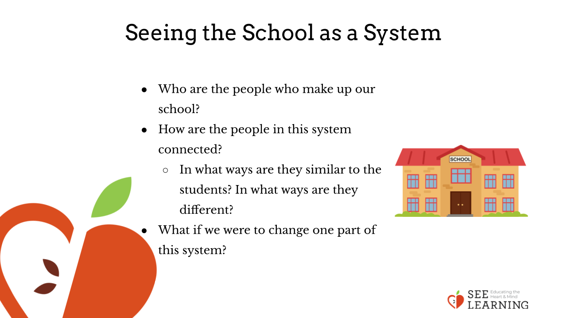 | Sample Script  - " A while ago, we made a drawing of [whatever your class drew) and we connected all the people and things needed to make that [thing) possible. Think for a moment about someone or something that was on that poster, that helped make [insert your previous topic here] possible. [Pause.) Turn to a nearby partner and share one idea that you remember. [Pause .)  - When we did that we were talking about interdependence, and we're going to do another drawing today that is similar to that. For this drawing today, however, we are going to use our school as the focus. I'll draw the school here in the center.  - First, let's use our "Systems Checklist" to verify that our school is a system. [Go through each step, taking input from students.)  - Let's explore our school as a system. Think about these three questions for a few seconds: Who are some of the people we need to have a school? Who contributes to making our school work effectively and be a safe and comfortable place to be? [Pause for students to think.)  - Who are some of the actual people or kinds of jobs that our school connects to, needs, or depends on? [Allow time for sharing; draw or write the people/categories students share.)  - If they need additional prompting:  - When you look around this room, what categories of people or roles come to mind?  - When you walk down the halls, walk all around our building, who would you see? What jobs are people doing that contribute to this system that is our school?  - When you think about the physical building and the grounds (the land it sits on), what jobs or people come to your mind?  - Let's look at this group of people - the teachers. In what ways are they similar to the students? In what ways are they different? [Draw or write the similarities and differences.  Repeat for other groups of people on the chart.]  - So it looks like the school has a lot of parts and they are connected to each other. The next requirement for a system is that if one part of the system change s, the whole larger system is affected. ls that true for the school?  - Let's see: what if some of these people were to not be able to come to school? What would happen? Would it change anything for us? [For example, if students didn't come, teachers wouldn't have anyone to teach; if individual students didn't come, we would miss them...)  - If we look at the school as a system, how is our class a part of that system?  - What about each of us? Are we each part of the system of the school?  - How we affect each other? How do we affect people outside our class?"
Debrief (3 minutes)
Slide 5: Debrief  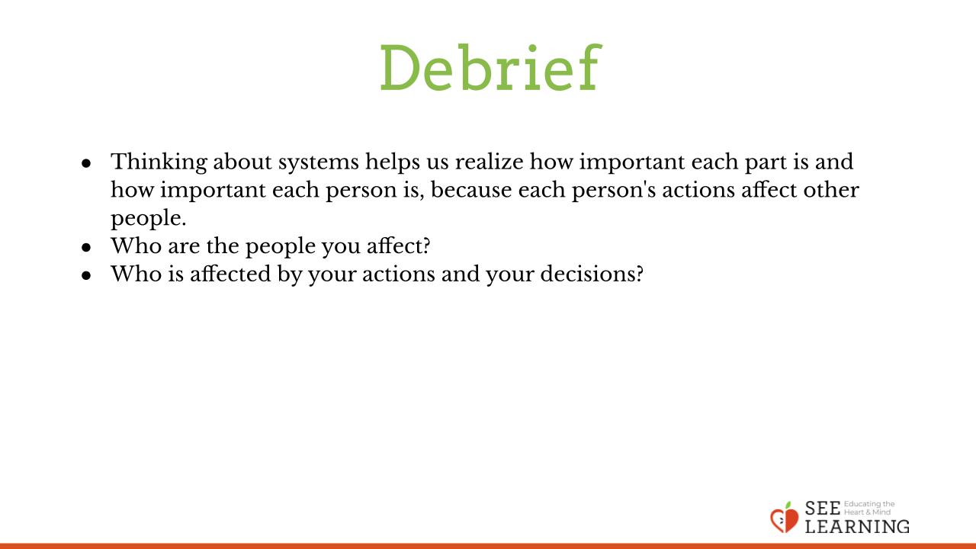 | Sample Script  - " Thinking about systems helps us realize how important each part is and how important each person is, because each person's actions affect other people.  - Who are the people you affect?  - Who is affected by your actions and your decisions?"

