Exploring Forgiveness
Needs to be updated after SD is created

Purpose:
In this learning experience, students explore forgiveness as the letting go of negative emotions towards another person without necessarily approving of that person’s action. A story is presented in which seeing another child’s behavior and emotions in context allows anger to turn into forgiveness and compassion. Students then reflect on experiences they may have had in which they let go of anger.
Learning Objectives:  Students will be able to:  - Explore the concept of forgiveness as a releasing of negative emotions towards oneself or another person.  - Explore the word compassion and its meanings.  - Explore how seeing another person's behavior and emotions in context may help us understand that person and have compassion for them.  - Explore the relationship between feeling unhappy and choosing to hurt others or be mean.  - Reflect on times when they felt anger towards someone but were able to release it without hurting anyone | Primary Core Component  Compassion for Others
Length  25 minutes | Materials Required  - Whiteboard or chart paper  - Markers

Check-In | 4 minutes
Slide 2: Check In   | Sample Script  - " Let's do a short attention practice. How do we want our body to be?  - First we'll take a comfortable and upright posture. I'll be keeping my eyes open, but you can close them or look at the ground.  - Now choose one of your resources from your resource kit, or you can think of a new resource if you like: something that makes you feel better, safer, happier.  - Let's bring our resource to mind and focus on it for a few moments quietly. You can also do grounding if you prefer. [Pause.]  - What do you notice inside? If you feel pleasant or neutral, you can rest your mind on that. If you feel unpleasant, you can shift to a place in your body that feels better. [Pause.]  - Now let's become aware of our breathing. Let's see if we can pay attention to the breath as it enters and leaves our body.  - If you find paying attention to the breath uncomfortable, then feel free to go back to your resource or grounding. [Pause for 15-30 seconds.]  - If you ever get distracted, you can just return your attention to the breath. You can also count your breath. [Pause for a longer time, such as 30-60 seconds or longer.]  - Now let's end the practice and open our eyes. What did you notice ?" [Share aloud.]

Discussion: (5 minutes)
Overview

Students will explore the meaning of the word "forgive" using a word map and examples from their experience.

Content to be Explored

- Forgiveness means letting go of the anger and negative emotions we hold towards ourselves or someone

Materials

- Whiteboard or chart paper
- Markers

Instructions

- Explain that today your class will explore forgiveness and what it means to forgive someone.
- Write the word "forgive" on the board.
- Ask if anyone knows what this word means or words that could be connected with "forgive." Write these words around the word "forgive."
- Give an example of forgiveness yourself, starting with something small. Then invite students to share ideas about other times that could lead to someone forgiving another person. Remind them, as needed, not to use names. (Some schools use "I know someone who..." language; or just keeping as a rule of thumb that we don't share any names in our stories, because they are about the idea of the story, and what we can learn from it, not the people involved.)

Teacher Tips
- If you choose to give examples of forgiveness, including examples from your own life, begin with very small things, such as minor inconveniences. Be sure to avoid any major transgressions. Start with forgiveness of another person, rather than self-forgiveness.
- Try to reinforce the ways people regularly forgive minor transgressions, rather than the times people are unable to forgive. This is the way to adopt a strengths-based approach, rather than a deficit-based approach.

Slide 3: “title”  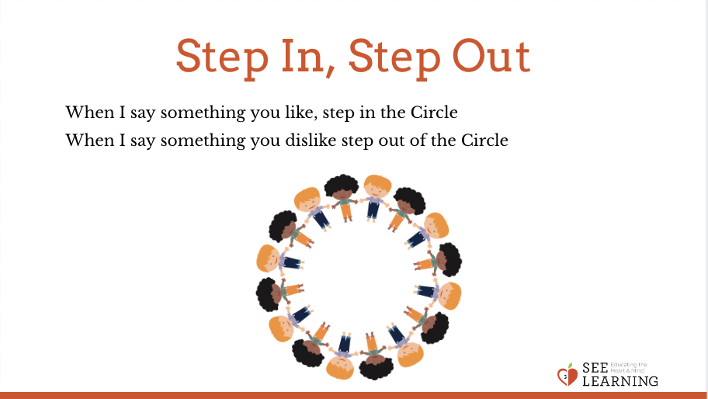 | Sample Script  - " Today we're going to learn more about forgiveness and what it means to forgive someone. [Write forgive on the board.]  - What do you think the word forgive means? What does it connect to?  - Does anyone have a story about someone forgiving someone else? [If students don't have stories to volunteer, please share from your own experience.]  - Have you ever said you're sorry when you didn't really mean it? Why?"

Insight Activity: (13 minutes)
Overview

In this activity, students will hear a story about a person being harmed, learning information that leads to understanding, forgiveness, and compassion, and then reaching out to help the person who caused the harm. They will explore why anger might turn into compassion and forgiveness, and what would happen if anger never turned into compassion or forgiveness.

Content to be Explored

- We can hold onto negative emotions but this can affect our happiness and ability to enjoy life.
- Forgiveness is the letting go of negative emotions to another person, even if what they did was wrong.
- Understanding another person's behavior in context can help us have compassion towards that person.
- Strong compassion for another person can lead us to want to help them.

Materials

None

Instructions
- Read the story below, pausing appropriately when there is an asterisk (*) to ask one or more of the following questions:
- " What emotions do you think Nelson is feeling right now?
- What might he need right now?
- What might he be thinking or saying to himself?
- What do you think the other students are feeling or thinking?
- What might they need?
- What do you think Nelson should do?"
- When you've finished reading the story, ask your students about what happened using the questions provided below the story (labeled "Discussion of the Story").
Teacher Tips
- If the story is too long to read all at once, it can be broken up into smaller parts. The parts are labeled as Part 1, 2, and 3.
- If you can have two sessions in close succession, consider reading Parts 1 and 2 and then pausing to discuss how the story might continue. Then read Part 3 for the next session and continue.
Slide 4: “title”  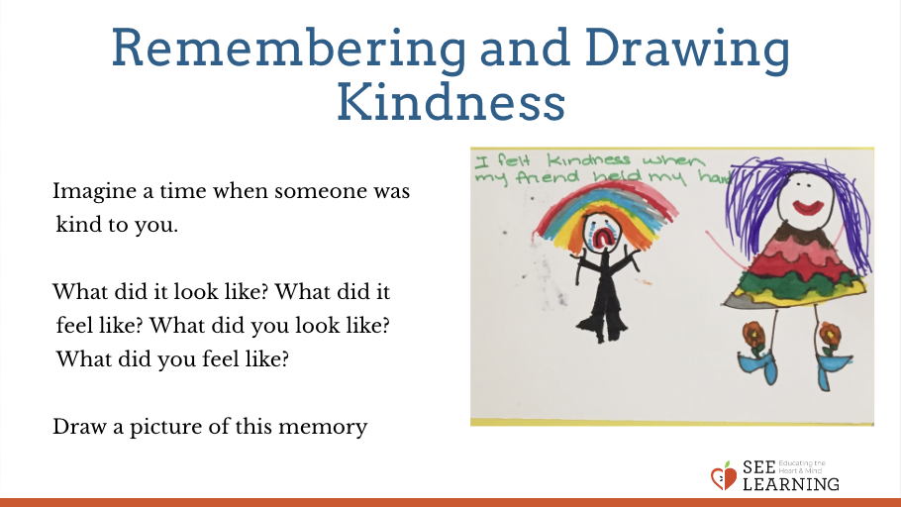 | Sample Script  - " I'm going to read a story about Nelson, Theresa, and Albert.  - Please think about what each person is thinking and feeling, so that you'll have some ideas in mind when I pause to ask about this." [Read the story below and stop and ask questions at the asterisks or where you feel it is appropriate. Discussion questions follow the story.]
Story: Nelson Forgives Part 1

" One day Nelson was outside playing with a ball with Albert and Theresa at school. When the ball came to Nelson, he was about to throw it to Theresa, but another boy came over and pushed him. Nelson fell into a pile of mud.

"Hey, what are you doing?" asked Nelson . The boy just laughed and picked up the ball Nelson had dropped.

"I'm taking this ball from you," he said and he walked away.*

"That's so rude," said Theresa.

"It's not just rude. It's mean, 11 said Albert. "That's Teddy. He's always picking on us."

Nelson stood up and tried to wipe the dirt from his clothes, but he couldn't get it out.

"I wish there was something we could do, 11 he said. But Teddy was a lot bigger than Nelson, so Nelson didn't do anything. *"

Part 2

" Later that day Nelson went home from school. His mother saw his dirty clothes and asked him what had happened. He remembered Teddy pushing him, and he felt himself getting really angry. In fact, he was so upset he couldn't enjoy his dinner later that evening.*

The next day Nelson was still in a bad mood. Even when he saw Albert and Theresa, he didn't feel that happy. At lunch they all sat together. Nelson saw that Teddy was also having lunch, but he was sitting by himself.*

"Nobody likes him!" said Theresa.

Nelson watched but didn't say anything. Then he saw Ms. Kelly, a teacher, go over to Teddy. Ms. Kelly put her hand gently on Teddy's back and she spoke to him in a soft voice. It seemed she was being kind to him.*

When Ms. Kelly was walking away, Nelson went
up to her. "You shouldn't be nice to Teddy, Ms. Kelly. He pushed me onto the ground yesterday and stole my ball. He's always mean to everybody. He should be punished."

Ms. Kelly smiled at Nelson. "If he pushed you and took your ball, then that was wrong of him, and I will have a talk with him later about it. But we should also be kind to Teddy. His mom is sick right now. So we also need to be part of his family no w."*"

Part 3

" After lunch, Nelson went out with Theresa and Albert to play for a little while. They were kicking the ball around to each other when Nelson saw Teddy standing all by himself on the field. Nelson remembered what Ms. Kelly had told him and he noticed he didn't have
that tight feeling of anger in his chest any more when he saw Teddy.

"Hey, maybe we should ask Teddy if he wants to play with us," Nelson said.*

"Are you kidding?" said Albert. "He's the one who pushed you yesterday and ruined your clothes!"

"Yeah, but I think he's lonely," said Nelson. "Ms. Kelly told me his mom is sick. That must make him sad and maybe even afraid."

"That doesn't mean you can push people around," said Albert.

"That's true," said Nelson. "Ms. Kelly said people don't choose to do mean things unless they're unhappy on the in side . I think he was just feeling unhappy. It was wrong for him to push me, but I don't feel angry at him any more."*

"I can't imagine what it would be like to not have your parents," said Theresa. "No wonder he's rude sometimes. And he doesn't have any friends. I think we should be kind to him."

Theresa took the ball and walked over to Teddy. "Hey, Teddy. We're playing ball. Want to join us?"

Teddy looked surprised. He looked at all three of them. "Do you really want to play with me?"

"Yes," Nelson said. "I'm not angry with you any more. Please don't do that again, though."*

That afternoon when Nelson went home, his mother asked him, "How was school today?"

"Good," said Nelson. "We played with Teddy."

"Isn't he the boy who was mean to you yesterday?" asked his mother. Then she smiled at him. "I'm very proud of you, Nelson." "

DISCUSSION OF STORY

After reading the story, ask some or all of the following questions:

- " Why do you think Teddy pushed Nelson?
- How long did Nelson hold onto his anger? How did it make him feel when he was holding onto anger?
- Do you think Nelson forgave Teddy? How do you know?
- Why did Nelson choose to act kindly toward Teddy?
- What do you think would have happened if Nelson and his friends had stayed angry with Teddy?
- Have you ever said "It's okay" when somebody said they were sorry, but you still felt angry inside? Is that forgiveness? What else needs to happen for real forgiveness? (releasing the negative feelings)
- What might Teddy have been feeling when he pushed Nelson? What else could he have done with all of those big feelings? Who might have been able to help him?
- What could Teddy do to show he's sorry for having hurt Nelson?
- Once they all started playing ball together, what do you think each of the kids was feeling?”
Debrief (3 minutes)
Slide 5: Debrief  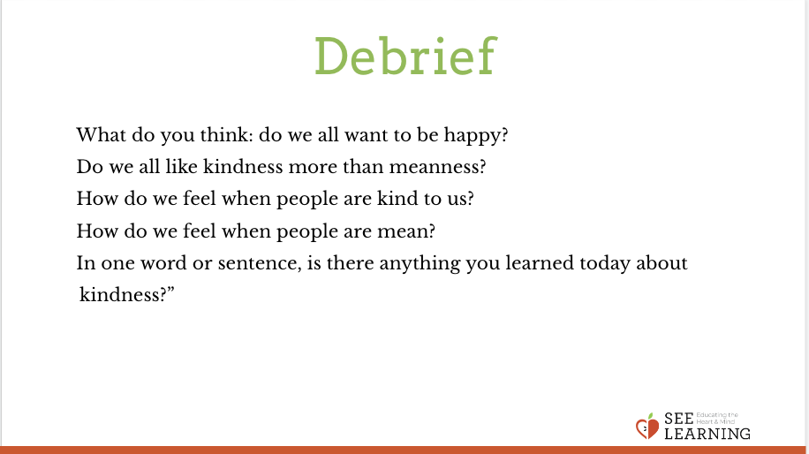 | Sample Script  - " How would you explain forgiveness to someone who didn't know what it was?  - Have you learned something today that you'd like to remember?"

