Exploring Kindness to Oneself: Part 2

Purpose:
In this learning experience, students explore how to express tenderness and kindness towards themselves, much in the way they would express it to a close friend or family members especially in the face of adversity or difficulties. This learning experience is best done following closely on the previous one, which explored positive and negative talk.
Learning Objectives:  Students will be able to:  - Explore the idea that one can be one's own friend.  - Explore practices of kindness to others that could be extended to oneself. | Primary Core Component  Self-Compassion  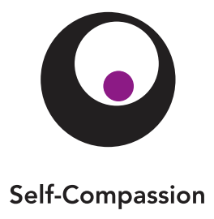
Length  30 minutes | Materials Required  - Paper  - Utensils for drawing

Check-In | 4 minutes
Slide 2: Check In   | Sample Script  - " Let 's do a short attention practice. How do we want our body to be?  - First we'll take a comfortable and upright posture. I'll be keeping my eyes open, but you can close them or look at the ground.  - Now choose one of your resources from your resource kit, or you can think of a new resource if you like: something that makes you feel better, safer, happier.  - Let's bring our resource to mind and focus on it for a few moments quietly. You can also do grounding if you prefer. [Pause.]  - What do you notice inside? If you feel pleasant or neutral, you can rest your mind on that. If you feel unpleasant, you can shift to a place in your body that feels better. [Pause.]  - Now let's become aware of our breathing . Let's see if we can pay attention to the breath as it enters and leaves our body.  - If you find paying attention to the breath uncomfortable, then feel free to go back to your resource or grounding . [Pause for 15-30 second s.]  - If you ever get distracted, you can just return your attention to the breath. You can also count your breath. [Pause for a longer time, such as 30-60 seconds or longer.]  - Now let's end the practice and open our eyes. What did you notice? [Share aloud.]

Insight Activity: Being Kind to Ourselves Like a Friend (8 minutes)
Overview

This activity invites students to collectively brainstorm how we might be kind to someone who is discouraged and then act out some of those actions in pairs. They then explore which actions and positive talk could be done by oneself, even if a friend were not around.

Content to be Explored

- There are specific things we can say and do to encourage and help someone who is discouraged.
- Some of these things we can also say and do for ourselves when we are discouraged.

Materials

None

Instructions

- Ask students to imagine two close friend s. Remind them of the recent story "Nelson the Photographer" and how Nelson and Theresa are friend s.
- Ask students how someone would treat their friend with kindness if their friend were sad, unhappy, or had just faced a difficult challenge, just like Nelson had. What are things that person might feel, say, or do, seeing their friend was unhappy?
- Write their suggestions under the headings "Feel," "Say," and " Do."
- Ask for two volunteers. One will be discouraged like Nelson after seeing none of his pictures turned out well. The other will be like Theresa, encouraging her friend . Ask the encourager to choose from one of the "Say" or "Do" actions and act it out towards the character being like Nelson. Then ask the student playing the part of Nelson to express how he or she feels after being encouraged in that way. Repeat this 3 or 4 times with new volunteers .
- Point out that our friends aren't always around. Ask if we could do any of these things for ourselves if a friend were not around. Use the example of Nelson again if this is helpful.
- Put a check next to those things we could say, feel, or do for ourselves.
- Ask if there's anything we could add to the list. What could we say, feel, or do if we faced difficulties that would be kind to ourselves and helpful?

Teacher Tips
- For the paired volunteer activity, you can model this once with a single student and yourself first so that students can see a clear example.
Slide 3: “Being Kind to Ourselves Like a Friend”  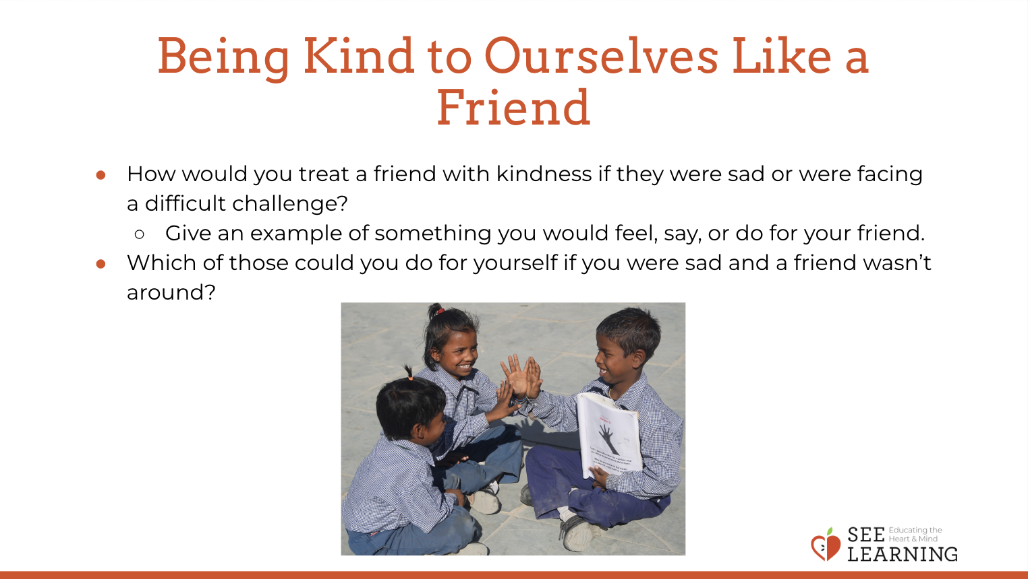 | Sample Script  - " Remember the story we heard last lesson, called Nelson the Photographer, that involved the camera, Nelson, and Theresa at her birthday party?  - How did Theresa respond when she saw Nelson's pictures? [Take responses.] Theresa was a good friend and used kind words to help Nelson.  - Now we're going to imagine that you were in Nelson's shoes and felt badly about taking blurry birthday pictures. What would you want a good friend to say to you? [Take responses, and write students suggestions under headings "Say" and "Do."] Ok, let's review the things a good friend could say or do to help us when we're sad or discouraged. [Read answers again.]  - Now, let's see if we can put these ideas into practice. I'll need two volunteers who can do a skit. One of you will play the part of the friend who messed up the birthday pictures. You made a mistake and feel badly about it. The other part is that of a good friend . Good friend, you can act out anything from the list we just created. Let's see what happens. How was that?  - But what if a good friend isn't around and you're feeling mad, sad, scared, or discouraged? What could say or do for yourself in that case ?"

Reflective Practice: Being Kind to Ourselves (15 minutes)
Overview

In this reflective practice, students apply what they have been learning to their own lives
by writing and drawing the ways they are already practicing self-kindness when they are
discouraged. They then add additional ways they think they could be more kind to themselves.

Content to be Explored

- We already engage in many acts of self­ kindness.
- We can learn more acts of self-kindness from others.
- We can add to our tools of how to be kind to ourselves.

Materials

- Paper
- Utensils for writing and drawing
- Illustration of a thought bubble (included here)

Instructions
- Provide each student with a piece of paper and drawing utensils.
- Show them a thought bubble. Use the illustration provided.
- Ask students to draw a time when they needed to use positive talk to themselves.
- What is something positive that you could say to yourself next time?
- Ask students to share if they are willing.
- Having heard all these ways of being kind to oneself, ask them to return to their drawings and add any new ways they could be kind to themselves in future. These could be things they have heard from others, or new things that they imagine they could do.
- Collect the drawings and put them on a bulletin board or on the class wall.
Teacher Tips
- You can copy the provided illustration and provide to students as a worksheet if you prefer.
Slide 4: “Being Kind to Ourselves”  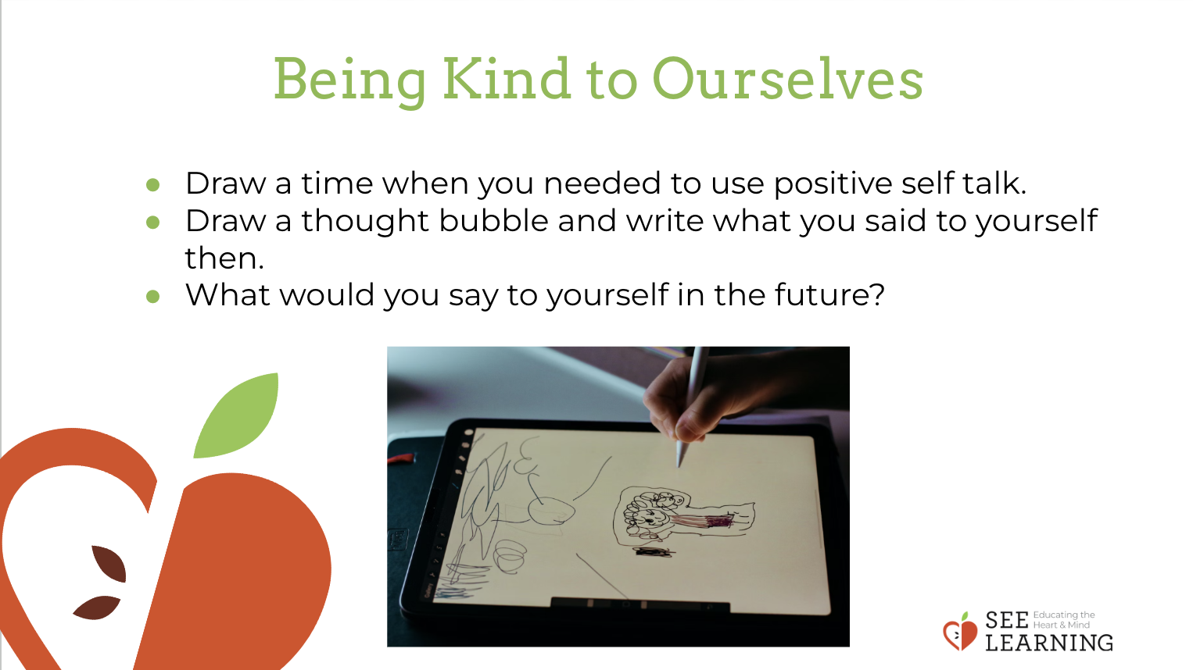 | Sample Script  - " So, we just practiced how we might be kind to our friends and then to ourselves. We're going to go a little further with this as we reflect through drawing.  - I want to invite you to draw a time when you needed to use positive talk for yourself. Here is a thought bubble. In the thought bubble, write what you said to yourself and what you might say to yourself next time . [Provide time for students to draw and write.]  - Who would like to share their drawing or what positive talk they wrote in the thought bubble? [Provide time for sharing.]  - Thank you for sharing. Now that you have heard from the group about what positive talk they use, is there any positive talk you would like to add to your thought bubble so you might use it in the future? [Provide a few minutes for additions to the thought bubbles.]  - Wonderful - now I will collect your drawings . Thank you."
Debrief (3 minutes)
Slide 5: Debrief  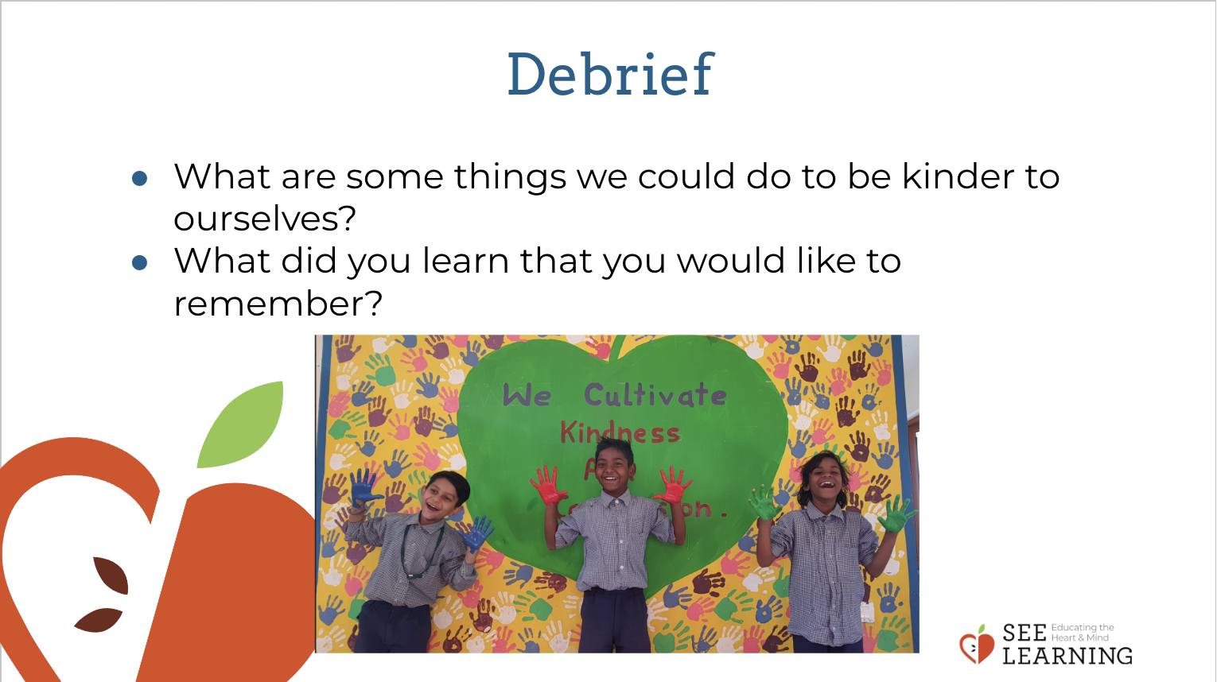 | Sample Script  - " What are some things we could do to be kinder to ourselves?  - What did you learn that you would like to remember?"

