Exploring Kindness to Oneself: Part 1
Needs to be updated after SD is created

Purpose:
In this learning experience, students explore the concepts of positive and negative talk, especially as it manifests in self-judgment and self-criticism when facing an obstacle or challenge. Through a story, they explore how having difficulty with new tasks is normal and can often be accomplished with practice and help from others.
Learning Objectives:  Students will be able to:  - Explore the concept of positive (helpful) and negative (unhelpful) talk to oneself and others.  - Explore the idea that one can be kind and encouraging to oneself, just as to a friend. | Primary Core Component  Self-Compassion  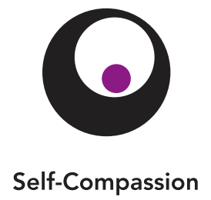
Length  25 minutes | Materials Required  - Chart paper or whiteboard  - Markers  - The "Nelson The Photographer" story (included here)  - Cards that say "Positive" and "Negative" (included here)  - Three puppets for Nelson, Theresa, and Teddy (or printouts of the three pictures included here)

Check-In | 3 minutes
Slide 2: Check In   | Sample Script  - " Let 's do a short attention practice. How do we want our body to be?  - First we'll take a comfortable and upright posture. I'll be keeping my eyes open, but you can close yours or look at the ground.  - Now choose one of your resources from your resource kit, or you can think of a new resource if you like: something that makes you feel better, safer, happier.  - Let's bring our resource to mind and focus on it for a few moments quietly. You can also do grounding if you prefer. [Pause.]  - What do you notice inside? If you feel pleasant or neutral, you can rest your mind on that. If you feel unpleasant, you can shift to a place in your body that feels better. [Paus e.)  - Now let's become aware of our breathing. Let's see if we can pay attention to the breath as it enters and leaves our body.  - If you find paying attention to the breath uncomfortable, then feel free to go back to your resource or grounding . [Pause for 15-30 seconds.)  - If you ever get distracted, you can just return your attention to the breath. You can also count your breath. [Pause for a longer time, such as 30-60 seconds or longer.)  - Now let's end the practice and open our eyes. What did you notice? " [Share aloud.)

Discussion: Positive Talk (7 minutes)
Overview

This discussion explores the idea of whether one can be kind to oneself and what that might look like. One can learn to recognize negative self-talk and its unhelpful effects. One can also learn to offer oneself the kindness one would offer a friend.

Content to be Explored

- We can talk positively to a friend experiencing difficulties.
- We can talk positively to ourselves when we face difficulties.

Materials

- Chart paper or whiteboard
- Markers
- Printouts of the pictures of Nelson, Theresa, and Teddy or puppets to represent them

Instructions

- Nelson says: "I tried to ride my bike without training wheels and I couldn't do it. I'll never be able to do it." Theresa is the other puppet. Is there anything she can say to help Nelson feel better? What could she say? Show Nelson being happier/moving in a happy way. When we say something that is helpful, we call that positive talk (write on board). Then Teddy comes along. "It's true, you'll never learn how to ride a bike without training wheels." Now Nelson looks sad. Ask: Now what happened just now? Explain this is an example of negative talk (write negative talk on board).
- Repeat with puppets or picture. Nelson comes along and doubts himself. What could Nelson say to himself? This is self-talk. Self-talk can be positive or negative.
- Lead a discussion with your students about the difference between positive (helpful, true, kind, encouraging) talk and negative (unhelpful, untrue, unkind, discouraging) talk.
- Identify "positive self-talk" as a way that we can keep up our courage and sense of persistence when we are facing difficulties. Ask for examples from the students of a difficulty someone could face, and then model / take examples from the class of what positive self-talk could sound like in that situation. Keeping the examples general, not specific to any student, reduces the vulnerability of those generating ideas.

Teacher Tips
- If possible, use puppets or the picture provided of Theresa comforting Nelson.
- At this age, not all students may experience negative self-talk, and not all may feel like not succeeding in something makes them feel like a failure or makes them feel severely discouraged. Even so, they may still be able to recognize negative self-talk in others (seeing someone struggle at something and then hearing that person say they feel discouraged because of it), and this is valuable both for empathizing with others and for themselves in the future when they may feel this way.
Slide 3: Insight Activity - Positive Talk  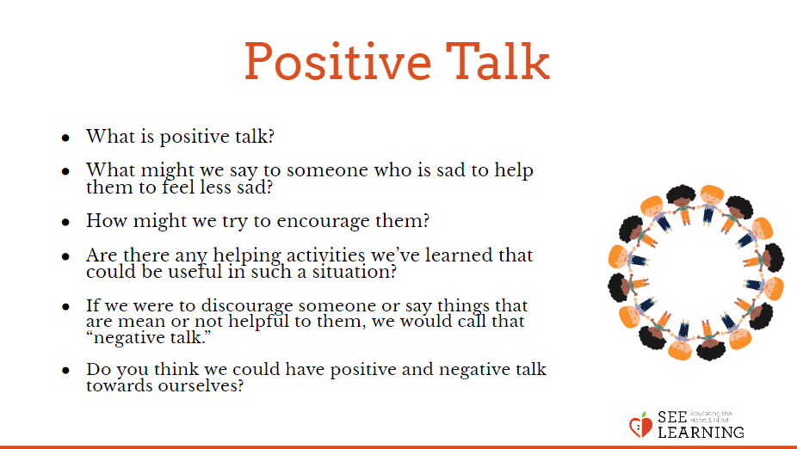 | Sample Script  - " We've been learning a lot about why it's important to show kindness. And we've learned different ways of being kind to each other.  - Let's say we have a close friend or family member and they try to do something but it doesn't work . Like maybe it was their job to take pictures at a party, but none of the pictures came out right, and they feel really bad about it.  - What might we say to them to be kind and help them to feel less sad? How might we try to encourage them?  - We can call saying things that are helpful and kind "positive talk." [Write the words "positive" and "kind" on the board.] When we say the word "positive" here, we mean things that are helpful, kind, nice, useful.  - Are there any helping activities we've learned that could be useful in such a situation?  - If we were to discourage someone or say things that are mean or not helpful to them, we would call that "negative talk." Negative is the opposite of positive. [Write the word "negative" on the board.]  - Think of a time when someone encourages a young person to use positive self-talk, maybe a coach or teacher or another kid? [Paus e.] What kinds of things might they encourage saying? [Solicit answers, such as "You can do!" “Keep Trying!” …]  - What if it was us ourselves who had not succeeded and we were the ones feeling sad? Like if it was me, I might say or think things to myself, like "I'm no good. I'll never be able to do this!" And then it might get even worse. I might start to think, "I'm no good at anything!"  - Then, instead of trying harder or practicing more so that I can succeed, I might just give up. I might even feel like a failure for a while. Do you think that could happen sometimes?  - These aren't very kind things for me to say to myself. They're not things I would say to a friend . They're not even true.  - If I said things like that, would that be positive or negative talk?  - But if I were kind to myself, the way I'm kind to a friend who is having problems, then that would be positive.  - We're going to read a story about Nelson and Theresa, and I'd like you to pay attention and see if you can find any times when one of them is doing negative or positive talk."

Insight Activity: Nelson the Photographer (12 minutes)
Overview

This insight activity invites students to think about and discuss failure and how one can show kindness to oneself and others during such situations

Content to be Explored

- Sometimes if we don't succeed to our expectations, we may feel discouraged.
- Having difficulty with new tasks is normal but they can often be accomplished with practice and help from others.

Materials

- Printouts of the "Positive" and "Negative" cards at the end of this learning experience (or you can make your own)

Instructions
- Read Part 1 of the story below. Ask students to raise their hands if they hear a character doing negative or positive talk to another person or to themselves.
- When students raise their hands, ask them to explain where they saw negative or positive talk.
- At the points marked with an asterisk (*), you can pause to ask your students questions such as:
- What do you think Nelson might be thinking now?
- What emotions do you think Nelson might be feeling?
- What do you think the other characters in the story are thinking or feeling now?
- Is anyone doing positive or negative talk right now?
- After finishing Part 1, ask the students to describe what has happened in the story thus far and what they think might happen next.
- Have a few children volunteer to choose one of the cards that say "positive" or "negative" and give actual examples of things someone could say at that point in the story.
- Read Part 2 of the story, using the same method noted above.
- Conclude with the questions below, which encourage the students to think about what it means to be kind and encouraging to oneself with positive talk when facing difficulties.
Teacher Tips
- You can use the puppets to act out the story as well.
- You may want to record students' words of kindness for Nelson on a poster so they can be displayed in your classroom as a resource. You may consider writing these out generically (e.g . "You're not good at that yet.") so they can be used in a more universal way.
Slide 4: Insight Activity- Nelson the Photographer  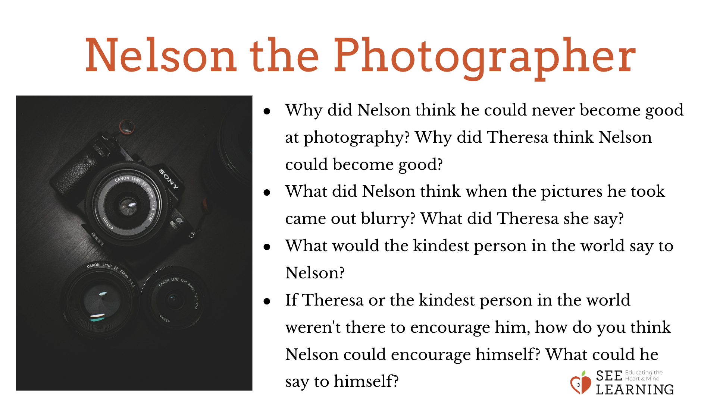 | Sample Script-Discussion Questions  - " Why did Nelson think he could never become good at photography?  - Why did Theresa think Nelson could become good at photography?  - What did Nelson think to himself when he realized that the pictures he had taken came out blurry?  - How did Theresa react to the blurry pictures? What kinds of things did she say to Nelson?  - What would the kindest person in the world say to Nelson? [Examples below.)  - You will do better next time.  - You can learn how to take good pictures with practice.  - You're not terrible, you're just not a very good photographer yet.  - If Theresa or the kindest person in the world weren't there to encourage him, how do you think Nelson could encourage himself? What could he say to himself? [Examples below.)  - I made a mistake.  - I will do better next time.  - I can learn how to take good pictures with practice.  - I'm not terrible, I'm just not a very good photographer yet."
Debrief (3 minutes)
Slide 5: Debrief  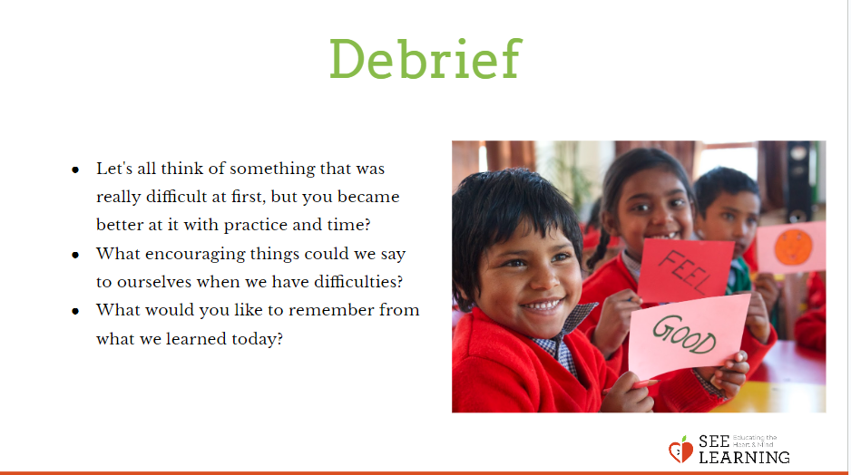 | Sample Script  - " Let's all think of something that was really difficult at first, but you became better at it with practice and time? [PAUSE.) Let's hear from a few people...  - What encouraging things could we say to ourselves when we have difficulties?  - What would you like to remember from what we learned today?"

