Emotional Hygiene

Purpose:
The purpose of this learning experience is to introduce the concept of “emotional hygiene” as a way of dealing with or preventing risky emotions before they cause difficulties for oneself and others. Students imagine scenarios and run through a checklist for each risky emotion, seeing what can be done by oneself and what one can do for others experiencing that emotional state.
Learning Objectives:  Students will be able to:  - Explore the concept of "emotional hygiene" as practices of self-care and restraint .  - Identify strategies for dealing with risky emotions in oneself and others. | Primary Core Component  Attention and Self-Awareness  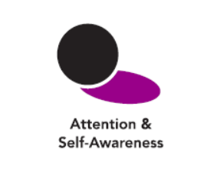
Length  35 minutes | Materials Required  - The emotion family chart (created) earlier on a board or piece of chart paper that students can see  - A piece of blank chart paper or board  - 4 Insight Activity Worksheets for each student  - 1 Reflective Practice Worksheet for each student

Check-In | 4 minutes
Slide 2: Check In   | Sample Script  - " Let 's do some resourcing and grounding to calm and relax our bodies.  - First we'll take a comfortable and upright posture. Then we'll keep our eyes on the ground or close them.  - Now let's choose a resource. It can be one from your resource kit, a new one, or you can imagine one.  - Let's bring our resource to mind and pay attention to it for a few moments quietly.  - If you'd rather do grounding, you can do that too. [Pause.]  - What do you notice inside? If you feel pleasant or neutral, you can rest your mind on that.  - If you feel un pleasant , you can shift to a different resource, or you can ground . You can also change your posture but try not to disturb anyone else if you do that. Otherwise, just keep your attention resting with your resource. " [Pause.]  End here, or if time allows, continue with a practice for strengthening attention:  - " Now let's become aware of our breathing . Let's see if we can pay attention to the breath as it enters and leaves our body.  - If you find paying attention to the breath uncomfortable, then feel free to go back to your resource or grounding, or just take a small break, making sure not to disturb anyone else. [Pause for 15-30 seconds.]  - If you ever get distracted, you can just return your attention to the breath. You can also count your breath . [Pause for a longer time, such as 30-60 seconds or longer.]  - You can strengthen your attention by focusing on sensations or by focusing on the breath. It's your choice - it's always up to you.  - What did you notice ?" [Share aloud.]

Discussion: What is Emotional Hygiene? (5 minutes)

Overview

This discussion introduces the concept of emotional hygiene.

Content to be Explored

- Just as we take care of our bodies (physical hygiene), we can take care of our minds (emotional hygiene).
- Emotional hygiene allows us to "think twice" when we experience a risky emotion, protecting ourselves and others.

Materials

None

Instructions
- Engage the students in a brief discussion of emotional hygiene by first talking about
physical hygiene and taking care of our bodies (You can use the script below.)
- Ask: What do we do to take care of our bodies? Why do we do it? (Bathing, brushing our teeth, etc.)
- Ask if we can take care of our emotions the same way. What would that look like?
- What have we already learned that could help us practice emotional hygiene?
Teacher Tips
None
Slide 4: What is Emotional Hygiene?  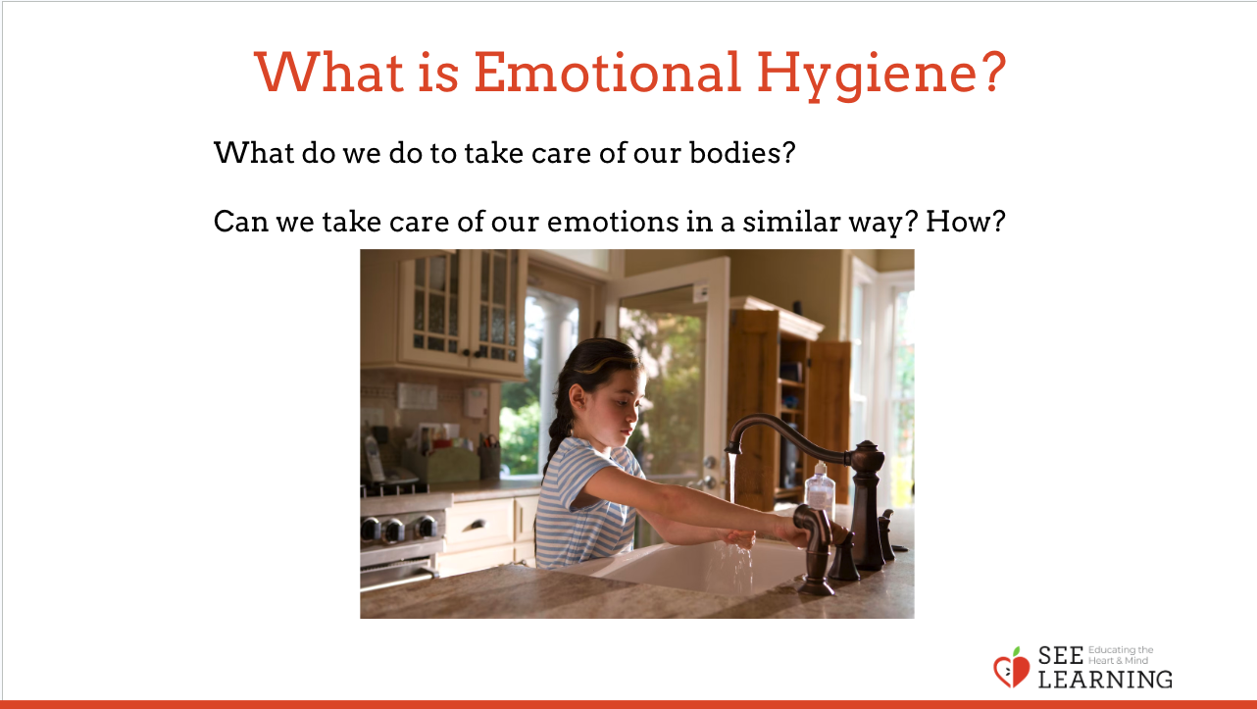 | Sample Script  - " Who has heard the word hygiene before?  - Does anyone know what it means? Let's see if together we know what it means.  - Yes, hygiene is like he alt h. It means taking care of something in order to stay healthy. Usually we are used to hearing this word when it comes to taking care of our bodies. We use the term physical hygiene . That means taking care of our bodies so our bodies stay happy and healthy.  - What are some things we do to take care of our bodies' physical hygiene?  - Why do we take care of our bodies? (To stay healthy, to feel good, so it can do all the things we want it to do.)  - Let's think about our emotions now. Do you think we can take care of our emotions too? Would that help us stay happy and healthy?  - Is there anything you know of or that we have learned together that could help us keep ourselves happy and healthy when it comes to our emotions?  - Why would it help if we took care of our emotions? [We'd be happier. We would be better able to handle risky e motion s. We wouldn't act out harmful behaviors due to strong negative emotions.]  - That's great. You are all talking about emotional hygiene ."

Insight Activity: Practicing Emotional Hygiene (15 minutes)
Overview

In this insight activity, students identify strategies that they can use if they experience risky emotions getting out of hand.

Content to be Explored

- Just as we take care of our bodies (physical hygiene), we can take care of our minds (emotional hygiene).
- We can come up with a number of possible strategies for navigating risky emotions.
- Emotional hygiene allows us to "hold back," protecting ourselves and others.

Materials

- A large piece of chart paper or board with the "Strategies for Dealing with Risky Emotions" questions written on it
- Individual worksheets for students to fill out­ each student will need 4 copies of the Insight Activity sheet and 1 copy of the Reflective Practice sheet

Instructions
- Remind the class of the "Creating Emotion Families" activity and which emotions were identified as risky. Hang up the chart that you made or make a list of the risky emotions the students identified so that everyone can see it.
- Refer back to Nelson, from the "Nelson's Difficult Day" or "Nelson's Day at Grandma's House" (found in learning experience 2 of this chapter) stories. Since it may have been a while since they heard the story, you can remind them of the story or re-read the beginning of it.
- As you go through the story, ask students when Nelson may have felt one of the risky emotion s. Create a version of the handout on chart paper or the whiteboard to model the first risky emotion.
- When they identify a risky emotion Nelson might be experiencing, use the strategies checklist (provided at the end of this learning experience) to generate ideas about what Nelson could do to help himself handle that particular risky emotion.
- In pairs or trios, have students continue through the story finding other risky emotions and exploring strategies of how Nelson might deal with each one.
- Provide time to share.
Teacher Tips
- If the opportunity arises, you can point out that sometimes a strategy might work well for a risky emotion in one situation but not in another situation . This is one reason why it's good to have several strategies for handling risky emotions and not just one.
Slide 4: Practicing Emotional Hygiene  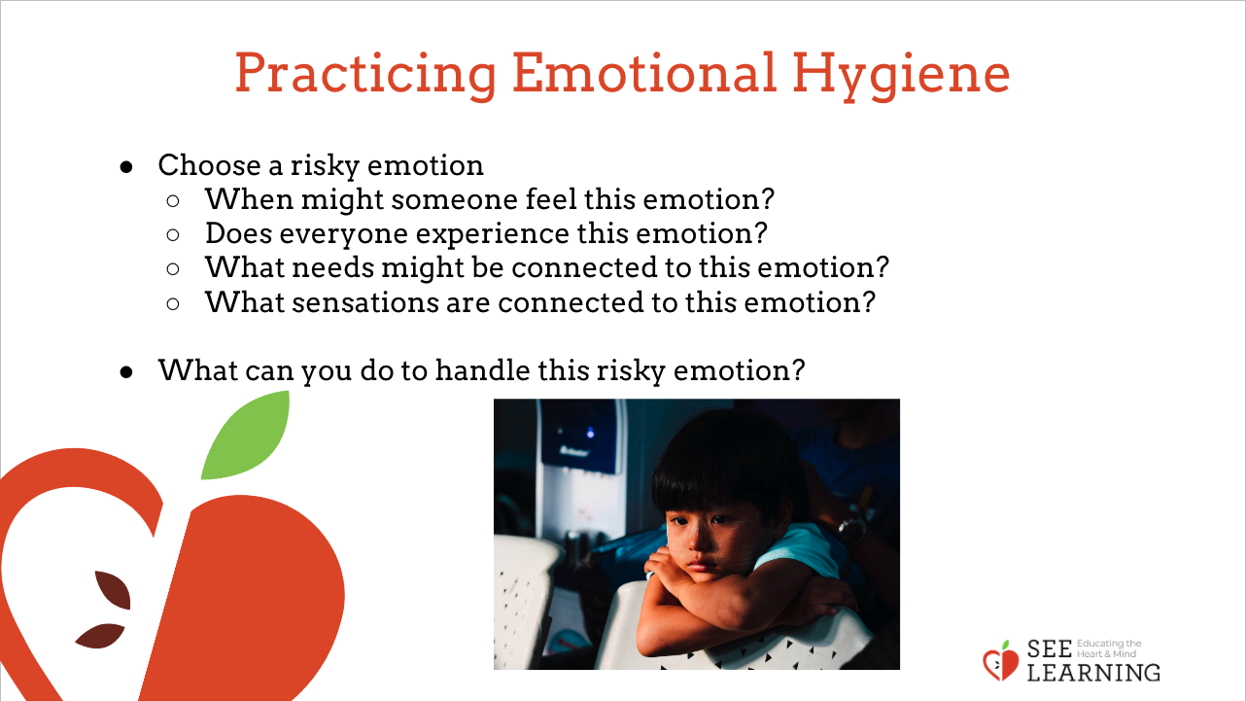 | Sample Script  - " Who remembers when we did the activity about emotion families? Can you share with the group so we can all remember?  - Yes, we came up with related words for the emotions .  - Can anyone remember an emotion that we decided was a risky emotion? [Review this with your class, reminding them of which emotions they decided were more risky. Hang up a chart of the risky emotions identified in the previous learning experience.]  - Does everyone experience this emotion at some point?  - Let's go back to the story we read about Nelson visiting his grandmother's house. Do you remember that story?  - Nelson was visiting his grandmother's house . When he woke up he didn't remember where he was. Then later he learned that his friend couldn't come play with him. A little later he went to play in the park but the other children wouldn't let him play with them .  - Do you think it's possible Nelson might feel some risky emotions during this? Which risky emotions could he be feeling? [Once a student says a risky emotion, write it on the top of the handout and have the other students do the same on their own copies.]  - If he were feeling that risky emotion, what sensations might he be feeling in his body?  [Record these on the handout and have the class do the same.]  - What could he do to help himself if he were feeling that particular risky emotion? Have we learned any strategies he could use? (Write these on the board under the heading "Things We Can Do For Ourselves")  - What if we were there with him? What could we do to help him if we saw him feeling that emotion? (These are strategies for others. Write these on the board under the heading "Things We Can Do For Others")  - That's wonderful. We've come up with some ways we can help ourselves and ways we can help others.  - What if Nelson felt one of the other risky emotions? Like if he felt afraid, or angry, or frustrated, or lonely?"  In pairs or trios, have students work on four more risky emotions together. Repeat the questions:  - " How this would feel in his body?  - What he could do for himself?  - What a friend could do for him?  - Imagine if Nelson came to us for help because he kept feeling risky emotions . He heard we are learning about emotional hygiene. What could we teach him that he could do every day to help him feel prepared and confident to keep a spark from turning into a fire ?"

Reflective Practice: What Can I Do When I Feel A Strong Emotion? (13 minutes)

Overview

In this reflective practice, students will choose a strong emotion from the emotion families chart that could cause problems for oneself and others. They will then draw what a student of their same age (Nelson) could do if such an emotion were to arise.

Note: This can be done on a 2nd day as a continuation of Part I.

Content to be Explored

- We can employ strategies for dealing with risky emotions when they arise in ourselves or others.

Materials

- Reflective Practice Risky Emotions handout
- Emotions family chart and cards

Instructions
- Explain that Nelson has learned from our class what he can do to practice emotional hygiene. Because of that, when he starts to experience a risky emotion, he knows some things he can do.
- Explain that each student (or partners) can choose another risky emotion from the ones identified in the emotion families chart (you can have them pull randomly from the cards if you want). Then ask them to reflect about Nelson using the strategies they've learned to deal with that particular risky emotion so that it doesn't cause bigger problems for themselves and others.
- Allow time for sharing of the strategies.
Teacher Tips
- Talking about risky emotions and the potentially harmful behaviors they can lead to can itself be risky if the students immediately talk from their own lives and experience from the start . This is why they are first introduced to it through a third-person fictional character (Nelson). They will naturally apply this learning to themselves. It many cases is advisable to start with this indirect method first before having students talk about their own emotional lives in the classroom.
Slide 4: What Can I Do When I Feel A Strong Emotion?  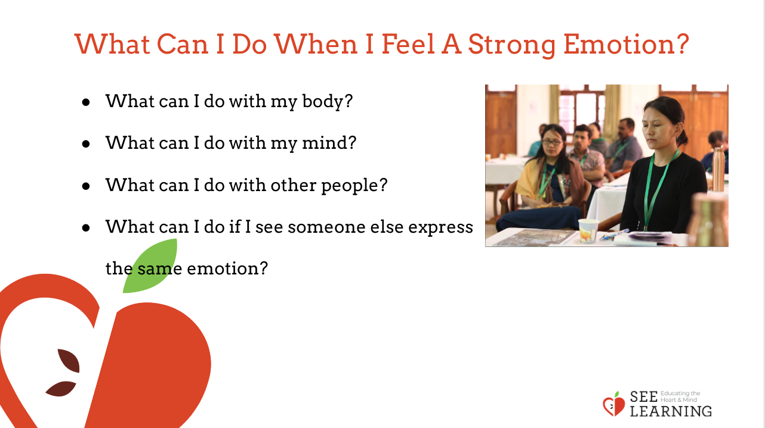 | Sample Script  - " Let 's pretend that Nelson has been in our class with us and has learned the same things as we have . He can practice emotional hygiene. Because of that, when Nelson starts  - to experience risky emotions, he knows some things he can do to handle them.  - Each of you will choose a risky emotion from the ones we talked about in the families chart.  - Next think about what Nelson could do to handle that risky emotion so that it doesn't turn into a bigger problem, so the spark doesn't become a forest fire.  - Then reflect in writing or drawing about Nelson using a strategy he has learned to deal with that one particular risky emotion on your emotions sheet. After some time for writing or drawing, those who want to can share what they wrote with the class."  - [Allow 10 minutes or so for writing/drawing. Then allow students to share out.]

Debrief (3 minutes)
Slide 5: Debrief  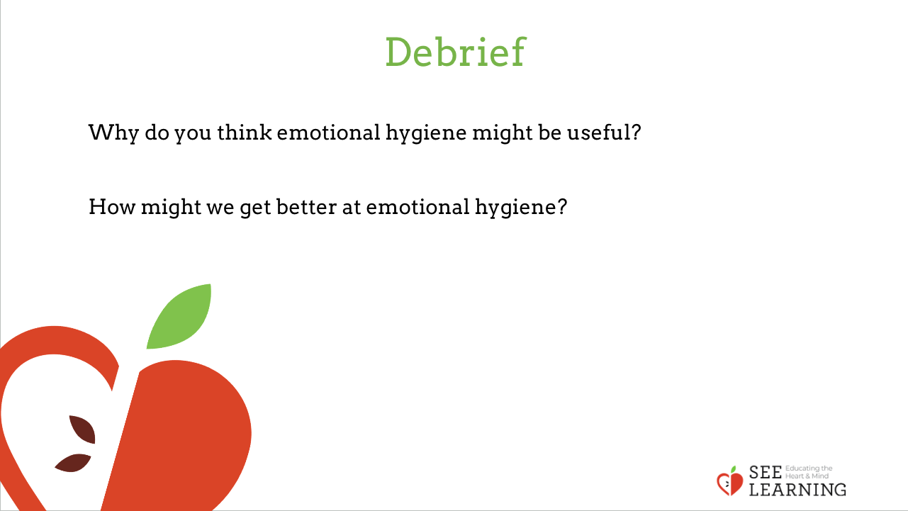 | Sample Script  - " Why do you think emotional hygiene might be useful?  - How might we get better at emotional hygiene ?"

EXTENSION OPPORTUNITY

Students could turn their emotion handouts into their own illustrated stories that could help others deal with risky emotions. These could provide step-by-step suggestions for others in times of need.

