Investigating Risky Emotions

Purpose:
The purpose of this learning experience is to help students identify the characteristics of difficult or “risky: emotions by engaging in a guided process of inquiry. This process can then be used to think about any emotion and its potential risk for oneself and others if it gets out of hand.
Learning Objectives:  Students will be able to:  - Practice discerning emotions that can be risky when they become too strong.  - Recognize that one can investigate emotions by using a process. | Primary Core Component  Attention and Self-Awareness  
Length  25 minutes | Materials Required  - The "emotion families" created earlier in the "Creating Emotion Families" activity, ideally placed on a board so everyone can see  - A large piece of chart paper with the questions from the "Investigating Risky Emotions Checklist" (provided at the end of this learning experience) written on it so everyone can see it.

Check-In | 4 minutes
Slide 2: Check In   | Sample Script  - " Let's do some resourcing and grounding to calm and relax our bodies.  - First we'll take a comfortable and upright posture. Then we'll keep our eyes on the ground or close them.  - Now let's choose a resource. It can be one from your resource kit, a new one, or you can 1mag1ne one.  - Let's bring our resource to mind and pay attention to it for a few moments quietly.  - If you'd rather do grounding, you can do that too. [Pause.]  - What do you notice inside? If you feel pleasant or neutral, you can rest your mind on that.  - If you feel unpleasant, you can shift to a different resource, or you can ground. You can also change your posture but try not to disturb anyone else if you do that. Otherwise, just keep your attention resting with your resource." [Pause.]  End here, or if time allows, continue with a practice for strengthening attention:  - " Now let's become aware of our breathing. Let's see if we can pay attention to the breath as it enters and leaves our body.  - If you find paying attention to the breath uncomfortable, then feel free to go back to your resource or grounding, or just take a small break, making sure not to disturb anyone else . [Pause for 15-30 seconds.]  - If you ever get distracted, you can just return your attention to the breath. You can also count your breath. [Pause for a longer time, such as 30-60 seconds or longer.]  - You can strengthen your attention by focusing on sensations or by focusing on the breath. It's your choice - it's always up to you.  - What did you notice ?" [Share aloud .]

Insight Activity: Investigating Risky Emotions (12 minutes)
Overview

In this insight activity, students investigate risky emotions, thinking about how risky an emotion could be and what those emotions might have in common.

Content to be Explored

- Some emotions are more risky than others, in that they can prompt behaviors that harm ourselves and others when they get out of hand.
- We can identify risky emotions by asking questions about them.
- Once we identify risky emotions, we can be heedful (exercise caution) of them and "hold back" (exercise restraint) when we feel notice them getting strong.

Materials

- The "emotion families" created earlier in the "Creating Emotion Families" activity, ideally placed on a board so everyone can see
- A large piece of chart paper with the questions from the "Investigating Risky Emotions Checklist" (provided at the end of this learning experience) written on it so everyone can see it

Instructions

- Show your students the emotion family groupings they created in the "Creating Emotion Families" activity . Place these on a board where everyone can see them.
- Remind them of the spark and the forest fire analogy . Some emotions can be sparks and can become big forest fires if we let them get out of control. We call these "risky emotions."
- Ask them if any of the emotions on the emotion family cards could start a big fire. These emotions are ones that could become risky. Whichever ones they choose, explain that you will then as a class "investigate" that emotion like a detective, using your "risky emotions checklist . " Invite them to come up to the board and put a mark next to whichever emotions they feel might be risky and should be investigated
- Distribute the "risky emotions checklist" to all students.
- Choose one of the marked emotions to start with, then run through the checklist as a class, reading aloud and asking each question in turn of that emotion.
- Move on to the next term they marked and go through the checklist again .
- Debrief by asking if the risky emotions they identified have anything in common, and whether we should be careful if we notice risky emotions in ourselves or others.

Teacher Tips
- Be attentive in case students feel that risky emotions are "bad" or that they need to fear or suppress them. There are many things in life that we need to be heedful of, and exercise restraint around, such as fire, electronics, or valuable and fragile objects.
- Restraint does not mean repression, but implies dealing with something constructively to prevent harm to self and others. The purpose of identifying risky emotions and strategies for dealing with them is for students to learn to navigate emotions constructively without having to suppress or repress them .
- The purpose of the "investigating risky emotions checklist" is to get students to think for themselves about how to analyze thoughts and emotions in terms of the benefit or potential harm they can bring. Its purpose is not to provide a definitive tool for determining which emotions are risky or not.
- Allow as much time as you have for students to assess the other risky emotions. It may save time to divide them into small groups and assign emotions.
Slide 3: “Investigating Risky Emotions”  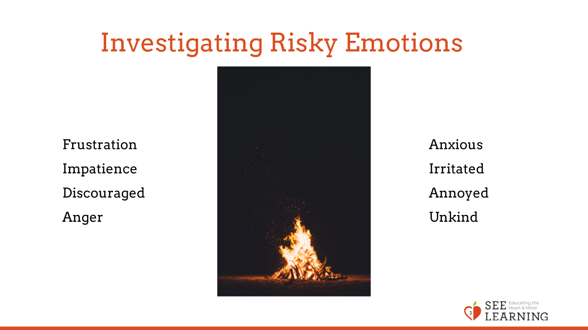 | Sample Script  - " Remember these cards that you created in our last activity? I'm going to place them where everyone can see them .  - Who can help us remember what we meant when we talked about the spark and the forest fire? How can emotions be like a spark that leads to a forest fire?  - Some emotions can turn into big fires if we let them get out of control.  - How did we describe those emotions that can turn into big fires? We call them risky emotions. They are emotions that can grow bigger and sometimes cause us to have bigger difficulties.  - Do any of these emotions on the board seem like they might be risky? [Call on specific students and have them come up and mark the emotion they feel might be risky and should be investigated.]  - We're going to investigate these risky emotions, as if we were detectives, to see how risky they are.  - Fortunately we have a good detective tool. It is this checklist. It has questions we can use to see if an emotion is risky and if so, how risky.  - Using the checklist let's first investigate the emotion "frustration." (Go through the questions on the checklist with students, asking for how they would answer the questions. Write their answers on the board or chart paper.)  - Now that we've answered all the questions, let's decide. Is frustration a risky emotion? If so, is it very risky or just a little risky?  [Continue on to a few other emotions, as you have time.]  - Now that we've identified some risky emotions, let's think about what they have in common. What is alike about these emotions?  - How can we be careful when we notice risky emotions in ourselves or others?  - What is one action you can take if you think you're experiencing a risky emotion?"  [Note: Be sure to help students think of ways they can process or handle a risky emotion that does not involve merely suppressing it. Many such strategies have already been presented in the SEE Learning curriculum, such as grounding, resourcing, and Help Now! They can be encouraged to find other strategies too, such as talking to an adult or friend, taking deep breaths, taking a pause, walking away, finding a solution to the problem, etc.]

Reflective Practice: Observing the Mind for Emotions (6 minutes)
Overview

This is similar to the final reflective practice in Chapter 3, which is found in learning experience 6 and is titled "Observing the Mind." The only difference here is asking students what emotions they noticed at the end of the practice. They will raise their hands silently when they notice an emotion, thought or sensation and lower their hand when it goes away.
Slide 4: “Observing the Mind for Emotions”  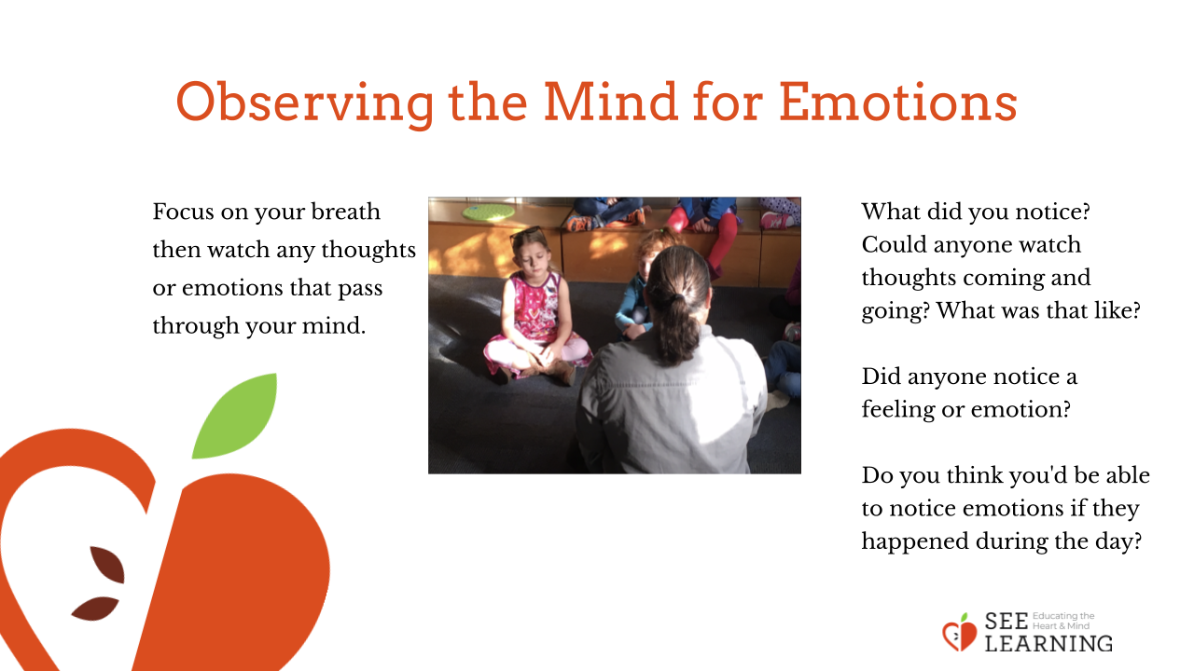 | Sample Script  - "Let 's sit up and get into a comfortable sitting position.  - If we're too excited or too tired, or if we're not in our resilient zone, it will be hard to train our attention. Just like in our drawings where we drew our minds when they were too dull or too excited.  - So let's sit upright with our backs straight. And so we don't get distracted, let's lower our eyes to the ground or close them.  - First we'll do a resourcing and grounding activity to help us be in our resilient zone .  - Let's think of one of our resources in silence, perhaps think of a favorite person or thing.  - Or if you prefer, you can do some grounding where you are sitting. Really feel the chair against your body and imagine you are a sturdy tree, with roots going down into the ground . [Pause.]  - Let's focus on our breath now. Be aware of your breath as it goes in your nose and into your body. Then, feel it as you breathe out. Remember if you start to feel uncomfortable, you can go back to your resource or to grounding. [Pause for 30 seconds or longer if your students are comfortable doing so .]  - Now let's practice just watching our mind.  - We're going to stop focusing on our breath. Instead, we're just going to watch to see whatever comes up in our mind.  - But instead of getting caught up in our thoughts or emotions, we're going to see if we can just be observers. That means not following your thoughts or feelings, but just noticing what comes up.  - Let's be silent and pay close attention and see if we can do that. [Pause for 15-30 seconds, or more if your students are comfortable doing so .]  - When you notice an emotion, a thought, or a sensation, raise your hand silently. Then put your hand down when it goes away .  - If we get distracted or caught up in our thoughts or emotions, let's just remember that we're just watching them like an observer. We're seeing them come, stay, and go. Let's try to do that just a little bit more. [Pause for 15-30 seconds or more.]  - Now let's open our eyes and share.  - What did you notice?  - Could anyone watch thoughts coming and going? What was that like?  - Did anyone notice a feeling or emotion?  - Do you think you'd be able to notice emotions if they happened during the day?"
Debrief (3 minutes)
Slide 5: Debrief  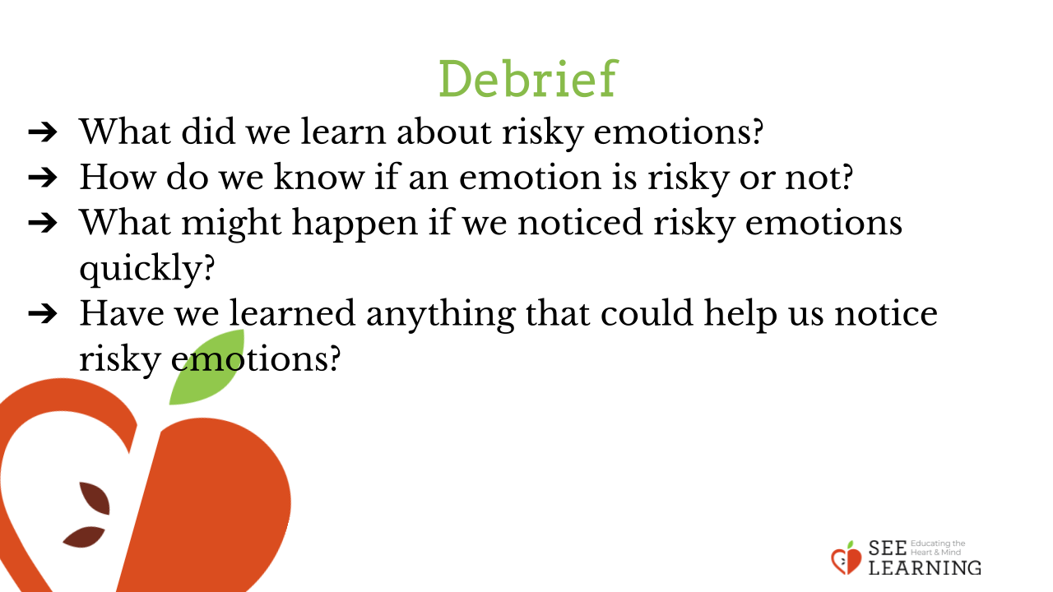 | Sample Script  - "What would you like to remember about what we called risky emotions, like anger?  - What did we learn about how we can tell if an emotion is a risky emotion? How do we know if it's risky or not?  - What might happen if we noticed risky emotions quickly?  - Have we learned anything that could help us notice risky emotions? "

Extension
On a separate day, have students reconvene with their SEE journals. They will have the opportunity to engage in a writing exercise.

- " You are going to choose one of the risky emotions by thinking, "What is a risky emotion for me?" Write it down on a free journal page. Once you've chosen your risky emotion, we are going to reflect about this.
- Some questions to think about as you write:
  - How do you know this is a risky emotion for you?
  - What clues do you get from you body that you are experiencing this emotion?
  - What resources have helped you (or would help you) move through this emotion (they can be personal or from other people)?
  - What would happen if you could notice this emotion quickly before it became a fire?

