Emotion Families

Purpose:
The purpose of this learning experience is to help students build up their vocabulary of emotion words by creating “emotion families” or collections of related emotion. They will also notice different families of emotions tend to make us feel different ways, are connected to different sets of sensations, and prompt different types of behaviors.
Learning Objectives:  Students will be able to:  - Develop a wider vocabulary of emotion terms.  - Explore the ways different emotion terms are related to each other. | Primary Core Component  Attention and Self-Awareness  
Length  30 minutes | Materials Required  - Print-outs of the cards at the end of this learning experience  - The emotion families created in the previous activity  - SEE Learning journals  - Writing utensils

Check-In | 4 minutes
Slide 2: Check In   | Sample Script  - " Let 's do some resourcing and grounding to calm and relax our bodies.  - First we'll take a comfortable and upright posture. Then we'll keep our eyes on the ground or close them.  - Now let's choose a resource. It can be one from your resource kit, a new one, or you can imagine one.  - Let's bring our resource to mind and pay attention to it for a few moments quietly.  - If you'd rather do grounding, you can do that too. [Pause.]  - What do you notice inside? If you feel pleasant or neutral, you can rest your mind on that.  - If you feel un pleasant, you can shift to a different resource, or you can ground. You can also change your posture but try not to disturb anyone else if you do that. Otherwise, just keep your attention resting with your resource. " [Pause.]  End here, or if time allows, continue with a practice for strengthening attention:  - " Now let's become aware of our breathing. Let's see if we can pay attention to the breath as it enters and leaves our body.  - If you find paying attention to the breath uncomfortable, then feel free to go back to your resource or grounding, or just take a small break, making sure not to disturb anyone else. [Pause for 15-30 seconds.]  - If you ever get distracted, you can just return your attention to the breath. You can also count your breath. [Pause for a longer time, such as 30-60 seconds or longer.]  - You can strengthen your attention by focusing on sensations or by focusing on the breath. It's your choice - it's always up to you.  - What did you notice?" [Share aloud.]

Insight Activity: Creating Emotion Families (15 minutes)
Overview

In this insight activity students will make "emotion families" to expand their vocabulary of emotions and see how emotions relate to each other.

Content to be Explored

- Emotions can vary in strength.
- Some emotions are related to each other.

Materials

- 5 sets of the print-outs of the emotion cards at the end of this learning experience

Instructions

- Divide the students into groups of 3-5 or you can choose to do this activity as a whole class. (The script below is written for instruction for small groups.) Each group should be stationed around a table or gather together on the floor.
- Hand out the main emotion cards (happy, kind, sad, angry, afraid) to each group. These can be found at the end of this learning experience. Explain that this emotion is the "parent" of each group.
- Then give each group one set of the rest of the emotion cards. These are for the additional "family members."
- Read all the words with students to be sure they know how to read each card.
- Instruct students that their job will be to create "emotion families" by grouping together the words that go together.
- Do the happy emotion family all together as a class. Ask students to find another word that is similar to "happy." When they find it, they can place it next to the happy card. And so on.
- Have students do the rest of the activity in their small groups, placing all emotions in family groups.

Teacher Tips
- Here is the list of completed emotion families:
- Happy: joyful, excited, content, pleased
- Kind: caring, loving, friendly, empathetic
- Sad: lonely, gloomy, miserable
- Angry: frustrated, impatient, annoyed
- Afraid: worried, scared, nervous
- Each group will need enough room (flat surface like table, or floor) to place the emotions cards under each family group card.
- It can be helpful to draw faces or use "emojis" on the emotion cards as well, especially for students who cannot yet read well.
Slide 3: “Creating Emotion Families  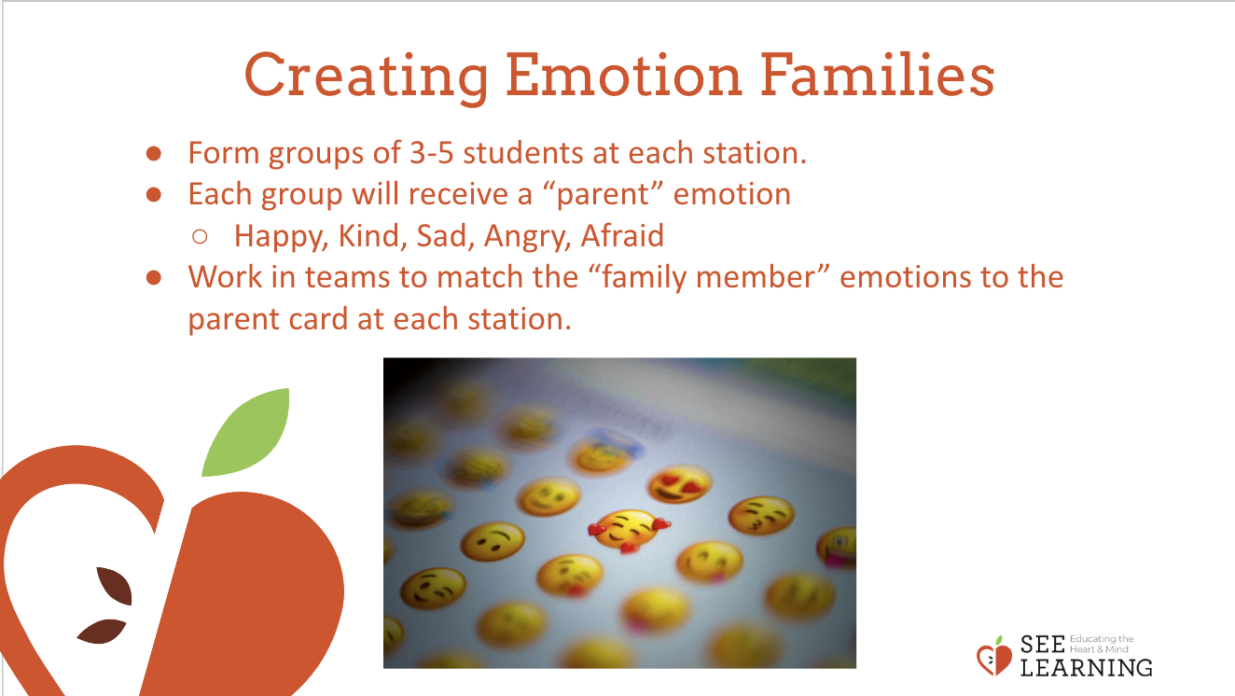 | Sample Script  - " Here we have 5 main e motion s. I' m going to give one to each of your groups. This is the main "parent” of your emotion family. Let's read them aloud together.  - We also have a lot of other emotion cards too. They are like relatives. Each one will go to one of the main groups where it will join its parent. (Teacher holds up and reads each card with the help of students.)  - Now let's see where they should go. Let's start with the emotion family of “happy” and do that together.  - If I feel happy, what other emotion might I feel? What's an emotion related to feeling happy? Find the card in your deck that has a word that is similar to happy. [joyful, excited] Great, I will place joyful right under happy.  - What other emotions do we have here that would fit with happy? [Ask for suggestions.]  - Now let's do the rest in groups. Find what cards you have that fit with your main emotion parent and place them around the parent. [Give enough time for them to work in groups, checking in on each group.]  - Now let's share. Which group would like to go first? Tell us your emotion parent, and then tell us which other emotions you decided were related. [Allow each group to share.]  - Were there any emotion words you didn't understand?"

Reflective Practice: What Emotions Do I Notice Most In People Around Me? (8 minutes)
Overview

Students will reflect on and draw what emotions they notice in people around them.

Content to be Explored

- We can notice emotions in the people around us.
- We can reflect on what needs those people might have.

Materials

- The emotion families created in the previous activity
- A piece of drawing paper for each student
- Colored markers or pencils
- SEE Learning journals

Instructions
- Choose a selection of emotion words that your students made during the "Creating Emotion Families" activity. Choose positive or neutral emotion words (like happiness, joy, excitement, surprise, wonder) rather than negative emotions (like sadness or anger).
- Starting with the first word, ask the class if anyone can share a time when they noticed one of these emotions in someone else. Invite them to share. Then move on to the next word.
- Give each student a sheet of paper. Ask them to draw what emotions they most notice in the people around them. Explain that they do not have to share this if they don't want to.
- After giving them a few minutes to draw, ask them now to imagine what needs those people might have when they experience those emotions. Again, give them a few minutes to draw or write.
- Invite anyone who wants to share to do so. Invite anyone who wants to pass their drawing to you, to do so. Remind them that no one needs to share.
Teacher Tips
None
Slide 4: What Emotions Do I Notice Most In People Around Me?  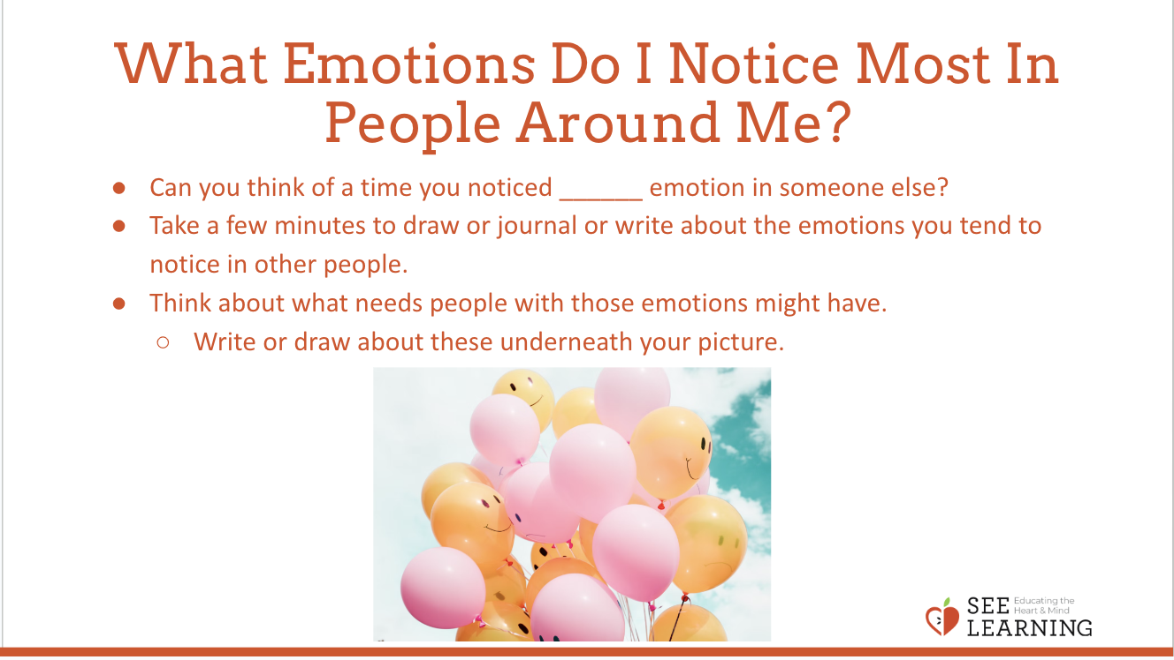 | Sample Script  - " Let 's focus on these emotions for this practice.  - Can you think of a time you noticed one of these emotions in someone else? Can you describe it?  - Now let's do a brief reflective practice in silence. This is only for you, you will not have to share this if you don't want to.  - Take your piece of paper or use your journal and draw or write about the emotions you tend to notice most often in the people around you. You can draw or write about more than one emotion and they do not have to be from the same family. [Pause for a few minutes.)  - Next, think about what needs those people might have when they experience those emotions. Draw or write those needs underneath each picture. [Pause for a few minutes.]  - Would anyone like to share out loud? [Allow time for sharing.) What emotions did you draw? What needs did you notice?  - Would anyone like to share their drawing with just me? If so, please pass it to me."
Debrief (3 minutes)
Slide 5: Debrief  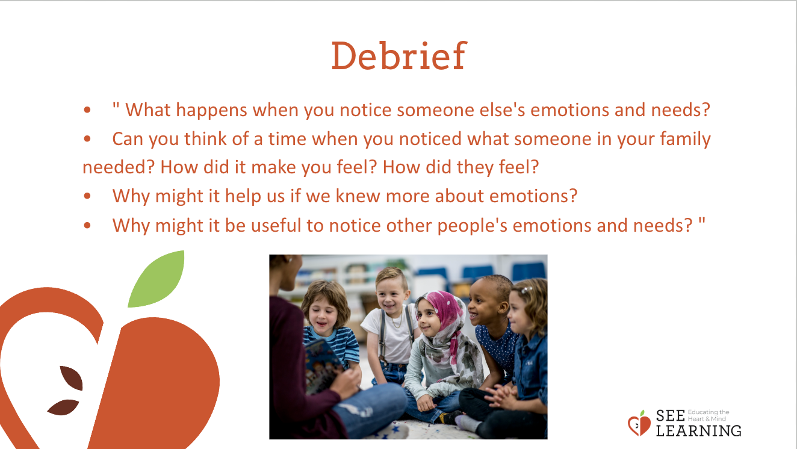 | Sample Script  - " What happens when you notice someone else's emotions and needs?  - Can you think of a time when you noticed what someone in your family needed? How did it make you feel? How did they feel?  - Why might it help us if we knew more about emotions?  - Why might it be useful to notice other people's emotions and needs? "

