Personal Needs

Purpose: The purpose of this learning experience is to give students an opportunity to explore their own needs. After a brief insight activity intended to reinforce the connection between needs and emotions, students will engage in a reflective practice in which they explore one of their own personal needs. They will reflect on what helps them meet this need and what it feels like for them when that need is met.
Learning Objectives:  Students will:  - Explore personal needs.  - Explore the emotions and sensations that arise when one's needs are met. | Primary Core Component  Attention & Self-Awareness
Length  25 minutes | Materials Required  - A large piece of chart paper  - The shared needs list created earlier  - An index card or piece of paper for each student  - Writing utensils for each student  - The "Needs" handout

Check in (4 min)
Slide #2: Checking In   | Sample Script  - " Let's do some resourcing and grounding to calm and relax our bodies.  - First we'll take a comfortable and upright posture. Then we'll keep our eyes on the ground or close them.  - Now let's choose a resource. It can be one from your resource kit, a new one, or you can 1mag1ne one.  - Let's bring our resource to mind and pay attention to it for a few moments quietly.  - If you'd rather do grounding, you can do that too. [Pause.]  - What do you notice inside? If you feel pleasant or neutral, you can rest your mind on that.  - If you feel unpleasant, you can shift to a different resource, or you can ground. You can also change your posture but try not to disturb anyone else if you do that. Otherwise, just keep your attention resting with your resource." [Pause.]  End here, or if time allows, continue with a practice for strengthening attention:  - "Now let's become aware of our breathing. Let's see if we can pay attention to the breath as it enters and leaves our body.  - If you find paying attention to the breath uncomfortable, then feel free to go back to your resource or grounding, or just take a small break, making sure not to disturb anyone else. [Pause for 15-30 seconds.]  - If you ever get distracted, you can just return your attention to the breath. You can also count your breath. [Pause for a longer time, such as 30-60 seconds or longer.]  - You can strengthen your attention by focusing on sensations or by focusing on the breath. It's your choice - it's always up to you.  - What did you notice?" [Share aloud.]
INSIGHT ACTIVITY: Feelings and Needs of a New Student (8 min)
Overview
In this insight activity students will explore the relationship between feelings and needs by imagining how a new student might feel if he or she just joined the class, and what needs he or she might have.

Content to be Explored
- We can have different types of feelings: some are sensations (how we feel in specific parts of the body) and some are emotions (how we feel about a situation).
- People experience different sensations and emotions when their needs are met or go unmet.

Materials
- A copy of the Shared Needs List created earlier
- 1 piece of paper for each student
- Crayons, markers, or pencils for each student

Instructions
- Begin by asking students to remember the moments of kindness they have discussed before. Check to see if kindness is on the list of shared needs.
- Ask them how it makes them feel when they get kindness when they need it.
- Ask them how it feels to need something like kindness and not get it.
- Explain what "met" and "unmet" needs are.
- Refresh students on what a sensation is and list a few. Refresh students on what an emotion is and list a few.
- Bring up a scenario with Nelson as a new student. Ask what needs he might have if he is shy. Ask how he would feel if those needs were met or were unmet.
- Bring up a scenario with Theresa as a new student. Ask what needs she might have, if she is outgoing. Ask how she would feel if those needs were met or were unmet.
- Take a moment to pause and have students silently visualize a time when they had a need that was met. Ask them to consider what sensations or emotions they felt.
- Provide time for sharing.

Teacher Tips
Remember that students should only be prompted to visualize situations that they find pleasant or neutral, not situations that would make them feel unpleasant or uncomfortable.

Slide #3: Title  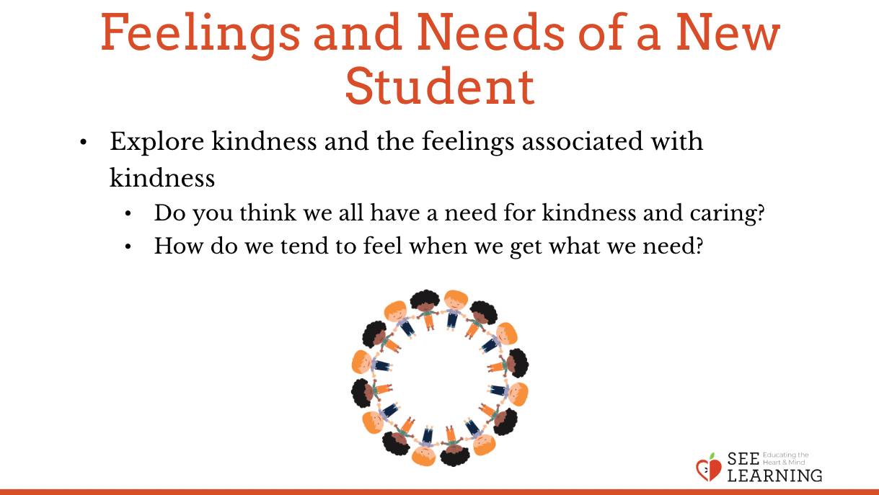 | Sample Script  - "We've talked about remembering moments of kindness and how it makes us feel.  - Do you think we all have a need for kindness and caring? Did we include that in our list of shared needs?  - How do we tend to feel when we get what we need? Like if I need kindness because maybe I'm feeling sad and I get kindness-how might that make me feel?  - When we get what we need, we say that the need is "met.  - And what if I needed kindness or needed friendship because I am feeling a bit lonely, but I don't get it. Does that happen sometimes-that we don't get what we need? How might I feel then?  - When we don't get what we need, we say the need is "unmet. That means we didn't get what we needed.  - Now let's think about our friend Nelson. What if Nelson had just joined our class and was a new student here with us. Nelson is a bit shy and he doesn't know anyone at the school. What needs might he have? [Ask for suggestions.]  - How might he feel if that need was met? That means, if he got what he needed?  - How might he feel if that need was not met? That means, if he didn’t get what he needed?  - Now some of the things Nelson is feeling could be sensations. Does anyone remember what a sensation is that we can feel in our bodies? [Show your list of sensation words or prompt them.]  - Sensations are things we feel in parts of our bodies: like feeling cold, feeling warm, feeling our heart pounding, feeling our breathing coming fast, feeling tingling, feeling tight, or loose. What else might we feel in our bodies?  - Nelson could also be feeling emotions. What about emotions? Does anyone know any emotion words? [Show your list of suggested emotion words or prompt them.]  - Emotions are words for how we feel about a situation: like feeling happy, feeling sad, feeling mad, or feeling scared. Can anyone think of other emotion words?  - Let's think of more things Nelson might need as a new student and how he might feel if he got what he needed. [Ask for suggestions as above.]  - Let's think of a different new student, Theresa, who is outgoing. What needs, and emotions might she have and how might she feel if she got what she needed?  - Now we're going to try to think about ourselves. Let's think of a time when we had a need and it was met. It might be a need on our list or one not on our list.  - Would anyone like to share?  - What was your need and how was it met?  - How did you feel when your need was met? Did you feel any sensations or emotions?"

REFLECTIVE PRACTICE: My Needs (10 min)
Overview
In this reflective practice, students will do a brief reflective practice on what need they feel is most important to them right now and what is helping them meet it. They will combine this with the tracking of sensations in the body.

Content to be Explored
- What needs are most important can vary from person to person, or from time to time.
- Thinking about our needs being met or unmet affects our emotional state and our nervous system.

Materials
- The shared needs list created earlier
- Their list from their journal of important needs
- The "Needs" handout
- A writing utensil for each student

Instructions
- Ask students to put their name on hand out.
- Ask them to identify for themselves a particular need that they feel is especially important to them right now and write it on their sheet. It can be from the shared needs list or a need they feel that is not on the list, or one from their journal from Learning Experience 1.
- Explain this is a private practice and they won't have to share what they write with anyone, unless they want to.
- Ask them to reflect silently on what things in their life are helping them meet this need, and to write these down on the card. If they can't think of anything helping them to meet their need, ask them to write what they could imagine happening that would help them meet it.
- Ask them to reflect on what it would feel like to have their need met completely. Then ask them to notice what this feels like on the inside (tracking). Give them the opportunity to ground or resource if they notice unpleasant sensations.
- Invite anyone who wants to share to do so.
- Invite them to put their sheet in their resource kit or hand it into you so you can read it privately.

Teacher Tips
- Observe students as they complete their drawings to ensure that they are depicting a time when their need was met. If they have trouble thinking of a time, remind them of the way that the other students and you welcomed them into the class this year.
- Note that the needs that your students share with you can be important sources of information about them. Be careful to respect their privacy, while also recognizing that they may choose to share things that can help you to know more about them and their needs.

Slide #4: My Needs  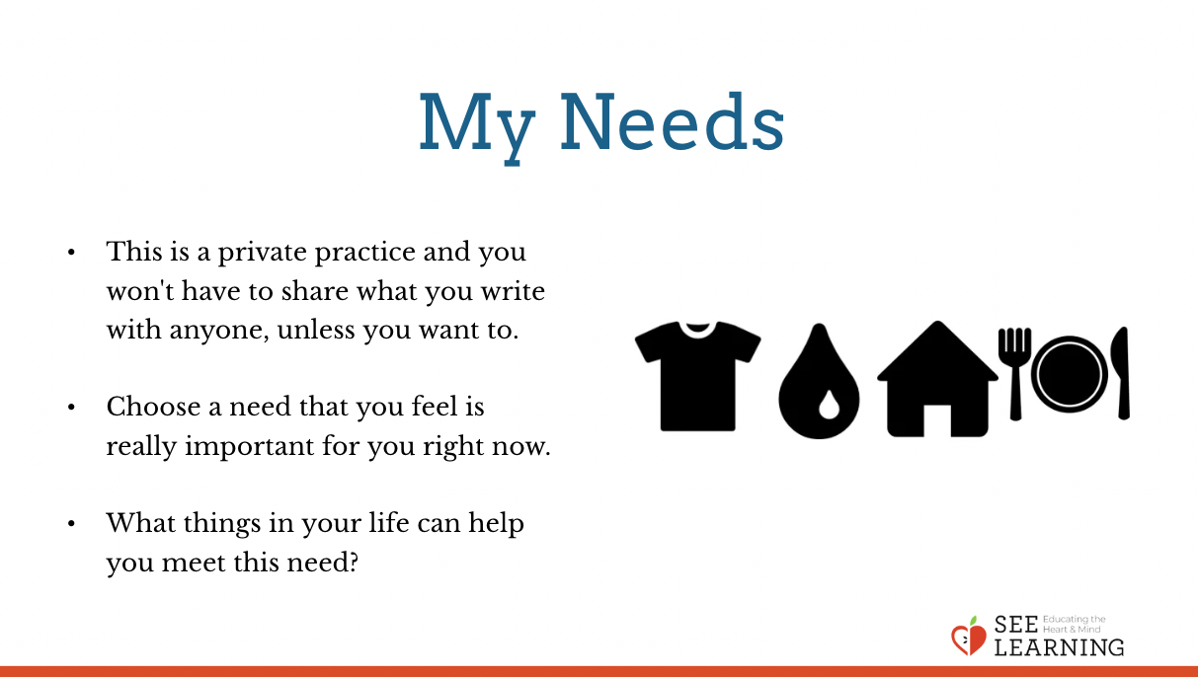 | Sample Script  - "Everyone should have a Needs sheet and a writing utensil. Write your name on the paper, please.  - Now choose a need that you feel is really important for you right now. We can look at the needs list we made if we need ideas or you can look in your journal.  - Write down that one need on your paper.  - Now let's take a moment to think. What things in your life can help you meet this need? You can include other people in your drawing. If your need hasn't been met yet, you could still imagine other people helping you.  - Now let's write. Answer these questions:  - What is helping you have this need met?  - If it is not being met, what might help it be met?  - Now let's take a moment to think: What would it feel like to have this need completely met? Take a moment to imagine this. [Pause 30 seconds.]  - Use words or pictures to describe what it would feel like to have this need met completely.  - Now take a moment to check what you notice on the inside while you are imagining this need being completely met. [Pause 30 seconds.]  - Use words or pictures to describe what you feel on the inside.  - Thank you. I'd like to invite you to share, if you like. Who wants to share? [Allow time for sharing.]  - Now you can place your drawing in your resource kit. Or if you want to share it with me, you can hand it to me. I will keep them private."

Debrief (3 min)  Slide #5: Debrief  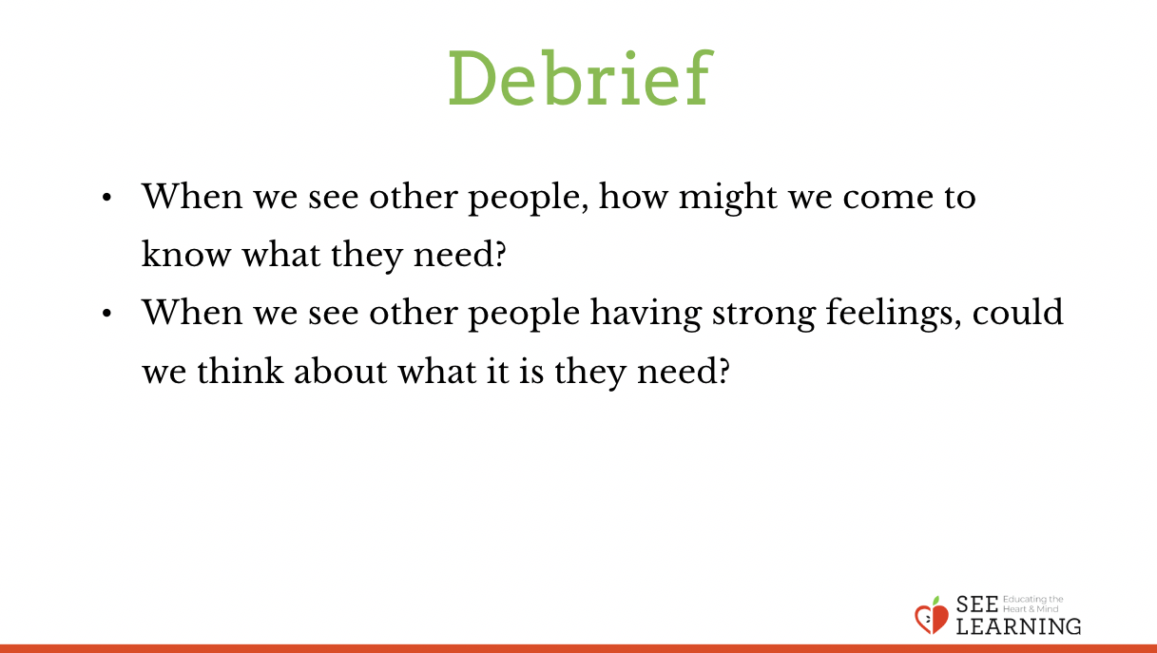 | Sample Script  - "When we see other people, how might we come to know what they need?  - When we see other people having strong feelings, could we think about what it is they need?"

