Exploring Needs

Purpose: The purpose of this learning experience is to begin exploring needs that we have to live, learn and be happy, and to explore shared needs. Recognizing that all people have needs and that we share needs can be an important precursor to developing greater empathy and compassion both for oneself and others.
Learning Objectives:  Students will be able to:  - Explore the basic human needs for happiness, life and learning. | Primary Core Component  Attention & Self-Awareness  
Length  25 minutes | Materials Required  - Whiteboard or chart paper and markers  - SEE Learning journals  - An index card or small piece of paper for each student  - Writing utensils for each student

Check In (4 min)
Slide 2 : Check In   | Sample Script  - "Let's do some resourcing and grounding to calm our mind and relax our bodies.  - First, we'll take a comfortable and upright posture. Then we'll keep our eyes on the ground or close them.  - Now let's choose a resource. It can be one from your resource kit, a new one, or you can 1mag1ne one.  - Let's bring our resource to mind and pay attention to it for a few moments quietly.  - If you'd rather do grounding, you can do that  - too. [Pause.]  - What do you notice inside? If you feel pleasant or neutral, you can rest your mind on that.  - If you feel unpleasant, you can shift to a different resource, or you can ground. You can also change your posture but try not to disturb anyone else if you do that. Otherwise, just keep your attention resting with your resource." [Pause.]  End here, or if time allows, continue with a practice for strengthening attention:  - " Now let's become aware of our breathing. Let's see if we can pay attention to the breath as it enters and leaves our body.  - If you find paying attention to the breath uncomfortable, then open your eyes and look at your resource again. Or you can just take a small break, making sure not to disturb anyone else. [Pause for 15-30 seconds.]  - If you ever get distracted, you can just return your attention to the breath. You can also count your breath. [Pause for a longer time, such as 30-60 seconds or longer.]  - You can strengthen your attention by focusing on sensations or by focusing on the breath. It's your choice - it's always up to you.  - What did you notice?" [Share aloud.]

Insight Activity 1: Shared Needs (17 minutes)
Overview
In this insight activity, students will create a list of "needs": what people need for happiness, life, and learning. They will identify those needs that are basic to most people.

Content to be Explored
- We all have needs.
- Although some of our needs may be specific to ourselves, many are shared among ourselves and others.

Materials
- A whiteboard or large piece of chart paper for the list of needs
- SEE Learning journals
- Writing utensils

Instructions
- Write the word "NEEDS" on the whiteboard or a large piece of chart paper.
- Ask students to name some things that we need to be happy, to live, and to learn.
- Write their suggestions as a list on the board. Explain that the class is making a list of our "needs," meaning things we need to be happy, live, and learn.
- Once you have a list of ten or more needs, ask students which of the needs seem common to all or most people. Put a star next to those. Identify these as "Shared Needs. "
- Once you have a list of ten or more needs, ask students which of the needs they think everyone has: Do all people have this need? Put a star next to those. Identify these as "Shared Needs."

Teacher Tips
- Students may suggest things that do not seem to be needs, but rather wants or other things. Return to the question, "Is that something we need to be happy, to live or to learn?" If the student says yes, then to acknowledge and encourage student participation, write their suggestion on the board also, but put it to one side. You can say something like, "I'm going to put it here on the side and we can see if it fits later." As you go along, and especially when you make the list of shared needs, it will become clearer to students what is meant by a "need."
- A sample list of shared needs is provided at the end of this learning experience for your reference.
- If students have trouble coming up with ideas, offer suggestions, such as, "What about friends? Do we need friends to be happy? Or what about time to play?"
- It could be helpful to ask students to think about the things they do every day, since many of the things we do daily (eating, sleeping, going to school, playing with friends, and so on) have to do with our needs.
- Students this age are likely to list concrete things (like shoes, teachers, cars, pencils) rather than the abstract categories in the provided list. You can either write that concrete item on the list as a need, or you can probe further by asking, "Why do we need a pencil? So that we can write and do our homework? So we need to be able to study and learn things or we need to be able to do work?" In this way you can lead them to more general needs.

Slide 3: Shared Needs  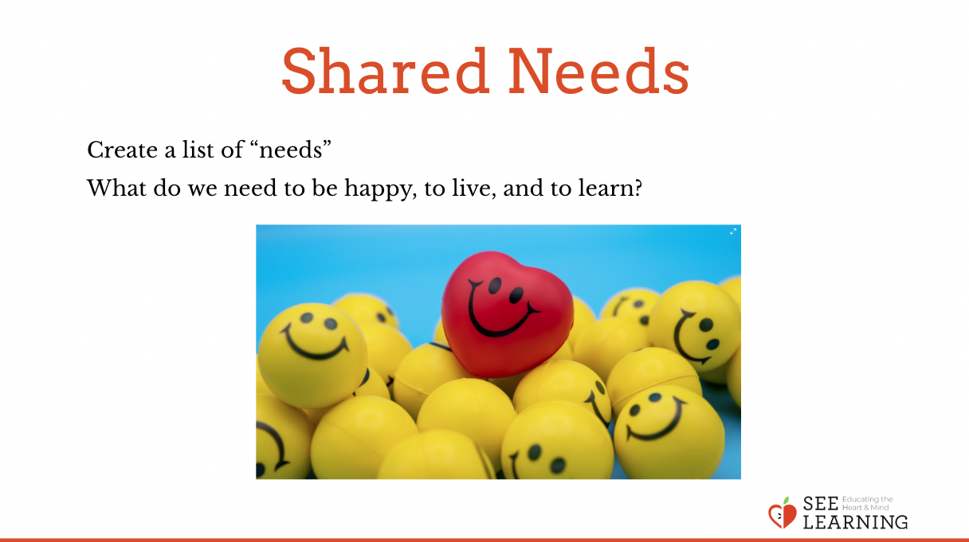 | Sample Script  - "Today we're going to talk about needs. These are things that we need as human beings to be happy, to live and to learn.  - What are some things that we need? Let's talk first about what we need to be happy.  - What do we need to live?  - What do we need in order to learn?  - [If students have trouble, offer suggestions, such as, "What about friends? Do we need friends to be happy? Or what about time to play?"]  - Let's look at our list so far. What do you notice?  - Which of these needs seem common to all or most people? I'll put a star next to the ones you think are most common. Let's discuss them.  - These needs with the stars next to them are "shared needs."  - Now that we have a list of needs and have thought about shared needs, needs that many people have, I want you to think about what needs you have. What needs are pressing for you regularly?  - Let's think silently for 30 seconds about the needs that are very important to you, then you will write out 5-7 of the needs that are very important to you in your journals. They don't have to be the shared needs, but they might be. [Pause.]  - Now, please write your needs in your journals." [Provide about 2 minutes to write.]

Debrief (4 min)

Slide 4: Debrief  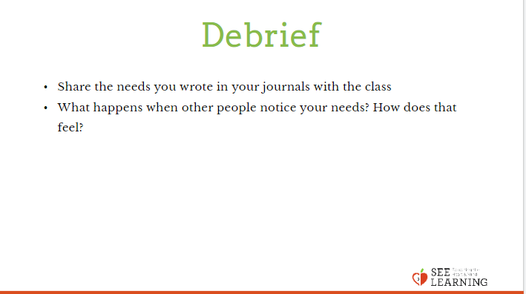  Animated slide | Sample Script  - Ask if anyone would like to share the needs that they wrote in their journals.  - " What happens when other people notice your needs? How does that feel?  - How does someone show that they have noticed a need you have?" (Be specific here, ask "how has someone noticed your need to be loved" or any other one of the needs.)

