Exploring Needs and Feelings

Purpose:
The purpose of this learning experience is to help students identify the characteristics of difficult or “risky” emotions by engaging in a guided process of inquiring. This process can then be used to think about any emotion and its potential risk for oneself and others if it gets out of hand.
Learning Objectives:  Students will be able to:  - Practice discerning emotions that can be risky when they become too strong.  - Recognize that one can investigate emotions by using a process. | Primary Core Component  Attention & Self-Awareness  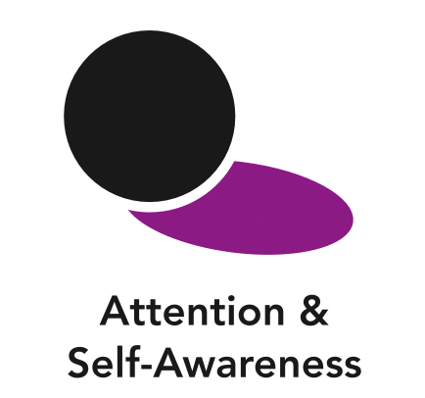
Length  25 Minutes | Materials Required  - The “emotion families” created earlier in the “Creating Emotion Families” activity, ideally placed on a board so everyone can see  - A large piece of chart paper with the questions from the “Investigating Risky Emotions Checklist” (provided at the end of this learning experience) writing on it so everyone can see

Check In (4 min)
Slide 2 : Check In   | Sample Script  - “Let’s do some resourcing and grounding to calm and relax our bodies.  - First we’ll take a comfortable and upright posture. Then we’ll keep our eyes on the ground or close them.  - Now let’s choose a resource. It can be one from your resource kit, a new one, or you can imagine one.  - Let’s bring our resource to mind and pay attention to it for a few moments quietly.  - If you’d rather do grounding, you can do that too. [Pause.]  - What do you notice inside? If you feel pleasant or neutral, you can rest your mind on that.  - If you feel unpleasant, you can shift to a difference resource, or you can ground. You can also change your posture but try not to disturb anyone else if you do that. Otherwise, just keep your attention resting with your resource.” [Pause.]  - End here, or if time allows, continue with a practice for strengthening attention:  - “Now let’s become aware of our breathing. Let’s see if we can pay attention to the breath as it enters and leaves our body.  - If you find paying attention to the breath uncomfortable, then feel free to go back to your resource or grounding, or just take a small break, making sure not to disturb anyone else. [Pause for 15-30 seconds.]  - If you ever get distracted, you can just return your attention to the breath. You can also count your breath. [Pause for a longer time, such as 30-60 seconds or longer.]  - You can strengthen your attention by focusing on sensations or by focusing on the breath. It’s your choice - it’s always up to you.  - What did you notice?” [Share aloud.]

Insight Activity 1: Investigating Risky Emotions (12 min)
Overview
In this insight activity, students investigate risky emotions, thinking about how risky an emotion could be and what those emotions might have in common.

Content to be Explored
- Some emotions are more risky than others, in that they can prompt behaviors that harm ourselves and others when they get out of hand.
- We can identify risky emotions by asking questions about them.
- Once we identify risky emotions, we can be heedful (exercise caution) of them and “hold back” (exercise restraint) when we notice them getting strong.

Materials
- The “emotion families": created earlier in the “Creating Emotion Families” activity, ideally placed on a board so everyone can see.
- A large piece of chart paper with the questions from the “Investigating Risky Emotions Checklist” (provided at the end of this learning experience) written on it so everyone can see it.

Instructions
- Show your students the emotion family groupings they created in the “Creating Emotion Families” activity. Place these on a board where everyone can see them.
- Remind them of the spark and the forest fire analogy. Some emotions can be sparks and can become big forest fires if we let them get out of control. We call these “risky emotions.”
- Ask them if any of the emotions on the emotion family cards could start a big fire. These emotions are ones that could become risky. Whichever ones they choose, explain that you will then as a class “investigate” that emotion like a detective, using your “risky emotions checklist.” Invite them to come up to the board and put a mark next to whichever emotions they feel might be risky and should be investigated.
- Distribute the “risky emotions checklist” to all students.
- Choose one of the marked emotions to start with, then run through the checklist as a class, reading aloud and asking each question in turn of that emotion.
- Move on to the next erm they marked and go through the checklist again.
- Debrief by asking if the risky emotions they identified have anything in common, and whether we should be careful if we notice risky emotions in ourselves or others.

Teacher Tips
- Be attentive in case students feel that risky emotions are “bad” or that they need to fear or suppress them. There are many things in life that we need to be heedful of, and exercise restraint around, such as fire, electronics, or valuable and fragile objects. Restraint does not mean repression, but implies dealing with something constructively to prevent harm to self and others. The purpose of identifying risky emotions and strategies for dealing with them is for students to learn to navigate emotions constructively without having to suppress or repress them.
- The purpose of the “investigating risky emotions checklist” is to get students to think for themselves about how to analyze thoughts and emotions in terms of the benefit or potential harm they can bring. Its purpose is not to provide a definite tool for determining which emotions are risky or not.
- Allow as much time as you have for students to assess the other risky emotions. It may save time to divide them into small groups and assign emotions.
Slide 3: Step In Step Out  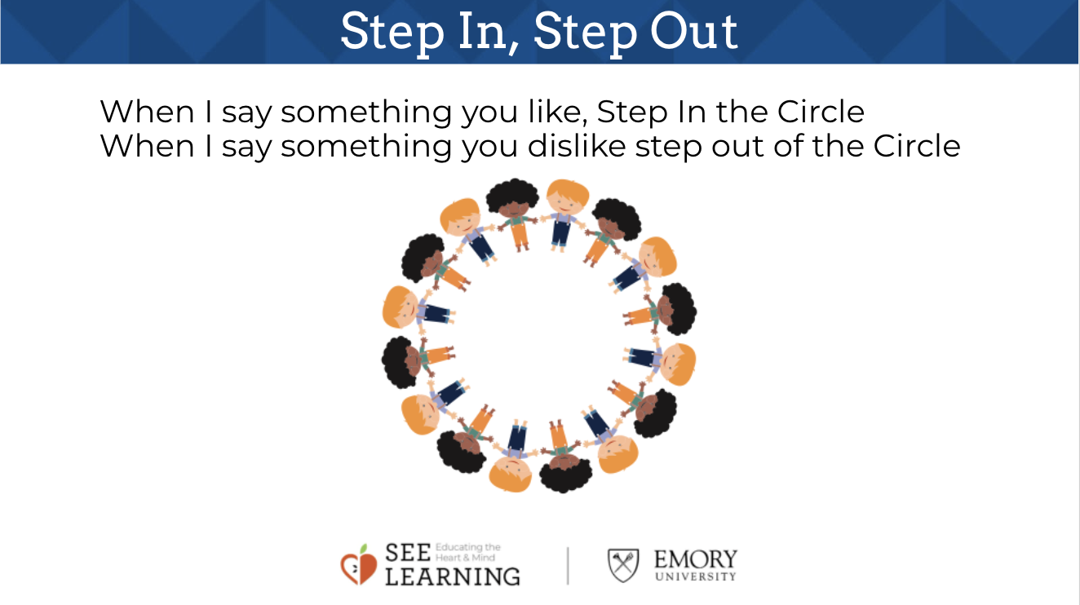 | Sample Script  - “Remember these cards that you created in our last activity? I’m going to place them where everyone can see them.  - Who can help us remember what we meant when we talked about the spark and the forest fire? How can emotions be like a spark that leads to forest fire?  - Some emotions can turn into big fires if we let them get out of control

Insight Activity 2: Remembering and Drawing Kindness (12 min)
Overview
Students will produce a drawing of when someone was kind to them with some sentences underneath explaining the scene and how they felt.

Content to be Explored
- We can recall memories or imagined acts of kindness
- Kindness adds to our happiness
- We all want to be happy

Materials
- Paper for each student
- Pencils, markers or pens for drawing

Instructions
- Ask students to silently imagine a time when someone was kind to them.
- Ask students to draw an image of that time. Then ask them to write a few sentences to answer these questions about the memory/ image:
- What did it look like? What did it feel like? What did you look like? What did you feel like?
- Give students a few minutes to draw, guiding individual students as necessary. When it seems that most students are ready, invite them to share.
- When they are sharing, ask them what it felt like when they were shown kindness.
- If students share moments that were not kind, or that made them feel bad, remind them that kindness is something that makes us feel happier when we receive it from others, and ask them to think of another time when they were shown kindness and felt happy receiving that kindness.
- Allow as many children to share as time allows, drawing their attention to the simple fact that we all want kindness, because it adds to our happiness, and we all want to be happy.

Teacher Tips
- You can do this activity sitting at tables or desks or together as a whole group, sitting in a circle. The script below is written for students sitting at tables or desks.
- Have a few students share their moment of kindness in case others are stuck as this will give some more scaffolding.
- You may want to model with a drawing you have made.
- Depending on the size of your class and the reluctance of some students to talk in a large group, you might ask them to pair up to talk first.
- You can also ask other students what they feel when they see another student sharing their kindness moment, as it may also make them feel happy, or it may remind them of a time when they received a similar kindness.
- This drawing activity can be done more than once in different class sessions, but make sure to save at least one copy of the drawings as they will be used again in later learning experiences. The students can save their own drawing, you can hang them up on the wall, or you can collect them and distribute them again later when they are needed. This activity can be repeated at least once a mont
Slide 4: Drawing Kindness  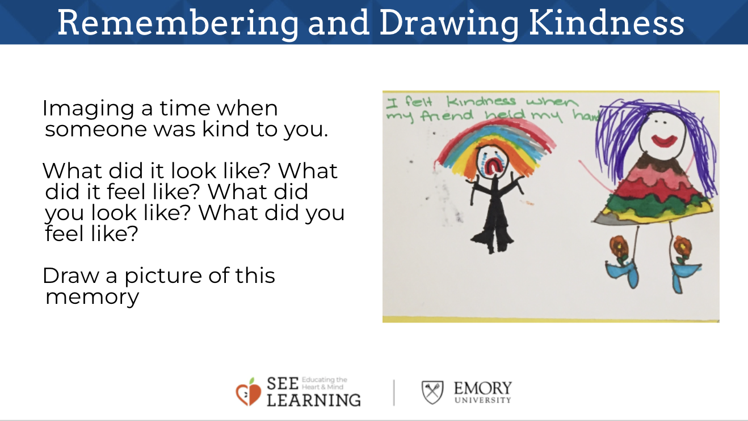 | Sample Script  - “Let’s go back to our desks.  - Remember how we saw that we all like it when people are kind to us?  - Let’s be silent for a moment and think about a moment when someone was kind to us. Sometimes it is easier to bring memories to our mind if we close our eyes or look at the ground. I’ll keep my eyes open.  - It could be something very special, or it could be something very simple.  - It could be someone helping you, or someone saying something nice to you.  - It could be a friend who played with you, or someone giving you a toy or present.  - Raise your hand if you’ve thought of a time when someone was kind to you. [Have a few students share in case others are stuck - this will give some more scaffolding.]  - Now we’re going to draw what happened when someone was kind to us.  - Answer these questions: what did it look like? What did it feel like? What did you look like? What did you feel like? [Give students a few minutes to draw, guiding individual students as necessary. When it seems that most students are ready, invite them to share.]  - Okay, we’ve all done some drawing now of a time when someone was kind to us.  - Who would like to share their drawings and tell us about that time?  - These drawings will be available to you as a resource to come back to if you need a reminder of a kind moment. You are always welcome to look back at what we’ve done and bring positive feelings forward.”

Debrief (3 min)
Slide 5: Debrief  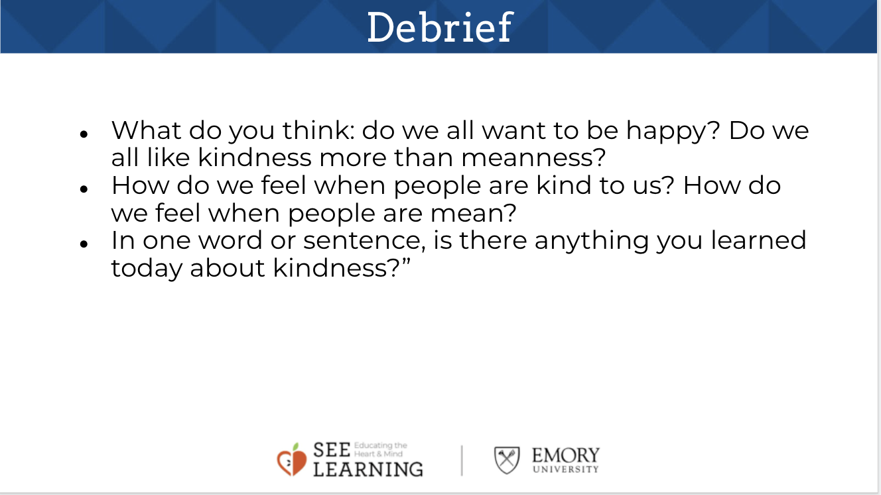  Animated slide | Sample Script  - “What do you think: do we all want to be happy? Do we all like kindness more than meanness?  - How do we feel when people are kind to us? How do we feel when people are mean?  - This year we’re going to be helping each other create a caring classroom. If we all want to be happy, and we all like kindness, then we should learn to be kind to each other. So that’s what we’re going to do.  - In one word or sentence, is there anything you learned today about kindness?” (Invite individual students to share out.)

