Strengthening Attention and Self-Awareness: The Mind Desk

Purpose:
Students have already learned to direct their attention inwards to the body and sensations. In this learning experience they will explore directing attention inwardly to the mind (called “meta-cognition”), meaning thoughts, emotions, and feelings. However, we can also start to help students understand the thoughts in their head and take ownership over them. Are these some thoughts that are more costly? Do you come back to similar thoughts a lot? How do your thoughts change? Thoughts can feel automatic, but we can have power over them and talk back.
Learning Objectives:  Students will be able to:  - Learn the practice of observing their own thoughts and feelings.  - Make a map of their mind, looking at what thoughts are present currently. | Primary Core Component  
Length  30 minutes | Materials Required  - Paper to draw on  - Provided stories  - Writing utensils

Check In (4 min)
Slide 2: Checking in   | Sample Script  - "Let's prepare for a short attention practice on the breath. How do we want our body to be?  - First we'll take a comfortable and upright posture. Then we'll keep our eyes on the ground or close them.  - Before we strengthen our attention, we'll do some resourcing or grounding to calm our bodies. Choose one of your resources from your resource kit, or you can choose a new one, or you can imagine one.  - Now let's just bring our resource to mind. And let's see if we can just pay attention to our resource with our mind for a few moments quietly. Or if you'd rather do grounding, you can do that too. Whichever you choose, we're going to rest quietly and pay attention for a few moments. [Pause.]  - What do you notice inside? If you feel pleasant or neutral, you can rest your mind on that.  - If you feel unpleasant, you can shift to a different resource, or you can ground. You can also change your posture but try not to disturb anyone else if you do that. Otherwise, just keep your attention resting with your resource. [Pause.]  - Now let's become aware of our breathing. Let's see if we can pay attention to the breath as it enters and leaves our body.  - If you find paying attention to the breath uncomfortable, then feel free to go back to your resource or grounding, or just take a small break, making sure not to disturb anyone else. [Pause for 15-30 seconds.]  - If you ever get distracted, you can just return your attention to the breath. You can also count your breath. [Pause for a longer time, such as 30-60 seconds or longer.]  - What did you notice?"

Insight Activity: The Mind Desk (15 min)
Overview
In this insight activity, students will explore the concept of the map of the mind using the metaphor of a desk to represent the mind.

Content to be Explored
- We can pay attention to our thoughts and emotions in our mind
- When we watch simply observe our thoughts, we get less caught up in them.
- Watching our thoughts helps us learn about what's going on inside us and helps us be less reactive.
- When we understand our thoughts, we develop into more self-aware individuals and less reactive.

Materials
- Paper to draw on
- Provided stories
- Writing utensils

Instructions
- Explain how we can think about our minds like a desk, with limited space to hold objects.
- Optional: Show examples of messy and neat desks.
- Provide each student with a blank piece of paper. Ask them to draw a large rectangle on each side of the paper to represent the desktops of two students they're going to hear about.
- Draw two large rectangles on the board or on chart paper to represent Theresa's and Desmond's "desks."
- Tell the stories below. Solicit help from students and draw on the desks when noted in the stories. After each story ask:
- What do you notice about the "desk?" What is their mind like?
- After you read the second story, compare the "desks" and discuss whose attention will feel stronger in math class today. Reiterate that attention can change over time, it does not exist in a permanent state.

Teacher Tips
- You can facilitate this learning experience as teacher-led or you can have students work in pairs or trios and then share out. The script is written as a teacher-led activity.
- Feel free to adapt the stories to your class's context.
Slide 3: The Mind Desk  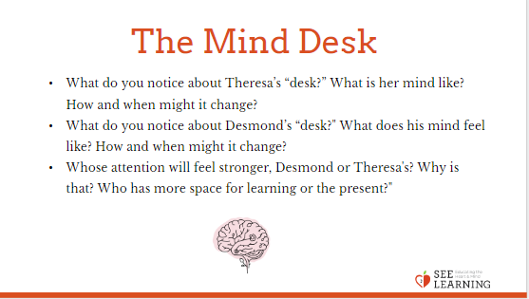 | Sample Script  - "Today we are going to think about our minds as a being like a desk, with a limited amount of desk space. Our desk space constantly looks different. Sometimes it's very organized; sometimes there are papers everywhere. Sometimes one thing is taking up the entire space; sometimes everything gets equal space.  - We are going to look at what Theresa's mental desk space (her mind) looks like. I'm going to tell you a story and based on what we learn in the story we will make changes to Theresa's “desk.”  - [Read Theresa's story (on the handout) and draw as noted.]  - What do you notice about Theresa’s “desk?” What is her mind like? How and when might it change? [Allow time for discussion.]  - Now, let's focus on Desmond and his “desk.” I have a story about him too. We’ll do the same activity with Desmond's story.  - [Read Desmond's story (below) and draw as noted.]  - What do you notice about Desmond’s “desk?" What does his mind feel like? How and when might it change? [Allow time for discussion.]  - Whose attention will feel stronger, Desmond or Theresa's? Why is that? Who has more space for learning or the present?"

Reflective Practice: Observing the Mind* (8 minutes)
Overview
As in the reflective practice of the previous learning experience, students will watch their minds, noticing what fills up their "mind desk," meaning the space of their minds.

Teacher Tips
- This practice combines resourcing and grounding, attention on the breath, and then observing the mind.
- If your students can do this practice without too much difficulty, repeat it once or twice a week.
Slide 4: Observing the Mind  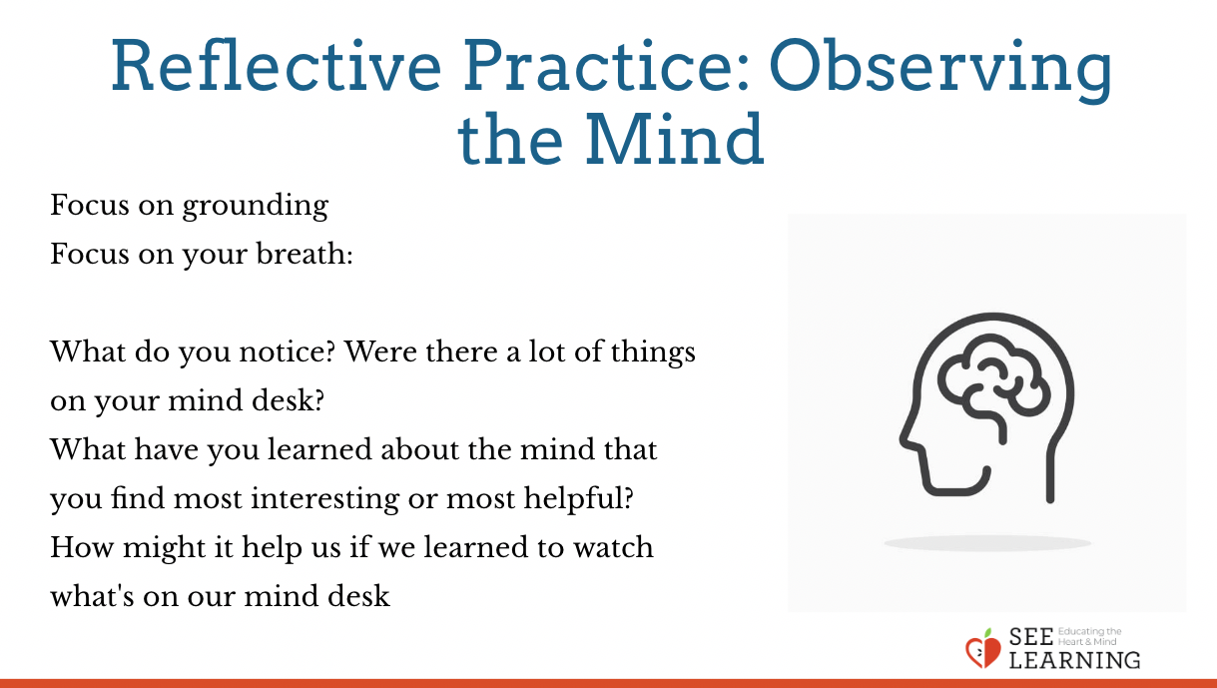 | Sample Script  - "Let's take a comfortable, alert posture and see if we can watch our own mind desk.  - So let's sit upright with our backs straight. And so we don't get distracted, let's lower our eyes to the ground or close them.  - First we'll do some grounding.  - Let's notice how our bodies are supported. You can change the way you're sitting if it makes you more comfortable. Let's see what we notice on the inside. [Pause.]  - Let's focus on our breath now. We’ll use that as our object of focus. Remember if you start to feel uncomfortable, you can go back to a resource or to grounding. [Pause for 30 seconds or longer if your students are comfortable doing so.]  - Now let's look at our mind desk.  - We're just going to watch to see whatever comes up in our mind.  - But instead of getting caught up in what's on our mind desk, we're going to observe it.  - Let's be silent and see if we can do that. [Pause for 15-30 seconds, or more if your students are comfortable doing so.]  - If we get distracted or caught up in something, let's remember that we're just looking at our mind desk. Whatever comes and goes is okay. [Pause for 15-30 seconds or more.]  - Now let's open our eyes and share.  - What did you notice?  - Were there a lot of things on your mind desk?  - Did anyone have nothing much on their mind desk?"

Debrief (3 minutes)
Slide 5: Debrief  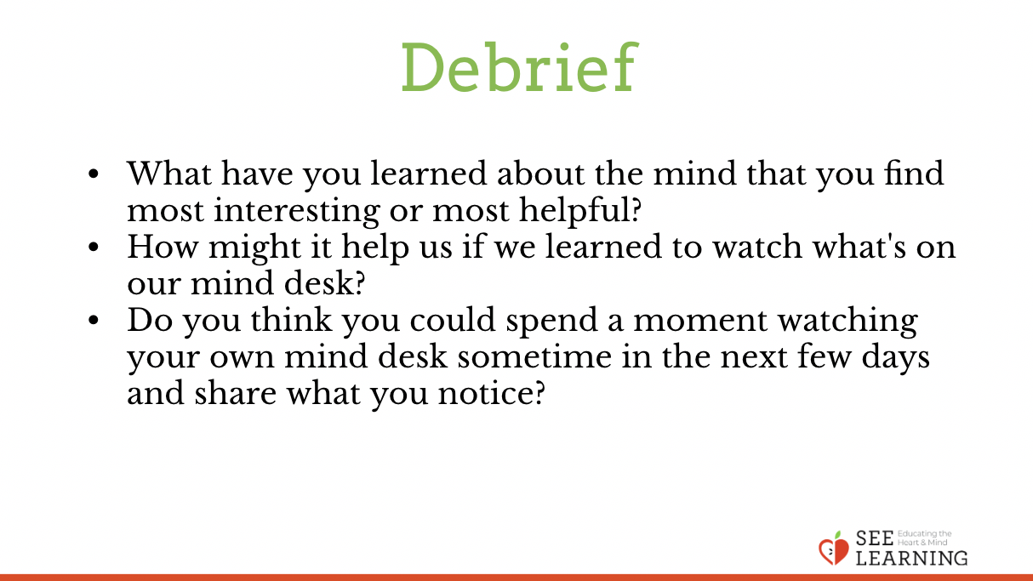 | Sample Script  - "What have you learned about the mind that you find most interesting or most helpful?  - How might it help us if we learned to watch what's on our mind desk?  - Do you think you could spend a moment watching your own mind desk sometime in the next few days and share what you notice?"

