Practicing Kindness
Needs to be updated after SD is created

Purpose:
The focus of this third learning experience is to build on prior learning and engage in the actual modeling and practice of kindness for experiential and embodied understanding. This involves two steps: an insight activity whereby the students translate the class agreements into practical examples that can be acted out; and then a practice activity where they act out those examples in front of each other and reflect on what they experienced. By acting out the very same items they said they wanted in the classroom they will come to a better understanding of kindness, of their class agreements, and of how they look in practice. This process of embodied understanding should continue as the school year goes on and will make it easier to refer to the lass agreements concretely throughout the year.
Learning Objectives:  Students will be able to:  - Develop specific ways of exhibiting kindness based on the class agreements.  - Apply their understanding of kindness in concrete individual and collective actions | Primary Core Component  Relationship Skills
Length  30 minutes (You will likely want to repeat this learning experience more than once so that you can get through all your class agreements.) | Materials Required  - Your class agreements listed on a piece of chart paper or on the board

Check-In | 3 minutes
Slide 2: Check In  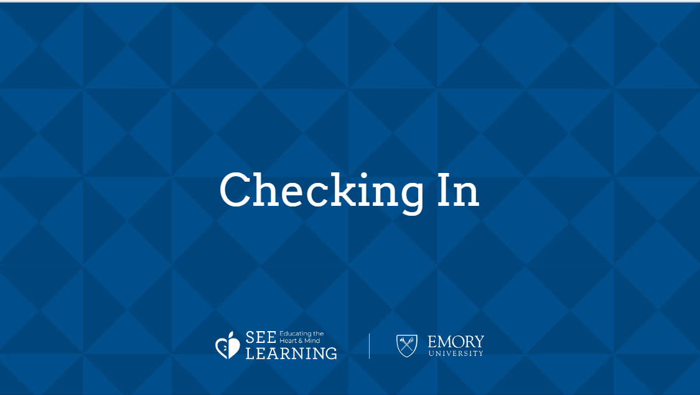 | Sample Script  - " Let 's take a moment to sit quietly and rest our minds and bodies so that we can think a bit. [Pause.] Maybe you are tired or full of energy, maybe it's been a challenging morning (day) or an exciting one. Either way, it's okay.  - Now let's all see if we can think of any moments of kindness in the day so far. Maybe something happened at home or on your way to school or as recently as just a minute ago.  - See what comes up for you. Don't worry if you can't think of something, you can always imagine a moment of kindness too. [Pause.]  - Let's sit with your moment of kindness for a little bit.  - Would anyone like to share what they thought of?  - How did that make you feel?  - Anyone else?"

Insight Activity: Turning Class Agreements into Helping Actions (22 minutes)
Overview

In small groups, students will get act out one of the agreements. The rest of the class will guess which agreement they are modeling. You will likely want to repeat this learning experience more than once so that you can get through all your class agreements.

Content to be Explored

- We all want kindness and happiness.
- There are specific actions we can take to support each others' happiness.

Materials

- Your class agreements listed on a piece of chart paper or on the board
- Each class agreement typed (or written) on separate sheets of paper

Instructions

- After you have agreed on your class agreements, put them each on an individual piece of paper (one agreement per sheet).
- Divide your group into small groups (3-5 students each) and give each group one agreement.
- Tell them they will be in charge of acting out their agreement to show what it looks like in action. The groups will think of the best way to demonstrate the agreement and quickly practice before showing the class. Provide 3-5 minutes for deciding and practicing.
- When groups are ready, groups will act out the agreement in front of the rest of the class. Other students in the audience can even be asked to guess which of the agreements is being acted out instead of being told before each performance. If you run out of time, you can continue during the next class.

Teacher Tips
- Try this format with several of the class agreements. When you come to a good stopping point, you can suggest returning to the rest of the agreements during other class meeting times. Eventually you will have specific ideas connected to each general agreement.
- It would be helpful to record these "skits" as references for the rest of the year.
- It's important to have students act out positive behaviors instead of having them demonstrate less desirable behaviors.
Slide 3: “title”  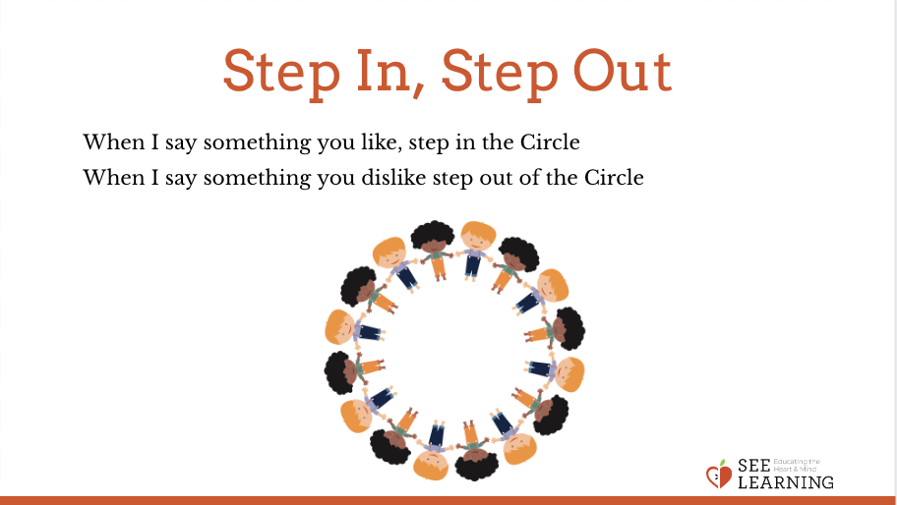 | Sample Script  - "Last time we were together, we worked on class agreements. Why is it important for us to have these kinds of agreements with each other? [Allow several students to share.]  - If no one says it, add: We have these class agreements so we feel happier and safe here in our classroom.  - Today we're going to act out what some of our agreements look like. First I'm going to divide you into small groups.  - Now that you are in small groups, I will give each group one of the agreements. As a group, you are in charge of acting out this agreement to show what it looks like in action. You will have just a short amount of time to brainstorm, agree and practice your brief skit. Then you will act it out for the rest of the class. [Provide 3-5 minutes for deciding and practicing.]  - Ok, let's have our first group present to the class. Those of you in the audience, be prepared to guess which of the agreements is being acted out. If we run out of time, we can finish during our next class together."  - [Repeat for each small group until you make it through all the agreements.]
Debrief (4 minutes)
Slide 5: Debrief  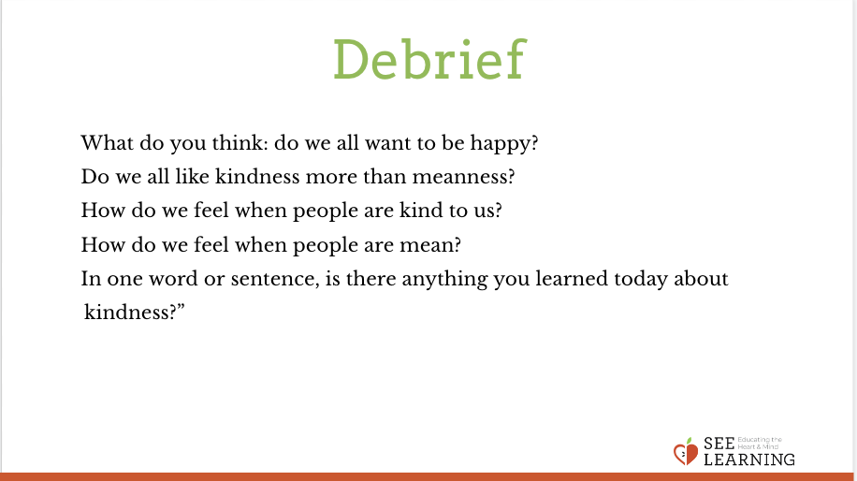 | Sample Script  - " Let 's take a moment to sit and think about what we just saw and felt.  - Did you notice how you felt when you saw people needing help or getting help?  - It often feels good not just to get help but to give it, and even to see someone being helped. It can make us feel happier and safer when we are helped by others and when they show us kindness.  - Is there anything you learned or practiced about kindness that you might like to use again sometime?  - Is there anything you think we should add to the class agreements after what we did today?"

EXTRA PRACTICE

- It's important for kids to be able to practice kindness in authentic situations. Over the next week, set a goal each day for kids to practice one of the agreements (this can be set at the beginning of the day) and then check-in at the end of the day to see how it went. This can also be brought back throughout the year when kids seem to be becoming lax about class agreements.
- In SEE journals, kids can write about how they would respond if someone were violating a class agreement. For example, "if we saw someone not respecting classroom property, what could we say or do”. They can also journal about instances when they saw someone following the class agreements or when they personally did so.

